REMOTE MONITORING AND CONTROLLING OF DC MOTOR USING ZIGBEE
D.G GAHANE, Professor, Electronics and telecommunication department ,priyadarshini college of engineering Nagpur.
Harsha Rebhankar,Pooja Wallalwar, Komal Johare,Payal Gowarkar,Yamini Barapatre, Sushma Meshram, student, Electronics and telecommunication department ,priyadarshini college of engineering Nagpur.

Abstract:Wireless based industrial automation is very important in our day-to-day life. The approach to Zigbee Based Wireless Network for Industrial Applications has been standardized nowadays.This project will control the speed of dc motor and its direction.The system will be wireless.The zigbee will be used for wireless communication. Zigbee is a wireless device and it is used to transmit or receive data simultaneously and also for safe and economic data communication in industrial fields where the wired communication is either more costly or impossible due to physical conditions.The project involves the design of remotely starting ,stopping, increamenting, decreamenting , rotating clockwise and anticlockwise.
Keywords:DC Motor,Monitor& Control System, Zigbee.
- Introduction
In many industry such as paper mills, rolling mills, printing machine machine tools, excavators and cranes etc. the dc motor is used for waying a product from one place to another on the conveyer belt. So due to these the speed and direction control of the dc motor is very important. Purpose. Motor speed controller is to take a signal representing the required speed and to drive a motor at that speed for that purpose wireless speed and direction control of dc motor by radio frequency technique is very crucial with pulse width modulation and H-Bridge converter. The microcontroller AT89S51 is used to control the dc motor speed and Transistorised h-bridge converter is used for direction control. By adjusting the duty cycle of pulse from Pulse Width Modulation technique simultaneously the terminal voltage of motor is change and hence speed will be vary with terminal voltage. H-Bridge is a DC to DC converter used for direction and made by 4 transistor switch across it a diode is connected. For speed control of dc motor many methods are available which are either be a mechanical or electrical for example armature control, field control, flux control method etc but this methods required large size hardware to implement. So for easy control of speed and the direction control of dc motor the wireless speed and direction control of DC motor by using radio frequency technique is very much essential and economical to used. For variable DC voltage we can used a controlled rectifiers which are converted a variable dc voltage from fixed DC voltage. Due to their ability to supply a continuously variable dc voltage. Many analoge and digital chips are used in firing or controlling circuits but transistor and thyristor control are more accessible due to theirinnumerable application in various industry. Recent development in the area of semiconductor technology have made faster,very small size microprocessors and microcontroller are available at in much reduced cost. The microcontroller can provide a controlling ofwidth of pulse provide to a controlling a voltage of motor terminal simultaneously the speed of motor cancontrolled. For that purpose the Pulse Width Modulation phenomena is used forcontrolling the width ofpulse.Pulse Width Modulation variable speed drives are fast applied in various new industrial application that required higher performance, reliable,easy control as well as economical purpose. In most of the application sinusoidal Pulse Width Modulation have been used. For direction control of DC motor we can simply change the input terminal of DC motor the direction will be change but this is not possible at running time as well as not safety operation.So for these direction control of DC motor we can used a H-Bridge circuit. It is made up from four transistor switches. Hence the microcontroller can send a signal to constant voltage supply and H-bridge can control the direction of DC motor.

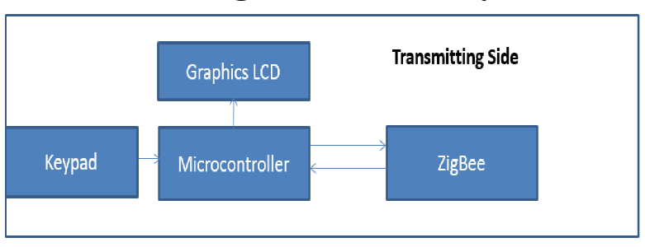
System Block Diagram
Figure (1) block diagram of transmitter module
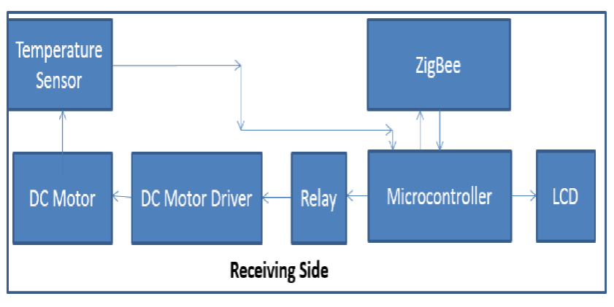
Transmitter is developed using 89c51, zigbee and graphic LCD. The six keys are connected at port 1.By default when the keys are up at that time the values of port pins are 1. The zigbee is connected at USART (universal synchronous asynchronous receiver and transmitter)pins of microcontroller. When any key is pressed. i.e 0 the microcontroller read the pin value and send the related characters to the receiver side through zigbee. At the same time the concern action will be displayed on graphics LCD.

Figure (2) block diagram of receiver module
In the receiver side the two microcontroller are used. The first microcontroller will read the messages coming from the transmitter and accordingly will control the DC motor. The second microcontroller is used for controlling the DC motor. The first microcontroller is connected at the zigbee. The second microcontroller is connected with DC motor driver IC L293D. The DC speed will be controlled with pulse width modulation techniques. The PWM will be generated with help of microcontroller. The 555 IC is used to select the relays for changing the direction of motor.
The power supply of 12v and 5v will be generated with the help of 7805 and 7812 regulator IC. Bridge rectifier will be used to change the AC signal into DC signal.1000 mf capacitor is used for filtering AC signals.

3.Software Design for Proposed System
Ride C5 compiler is used for programming for microcontroller. The burning of program into the flash ROM of the microcontroller is done by using the Uni pro software with the help of universal IC programmer and tester.

4.Components used in the Project
- Zigbee :Zigbee required low power, as well as it is dedicated transmitter and Receiver.
- Microcontroller 89C51
- Alpha numeric LCD(16*2): LCD screen is an electronic display module and find a wide range of applications.A 16*2 LCD Display is very basic Module preferredover seven Segments. And other multi segment LEDs .the reason being that LCDs are economical; easily programmable ; have nolimitation of displaying special and even custom characters
- Graphic LCD : The graphic LCD are used to displayCustomized characters and images
- Driver IC L293D :L293D is a dual H-bridge motor driver integrated circuit. Motor drivers act as current amplifiers since they take a low-current control signal and provide a higher-current signal. This higher current signal is usedto drive the motors.
- DC motor :DC motor gear type used as it has high torqued as compared to otherDC motor.
5. PCB Layout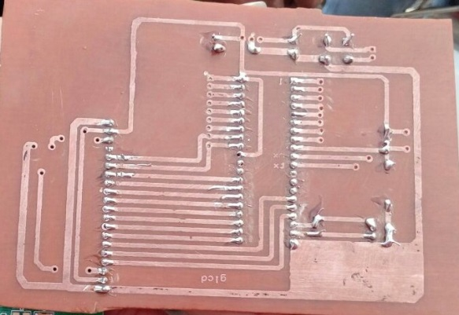
PCB LAYOUT OF TRANSMITTER
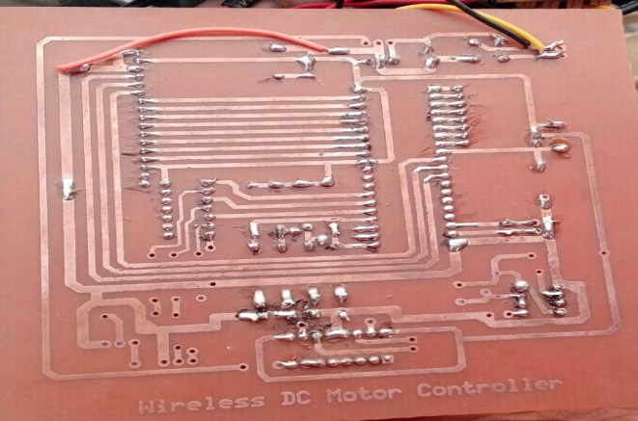
PCB LAYOUT OF RECEIVER

6. Application
1. Industrial purpose for monitoring process, control, inventory tracking data links and bar codes reading devices.
2. Commercial wireless application such as door announcers , security and access systems , gate control, remote activation , score board and paging system.
3. Consumer product including electronics toys ,home security gate and garage door opener intercom fire and safety system and irrigation controllers .
4. Bottle filling system, visitors counters and conveyor application.

7. Results
_{1st LED: Start the DC motor.}
_{2nd LED: Stop the DC motor.}
3rd LED: Increase the speed of DC motor.
4th LED: Decrease the speed of DC motor.
Rotate clockwise and anticlockwise.
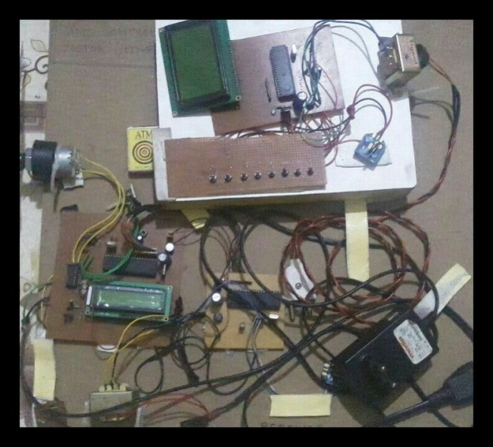

8. Conclusion
This system will help in monitoring and control the D.C motor parameters which is widely used in industries. Because of Using Zigbee communication protocol the wires and hardware are reduced significantly. Remote monitoring and controlling is possible.
9. References
[1] Kurnera, Dayananda And Jayawikrama , “ The Use Of Chopper In Collaboration To PC For The Control Of Dc Motor Speed”, International Journal Of Engineering Trends And Technology- Vol 3 , Issue 2 , P.P 110, 2012.
[2] Nicolai And Castgnct, “ How A Microcontroller Can Be Used For Speed Control”, International Journal Of Advanced And Scientific And Technical Research,- Vol 1, Issue 3, P.P 648, Jan-feb 2013.
[3] LCD& Graphic LCD -Embedded Journel –June25,2014.
[4] Khoel And Hadidi , “Controlling Dc Motor Using Microcontroller”, International Journal Of Engineering Research, Vol 1, Issue 2, P.P 45-47 , 01 Dec.2012.
[5] Nisha Ashok Somani And Yask Patel , "Zigbee Technology”, International Journal Of Control Theory And Computer Modelling (Ijctcm) Vol.2, No.3, May 2012.
[6] Www. Garage.Com/Electronic/Component/L2939-motor-driver-ic.

