Fabrication Of Power Operated Sand Filtering Machine

Dr. S.M.Mowade ¹, . Rohit Dhakulkar², Sachin kapgate³, Nitesh Meshram⁴, Rohit Hemane ⁵
¹Head Of Department, Department of Mechanical Engineering, SRPCE, Nagpur
²³⁴⁵Students, Department of Mechanical Engineering, SRPCE, Nagpur

ABSTRACT: Here we reveal the production structure. Sand is used being developed, delivering and numerous adventures. Sand ought to be moved from unessential particles, stones and other gigantic particles before it is put to utilies.Here we utilize engine that is mounted on a level plane utilizing mounts. The pole is associated with a rectangular channel outline with sifter beneath and encasing outline on the sides. We currently have a pole associated from the pole to the rectangular

Casing in a path, for example, to perform responding movement. Additionally we have a supporting edge to hold the rectangular channel outline set up while guaranteeing appropriate level movement. When we begin the engine shaft transmit the movement starting with one pulley then onto the next pulley by utilizing belt drive, at that point another pulley is associated with the rectangular edge that perform responding movement. This responding movement help to channel sand.

Substance Terms – Supporting Frame, Ac Motor, and Tool Equipment's.

- INTRODUCTION

For the most part while setting up the solid for development reason, the procedure of sand sifting are done physically. Separating of sand is completed utilizing rectangular work which is slanted at certain point.

In the present sand sifting technique, the example is exposed to even development for example responding development as per the picked technique. This causes a relative movement between the particles and the strainer. Contingent upon their size the individual particles either go through the sifter work or held on the strainer surface.

There are diverse machines that are being utilized for sand separating, yet we show the power worked sand sifting machine. Sand is utilized in development, producing and numerous ventures. Sand should be separated from unessential particles, stones and other vast particles before it is put to utilize.

Our framework advances control worked sand separating framework that naturally channels the sand utilizing responding movement of sifter poured on it. The primary sand sifting is done to dispose of the sand with a bigger than standard retention sand channel and the second sand channel is done to dispose of the sand with a size too little implies that the sand channel is disregarded. A work is a gadget for isolating fundamental components from unessential material or for deciding the molecule measure regulation of an example, commonly utilizing a weave screen, for example, a work or net or metal.

- LITERATURE REVIEW

1V.P.Duriraj 2J.Manikandan 1,2Asst Professor, Department of Mechanical Engineering, Bharath University, BIHER, Chennai. 1amaldhasan.mech@bharathuniv.ac.in, 2manikandan.mech@bharathuniv.ac.in Design and fabrication of sand sieving machine
The aim is to separate screws, nuts & bolts and Dust depend upon their size to change different size of mesh”. According to the current situation, society of labour, salary, and for automatic operation elimination of labour work is necessary for the future days. In current situation the water treatment plant uses these types of separator to separate the faces and unwanted material from the water. The vibrating table is fixed with the crank which moves the tray to vibrate it and act as a separator with the help of DC motor. Thus try the Design and fabricating of Sieving Machine to help the industrial people and farmers on the global market.
Sanjay N.Havaldar, Altaf Somani, Anusha Pikle, Yash Siriah and Samiksha Patil”, InternationalJournal of Current Engineering and Technology (IMPRESSCO), 4 March 2016. This paper analyses the design of a pedal operated water filtration system to be used by local dwellers. The design comprises of a peristaltic pump powered by pedaling, a filter and hose or flexible tube. As the operator sits on the seat and pedals, the pedal crank transfers the motion to the rotor thus the rollers and the tube is squeezed by the set of rollers to move the fluid.

As per Mr. Sai Karthik, Automation is the need of the time considering labor shortage , stringent labour laws , and the most labour intensive industry being the construction and foundry industry where sand sieving is must. Thus wither industry have opted for fully automatic sieving machines. But the small scale foundries and low level contractors are cannot afford this high end technology and hence require low cost methods and machine .Authors
Vol-4 Issue-3 2018 IJARIIE-ISSN (O)-2395-4396
8358 www.ijariie.com 4
Describe the sieving process using a rectangular mesh with slight inclination as laborious. Authors not that there are different machines that are being used for sand sieving and cement mixing processes and in their concept both the process will took place simultaneously thereby eliminating the time consumed during the whole process of preparing the concrete is reduced.

- CONSTRUCTION

Air conditioning engine: The engine used to pivot the pulley. When we begin the engine, the pulley likewise pivots. It is a basic plan with no intrudes. The engine is associated with the pulley which is exchange the movement starting with one then onto the next. The pulley is associated with another pulley which is associated with the rectangular channel plate through belt. The turning movement of the electrical engine changes over to the sliding movement utilizing two pulley and belt.

Work: A work is a boundary made of associated strands of metal, fibre, or other adaptable or flexible materials. A work is a gadget for isolating basic components from unessential material or for deciding the molecule estimate administration of an example, normally utilizing a weave screen, for example, a work or net or metal.

Supporting Frame: The upheld outline is utilized to help the parts. The absolute course of action is relies upon this edge. This edge is made of iron or mellow steel. The different individuals, for example, pulleys and gears are mounted on it.

Shaft: A pole is a pivoting machine component, normally round in cross area, which is utilized to transmit control starting with one section then onto the next, or from a machine which produces capacity to machine.

Direction: A course is a machine component that compels relative movement to just the ideal movement, and diminishes erosion between moving parts. The structure of the bearing may, for instance, accommodate free direct development of the moving part or with the expectation of complimentary turn around a fixed pivot; or, it might keep a movement by controlling the vectors of ordinary powers that bear on the moving parts.

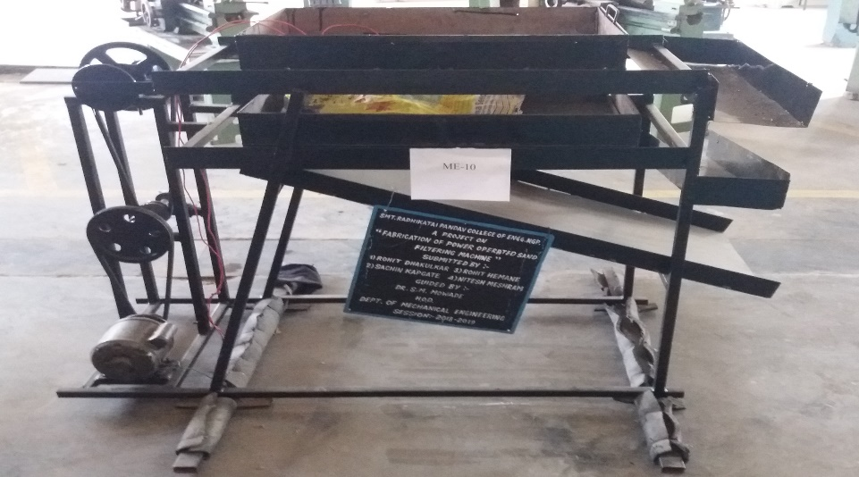
Fig.1: Fabricated Photo of sand filter

4. WORKING PROCESS

The entire work depends on power worked system. The revolution of the AC engine exchanges the movement to the development of rectangular shape channel .This system is utilized to pivot the pulley, the pulley which is having an all-encompassing pole is associated with the sliding part of the rectangular plate legitimately by methods for a linkage.

The rectangular plate is gone through the guide ways by methods for keeping up the cutting pivot. As the client begin engine, the plate moves directly on guided way. The engine is associated with the pulley which is exchange the movement starting with one then onto the next. The pulley is associated with another pulley which is associated with the rectangular channel plate through belt. The turning movement of the electrical engine changes over to the sliding movement utilizing two pulley and belt. The sliding wrench instrument is utilized in this venture. The engine is associated with the flywheel which is exchange the movement starting with one then onto the next. The flywheel is associated with another wheel which is associated with the rectangular channel plate through chain/belt. The pivoting movement of the electrical siphon changes over to the sliding movement utilizing two flywheels and chain/belt.

The sliding wrench instrument is utilized in this undertaking. The flywheel which is put at the top is utilized as wrench and associating pole in the middle of the rectangular plate and flywheel. At the point when the flywheel is pivoting, the rectangular plate perform responding movement.

5. ADVANTAGES

• Simple in development.
• Easy to utilize.
• Now days, partition of various sizes of strong material is need of hours, this venture can be utilized for detachment of various sizes of strong just by changing cross section of required size.

• Substance industry: tar, shade, modern medication.

• Foodstuff industry: sugar powder, starch, salt, milk powder.

6. STRUCTURE CONSIDERATIONS

• The gadget ought to be reasonable for neighbourhood producing abilities.
• The connection should utilize minimal effort materials and assembling techniques.
• It ought to be open and moderate by low-salary gatherings, and ought to satisfy their essential requirement for mechanical power.
• It ought to be easy to fabricate, work, keep up and fix.
• It ought to be as multi-reason as could be expected under the circumstances, giving capacity to different rural executes and for little machines utilized in rustic industry.
• Iron poles, point iron, and level stock that are locally accessible ought to be utilized.

Accordingly a minimal effort and straightforward plan control worked sand channel machine is created. The venture can be exhaustive to proceed with partition of various sizes of nuts by including arrangement of work. Through this task one can dispose of manual detachment which is tedious. The venture can be actualized every single other sort of division of mix with the contribution of various kinds of work. This venture is controlled by AC engine which is associate or supplies power. The rotational movement of AC engine is utilized to give responding movement to the work as aftereffect of forward and backward movement of work distinctive sorts and sizes of nuts can be isolated. Along these lines this venture continuously is giving simple method for division of various sizes of nuts and some other blend contingent upon work measure.

8. FUTURE SCOPE

Following a wide range of activity can be completed by the best possible power worked system connection according to the necessity. Here are a few tasks

• Rice Threshing

• Winnowing

• Corn Shelling

• Peanut Shelling

• Operating a Circular Saw

• Water Pumping from a Shallow Well

• Operating a Wood Working Lathe

9. REFERENCES

- Kumar J., Sathish Kumar K., Dayakar P., Effect of micro silica on high strength concrete, International Journal of Applied Engineering
- B.V, Verde International. “The Green Peristaltic Pump”. 16 March2014.

- Flahiff, Daniel. "Aquaduct Bike Purifies Water as you Pedal." 08 November 2008. Inhabitat.com March 2014
- Srinivasan V., Analysis of static and dynamic load on hydrostatic bearing with variable viscosity and pressure, Indian Journal of Science and Technology, v-6, i-SUPPL.6, pp-4777-4782, 2014
- ipton, Josh. "Trailer for Adult Passengers" 4 July 2007. BikeShopHub.com Blogs. March 2014.

