IOT Based Garbage Monitoring System

Mayuri Dongre¹, Shruti Walde², Rupali Babde³, Charul Vaidya⁴, Varsha Lanjekar⁵

¹UG student, ²UG student, ³UG student, ⁴UG student, ⁵Assistant professor
Dept. of Electrical Engineering, Shradha Park, B-37/39 Hingna- Wadi, Link Rd, nagpur, Maharashtra 440028

Abstract - The increase in population of the world is resulting in very adverse effect on our environment. The waste is increasing day by day all over the world, cities are getting polluted even more and diseases are spreading around us at very high rate, which is creating major health issues. The root cause of all this unhygienic condition is our poor waste management system. The key issues in waste management system are the waste is not collected, managed and disposed properly. Sometimes, due to the overloading of the bin, large portion of the waste gets spill over the road side. Sometimes, dustbins are not get cleaned at appropriate time. Sometimes, due to the delay in collecting the waste, it prompts various types of ailments, expansive number of creepy crawlies, mosquitoes and bad odor. The traditional way of managing the garbage is complex, cumbersome process and also utilizes more human efforts, time and cost. Thus, to defeat these issues and to maintain cleanliness of environment we have designed completely automatic system called “IoT Based Garbage Monitoring System”. In a proposed system, the level of bin is checked time to time and also real time analysis can be done on webpage from anytime and anywhere in the world. Once the bin gets filled, it informs the garbage collector by sending text message to him that “THE BIN IS FULL.”

Keywords- Internet of Things (IoT), NodeMCU, Ultrasonic Sensor, Garbage, GSM..

- INTRODUCTION

The proposed system mainly consists of Node MCU, an ultrasonic sensor, GSM and cloud server. The Internet of Things used to make connection of our everyday physical objects to the internet. Thus, any object in the world which can be provided with an IP address over a network can be made part of IoT system by embedding them with electronic hardware such as sensors and software [1].
The internetworking of physical world and sensors are described as Internet of Things. Thus IoT can perform the function of sensing, gathering data, storing data and processing by connecting physical devices to the internet [2].
The basic idea of this project is to design a bin which can automatically manage itself without involving any other human being. As here, the dustbin is the main source to be focus on, we have designed a system in which a bin is connected to the internet through internet of things by using other main components.
An ultrasonic sensor which works on the principle of sending and receiving high frequency short sound pulse in air at speed of velocity of sound, used to measure a distance. Here this ultrasonic sensor is used to detect the level of the filled garbage in the bin by comparing it with the height of the bin. The ultrasonic sensor is placed at the top of the bin and is interfaced with the microcontroller Node MCU.
Node MCU is one of an important object of an IoT platform. It includes firmware which runs on ESP8266 Wi-Fi and hardware based on the ESP-12 module. The firm uses Lua Scripting language. Node MCU is of same type of microcontroller as that of arduino but it has certain advantages over arduino uno. These advantages are – Node MCU has an inbuilt Wi-Fi module and also has greater storage capacity than arduino uno while the costs of both are nearly the same. This system monitors the level of garbage in every 10 second, stores the data and whenever the garbage in the dustbin crosses its threshold value shows it on webpage. If the garage level is below 90% or less than it is fine, but if the garbage level is above 90% then NodeMCU gives information to server ESP8266 module which is inbuilt in Node MCU. A server stores data and also shows it on webpage. Now GSM comes into picture, it send text message on mobile of the garbage collector [2].

II. PROPOSED SYSTEM

The IOT Garbage Monitoring system is an automatic system which will help to keep our cities clean and beautiful. In the proposed system, the level of garbage in
the dustbin is detected by using ultrasonic sensor and the ultrasonic sensor provide the real time results with ESP8266 Wi-fi module and send it to the web application. For this web page is built and new database has been created. The Web Application shows the “status of bin” and “time at which dustbin got full” in tabular form. In case if the dustbin fill with garbage like 90 to 100 % then GSM will automatically send the SMS to specific mobile number of garbage collector to inform him about the same. Thus, municipal authority would be able to find at what time actually dustbin was full.
There is no proper system followed for the collection of waste and disposal in India. The waste is collected and dumped in various areas of the cities. The collected waste is not taken for disposal and left in same place for many days and becomes rotten in that place and cause bad smell, spreading diseases. That’s why; we have designed the given system. Hardware model of a proposed system is shown in fig.1a and fig.1b.

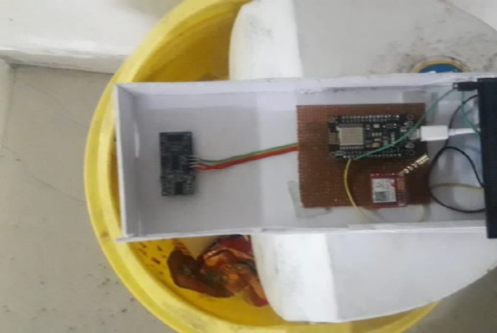
Fig 1a: Image of given proposed system
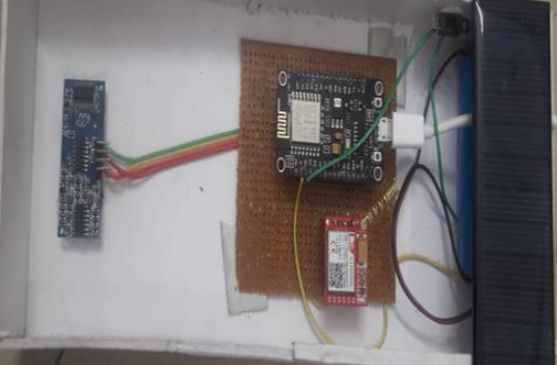
Fig. 1b: Image of given proposed system
Here in this project, the dustbin is placed with an ultrasonic sensor on its top. It checks the level of bin every time and whenever the value exceeds the threshold value, this information is shared with the server and garbage collector through GSM system [2]. The android mobile will fetch the information from the server in which area the dustbin is located by comparing the coordinates. Since now almost all common people use the smart phones it becomes easy for us to provide the product which will be helpful for us to keep the city clean.
This system can be implemented anywhere such as for domestic, commercial, industrial purpose etc. System can be supplied through a battery of anywhere between 3.5v to 5v DC, solar panel can also be used as a backup source. The system is not limited with only one dustbin, it can be used for several dustbin placed at different locations, connected in network along with GPRS location [3].

III. BLOCK DIAGRAM

All the embedded systems have equally different designs according to their functions and uses. The proposed system is implemented with NodeMCU (microcontroller), ultrasonic sensor, GSM, Wi-Fi module, cloud server as shown in fig. 2.
A. NodeMCU - NodeMCU is a low cost wi-fi SOC (system on chip) which has an inbuilt wi-fi. It is a highly integrated chip designed to provide full internet connectivity in a small packages. It functions as a microcontroller which can be programmed through USB port using LUA programming or arduino IDE [4].
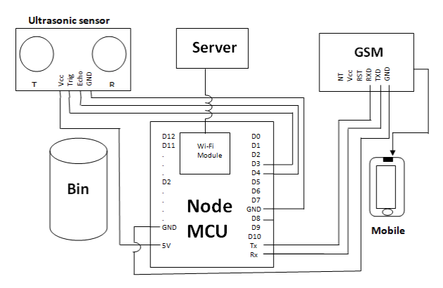
Fig 2: Block diagram of a proposed system
By simple programming we can establish wi-fi connection and define input/output pins according to our need. As it works as microcontroller it get information from sensor and process it on. It compares the data coming from an ultrasonic sensor and compares it with a preset value in coding and generates output accordingly.
B. Ultrasonic Sensor - It is another main component of a proposed system which is used to detect the level of garbage in bin. Ultrasonic sensor has two openings named as transmitter and receiver. It works on the principle of transmitting and receiving an ultrasonic wave. Transmitter emits ultrasonic waves of suitable frequency and after striking an object it reflects back and gets received by the receiver.
Here time and speed of sound in air plays an important role in calculating the distance. The time taken by ultrasonic sensor to receive back the wave can be converted in to distance by using some collaborations [5].
C. GSM Module - GSM is used to communicate between computer and GSM system. A SIM card of a specific number is inserted in GSM module. The main purpose of using GSM is to send message to the garbage collector whenever the dustbin is full [6].
D. Cloud Server - Cloud servers are virtual servers which delivers, stores and compute the information via internet. A large amount of data can be stored in cloud and can be easily accessed by higher authorities to monitor the working.
There are multiple paid as well as free local webhosts. Where one can make account accessed it freely. Thus we have used a free webhost which is called 000webhost.com. An account is created on the same webhost and created a website. Further database is added as per requirement of project which shows two columns that is date, time and status as shown in figure below. Thus, this website can be accessed from any device, any person and any place in the world.
IV- FLOWCHART
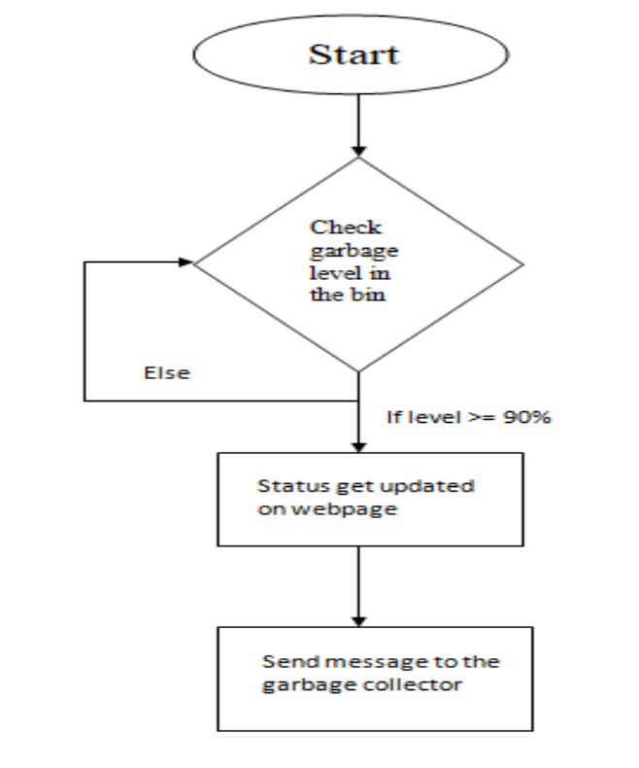
Fig 3: Flowchart of a proposed system
The key objective of a proposed system is to develop an intellectual monitoring system for proper management of waste. A municipal authority can adopt such type of system and monitor the waste collection status on real time based they can also prepare weekly or monthly report on it for their study.
This can be achieved by programming NodeMCU differently as per our requirement. The logic of program can be explained from a flowchart given in fig. 3. It says that, the ultrasonic sensor monitors the level of bin in every 10 seconds and compares it every time with the threshold value set in program. If the new value given by sensor is less than threshold value, it continues its operation that is, it will again check the level of bin in another 10 second but if the value send by ultrasonic sensor is greater than or equal to its threshold value (90%) the cursor comes out of its loop and it will generate an output. That is, it will update and stores on webpage about the status of the bin and what time it was full and also it will send a text message on garbage collector’s mobile to inform him about the same.
V. RESULT

We have developed a web page where time to time analysis could be done. Fig. 4a shows output of a proposed system on webpage. In this page the database has been mentioned showing date and time. The ultrasonic sensor sense the level of garbage and as the garbage level of the bin exceeds above 90%, the status is displayed on the webpage.
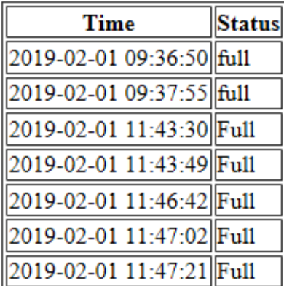
Fig 4a: Snapshot of output of a proposed system on webpage
The text message is also sent to garbage collector to inform him about the garbage bin status. Fig. 4b shows the snapshot of the message received on cell phone of garbage collector. This project will save the time of garbage collector. Though the system is costlier but it saves the labour cost and human efforts.
The following are the advantages which are obtained from this project:
- Weekly analysis could be done.
- Higher authority can monitor the work of labours.
- This will avoid overflowing of garbage.

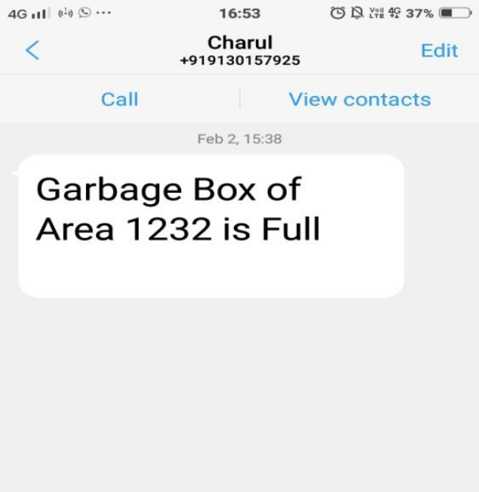
Fig 4b: Snapshot of message delivered on garbage collector mobile

VI. CONCLUSION AND FUTURE SCOPE

The paper gives the basic idea about efficient garbage monitoring system using the technology of IoT. The paper is presented keeping in mind the recent works. This project measures the level of waste and sends message through internet to cloud server. Thus, the given proposed system can be used in ‘SMART CITY’. It can further help in waste decomposition and Fertilization. This project is also beneficial under “SWATCCHA BHARAT ABHIYAAN”.

REFERENCES

[1] Anitha A, “Garbage monitoring system using IoT,” 14th ICSET-2017.
[2] Komal Pokalekar, Ashvini Salunkhe, Priyanka Kachare, Prof. N.C.Yadav, “IoT based garbage monitoring system,” in International Research Journal of Engineering and Technology(IRJET), volume: 05 Issue: 03 | Mar-2018.
[3] Namakambo Muyunda, Muhammad Ibrahim, “Arduino based smart garbage monitoring system,” IEEE 2017.
[4] Mamatha Dhanajaya, Priyanka. K. E, Nidhi. R, Pooja.. K, “Smart garbage monitoring system using nodeMCU,” Int. Conf. on Signal Processing Communication and Automation, ICSIPCA 2017.
[5] Sagnik Kanta, Srinjoy Jash, Himadri Nath Saha, “Internet of things based garbage monitoring system”, IEEE, 2017.
[6] S. Vinoth Kumar, T. sethil Kumaran, A. Krishna Kumar and Mahantesh Mathapati, “Smart garbage monitoring and clearance system using internet of things,” in IEEE 2017.
[7] S. Sunitha, “Distance measurement using ultrasonic sensor and nodeMCU,” International Research Journal of Engineering and Technology (IRJET), Volume: 04 Issue: 06 | June-2017.
[8] Dr. K. Alice Mary, Perreddy Monica, A. Apusurrunisa, Chatrhala Sreekanth,”IoT based garbage monitoring system,“ International Journal of Scientific & Engineering Research, Volume 8, Issue4, April-2017.
[9] Dr. N. Sathish Kumar, B.Vijayalakshmi, R. Jenifer Prarthana, A. Shankar, “IoT based smart garbage alert system using arduino UNO,” IEEE, 2016.

