Design And Fabrication of Solar Based Hybrid Grass Cutter

Amrin Ayyub Khan ¹

¹P.G, Integrated Drives & Circuits (Electrical), Priyadarshini College of Engineering, Nagpur, Maharashtra, India

Abstract- The present technology which is commonly used for trimming the grass is by using the manually handle device. In this paper we have proposed, specially designed and fabricated a semi-automated hybrid machine using a wireless remote controller in which various functions such as trimming the grass, floor moping, fan operation, mobile charging, emergency light, pesticide/insecticide sprayer and bird repellent siren, etc. are incorporated in a single hybrid machine.
The device consists of linear blade which is operated with the help of motor. The power supply to the motor is given by using a battery. The battery is charged by using a solar panel, and alternatively it can be powered by using an AC source. The system uses a 12 volt battery to power the vehicle movement as well as the grass cutting motor. The vehicle is fabricated using PVC pipes so as to make the vehicle light in weight, robust and non-corrosive. It has an IR sensor for obstacle detection in case if an obstacle is detection the IR sensor will monitor it and the switch arrangement will stops the grass cutting motor to avoid any accident.

Keywords- Solar Panel, DC Motor, Obstacle Sensor, RF based Remote Controller, Sprinkler.
I-INTRODUCTION
In the field of manufacturing engineering product design plays key role in terms of geometrical parameter i.e., size shape and easiness for users. There is lots of progress in today’s world but there is still some labour power which requires lots of income allocation for a small work. So it is

required that exertion should have some other substitute so that the labour power surplus can be avoided.
Moving the grass cutters with a standard IC engine is not feasible, and no one takes contentment in it. Cutting
grass cannot be effortlessly accomplished by elderly, younger, grass cutter moving with engine create noise pollution due to the loud engine, and local air pollution due to the combustion in the engine. Also, a motor powered engine requires intermittent maintenance such as altering the engine oil. Even though electric solar grass cutter is ecofriendly. The trial product will also be charged from sun by using solar panels. The design of solar powered agricultural equipment (e.g. grass cutter) will include direct current (D.C) motor, a rechargeable battery, solar panel, and control switch.
In our project we are trying to make a daily purpose machine which is capable of cutting the grass in lawn, for floor cleaning, insect killer, and as a fan. The system will have some automation work for assistance and other obstacle recognition. The supply to the system is given by a battery which is charged using a solar panel which is attached on the top of the machine and it can also be powered by using AC source.
This document is a template. An electronic copy can be downloaded from the International Journal (IJRST) website. For questions on paper guidelines, please contact the conference publications committee as indicated on the IJRST website. Information about final paper submission is available from the IJRST website.

II- METHODS AND MATERIAL
MAIN COMPONENTS
- Solar panel
- Battery
- Charge controller
- DC motor
- IR sensor
- Blades
- RF Module With Controller

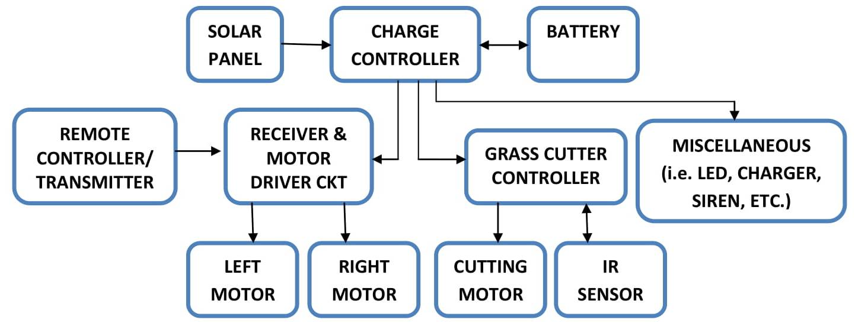

Figure 1: Block diagram of hybrid grass cutter

SOLAR PANEL
Solar energy is clean, cheap and abundantly available. Here we are using polycrystalline type solar panel. The

grass cutter works on the photovoltaic principle. When photons from sun are absorbed in a semiconduter that produces free electrons with higher energies, these electrones are combining with holes in semiconducter and produces electron hole pair and hence th external conducter constitutes electrical current to do useful work. The specifications of solar panel we are using is 40W, Voc = 22.18, Isc = 2.36.
CHARGE CONTROLLER
The charge controller sits between the array of panels, the batteries, and the equipment or loads. By monitoring the voltage of battery, the charge controller disconnect the array of panels from the battery to avoid overcharging, and they disconnect the battery from the load to avoid over discharging. The connection and disconnection is done by means of switches which can be of two types: electromechanical (relays) or solid state (bipolar transistor). the switch opens the charging circuit when the voltage in the battery reaches its high voltage disconnects (HVD) or cut-off set point. The low voltage disconnects (LVD) prevents the battery from over discharging by disconnecting the load. The specifications of charger that we are using in this project is 12volt, 10amp, 2 load arrengment.
BATTERY
The batteries are used as a storage device for solar energy which can be further converted into electrical energy. The specifications of battery that we are using in this project is Ni-cd sealed maintenance free, 12 Volts, 26Ah. The battery should have properties like Long life, High reliability, Low cost, High overall efficiency
DC MOTOR
Here the dc motors used are 12V, 10,000 rpm, permanent magnet DC motors for grass cutting, mopping and fan operation. 2 Motors which is of 12V, 30 rpm are used to power the wheel that would rotate in the desired direction. Another motor and pump is connected with the tank and nozzle so as to carry out the sprinkling action when required.
Advantages of a brushed DC motor include low initial cost, high reliability, and simple control of motor speed. Disadvantages are high maintenance and low life-span for high intensity uses.
IR SENSOR FOR OBSTACLE DETECTION
An object can be detected with an infrared system consisting of an infrared transmitter and a receiver. An IR transmitter, also known as IR LED, sends an infrared signal with a certain frequency compatible with an IR receiver which has the task to detect it. The IR transmitter sends an infrared signal that, in case of a reflecting surface (e.g. white color), bounces off in some directions including that of the IR receiver that captures the signal detecting the object. When the surface is absorbent (e.g. black color) the IR signal isn’t reflected and the object cannot be detected by the sensor. This result would occur even if the object is absent.

RF MODULE WITH CONTROLLER
In this project RF module is used for remotely access of hybrid grass cutter. An RF module (radio frequency module) is a (usually) small electronic device used to transmit and receive radio signals between two devices. In an embedded system it is often desirable to communicate with another device wirelessly. RF communications incorporate a transmitter and receiver.
BLADES
Nylon blade: Length of wire: 10cm
Internal diameter: 10mm
Steel blade: Diameter of blade: 12.5 cm
Internal diameter: 10mm

III-METHODOLOGY
- The project mainly concentrates on designing a suitable operating system. To maintain simplicity and economy in the design the locally fabricated unit has been used. The hybrid machine is fabricated using PVC pipes so as to make the vehicle light weight, robust and non-corrosive.
- The working of hybrid grass cutter is it has solar panel mounted in a PVC chassis with adjustable arrangement so as to direct the solar panel towards sun at an angle of 45 degrees in such a way that it can receive solar radiation with high intensity easily from the sun. These solar panels convert solar energy into electrical energy, now this electrical energy is stored in batteries by using a solar charger. The main function of the solar charger is to disconnect the solar panels from the batteries when they are fully charged and also connects to the panels when the charging in batteries is low.
- The chassis is powered by 2 dc geared motor which is also supplied from same power source. The chassis is remotely operated using RF module. For forward/reverse movement both the motor are supplied at the same time by module and for left/right operation any one motor is connected to the power source.
- The motor is connected to the batteries through Charge controller. Between these a two motor driver is provided. It starts and stops the working of the motor. From this motor, the power transmits to the mechanism and this makes the blade to rotate with high speed and this makes to cut the grass as well as mopping operation. The blade will get kinetic energy while increasing the rpm. The cutting edges are very smooth and accurate .Also Electric Grass Cutting Machines are much easier to be used in garden, lawn and grass fields. In order to enhance the beauty of lawns and play grounds.
Also an arrangement is also provided to cut the grass in required length.
- For fan/blower operation the movable arm is tilt to 90º vertical and replacing the detachable cutting blade with fan propeller we can use the same project for fan operation.
- The project also has additional features like mobile charging, emergency light, pesticide/insecticide sprayer and bird repellent siren.

- RESULTS AND DISCUSSION

EQUATIONS
Force required by cutting blade to shear the grass is given by;
F = T/R .......... (1)
Where,
T = Shaft torque
R = Radius of cutting blade
Shaft torque is given by;
T = P/2πN ..........(2)
Electrical power is given by;
P = I * V .......... (3)
Torque of motor is given by;
P = 2πNT / 60 .......... (4)
T = (P*60) / (2πN) .......... (5)

CALCULATIONS

Amp hour = | Total wattage of load * | Working time
 |  | Total voltage
= (54*5) / 12
=22.5 Ah
Hence we are using 26Ah Lead Acid Battery
Wattage hour of = battery | Amp hour * | total voltage
=26*12
=312 Whr
Time required for= charging | Whr
 | panel wattage
=312WHr /40W
=7.8 Hr
Hence time require for 100% charging using 40W solar panel is approximately 8Hour

COMPARISON

Table 1- Comparison Between Solar and IC Engine Cutter
Sr. No | Particular | Solar Based Grass Cutter | IC Engine Grass cutter
1 | Pollution | No | Pollution is great factor
2 | Fuel | No fuel consumption | Fuel is major factor
3 | Friction | Greatly reduced | High
4 | Cost | Low | High
5 | Maintenance | Low | High
6 | Load carrying capacity | Low | High

- CONCLUSION

The project entitled “Design and Fabrication of hybrid grass Cutter” is successfully completed and the results obtained are satisfactory.
The presented paper provides the fabricated information to the common man as it is having much more advantages i.e. smooth grass cutting operation with an adjustable arrangement provided, no fuel cost, no pollution, cost effective, less wear and tear because of less number of moving components, and as the chassis is fabricated using PVC pipes, it makes the vehicle light weight, robust and non-corrosive. Also Non skilled person can also handle it easily. The system is operated by using solar energy. Also this system is having facility of charging the batteries while the solar powered grass cutter is in motion. So it is much more suitable for grass cutting also. The same thing can be operated in night time also, as there is a facility to charge these batteries in day light. Other features of Hybrid grass cutter like floor moping, fan operation, mobile charging, emergency light, pesticide/insecticide sprayer and bird repellent siren are working efficiently and make our project a multipurpose machine.

FUTURE SCOPE

Microcontrollers and advanced electronic devices can be used for further modifications like path algorithm, ultra sonic sensors for obstacle detection, PIR sensors for human detection and automatic movement decision controller of chassis when obstacle is detected. Wi-Fi based Remote access with camera installed in chassis so as to see the ground view while operation.

REFERENCES

- R.S. Khurmi and Gupta, “Machine Design” 14th edition, S. Chand
- V.B. Bhandari, “Machine Design” 3rd edition, Tata McGraw Hill
- U. C. Jindal, “Machine Design”.2 reprint edition, Pearson Education India
- K.Sawney, “Electrical and Electronic Measuring Instruments”, Dhanpat Rai and
- G.D. Rai ,Non-Conventional Energy Source
- Godfrey Boyle ,Renewable Energy-Power For A Sustainable future
- Ms. Yogita D. Ambekar, Mr. Abhishek U. Ghate. Solar based grass cutter, International journal of Electrical and electronics engineering. Vol 9 2017.
- Ms.Bhagyashri R. Patil, Mr.Sagar S patil, Solar based Grass Cutter, International journal of Electrical and electronics engineering. Vol 9 2017.
- E. Nareshbossbabu, G Rahul, Grass Cutting Machine by Solar energy power, International journal and magazine of Engineering and Technology, Management and Research. Vol-3 2016.
- P. Amrutesh, B. Sagar, B. Venu, Solar Grass Cutter with linear blades by using scotch yoke mechanism. International journal of Engineering Research and application. Vol-4 2014.
- P. M Madhav, H.B. Bhaskar, novateur publications international journal of innovations in engineering research and technology [ijiert] ISSN: 2394-3696 volume 2, issue 2 Feb. -2015.
- S.O. Nkakini, B.E. Yabefa, European International Journal of Science and Technology, ISSN: 2304-9693, Vol. 3, No. 4 May-2014.
- Vishal Danve, Anindu Bose and Varun Dhawan” Solar powered gardener” International Journal of Technical Research and Applications e-ISSN: 2320-8163, www.ijtra.com Special Issue 39 (KCCEMSR) (March 2016),PP. 39-43
- Praful P. Ulhe, Manish D. Inwate “Modification of solargrass cutting machine”, IJIRST –International Journal for Innovative Research in Science & Technology| Volume 2 | Issue 11 | April 2016 ISSN (online): 2349-6010 science and engineering, November 2, 2011.

