NFC Based Tourist App
Dhiraj D.Dahiwade, PranaykumarS.Wakodikar, Pravin A.Kumbhare, MayuriA.Gajbiye

CSE Department AGPCE Nagpur., India

Abstract – Technological progress and tourism have been gone hand in hand for years. The use of mobile devices such as smart phones and tablet computers has increased at a phenomenal rate in recent years. With the increase in the number of mobile devices more and more devices will be supporting Near-Field Communication (NFC), which is a short range and wireless technology for data transfer without physical touch. NFC technology will open up new opportunities for various stakeholders in tourism from destination level to tourism researchers. In this article earlier research on NFC technology is reviewed and categorized into four different topics: business models and ecosystems, software and applications, security and hardware, and threats and issues. Current and potential applications of NFC in tourism are also reviewed using existing case studies. Also managerial contributions of the study are presented.

- INTRODUCTION

The number of tourist users especially foreign is increasing rapidly year by year along with the traveling areas especially in cities. Nearly 40 to 50% of the families have their own view and apart from this there are tourist cabs and taxis. Number of tourist areas has also been increased not only in cities even in towns where some tourist attraction places are there. In cities and tourist places is provided to users with fees. There are some free tourist areas provided by the governments in public places but the safety of the tourist which is done in those free areas is not assured. So many people are ready to spend some money for safety of their tourist. In our normal day to day life, lots of problem have been faced due to the payment system in
Parking’s. During peak hours a long queue will be created due to payment delay and also there is chance for miscalculation of tourist fees may occur. And it’s not that safe to carry cash to all places and using credit cards and debits in all locations may welcome cyber thieves and it is also not safety to use our cards in unknown places.To avoid all these problems and to make the life
a lot easier and simpler a technique is discussed in this paper which uses a smart phone embedded with NFC technology in it.
II. What is NFC?
Communication technology which operates at a frequency of 13.56MHz and transceivers the data between two NFC enabled devices within few centimeters at the rate of 424Kbps. NFC is an advanced version of Radio Frequency Identification (RF-ID) and which combines the operation of both smartcard and reader.
Generally NFC applications are based on smart
phones enabled with NFC technology. Nowadaysmany smart phones are enabled with NFCtechnology.
Some applications of NFC arepurchasing travel ticket and its payment, as electronickeys for vehicles and houses, as identification device
combined with a smart phone.
Since NFC is a short range communication technology, it can be assured that this technology is more secured when compared with other communication mechanisms such as radio frequency identification, infra red and Bluetooth.
Two different communication modes are there in NFC namely active and passive communication mode. An active mode device generates its own RFfield whereas a passive mode device has to bepowered by using the RF field of an active mode device and data transfer will be done by using load modulation.

LITERATURE REVIEW

A look at the scientific exploration of the “mobile services and tourism” issue shows that only relatively few papers have been published on this topic so far. The contributions have mainly been made by the IFITT community that has clearly committed itself to this issue with the ENTER conference and the Journal of Information Technology & Tourism. In 2010, Egger and Jooss published a German anthology entitled mTourism – Mobile DiensteimTourismus; no corresponding work has been published so far in the English literature. A search for publications on NFC in tourism provides just a mere hand full of papers (mainly Pesonen and Horster, 2012; Chung and Tsai, 2012; Borrego-Jaraba et al.,011; Isaksson, 2010; Baldo et al., 2010; O¨ ztaysi et al., 2009; Hardy et al., 2008; Madlmayr and Scharinger, 2010; Haid, 2007 as well as Hui et al., 2009). Only Pesonen and Horster(2012) focus decidedly on the interplay between NFC and Tourism, other papers deal only superficially with NCF, treat it as a side subject or describe a very concrete application from a mostly technology-oriented perspective.
This paper tries to close this gap in the literature by analyzing NFC technology in the context of tourism and trying to draft possible applications. The attempt is made to present a technology that could become omnipresent in tourism routines in the near future

Working
During a transaction, one party can be completely inactive, drawing power inductively from the active party.
Even the active party draws little power and can be left on all the time with minimal effect on the phone’s overall power draw. Also, the nearness of NFC transactions creates the possibility of using proximity as context. and triggering an appropriate action almost instantaneously.
When we touch our phone with another NFC device, the other device provides the context that can be used to automatically invoke one or more applications on our phone with appropriate parameters. We refer to this invocation method as contextual application invocation (CAI).PASSIVE COMMUNICATION MODE: The initiator device provides a carrier field and target device answer by modulating existing field .In this mode, Target device may draw its operating power from initiator provide electromagnetic field. ACTIVE COMMUNICATION MODE: Both initiator and target device communicate by alternately generating their own field .In this mode both devices typically need to have a power supply.

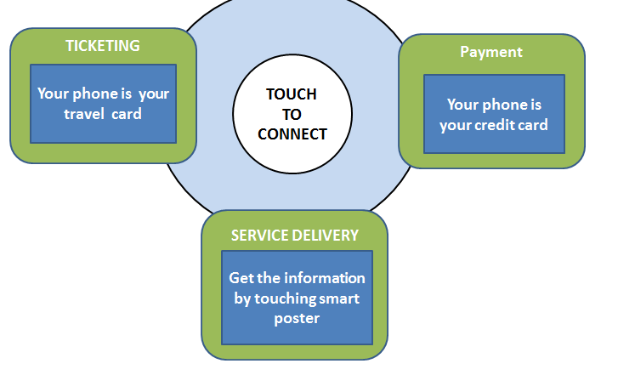

Fig1 : Block Diagram NFC

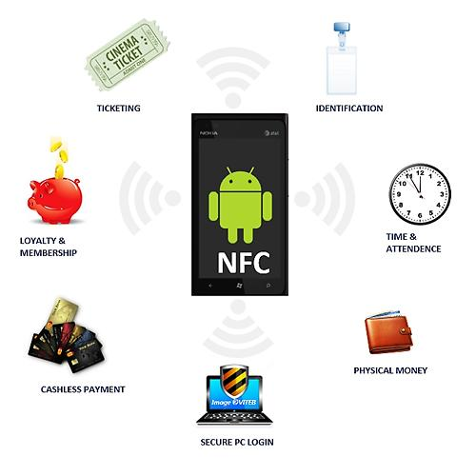
Fig2 : NFC Based Functionality.

The current work used Nearest Field Communications to get mobile nodes and creates Energy efficient architecture for tourist app. At initial stage when NFC nodes enter into sensor range, the NFC send signal and wait for response. As response arrived from receiverNFC tag, then algorithm measure NFC data and convert them into readable Format. From available data,. The proposed system can proceed through following steps :
A. Read write NFC Tag
B. Book Ambulance
C. Book Taxi

Read write NFC Tag
We will focus our attention on NDEF data that is a special type of NFC tag. There are some basic steps we have to follow to read and write NFC TAGS. droid NFC Tag, the first thing we want is our app is notified when we get near a NFC tag. To this purpose we use a intent filter.
Book Ambulance.
After reading and writing of NFC tag we can book ambulance automatically by using location of the NFC tag .
Book Taxi.
After reading and writing of nfc tag we can book taxi automatically by using location of the NFC tag.

APPLICATIONS

1. Interactive Advertising
You’re walking past a bus stop and see an advert for a movie or see a house for sale. All you need to do is wave your phone in front of the advert and you will be able to instantly watch a trailer or get more information. QR codes currently do this, but it can be a bit hit-and-miss, and it’s also a one-way-only data transfer.
NFC chips and stickers are tiny, and also relatively cheap. Their increasing prevalence in both mobile handsets and in retailers means people are rapidly becoming used to the idea, so it’s a space to watch for consumers, and fertile ground for innovators.
2. It brings back the mix tape!
NFC is bringing back the mix tape. Sharetapes allow you to make playlists and share it with friends using the technology. Who doesn’t love a mix tape? It’s a creative way to use the technology and you can keep the cards in your car, wave your phone at them and play your music without pressing any buttons.
3. Tourism experience
NFC can be used to guide tourists around a city. They can wave their devices in front of tags to give them information about iconic landmarks, download maps or coupons. The tech doesn’t require wifi and can transfer small bits of data to keep tourists informed. A nifty little smart city hack.
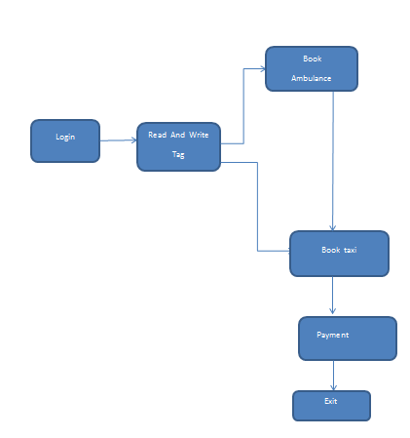
Fig 3: Project Modules.
REFERENCES

[1] Florian Michahelles, Frederic Thiesse, Albrecht Schmidt, John R. Williams, "Pervasive RFID and Near Field Communication Technology," IEEE Pervasive Computing, Vol. 6 (3), JulySeptember, 2007, pp. 94-96, c3.

[2] JormaYlinen, MikkoKostela, LariIso-Anttila and PekkaLoula, “Near Field Communication Network Services”, Third International Conference on the Digital Society, Cancun, Mexico, February 1-7, 2009, pp. 89-93.

[3] Bilginer, B. and Ljunggren, P. L.; “Near Field Communication,” Masters’s Thesis, Dept. Electrical Engineering, Lund University, Sweden, 2011.
[4] Al-Offishat, H. and Rababah, M. “Near Field Communication,” IJCSNS International Journal of Computer Science and Network Secutity, Vol.12, No.2, pp. 93-99, February 2012.

[5] Paus, A.: Near Field Communication in cell phones. White paper.Ruhr University at Bochum July (2007) ECMA International, Near Field Communication White Paper.ECMA International, 2007.

[6] Narada, W.: Near Field Communication (NFC) opportunities & Standards.

