Employee Webcam Attendance and Payroll System

Swapnil Baraskar¹, Nilesh Sahare ¹, Dhananjay Tembhurne ¹, Prof. Shubhash Malewar²

¹B.E Scholar, ²Assistant Professor
CSE Department,WCEM, Nagpur Nagar, Nagpur, India

Abstract – Employee Webcam Attendance and Payroll System helps to generate the rate of salary each month and it is also equipped with a system that can take care of attendance of the employee’s in the firm. It keeps the tract of employee’s attendance and on that basis it generates the monthly salary. It also helps to generate pay slip as well as summary of the payroll. The report of the ESI and provident fund is generated by this system. Printout is also available so that it can be submitted to the department. Managing employee’s information of a particular organization or for a small group is asstedious task. It has to store all the necessary record for each and every employee within the organization to assign correct task to correct person and right salary and perks to their eligible employees. Manual record keeping is a time taking process. As it cause delay in making query and generating the final results. Due to complex environment and working procedures, it is not possible to handle all the information with accuracy. This payroll management system Project will do all these jobs automatically and more accurately.

Keywords- Biometric Technology, Attendance Recording System, Automated Payroll System, Face detection algorithms.
- INTRODUCTION
The employee webcam attendance and payroll system helps to keep the record of the entire employee. We propose to develop attendance system to simplify the process of taking and maintaining the attendance records of employee. It reduces paper work and saves time.The employee attendance system can be integrated with web cam which instantly records the presence of the employee and updates it in the attendance system.The employee payroll system has been designed to record payment and salary details of the employee. The provident fund details and other tax related information is recorded on this employee payroll system for ease of access. Both the employees and the employer can access the employee payroll system to view all the information, input their tax savings certificates, salary break-up and fund or loan details. The employee payroll system is a very useful tool for the accounts department as it reduces their manual work, provides all necessary and updated information at one place at all times throughout the year.

  - RELATED WORK

- Automated Attendance Management System using Face Recognition was proposed by Mrumayee Shiodkar, Varunsinha[2], urvijain[3].This papers using Viola Jones face detection method; Local Binary Pattern algorithm for face recognition and Yale database techniques are being used which will give us an overall efficiency of 83.2%.

2. Face Detection And Recognition For Automatic Attendance System was proposed by Dr. Nita Thakare[1], MeghnaShrivastava[2], NidhiKumari[3]. System build around this proposal to realize that there are extensive variety of strategies, for example, biometric, RFID based and so forth which are time consuming and non-efficient. So to overcome, this above framework is the better and reliable solution from every perceptive of time and security. In this way we have accomplished to add to a reliable and effective participation framework to distinguish faces in classroom and recognize the faces accurately to mark the attendance.

3. A Survey Paper On Automated Attendance System was proposed by MayankRahate, PriyankaAuti, BhargavKulkarni, SurajMayande.On the basis of this method such as defaulters list, student’s lecture wise, total attendance in percentage and count can be calculated and access to the results can be made available for teachers as well as students to keep track of their respective attendance using face recognition and detection algorithm.

FUTURE WORK

The proposed attendance system mainly consists of four stages: Employee Registration, Employee Attendance, Employee Advance Management, Employee payroll Management.

Employee Registration:-
The administrative person or authorized person or clerk handled the software, Registration of an employee by filling suitable data of an employee in the registration page.

Employee Attendance:-
In this module the day to day attendance of an Employee will be punched. At the end of the month total attendance of an Employee will be calculated.

Employee Advance:-
In this module if an employee would require advance, after approval of his request the required amount will be given as an advance.
The head of an administrative department or authorized person in the department give the employee advance based on need or employee designation In every case, the employee must have a scheduled tour of duty and be serving under an appointment not limited to six months or less.
"Basic pay" for this purpose means the rate of pay fixed by law for the position plus any annual premium pay attached to the position; night differential for prevailing rate employees.

Employee payroll :-
An allowance is the financial benefit given to the employee by the employer over and above the regular salary. These benefits are provided to cover expenses which may be incurred to facilitate the discharge of service for example Conveyance Allowance is paid to foot expenses incurred for commuting to workplace. Some of these allowances are taxable under the head Salaries. A few of them again could be partly taxable and few others are non-taxable or fully exempt from taxes.

SYSTEM ARCHITECTURE

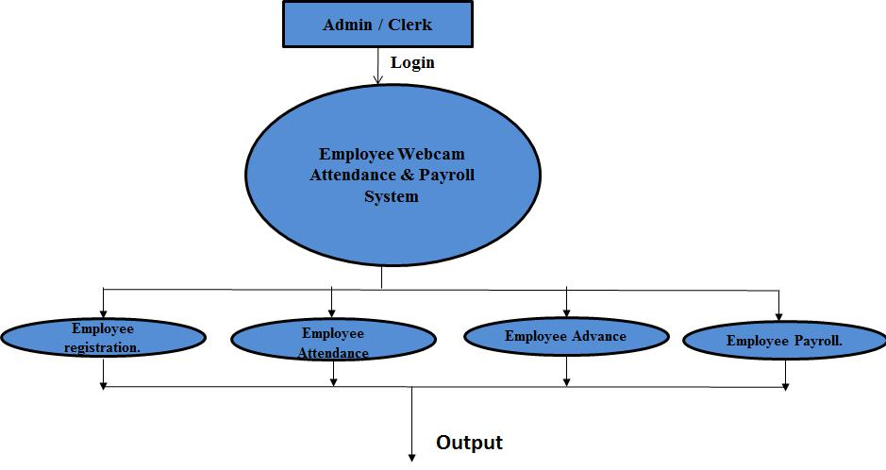

Viola–jones Algorithm | The viola –jones face detection is first face detection to provide competitive object detection only on frontal images of faces. Sensitive to lighting condition.
RFID  Algorithm | “Radio Frequency identification is technology” that incorporates the use of  Electromagnetic or electro station coupling in the radio frequency. RFID technology is harder to understand RFID tags are usually larger than barcode labels.
Emgu CV  Algorithm | “ Extroverted Modern generous unselfish”In this proposed system we use the technology EmguCV Algorithm for image  processing. The main goal is to show and  explains the easiest way to implement aface  detector and recognizer in real time.

- APPLICATION

Educational Institutions-
This system is very useful to record and maintaining the daily attendance sheet and also provide online performance report. Manually recorded attendance can be easily manipulated. Hence this method is proposed to Tackle all these issues.

Employee authentication –
Automated attendance management is a very active topic of research. A lot of work has been done in this field and there is a lot to improve. Being one of the most successful applications of the image processing, face recognition has a vital role in technical field especially in the field of security purpose. Human face recognition is an important field for verification purpose especially in the case of employee attendance.

Surveillance –
This automatic attendance marking system integrates video surveillance and face recognition algorithms into

the process of attendance management.The captured image undergoes face detection and faces recognition, and extracts all faces from the acquired images.

CONCLUSION

We come to realize that there are extensive variety of strategies, for example, biometric, EmguCV and so forth which are time consuming and non-efficient. So to overcome, this above framework is the better and reliable solution from every perceptive of time and security. In this way we have accomplished to add to a reliable and effective participation framework to distinguish faces in organization and recognize the faces accurately to mark the attendance. The scope of the project is the system on which the software is installed, i.e. the project is developed as a desktop application, and it will work for a particular institute / organization. But later on the project can be modified to operate it online.

Face recognition systems used today work very well under constrained conditions, although all systems work much better with frontal mug-shot images and constant lighting. All current face recognition algorithms fail under the vastly varying conditions under which humans need to and are able to identify other people. Next generation person recognition systems will need to recognize people in real-time and in much less constrained situations.

REFERENCE

- BhutanNE made (Ass. Prof), Mrunmaye Shirodkar , Vaun Sinha , Urvi Jain , “Automated Attendance Management System using Face Recognition”,International Journal of Computer Applications International Conference and Workshop on E merging Trends in Technology , Vol. No. 04, December, 2015

- Dr. Nita Thakare, Meghna Shrivastava, Nidhi Kumari , “Face Detection And Recognition For Automatic Attendance System”.International Journal of Computer Science and Mobile Computing , IJCSMC, Vol. 5, Issue. 4, April 2016, pg.74 – 78

- Mayank Rahate, Priyanka Auti, Bhargav Kulkarni, Suraj Mayande,“. A Survey Paper On Automated Attendance System”Department of Computer Engineering,PES’sModernCollegeof Engineering,Volume 4, Issue 6, November - December 2015

