**Android Based Department App-Using PDA System**

**Priyanka Jichkar1,Kalyani Gawande2, Arshadkhan Pathan3, Prof. Gangotri Nathaney4**

B.E Scholar, CSE Department, WCEM, Nagpur, India[1,2,3]

Assistant Professor, CSE Department, WCEM, Nagpur, India[4]

***Abstract –*** *There is a tremendous increase in users with an Android-based phone, Smartphone and tablet computers.This application provides ageneralized solution to monitor the various works that arecarried out by a Department of College for managing it. “Department App provides a simple interface for maintenance of student information. This app will be praxis by students, lecturers, HOD and parents.It can be used by educational institutes or colleges tomaintain the records of students. DepartmentApp deals with all kind of student details,academic related reports, department details, curriculum, batch details, placement details and other resourcerelated details too. This proposed project will be implemented in applications such as online study material, notices, results and attendance, timetable, and all department records using Android applications.Many techniques and languages are used for implementation such as Gson, access flags, Android, MySQL. This paper aims to develop a department application for student & staff information System.*

***Keywords-*** ***Android Technology, Administration, Smartphone’s, Database, Internet***

1. **INTRODUCTION**

The design and implementation of a ambientstudent information system and user interface is to replace the current paper records. Department Staff are able to directly accessall aspects of a student’s academic progress through a secure,online interface embedded using. By Department app.Previously, the college relied heavily on paper records forthis initiative. While paper records are a traditional way ofmanaged student data and different work, there are severaldrawbacks to this method. First, to convey information to thestudents it should be displayed on the notice board and thestudent will have to visit the notice board to check that information.It takes a very long time to deliver theinformation to thestudent. Paper records are difficult to manage and track. Thephysical stress required to retrieve, alter, and re-file thepaper records are all non-value added activities. This systemprovides a simple interface to maintains thestudent information. It can be usedby educational institutes orcolleges to maintain the records of students easily. Achievingthis purpose is difficult using a manual system as theinformation is scattered, can be redundant and collectingrelevant information may be very time consuming. All theseproblems are solved using Smart Connect. The paper focuseson presenting information in an easy and intelligible mannerwhich provides facilities such as profile creation of student,professor, principal and higher authority thus reducing paperwork and automating the record generation process in an educational institute.All data is stored securely on SQL serversmanaged by the college administrator and ensures highest potential level of security.Android is an mobile operating system developed by google based on the Linux kernel. Developing Android applications or games do not require a license. Therefore Android recommends open source tools for developers for the Eclipse IDE. The Android web browser is an open source engine running ToolKit with some properties from the Chrome browser. The programming language in Android is mostly Java and XML.

**2. METHODOLOY:**

Following flow explains the methodology of proposed System :



**Methods are uses:**

1) Gson:Sending data to app to server.

Gson file use to connectionbetween the android and server for download.

2) OnClickListener: Click event for Button to jump or next Page.

If user wants to jump one page to another then they can use the OnClickListener Event.

3) Input StreamReader: It is use for read the data.

4) equals (object obj): Compares this method against the specific object.

5) Declaring class: Methods declaring class.

It is used to show the different methods for declaring class.

6) access flags: Using for bits encoding access.To encode the data using various bits encoding techniques.

7) doget, dopost:doget and dopost method use to create a server in servlet.

**3. SYSTEM DESIGNING:**

Department app using Android is an integrated System developed to assist department management groups by enabling Students, H.o.d and Lecturers to immediately send and receive any data or information . This will minimize the number of minutes as compare to using any website application.

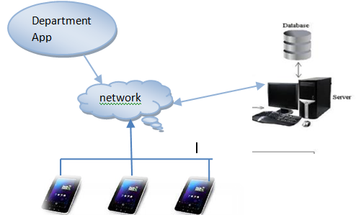

**Fig**: **System Architecture**

**4. IMPLMENTATION AND RESULTS:**

For implementation of the App, the Platform used is Android 4.2 and language used is Java and XML. MySQL is used at the backend. For setting environment of Android, there is a minimum requirement of JDK i.e.java must be installed on the system. JDK 8 software engginering development kit 7 is used for this purpose. Code is written by using a editor i.e Eclipse which is a open source editor available After Eclipse (Juno, the default version) is installed, there is a need to connect Android SDK with Eclipse,this is done by using ADT Plugin. By using ADT Plugin link, plugin developer tools can be downloaded and installed. MySQL is automatically embedded into the Android device.

A. **User login module:** In this module, user has to first register. User will be move to Register activity after clicking register button on Login screen. User has to fill details like Username, Email-id, Mobile number, Password and Confirm Password Etc.

B. **Admin module:**Admin panel upload time tables, any notice related to College, Result and Attendance.Admin has provided also authority for control on the System.

C. **Lecturer Module**:If the lecturer wants to upload assignments, Show Time Table to students the can easily send this information using department app.

D. **Student Module:** If the user wants to download assignments, having see anynotification,they can check easily after login successfully

E.**ParentModule :**Parents will see also their students exam time table and attendance.

**RESULTS:**

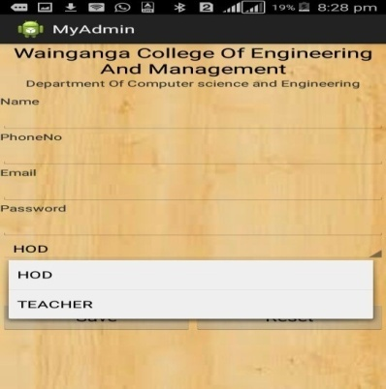

**Fig(a)** :This is Department app portal.

User can filled the details for

Registration.

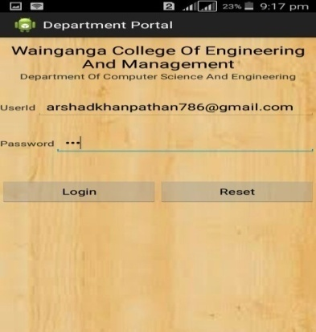

**Fig(b):**User can apply the login Registration

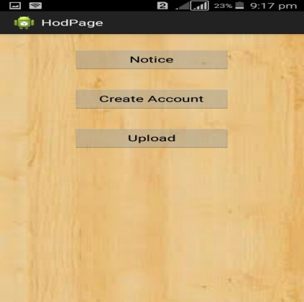

**Fig (c):**HOD can Create the account &

They can uploads the time table and send the Notice.

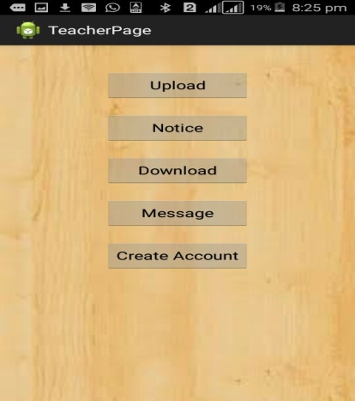

**Fig(d):**Teacher can first create the accounts of students and parents and own .They can upload ,download assignments & any department information details.Show Time Table ,Results &Attendance on the notice Board.

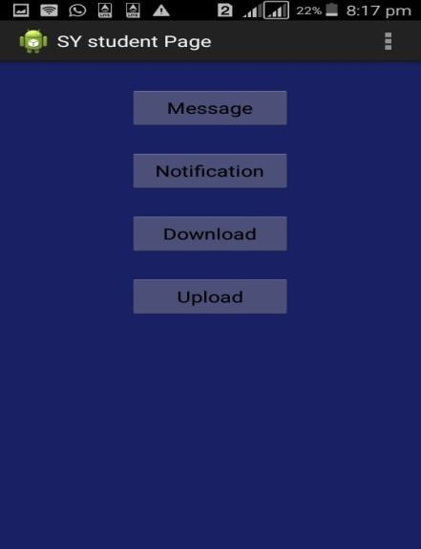

**Fig(e):**Second year student first create the login.

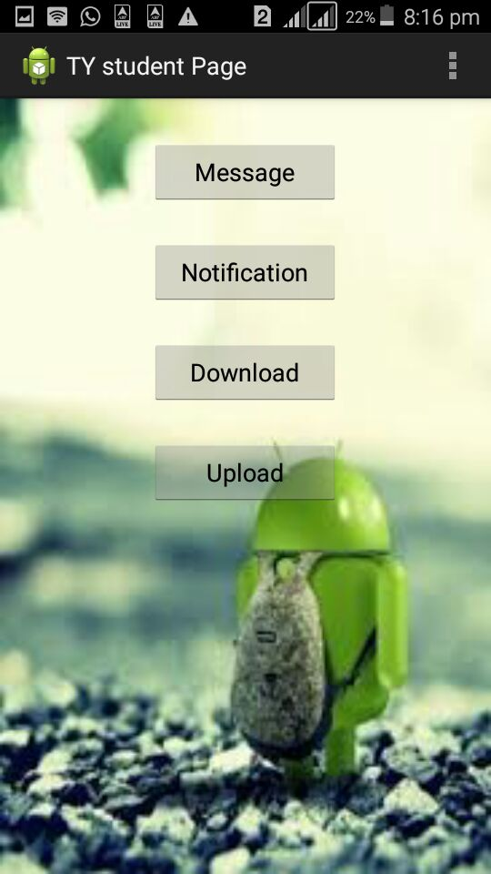

**Fig(f):**Third year students also after login registration completed.They can Download assignments,send message,check any department details notice.

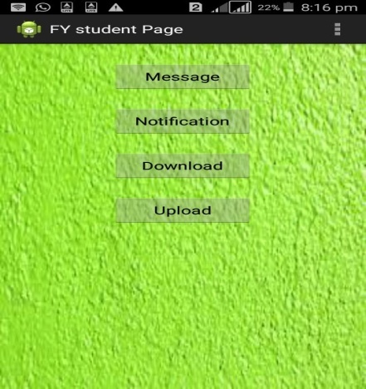

**Fig(g):**Final Year Students also check any notification about department details,and download any information.

**5. APPLICATIONS:**

This Application mostly useful Schools, Colleges, Univerities and TrainingInstitutions**.**

**6.ACKNOWLEDGMENT:**

We hereby thank the authors listed in the references for the valuable information and records statistics.

**7.CONCLUSION:**

"Android Based Department App Using Smartphone" is an Department system with Students feedback. This system is convenient, effective and easy thereby improving the performance of Department staff’s. It will also provide quality of service and students satisfaction. Overall conclusion is that, this is a Department app system for the department sector, made by combining the Android and Wireless technology.

In this, we compare the 3 major automaton tools in Department sector namely, the PDA based System, and Android based system. The user interface of Android based system is more attractive and informative than the PDA and Multi-touch systems. The processing speed of Android system and Multi-touch system is almost the same whereas the PDA based systems are slower than the other two systems.. This system is convenient, effective and easy thereby improving the performance of Department staff. It will also provide quality of service and customer satisfaction.

**8.REFERENCES:**

*[1]Lalit Mohan Joshi, “A Research Paper on College*

*Management System”, International Journal of Computer*

*Applications (0975–8887) Volume 122 – No.11, July 2015.*

*[2] PurviSankhe, HardikPunamiya, Vatsal Prasad, Raj Shrivastav,*

*“Android Application for College Management System”,*

*International Journal for Scientific Research & Development|*

*Vol. 2, Issue 02.*

*[3] S.R. Bharamagoudar, Geeta R.B., S.G.Totad (2013 "Web*

*Based Student Information Management System”,*

*International Journal of Advanced Research in Computer and*

*Communication Engineering Vol. 2, Issue 6, June 2013*

*[4] GarimaPandey,DikshaDani Android Mobile Application*

*Build on Eclipse" International Journal of Scientific andResearch Publications, Volume 4, Issue 2, February 2014 1*

*ISSN 2250-3153*

*[5] ShiplaHamale,ThakurGaneshsingh,SyedArshadHussain*

*“Android College Campus ”,International journal of ethics in*

*Engineering & Management Education,ISSN:2348-4748*

*[6] Android.[Online].Available:http://www.android.com*

*[7] KamaruddinMamata, FarokAzmat, “Mobile Learning*

*Applicationfor Basic Router and Switch Configuration on*

*Android Platform”published in Sixth International Conference*

*on UniversityLearningand Teaching (In CULT 2012) 1877-*

*[8] NurulFarhanaJumaata, ZaidatunTasir,“Integrating Project*

*BasedLearning Environment into the Design and*

*Development of MobileApps for Learning 2D-Animation”*

*1877-0428 2013Social andBehavioural Sciences 103(2013)*

*526-533.*

*[9] Christopher Dong, Xing Liu.,“Development of Android*

*applicationof Language studies” 2013 International*

*conference on Electronicengineering and computer Science.*

*2212-6678 2013.*

*[10] MHsuanChe Yang, Wen-YingWang.“Facilitating*

*AcademicService-Learning with Android-based Applications*

*and Ubiquitous Computing Environment” 978-0-7695-4493-*

*9/11 26.00 2011IEEEDOI10.1109U-MEDIA.2011.29.*

*[11] K.w.T.G.T. Priyankara, D. c. Mahawaththa,D.P.Nawinna,*

*J.M.A.Jayasundara, K.D.N. Tharuka, S.*

*K.Rajapaksh“Android Based e-Leaming Solution for Early*

*Childhood Education in Sri Lanka”,International Conference*

*on Computer Science and EducationColombo, SriLanka*

*(ICCSE) April 978-1-4673-44632013*

*[12] DjoniHaryadiSetiabudi, Lady Joanne Tatyana, Winsen.*

*“MobileLearning Application Based on Hybrid Mobile*

*ApplicationTechnology Running on Android Smartphone and*

*Blackberry”IEEE International Conference, 1 - 5, 2013*

*[13] AnkitaAgrawal and AshishBansal “Online Attendance*

*ManagementSystemusing RFID with Object Counter”,*

*International Journal ofInformation and Computation*

*Technology.ISSN 0974-2239Volume 3, Number 3 (2013), pp.*

*131-138*

*[14] Vishal Bhalla, TapodhanSingla, AnkitGahlot and Vijay*

*Gupta,“Bluetooth Based Attendance Management System”,*

*InternationalJournal of Innovations in Engineering and*

*Technology (IJIET) Vol.3 Issue 1 October 2013, ISSN: 2319*

*1058.*

*[15] Sarah Jane Aseniero, Arlene Buena, DannyCarreon, Joanna*

*De Luna, Ma. ErlindaSimangan, Engr. Mary Regina B.*

*Apsay.,“ELearningLuna, Ma. ErlindaSimangan, Engr. Mary*

*Regina B. Apsay.,“ELearningforProgrammin Languages On*

*Android Devices”,International journal of scientific and*

*technology research volume2, issue 9, September2013 ISSN*

*2277-8616 cm,” not “0.1  0.2 cm2.”*

*[16] AmitaDhale, MadhavMistry, TusharZore, “A Survey on*

*“SMART CONNECT” an Android and Web Based*

*Application for College Management System”, International*

*Journal of Science, Engineering and Technology Research*

*(IJSETR), Volume 3, Issue 11, November 2014.*

*[17] Jin Mei-shan1 Qiu Chang-li 2 Li Jing 3. “The Designment of student information management system based on B/S*

*architecture”.978-1-4577- 1415-3/12 2012 IEEE.*