A Review on Driver Drowsiness Detection System in Android
Ankita G. Titare¹, Anuja V. Zopate², Suraj A. Shelke³
¹Student, DES’sCOET Dhamangaon Rly Amravati, India, Pin 444710
²Student, DES’sCOET Dhamangaon Rly Amravati, India, Pin 444710
³Student, DES’sCOET Dhamangaon Rly Amravati, India, Pin 444710

Abstract – Driver fatigue is the major cause of accidents in the world. Detecting the drowsiness of the driver is the surest ways of measuring the driver fatigue. The purpose is to develop a drowsiness detection system. The drowsiness detection system works by using the information of ECG signal to minimalize the risk of the accident. ECG signal acquired from a sensor, which then transferred via Bluetooth to android device to calculated power ratio by applying hamming window and FFT technique. As the ratio decreasing, the system will activate the alarm which indicates the driver is drowsy. Heart rate variability (HRV) analysis is for the detection of driver drowsiness. However, the detection reliability has been lower than anticipated, because the HRV signals of drivers were always regarded as stationary signals. The aim of Heart rate variability (HRV) analysis is to classify alert and drowsy driving events using the wavelet transform of HRV signals over short time periods and to compare the classification performance of this method with the conventional method that uses fast Fourier transform (FFT)-based features. Based on the standard shortest duration for FFT-based short-term HRV evaluation, the wavelet decomposition is performed on 2-min HRV samples, as well as 1-min and 3-min samples for reference purposes.
Keywords-Drowsiness Detection, Heartbeat Rate, Power Ratio, Android, HR Sensor.

INTRODUCTION
Driver drowsiness is a major cause of mortality in traffic accidents worldwide. Many of deaths from accidents could be avoided if driver drowsiness could be properly monitored and drivers are given early warnings. Driver drowsiness, that is, excessive sleepiness, is more likely to happen when a person is driving for extended periods in monotonous environments, such as on a highway. The standard clinical tests for measuring sleepiness are the Multiple Sleep Latency Test (MSLT) and the Maintenance of Wakefulness Test (MWT), combined with polysomnography datasets. These measurements are very expensive and cumbersome to perform (at least eight channels are needed: four EEG, two Electrooculogram (EOG), one Electromyogram, and one Electrocardiogram (ECG), it would be practically impossible to use these methods to detect driver drowsiness in an actual driving environment. For instance, the use of multiple sensors would be uncomfortable for the driver and could even impede his or her movement. Thus, there is a strong demand for an easy-to-use driver drowsiness detection (DDD) system. In the Drowsiness Detection System Using Heartbeat Rate in Android, A sensor is used to detect the ECG signal of the driver and the signal will be sent to the android phone through the Bluetooth, with help of programmable application, developed using android SDK. The received ECG signals are processed in the android mobile. Signal-processing techniques such as Hamming window and FFT is applied. From the FFT the power spectrum is found and the low frequency (LF) to high frequency (HF) power ratio is calculated. The power ratio shows decreasing trends as the subject goes from awake to drowsy state.
Moreover, driving may affect the relaxation level signature on the EEG, Autonomic nervous system (ANS) activity presents alterations during stress, extreme fatigue and drowsiness episodes. Wakefulness states are characterized by an increase in sympathetic activity and/or a decrease of parasympathetic activity, while extreme relaxation states are characterized by an increase in parasympathetic activity and/or a decrease in sympathetic activity. The ANS activity can be estimated noninvasively from the heart rate variability (HRV) signal obtained from surface ECG. Low-frequency (LF) band (0.04–0.15 Hz) power is influenced by sympathetic and parasympathetic activity as well as other mechanisms. However, when it is expressed in normalized units, it is usually accepted as a measure of sym- pathetic activity dominance. High-frequency (HF) band (0.15–0.4 Hz) power is considered of parasympathetic origin in classical HRV analysis, when respiratory frequency is assumed to be in the range from 0.15 to 0.4 Hz [25]. Balance between sympathetic and parasympathetic systems is measured by the LF/HF ratio. The hypothesis states, drowsy states correspond with higher levels of HF resulting from parasympathetic activation. Fatigued states correspond with sleep demand (parasympathetic activation) counteracted by subject’s trying to stay awake which results in an increase in LF due to sympathetic activation. A relaxed and awake subject would present lower levels of HF and LF. Finally, stress states correspond with higher LF levels caused mainly by sympathetic activation while the subject is awake (Fig. 1).
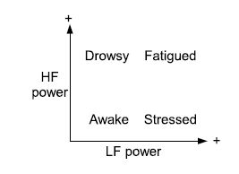
Fig-1: Hypothetical subject states distribution as function of high- frequency (HF) and low-frequency (LF) power of heart rate variability signal

Design
The system consists of four modules: (1) Bluetooth connection, (2) heartbeat measurement, (3) ECG signal retriever, and (4) heart rate variability including some variables based on the normal to normal heartbeat intervals analysis.
- Bluetooth Communication
Bluetooth technology has been applied so that the sensor device (I-Mami HRM2) and android device are able to communicate each other. I-Mami HRM2 sensor is a small, lightweight device that is worn across the chest. It sense the heart rate in a frequency of 250Hz. Initially, the sensor and the android device need to be paired. When heartbeats sense by the sensor, the signals are transferred to the android device via Bluetooth communication.
- ECG for Drowsiness Detection
Electrocardiography is a process of recording the electrical activity of the heart over a period of time. It is a measure of the change in potential of the order of 1mV produced as a result of the electrical stimulation during the cardiac cycle. This signal is retrieved from the sensor I-Mami HRM2, sent to the smart phone and displayed as ECG signals in the phone. This ECG signal is drawn in the screen of the phone.
- Heart Rate Measurement
In the heart rate measurement module, initially the sensor is selected from the menu and connected to the mobile. The heart rate of the person for every one minute is calculated and displayed. It also calculates the average value and the maximum value of the heart rate. The highest heart rate a person should achieve upon exertion with respect to age is the maximal heart rate. The battery level of the device is also displayed. In the heart rate module, the heart rate of a person is calculated for every one minute with the average value and the maximum value are also calculated. This information then will be displayed on the android device.
- Heart Rate Variability
Heart rate variability (HRV), known as the variation over time of the period between consecutive heartbeats, is predominantly dependent on the extrinsic regulation of the Heart Rate(HR). HRV is thought to reflect heart’s ability to adapt two challenging circumstances by detecting and quickly responding to unpredictable stimuli. HRV analysis is the ability to assess the overall cardiac health and the state of the autonomic nervous system (ANS) responsible for regulating cardiac activity. HRV is a useful signal for understanding the status of the ANS. HRV refers to the variations in the beat intervals or correspondingly in the instantaneous HR. The normal variability in HR is due to autonomic neural regulation of the heart and the circulatory system.
- I-Mami HRM2 Sensor
I-Mami HRM2 Sensor is the heart rate monitoring device. It is a device with Bluetooth connectivity which avoids wired connection and reduces the hardware cost for it. I-Mami HRM2 sensor supports Bluetooth to carry out the data communication from the sensor to the mobile. I-Mami HRM2 sensor is a small, lightweight device that is worn across the chest. Initially the sensor has to be paired up with the android device. When a heartbeat is sensed by sensor, the signals are transferred to the android device with the help of Bluetooth.

implementation

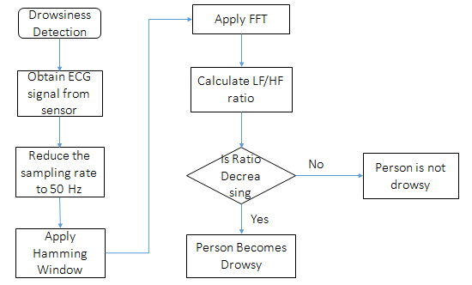
Fig-2: Flow of Drowsiness detection

- ECG Signal
As the heart undergoes depolarization and repolarization, the electrical currents that are generated spread not only within the heart, but also throughout the body. This electrical activity generated by the heart can be measured by an array of electrodes placed on the body surface. The recorded tracing is called an electrocardiogram (ECG or EKG).

- Drowsiness Detection From ECG
Recently, signal processing is performed in the vast majority of systems for ECG analysis and interpretation. The objective of ECG signal processing is manifold, comprises the improvement of measurement accuracy and the extraction of information not readily available from the signal through visual assessment. In many situations, the ECG is recorded such that the signal is corrupted by different types of noise, sometimes originating from another physiological process of the body. Hence, noise reduction represents another important objective of ECG signal processing; in fact, the waveforms of interest are sometimes so heavily masked by noise that their presence can only be revealed once appropriate signal processing has first been applied.

- Signal Processing Techniques
3.1 Decimation
Decimation can be regarded as the discrete-time counterpart of sampling. Whereas in sampling it starts with a continuous-time signal and converting it into a sequence of samples, in decimation it starts with a discrete-time signal and convert it into another discrete-time signal, which consists of sub-samples of. In decimation, the sampling rate is reduced from fs to fs/M by discarding M-1 samples for every M samples in the original sequence. Due to the lower sampling rate, an anti-aliasing digital filter precedes the down-sampler to prevent from aliasing error. In real time, the decimated signal appears at a slower rate than that of the original signal by a factor of M. If the sampling frequency of x[n] is fs, then that of y[n] is fs/M. The sampling rate of the sensor is 250 Hz which is very high to process the ECG signals, so the sampling rate of the signals was reduced by 50 Hz, which means 250/50, 5 samples per second and the decimation was done using a low pass filter.

3.2 Window Function
The process of measuring a signal for a finite time is equivalent to multiplying the signal by a function of unit amplitude. This function will last for the duration of the measurement time. The effects of spectral leakage can be reduced by reducing the discontinuities at the ends of the signal measurement time. This leads to the idea of multiplying the signal within the measurement time by some function that smoothly reduces the signal to zero at the end points and will avoid the discontinuities. Furthermore, this process of multiplying the signal data by a function that smoothly approaches zero at both ends, is called as 'windowing' and the multiplying function is called as Window function. It is easy to analyze the effect of a window function, the frequency spectrum of the signal is convolved with the frequency spectrum of the window function. The appropriate window function for ECG signal is the known as the Hamming Window function. The mathematical expression for Hamming Window is:
W(n)=0.54-0.46cos(2* pi*n/N-1)
Where n is the nth sample and N is the total number of samples. The samples in this research are those measured data. In the calculation, the ECG raw data will be multiplied with the Hamming window function before doing the FFT innorder to reduce the spectral leakage.
3.3 Fast Fourier Transform
The FFT is a faster version of the Discrete Fourier Transform (DFT). The FFT utilizes some clever algorithms to do the same thing as the DTF, but in much less time. The DFT is extremely important in the area of frequency (spectrum) analysis because it takes a discrete signal in the time domain and transforms that signal into its discrete frequency domain representation. Without a discrete-time to discrete-frequency transform, it is not possible to compute the Fourier transform with a microprocessor or DSP based system. This is known as the speed and discrete nature of the FFT which allows us to analyze a signal's spectrum.
Radix 2 Decimation in Time (DIT) FFT is applied to the measured ECG signals to find their power spectrum. Here the Radix 2 resembles the number of samples (N) which must be an integral power of two. Further it works on complex input data, where the real and imaginary parts are stored in two separate arrays. Also, the Radix-2 DIT divides a DFT of size N into two interleaved DFTs (hence the name "radix-2") of size N/2 with each recursive stage. Finally, the Radix 2 FFT is defined by the formula:
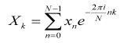
where k is an integer ranging from 0 to N-1.

Conclusion
In this system, driver drowsiness detection has been analyzed based on the ECG signal obtained from a sensor. It is characterized by maintaining simplicity, low cost and non-obstructive real time monitoring of drowsiness. The reliability and accuracy of driver drowsiness detection by using physiological signals is relatively very high compared to other methods. The intrusive nature of measuring the physiological signals is an issue to be addressed while driving. Wireless device is used to measure the ECG signal in a less intrusive manner and obtaining the signals using Bluetooth has been implemented. Various modules to detect the heart beat also been implemented. The application is successfully able to detect the heart beat accurately and it also displays the heart rate variability and the ECG signals in the android devices, respectively.

Screenshots
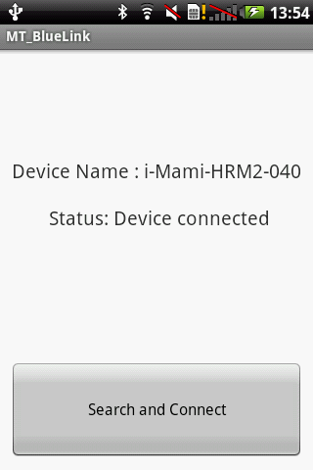
Figure 4: Sensor Connected to the mobile via Bluetooth

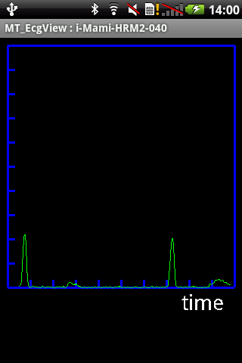
Figure 5: Displays the ECG signals

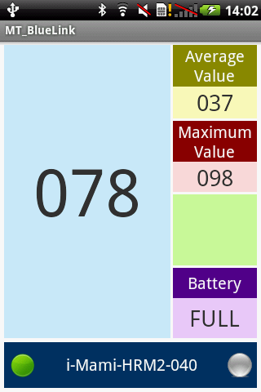
Figure 6: Displays the heart rate and other values
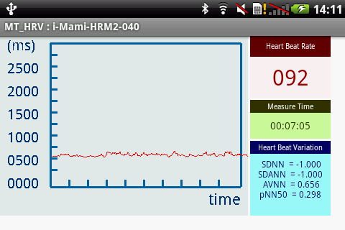
Figure 7: Displays the HRV

REFERENCES
- O. Tuner, L. Guvence, F. Coskun and E. Karsligil, “Vision based Lane Keeping Assistance Control Triggered by a Driver Inattention Monitor,” IEEE International Conference on Systems Man and Cybernetics (SMC), pp. 289-297, 2010.
- S. Klauser, T. Dingus, V. Neale, J. Sudweeks and J. Ramsey, The impact of driver inattention on near-crash/crshrisk : An analysis using 100-car naturalistic driving study data, Washington, DC: National Highway Traffic Safety Administration, 2006.
- W. Qiong, Y. Jingyu, R. Mingwu, Z.Yujie, “In Driver fatigue detection: A survey,” The Sixth World Congress on Intelligent Control and Automation, pp 8587-8591.
- Picot, S. Charbonnier and A. Caplier, “On-line detection of drowsiness using brain and visual information,” IEEE Trans. on Sys., Man and Cybernetics, Part A: Systems and Humans, 42, 2012, pp.764-775.
- S. Hu, R. L. Bowlds, Y. Gu and X. Yu, “In Pulse wave sensor for non-intrusive drivers drowsiness detection,” 31st Annual International Conf. IEEE EMBS, 2009; pp.2312-2315.
- C. Han, H. Y. Mark Liao, G. J. Yu and L. H.Chen, “In Fast face detection via morphology-based pre-processing,” Proceedings of the 9th International Conf. on Image Analy. and Proc., 1997; pp.469-476.
- M. H. Sigari, “In Driver hypo-vigilance detection based on eyelid behavior,” 7th International Conf. on Adv. in Pattern Recog.,4-6 Feb. 2009, pp.426-429.
- A.V. Oppenheim and R.W. Schafer, Digital Signal Processing, Englewood Cliffs: NI: Prentice Hall, 1975.
- Chandrakar, O.P. Yadav and V.K. Chandra, “A SURVEY OF NOISE REMOVAL TECHNIQUES FOR ECG SIGNALS” International J. Adv. Res. in Comp. and Comm. Eng., 2, 3 (2013).

