Indian Tsunami Warning System

Madhavi Kalsait
CSE 3rd Year DES'sCOET Dhamangaon(Rly.)

ABSTRACT

Tsunami is a system of ocean gravity waves formed as a result of large-scale disturbance of the sea floor that occurs in a relatively short duration of time. The Indian Ocean is likely to be affected by tsunamis generated mainly by earthquakes from the two potential source regions, the Andaman-Nicobar-Sumatra Island Arc and the Makran Subduction Zone. A state-of-the-art warning centre has been established at INCOIS with all the necessary computational and communication infrastructure that enables reception of real- time data from the network of national and international seismic stations, tide gauges and bottom pressure recorders (BPRs). Earthquake parameters are computed in the less than 15 minutes of occurrence. A database of pre-run scenarios for travel times and run-up height has been created using Tunami N2 model. At the time of event, the closest scenario is picked from the database for generating advisories. Water level data enables confirmation or cancellation of a tsunami. Tsunami bulletins are then generated based on decision support rules and disseminated to the concerned authorities for action, following a standard operating procedure. The criteria for generation of advisories (warning/alert/watch) are based on the tsunamigenic potential of an earthquake, travel time (i.e. time taken by the tsunami wave to reach the particular coast) and likely inundation. The performance of the system was tested on September 12, 2007 earthquake of magnitude 8.4 off Java coast. The system performed as designed. It was possible to generate advisories in time for the administration and possible evacuation was avoided.

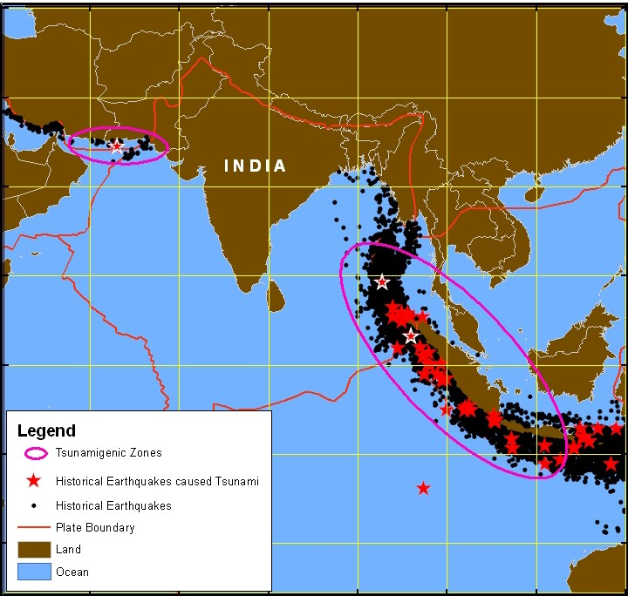
INTRODUCTION
“Tsunami” is a system of ocean gravity waves formed as a result of large scale disturbance of the sea bed in a short duration of time, mostly due to earth quake (or volcanic eruption or submarine landslides). As displaced sea water return by the force of gravity to an equilibrium position, a series of oscillations both above and below sea level take place, and waves are generated which propagate outwards from the source region. Tsunamigenic zones, the Andaman-Nicobar-Sumatra Island Arc in the Bay of Bengal and the Makran Subduction Zone in the North Arabian Sea, that threaten the Indian Ocean have been identified by considering the historical tsunamis, earthquakes, their magnitudes, location of the area relative to a fault (ANSS, 2007; HS, 2007; NGDC, 2007, ISG, 2007; USGS,
2007; Rastogi and Jaiswal, 2006), and also by tsunami modelling (Figure 1).

The Indian coast has recorded few tsunamis in the past. However, in spite of infrequent occurrence of tsunamis (about 6 events reported in the 20th century) in the Indian Ocean, they could occur at any time and could be very devastating. The latest Indian Ocean Tsunami (December 26, 2004) has been the one of the strongest in the world and the deadliest of all time by an order of magnitude.
Figure 1. Tsunamigenic zones in the Indian Ocean
The east and west coasts of India and the island regions are likely to be affected by tsunamis generated mainly due to earthquakes in these subsection zones. Hence there was a need for developing Tsunami Warning System In this paper, details about various components of tsunami warning centre, development of the application software and
it performance during the Java Earthquake of M 8.4 on September 12, 2007 have been discussed.

TSUNAMI WARNING SYSTEM
The following are major components of the tsunami warning system.

Estimation of Earthquake Parameters
A Network of land-based seismic stations for earthquake detection and estimation of focal parameters in the two known tsunamigenic zones is a prime requirement of the warningcentre. INCOIS is receiving real-time seismic data from international seismic networks as well as from India Meterological Department (IMD) and has been detecting all earthquake events occurring in the Indian Ocean in the less than 5 minutes of occurrence. Necessary software have been installed for real-time data reception, archiving, processing and auto-location of earthquakes as well as for alert generation and automatic notification.

Monitoring of Sea Level
In order to confirm whether the earthquake has actually triggered a tsunami, it is essential to measure the change in water level as near to the fault zone with high accuracy. Bottom pressure recorders (BPR) are used to detect the propagation of tsunami waves in open-ocean and consequent sea level changes. A network of Bottom Pressure Recorders (BPRs) has been installed close to the tsunamigenic source regions to detect tsunami, by the National Institute of Ocean Technology (NIOT). These BPRs can detect changes of 1 cm at water depths up to 6 km.

A network of tidal gauges along the coast helps to monitor progress of tsunami as well as validation of the model scenarios. Near-real time data is being received from national and international centers has been received. Necessary software for real-time reception, display and archiving of tide gauge data has been developed.

Tsunami Modeling
The TUNAMI N2 model basically takes the seismic deformation as input to predict the run-up heights and inundation levels at coastal regions for a given tsunamigenic earthquake (Imamura, 2006). The seismic deformation for an earthquake has been computed using Smylie and Mansinha, (1971) formulation using the earthquake parameters like location, focal depth, strike, dip and rake angles, length, width and slip of the fault plane. At the time of earthquake, only location, magnitude and focal depth are available immediately. For operational quantitative tsunami forecast, there needs to be a method to quickly estimate the travel times and run up based on the above available parameters. For this purpose, all the other input parameters such as length, width and slip are calculated from the magnitude using global relations (Papazachos et al, 2004). strike angle, dip angle and slip angle are considered for worst case scenario (strike angle parallel to trench or coast, dip angle 45 deg, slip angle 90 deg).

A database of pre-run scenarios has been created for 1000 unit sources covering all the tsunamigenic sources in the Indian Ocean region (Kuwayama, 2006). In the current database each unit source has a length of 100 km and width of 50 km that represents a rupture caused by a Mw 7.5 magnitude earthquake with a slip of 1m. At the time of earthquake occurrence, based on the location and magnitude of the earthquake, the basic unit source open ocean propagation scenarios in scenario database are selected to merge and scaled up/down using scaling relations.

High Resolution Data Base on Bathymetry and Coastal Topography
Generating and updating a high resolution database on bathymetry, coastal topography, coastal land use, coastal vulnerability as well as historic data base on tsunami and storm
surge to prepare and update storm surge/tsunami hazard maps. The accuracy of model predictions is directly related to the quality of the data used to create the bathymetry and topography of the model area.

Coastal Bathymetry is the prime determinant of the height of the tsunami wave or storm surge as it approaches the coast. High resolution coastal bathymetry is thus the key input for various tsunami and storm surge prediction models. Preliminary Surveys have already been conducted to acquire high-resolution bathymetry for a few vulnerable areas of the coastline. Naval Hydrographic Office (NHO) has been providing detailed bathymetry data.

Topography of the entire coastline of the country is required at 1:25000-scale with contours at intervals of 0.5 m to 2 m up to 20 m contour interval. Preliminary maps have been prepared of coastal topography using CARTOSAT-1 stereo data for the Indian coast. The National Remote Sensing Agency (NRSA) has been mapping the topography of about 15, 000 Sq km area with airborne LIDAR & Digital Camera data in conjunction with GPS control survey using photogrammetric techniques. 3000 sq km area has already been mapped. These products have been used to prepare coastal vulnerability maps.

Warning Centre
A dedicated 24 x 7 operating Tsunami Warning Centre comprising necessary computational, communication and technical support infrastructure as well as a robust application software that facilitates data reception, display, analysis, modeling, and decision support system for generation of tsunami advisories following a standard operating procedure has been established. The warning centre continuously monitors seismic activity in the two tsunamigenic source regions and sea level through the network of national and international seismic stations as well as tide gauges and bottom pressure recorders (BPR’s). The monitoring of water level enables confirmation or cancellation of a tsunami. A custom-built software application generates alarms/alerts whenever a pre-set threshold is crossed. Tsunami bulletins are then generated based on pre-set decision support rules and disseminated to the concerned authorities for action, following a Standard Operating Procedure (SOP).

2.6 APPLICATION SOFTWARE USING GEOSPATIAL TECHNOLOGY
One of the key components of the early warning centre is the development of application software around GIS technology that performs the following operations:
- Acquisition, display and analysis of real time data of seismic sensors, tide gauges and BPRs.
- Generation of model scenario database for assumed earthquake parameters as well as Retrieval, Display and Analysis at the time of an event.
- Generation, Display and Analysis of Bathymetric Data, Coastal Topographic Data and Vulnerability Maps.
- Decision support system for generation of tsunami advisories following a standard operating procedure.

Data warehousing, Data Mining and Data Dissemination Details of the individual functions are given below:

Data Acquisition and Display
The warning centre currently receives seismic data, tidal data and BPR data through VSAT links, Internet, and INSAT from multiple sources. All such data are centrally collected by high end servers where, it is processed by ETL jobs for loading into staging database followed by archiving staging database into the central database periodically.

The requirement is to display observational data (seismic, sea level) from selected platforms and modelled data (travel time, run up heights, inundation areas, DTMs, etc.). Other need is to plot real-time sea-level data overlaid on predicted tidal values at each specified location. The application software is capable of performing all the above functions.

Model Scenario Database
Tunami N2 model has been used to estimate travel time and run-up height for a particular earthquake. Since the model cannot be run at the time of an event, due to large computing time as well as due to non-availability of required fault parameters in real-time, a database of pre-run scenarios is essential. At the time of event, the closest scenario is picked from the database for generating the warning. The output from the modelling exercise is a huge database (approximate size is 6 Tera bytes) consisting of spatial maps depicting the water level in the Indian Ocean region at each time-step for about 5000 simulations. The application software has an interface to store, retrieve, analyze and display the spatial maps from the database. The spatial layers currently being handled by this application include fault lines, fault segments for different earthquake magnitudes, travel time maps, directivity maps, simulation results for about 1800 coastal forecast points, graphs of model and observed tsunami wave profiles at each coastal forecast point, etc. Application Software has a user friendly GUI/control panel depicted on a spatial canvas of the Indian Ocean Region through which user can perform GIS operations like navigating to a desired location, zoom, pan, query, analysis, etc.

Vulnerability Maps
Tsunami run-up causes flooding of seawater into the land up to few km resulting in loss of human life and damage to property. To minimise such losses, it is imperative to prepare coastal vulnerability maps indicating the areas likely to be affected due to flooding and rending damage. Tunami N2 Model has been customised for the Indian Ocean Region and has been validated using the December 2004 Tsunami observations. This model has been run for five historical earthquakes and the predicted inundation areas are being overlaid on cadastral level maps of 1:5000 scale. The maps are to be used by the central and state administration responsible for disaster management. These community-level inundation maps are extremely useful for assessing the population and infrastructure at risk. These maps will be provided using the web-GIS interface of the Application Software.

Decision Support System and Standard Operating Procedure
The decision support software is intended to

- monitor the online input data from individual sensors.

- generate automatic alarms based on preset decision rules for one or many of the input parameters and

- carry out criteria-based analysis for one or many of the above mentioned input parameters to generate online advisories (Figure 2).

The criteria for generation of different types of advisories (warning/alert/watch) for a particular region of the coast are to be based on the available warning time (i.e. time taken by the tsunami wave to reach the particular coast). The warning criteria are based on the premise that coastal areas falling within 60 minutes travel time from a tsunamigenic earthquake source need to be warned based solely on earthquake information, since enough time will not be available for confirmation of water levels from BPRs and tide gauges. Those coastal areas falling outside the 60 minutes travel time from a tsunamigenic earthquake source could be put under a watch status and upgraded to a warning only upon confirmation of water-level data.
The application software is capable of doing all the desired functions in addition to generating alerts (as and when each individual parameter exceeds a critical value) in the form of an alarm at the warning centre as well as SMS alerts to specified persons on a mobile phone. Provision in the software is made to modify threshold value, as and when need arises.

Data Warehousing, Data Mining and Dissemination
This module is capable of organizing the data and storing it in a centralized storage server with appropriate load balancing. The entire data is organized using state-of-the-art user friendly database for storing, analyzing and quick retrieval at the time of the event. This database is linked to a dedicated tsunami website through which data/information/advisories are made available to the users. The website support information in the form of text, maps and multi-media.
The application software enables dissemination of bulletins to designated contact points using SMS, e-mails, fax, telephone, VPNDMS, etc. The entire warning centre infrastructure is hosted on highly reliable hardware designed for mission critical applications with necessary redundancies.

PERFORMANCE OF THE SYSTEM
The system was fully tested on September 12, 2007, when earthquake of magnitude 8.4 struck near Java.
The performance of the end-to-end system is assessed based on the individual performance of the observation sub-systems (seismic, sea-level) and the
- performance of the application software sub-systems viz. display, analysis, modeling, DSS, SOP and dissemination.

The ultimate measure of the performance of the system is the accuracy and timeliness of the advisories generated. This can be assessed using performance indicators such as accuracy of

- earthquake determination;
- model scenario results viz. travel time and run-up estimates and
- real-time sea-level observations.

One of the most critical aspects of tsunami warning system is to estimate earthquake parameters with reasonable accuracy in shortest possible time. The elapsed time is generally less than
15 minutes in most cases. The earthquake location and its magnitude are two critical parameters to be estimated so that right scenario can be chosen. While it is important to be able to estimate earthquake parameters within acceptable errors (+/- 0.2 in magnitude and 30 km in location during initial estimates is considered good for tsunami warning applications), for an operational system, it is also extremely important to be able to do this consistently. To quantify the performance of our system, a comparison has been made with the earthquake parameters estimates by the United States Geological Survey (USGS) for abour 20 consecutive earthquakes. Results show that the desired performance has been achieved (Figure 3 and 4).
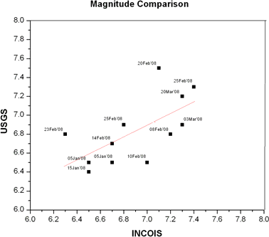 earthquake

The earthquake parameters for the September 12 event were computed within 13 minutes having initial magnitude 7.9 (USGS initial estimate being 8.0 in 12 minutes). Based on this magnitude a scenario was picked up from the database and travel time and run up heights at various coastal forecast points were estimated. The modelled and observed values are given in Table 1.

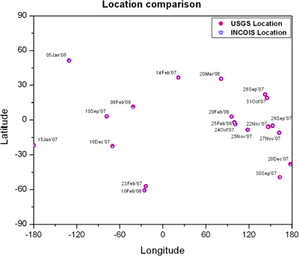
Location | Arrival Time (h) |  | Water Level (cm)
 | Estimat  ed | Observe  d | Estimat  ed | Observe  d
Padang | 1751 | 1754 | 80 | 60
Coco’s Island | 1748 | 1748 | 40 | 30
Sabang | 1903 | 1903 | 20 | 30
TB3 | 1903 | 1913 | 02 | 01
TB10A | 1931 | 1941 | 01 | 02
TB10 | 1930 | 1945 | 02 | 02
Port Blair | 2010 | 2013 | 10 | 08
Chennai | 2105 | 2110 | 20 | 18

Table 1: Performance of Tsunami Model

It can be seen from the table that system has performed well within the limits of acceptable error.

The end-to-end system performed extremely well enabling reception, display and analysis of the real-time and model data sets as well as generation and dissemination of timely and accurate advisories following the standard operating procedure. This information was used to provide necessary advisories to the concerned authorities, thus avoiding unnecessary public evacuation for this event.

5CONCLUDING REMARKS
Geospatial technology has immensely helped in the design of early warning system for tsunami. The system is capable of providing tsunami advisories (earthquake information, estimated travel times, run up heights, threat zones, etc) for the entire the Indian Ocean.

REFERENCES
ANSS, 2007. Global earthquake composite catalog search (1898 to present), Indian Ocean, http://www.ncedc.org/ anss/catalog- search.html (Accessed 26th June 2007).

HS, 2007. Harvard Seismology, Global Centroid Moment Tensor Catalog (1976 to present), Indian Ocean, http://www.globalcmt.org/CMTsearch.html, (Accessed 26th June 2007).

Imamura, F. 2006, TUNAMI-N2 (Tohoku University’s Numerical Analysis Model for Investigation of Near Field Tsunamis version 2) Manual draft, http://www.tsunami.civil.tohoku.ac.jp/hokusai3/J/projects/manu al-ver-3.1.pdf, (Accessed 16th Dec 2006).

ISC, 2007. International Seismological Centre, Online catalog rectangular area search, Indian Ocean, http://www.isc.ac.uk/search/bulletin/rectang.html, (Accessed 26th June 2007).

