Driver Safety System

Sayali Akare Shradha Khatri
Dept. of ETRX Dept. of ETC
GHRIET, Nagpur GHRIET, Nagpur
akaresayali@gmail.com shradha1995s@gmail.com

Abstract- This paper describes a real-time online prototype driverfatigue monitor. It uses remotely located charge-coupleddevice cameras equipped with active infrared illuminators to acquire video images of the driver. Various visual cues thattypically characterize the level of alertness of a person are extracted in real time and systematically combined to infer thefatigue level of the driver. The visual cues employed characterize eyelid movement, gaze movement, head movement, and facial expression. A probabilistic model is developed to model human fatigue and to predict fatigue based on the visual cues obtained. The simultaneous use of multiple visual cues and their systematic combination yields a much more robust and accurate fatigue characterization thanusing a single visual cue. This system was validated under real-life fatigue conditions with human subjects of different ethnic backgrounds, genders, and ages; with/without glasses; and under different illumination conditions. It was found to be reasonably robust, reliable, and accurate in fatiguecharacterization.

Keyword:National Highway Traffic Safety Administration (NHTSA), Accelerometer,angle based accelerometer (ACC)

- INTRODUCTION
This paper describes a real-time online prototype driverfatigue monitor. It uses remotely located charge-coupleddevice cameras equipped with active infrared illuminators to acquire video images of the driver. Various visual cues that typically characterize the level of alertness of a person are extracted in real time and systematically combined to infer the fatigue level of the driver. The visual cues employed characterize eyelid movement, gaze movement, head movement, and facial expression. A probabilistic model is developed to model human fatigue and to predict fatigue based on the visual cues obtained. The simultaneous use of multiple visual cues and their systematic combination yields a much more robust and accurate fatigue characterization than
using a single visual cue. This system was validated under real-life fatigue conditions with human subjects of different ethnic backgrounds, genders, and ages; with/without glasses;and under different illumination conditions. It was found to be reasonably robust, reliable, and accurate in fatigue characterization.
This paper describes a real-time online prototype driverfatigue monitor. It uses remotely located charge-coupleddevice cameras equipped with active infrared illuminators to acquire video images of the driver. Various visual cues that typically characterize the level of alertness of a person are extracted in real time and systematically combined to infer the fatigue level of the driver. The visual cuesemployed characterize eyelid movement, gaze movement, head movement, and facial expression. A probabilistic model is developed to model human fatigue and to predict fatigue based on the visual cues obtained. The simultaneous use of multiple visual cues and their systematic combination yields a much more robust and accurate fatigue characterization than using a single visual cue. This system was validated under real-life fatigue conditions with human subjects of different ethnic backgrounds, genders, and ages; with/without glasses; and under different illumination conditions. It was found to be reasonably robust, reliable, and accurate in fatigue characterization.

- CONCEPT
Sleep related accidents tend to be more severe, possibly
because of the higher speeds involved and because the driver is unable to take any avoiding action, or even brake, prior to the collision. Horne describes typical sleep related accidents as ones where the driver runs off the road or collides with another vehicle or an object, without any sign of hard braking before the impact. In 2002, the National Highway Traffic Safety Administration (NHTSA) estimated that 35 percent of all traffic deaths occurred in crashes in which at least one driver or no occupant had a BAC(Blood Alcohol Content) of 0.08 percent or more and that any alcohol was present in 41 percent of all fatal crashes in 2002.Such statistics are sometimes cited as proof that a third to half of all fatal crashes are caused by "drunk driving" and that none of the crashes that involve alcohol would occur if the alcohol were not present. But this is incorrect and misleading because alcohol is only one of several factors that contribute to crashes involving drinking drivers. Furthermore, some fatally injured people in alcohol-related crashes are pedestrians with positive BACs, and these fatalities still would occur even if every driver were sober. Distracted driving is a top danger behind the wheel. In fact, about eight out of 10 crashes involve some sort of driver inattention within three seconds of that crash. We've all seen it and likely even done it, driving distracted includes anything from talking on the phone, to messing with your music, to attending to your children or even pets. All of these actions can lead to serious consequences. Martha Meade with AAA Mid-Atlantic says, "People are dying because of a simple missed phone call, a dropped toy or some other event that is completely not important." Possible techniques for detecting drowsiness in drivers can be generally divided into the following categories: sensing of physiological characteristics, sensing of driver operation, sensing of vehicle response, monitoring the response of driver:available blink detectors in market (Catalog No. 9008 of Enable devices) or we can incorporate it with a special instruction written in image processing that, if there is no pupil found for the certain period of pre-determined i.e. time greater than the human eye blinking time then consider an event called “blink”, for which the set of operations will befollowed. Here, in this case we need to set time as 1 second or above it, as “blink event” is different from “normal eye blinking”. We need to perform testing for only blink event estimation, and not to find normal eye blinking.
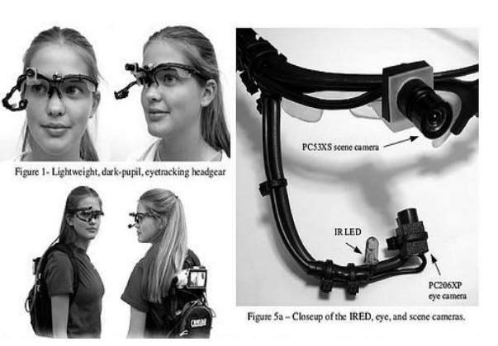

Figure1:Module for eye blinks detection

Figure shows the setup of IR sensors & camera module that is
to be used by the driver for Eye blink detection,the different blink events which differ from normal blinking of eye using cumulative index (CI) & Mutual index(MI) which is obtained at receiver of IR sensor in terms of Current & voltage and plotted on graph. The signal can be smoothened using above graph to avoid unnecessary blinking
event other than effective blinking event.

MOVEMENT DETECTION

Head movement detection is done through single step Accelerometer eg: ADXL330 which measures 3-axis detection. It consists of angle based accelerometer (ACC) input to simulate accurate head movement. Angle based approach does not require any pattern matching algorithms. ACC input signal is smoothened first to ignore any unwantedmovement. Angle based model is believed to effective byresearchers, which is debatable considering practical use of a single ACC sensor on head.

Definition of Tilt Angle
This system uses head movements as the sole input method; more precisely head’s tilt angles are used. Head tilt anglesdefine how much the head is rotated along an axis. There arethree possible head tilt movements, which are defined as:
- Pitch, the vertical head rotation movement (as in looking up or down)
- Roll, the head rotation that occurs when tilting head towards the shouldersYaw, the horizontal head rotation movement (as in looking toleft or right).
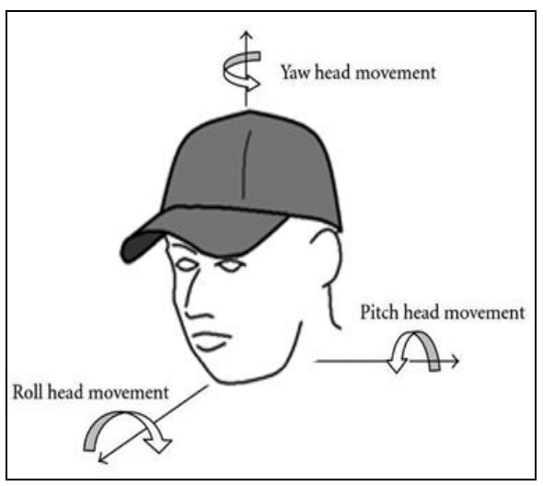
Figure2:Three possible head tilt movements
For the movement analysis, it is needed to somehow translate
the tilt angle data to displacement of mouse cursor that is calculating new head position. There are two main methods:
when calculating the new head cursor position:
- Absolute mapping in which every tilt angle corresponds to a position on screen.
- Relative mapping in which every tilt angle corresponds to a head displacement amount (stepsize) and this amount is summed by the coordinates of the head’s old position, to calculate new position.
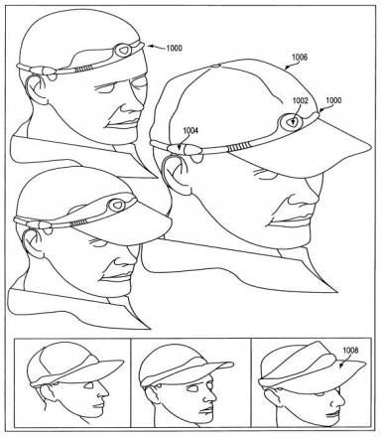
Figure3:Accelerometer Placement
Figure shows the real time placement of the accelerometer on
the driver head for the 3-axis detection of the head movement
while driving to monitor fatigue by converting the angle based
input to voltage output (in milivolts) for accurate detection.
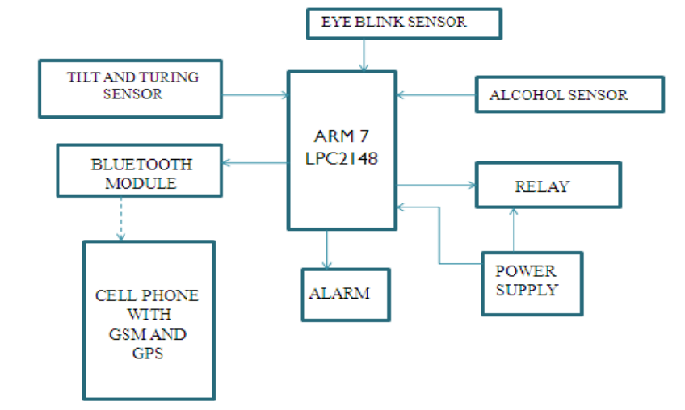
Figure4:Block Diagram

COMPONENT DESCRIPTION

We have used following components:
1. ARM processor.
2. Pair of IR transmitter and receiver for eye blinks
detection.
3. A sensor called MQ3 for the purpose of alcohol
detection.
4. An accelerometer ADXL330 for head movement
detection (tilting and turning of head).

ADVANTAGES

- Component establishes interface with other drivers very easily.
- Life of the driver can be saved by locking the ignition system of the car.
- Traffic management can be maintained by reducing accidents and traffic jams can be avoided.
- Using GPS & GSM exact location of the Car can betraced on MAP.
APPLICATION
- Automobiles.
- Security Guard Cabins.
- Operators at nuclear power plants where continuousmonitoring is necessary.
- Pilots of airplane.
- Military application wherehigh intensity monitoring of soldier is needed.
FUTURE SCOPE

- This system only looks at the number of consecutive frames where the eyes are closed. At that point it may be too late to issue the warning. By studyingeye movement patterns, it is possible to find a method to generate the warning sooner.
- Using 3D images is another possibility in finding the eyes. The eyes are the deepest part of a 3Dimage, and this maybe a more robust way oflocalizing the eyes.
- Instead of alarm we can use Automatic BrakingSystem which will reduce the speed of the car.
- We can automatically park the car by first usingAutomatic braking system, which will slow downthe car and simultaneously will turn on the parking lights of the car and will detect the parking space and will automatically park the car preventing fromaccident.
- Using Pressure sensor on the steering alarm orAutomatic braking System can be set in case ofdrowsiness.
- By using wire-less technology such as CarTalk2000 If the driver gets a heart attack or he is drunk it will send signals to vehicles nearby aboutthis so driver become alert.
RESULTS
Some of the results of eye blink detector through graph are
given below:
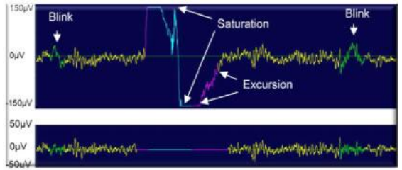
Figure5:Show Eye Blink
Figure shows the saturation & excursion effects occurred
before and after the blinking of eye to smoothen the signal.
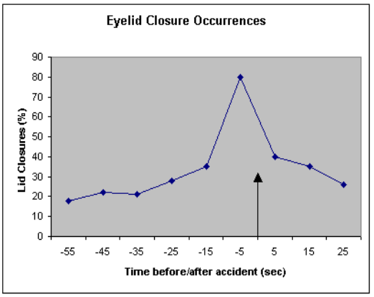
Figure6:Eyelid Closure Occurrences

Figure shows the “effective blinking event” for which lid closure is set 40% of closing of eye & above which if eye lid closes the event is occurred. Fig shows the lid closure % versus Time before/after accident meanwhile which the time is used to prevent the accident by using various techniques for eg: Buzzing the Alarm, Making Fake call on drivers mobile, etc using various self developed algorithms.

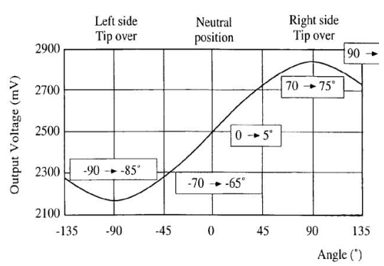
Figure7:Accelerometer detection using reference angle

Figure shows the head movement detection in which the voltage changes w. r. t change in accelerometer angle. Initially 0V is set at 5º i.e. at neutral position. Change in head movement beyond certain specified limits changes the output voltage& hence head movement is detected.

CONCLUSION

Eye based control will be the future of all types of device control, thus making the operation so comfortable and much easier with less human presence. Several risk operations canbe easily performed with this type of application and further research and study on these areas will create a new trend of interacting with machines. Hence, a system to monitor fatigue by detecting eye blink & head movement was developed using self developed algorithms.

REFERENCES
[1] Real-Time Non - intrusive Monitoring and Prediction of Driver Fatigue by QiangJi, Zhiwei Zhu, and PeilinLan, IEEE TRANSACTIONS ON VEHICULARTECHNOLOGY, VOL. 53, NO. 4, JULY 2004
[2] Boston University Computer Science Technical Report
No.2005-12 Real Time Eye Tracking and Blink
Detection with USB Cameras Michael Chau and
MargritBetke, Computer Science Department Boston
University Boston, MA 02215, USA { mikechau,
betke@cs.bu.edu} May 12, 2005
[3] Mandeep Singh, Gagandeep Kaur,” Drowsy Detection On Eye Blink Duration Using Algorithm ”International Journal of Emerging Technology and Advanced Engineering, April 2012, Volume 2, Issue 4,) pp 363-365
[4] Garcia, I.; Bronte, S.; Bergasa, L.M.; Almazan, J.; Yebes, J., "Vision-based drowsiness detector for real driving conditions," Intelligent Vehicles Symposium (IV), 2012 IEEE , vol., no., pp.618,623, 3-7 June 2012
[5]Rizwan, O.; Rzwan, H.; Ejaz, M., "Development of an efficient system for vehicle accident warning," Emerging Technologies (ICET), 2013 IEEE 9th International Conference on , vol., no., pp.1,6, 9-10 Dec. 2013
doi: 10.1109/ICET.2013.6743484

