The Effect of the Number of Spans on the Collapse Probability of Bending Frames and Concentric Braces Under Seismic Loading

Vahid Saberi ¹, Hamid Saberi ¹*, Hadis Shafiei Alavijeh ²
¹Graduate student of Civil Engineering, University of Eyvanekey, Semnan, Iran
² Assistant Professor, Department of civil engineering, University of Eyvanekey, Semnan, Iran

Abstract –Given the haphazard nature of earthquakes and the uncertainties in the behavior of structures, focusing on steel frames with braces is of special importance in order to improve the seismic performance of the steel structures. In this study, the effect of the number of spans was investigated on the seismic response of three short steel frame sets. In all three sets, one bending frame and the other two combined frames, one with an eccentric brace and the other with a regular concentric brace in a plan with a height of 3.2 m, were considered and assessed. The number of the spans in all three sets of frames was considered as 2, 3, and finally 4 for the three times of evaluation, respectively. The structures were examined under static nonlinear analyses (pushover) based on the base shear and roof displacement and nonlinear incremental dynamic analyses (IDA) with IM intensity measurement parameter corresponding to the maximum inter-story drift and the DM response parameter associated with the spectral acceleration of the first mode S_{a} (T₁,5%), in addition to the evaluation of the collapse prevention (CP) performance level. The results of the CP limit state fragility curves indicated that by increasing the number of spans and subsequently decreasing the amount of the structural vulnerability, the probability of failure increased as 10% for all the structures studied and hence, the degree of vulnerability of the structures deceased.
Keywords-Effect of number of spans, Bending frame, CBF frame, Chevron brace, Fragility curve
- INTRODUCTION
After the destructive 1994 Northridge earthquake and following the improper behavior of steel structure joints, particularly the special moment resisting frames

(SMRFs), the earthquake engineering studies were directed towards the evaluation of the seismic force-resisting systems such as all types of the braced systems for providing proper ductility and sufficient lateral stiffness in order to control the drift between stories in seismic areas. The concentric bracing system is one of these braced systems which has a better performance compared to the other systems due to the brace buckling when a large cyclic displacement is intended. This is due to the simple design and high performance of the concentric bracing frames (CBFs) relative to other systems, including SMRFs [1-2]. The advantages of a CBF system include increased stiffness, reduced lateral displacement, and ease of execution.
- LITERATURE REVIEW
Numerous investigations have been carried out for many years to improve the seismic characteristics of the existing structures and to design future earthquake resistant structures, leading to the improvements in the proper seismic performance regulations of structures. However, further studies are required regarding the parameters affecting the seismic performance of seismic force-resisting structures, including the study of the effect of the number of spans on the seismic response of the widely used systems in steel structures. These studies can also include the steel bending frames and concentric and Chevron braces using accurate nonlinear analyses such as nonlinear static analysis (pushover) and nonlinear incremental dynamic analysis (IDA). The following can be mentioned regarding the studies accomplished in this area:
In 2003, Rayi et al. evaluated the seismic behavior and upgrading of the Chevron bracing frames. They studied and evaluated a 4-story building with a steel concentric bracing frame (CBF) located in the northern Hollywood region, which was affected by the 1994 Northridge earthquake, but was not seriously damaged. They used nonlinear analyses such as nonlinear static analysis (pushover) and nonlinear dynamic analysis (time history) for the seismic evaluation and showed that filling the CBF braces with the plain concrete improved the seismic performance of the building. In addition, they found that by changing the configuration of the brace from the 2-story Chevron one to the cross-bracing, the instability and formation of plastic joints in the beams could be prevented. Redesigning the brace and the story beams to a weak brace-strong beam system such as special concentrically braced frames (SCBFs), an excellent hysteretic response and restriction of the non-elastic buckling could be achieved, resulting in the normal distribution of damage at the building height [3].
In 2004, Mokra et al. investigated the effect of column stiffness on the seismic behavior of a braced frame. They showed that in case of failure of the columns to tolerate the moment, based on the time history nonlinear dynamic analysis, a soft-story mechanism would most likely occur and cause large centralized deformations in only one story. They investigated the relationship between the column stiffness and drift intensity in a frame based on the dynamic and pushover analyses. They showed that the seismic continuity and gravitational columns in a building significantly reduce the probability of large drifts [4].
In 2006, Shay et al. explored a seismic design approach for CBFs to enhance the performance of these frames. They designed a single-span frame using nonlinear dynamic analysis in two methods of elastic design (based on the Code) and the energy-based plastic design. They showed that the code based design (SCBF) had a very poor response and early failure of the bracing, in addition to causing the structural instability and large drifts. However, the energy-based design fulfilled all the objectives intended by the designer, including the desired yield mechanisms and the story drift, and prevented the brace failure at different risk levels [2].
In 2007, Dekkeley et al. investigated the effect of the near-field earthquakes on the single- and multi-story single-span structures with Chevron steel braces with and without a fluid viscous damper (FVD). Conducting a nonlinear time history (NLTH) analysis, they indicated that the seismic performance of the CBFs without FVD was very weak and sensitive to the speed pulse period and intensity of the near-field earthquakes. Moreover, installing a FVD on the CBF structures significantly improved the seismic performance of the brace while maintaining its elastic behavior [5].
Gowal et al. (2008) examined the performance of steel structures with a CBF based on the plastic design method and using the NEHERP-1997 design spectrum. They showed that the steel structures with a CBF designed based on the plastic method on the basis of the FEMA 351 guidelines had higher levels of confidence in overall failure compared to the PBPD frames designed based on the NEHERP-1997 spectrum [6].
In 2008, Farshchi et al. experimentally studied the effect of strength of joints in the cross braced frames. They indicated that the frame joints in this system, despite the computations, had some degree of restraint, which reached a higher degree of restraint in these connections by the addition of the brace connection plates at the corner of the frame and its connection to the beam and column [7].
Ariaratana et al. (2011) examined the seismic buckling performance of a braced frame with respect to the resistance allocation. By the numerical and in vitro investigations of the buckling-restrained braced frames (BRBFs), they suggested that the seismic performance was predictable with a high ductility and a high energy absorption capacity. However, the post-yield stiffness of the BRBFs was low, causing the residual drifts not to allow a soft story formation. They employed a nonlinear dynamic analysis to evaluate the performance of the BRBF and BRBF-SMRT systems by evaluating the bending strength and beam-to-non-bending column joint in BRBF and showed that strength played an important role in the seismic behavior and performance of BRBFS [8].
In 2013, Amini et al. assessed the response of the braced frames with suspended zipper columns and Chevron braced frames under near fault records. They applied three near and far field records on the three 4, 8, and 12-storey frames, showing that the braced frames were capable of controlling the drifts, however the braced zipper frame had a fragile behavior, which was converted to a ductile frame with the distribution of the drifts at the structure height. Furthermore, the Chevron braced frame tended to a story failure mechanism, and the P-Δ instability was indicative of the drift concentration in particular stories [9].
In 2013, Abdollahzadeh et al. investigated the behavior coefficient of dual steel frames with large concentric braces. The large concentric brace was referred to the brace that connected each two stories in a cross-wise manner. They studied three 8, 10, and 12-story structures using the pushover, nonlinear IDA, and linear dynamic analyses and obtained the behavior coefficients of the structures studied. They found that in most models, the behavior coefficient and its influencing parameters, such as the reduction factors due to ductility and over-strength, decreased with increasing the number of stories, however the rate of reduction of the reduction factors due to ductility was faster compared to the rate of reduction of the reduction factor due to over-strength [10].
Rahmani et al. (2013) compared the seismic parameters in dual systems equipped with concentric and eccentric braces and side plate joints. They analyzed sample 4, 8, and 12-story dual systems. A sample structure system under consideration was a moment restrained frame equipped with CBFs, eccentric brace frames (EBFs), and side plate joints. They performed the behavior coefficient R as well as the pushover analyses of the aforementioned building systems with PERFORM-3D software. Then, by applying the Young method, they determined the ductility, over-strength, and behavior coefficients and compared the results. They concluded that the EBF system increased the ductility while the CBF system increased the lateral strength. Besides, the behavioral coefficient for EBF was higher than CBF with increasing ductility. [11]
Stephen Mahin et al. (2014) examined the seismic performance of the BRBF systems consisting of one Chevron frame and two single diagonal frames. Their tests indicated a good brace behavior [12].
In 2014, Deilami et al. investigated the effect of the number of stories and the number of spans of the steel building frames on the progressive failure resistance. They performed a nonlinear static analysis on the 2, 4, and 10-story structures and concluded that the higher the number of stories of structures, the greater their resistance to progressive failure. Additionally, increasing the number of spans increased the structural strength to the progressive failure, however the effect of this increase was less than that of the number of stories [13].
Erfani et al. in 2015 investigated the effect of the number of stories, length, and number of spans on the seismic behavior of steel bending frames. They examined 27 samples in accordance with the FEMA-P695 code to investigate the use of the RBS beams on the basis of the relations presented in the AISC code by varying different parameters such as the span length change, number of the span, story height, and number of stories examined. They designed the samples according to the AISC-2010 Regulations by ETABS software Version 9.7.14 and performed their pushover analysis in Abacus software. They found that RBS had a better performance in structures with a larger period and also with increasing the number of stories [14].
In 2015, Kalani et al. evaluated the correction coefficient response of CBFs and SMRFs in duplex buildings. Taking into account the fact the seismic design codes move towards reducing the analysis of the seismic loads on structures, they attempted to evaluate the R coefficients for the conventional CBFs and SMRFs in the steel duplex buildings with different levels on the stories. Since R coefficients depended on the ductility and the over-strength coefficient, they applied nonlinear incremental static analysis and pushover analysis to models of the 4, 7, and 10-storey structures with 3 different story levels and considered the CBFs and MRFs systems in the x and y directions of the building. They indicated that the R coefficients for the CBFs system in the duplex buildings were higher than those for conventional buildings without different levels of stories. Meanwhile, the R coefficients decreased for the MRFs system on stories 4 and 7 of the duplex building and increased with increasing the building height to 10 stories compared to the conventional models [15].
In 2016, Navid and Nima Rahgozar et al. investigated the seismic performance of a concentric braced frame, showing that the main patterns of the concentric braces for short- and mid-rise steel structures could provide sufficient safety margins against seismic loads [16].
In 2016, Gholhaki et al. explored the effect of the thin steel plate filler on the behavior of an inverted-V eccentric brace. They showed that the combination of the two systems of the eccentric brace and the steel shear wall increased the behavioral coefficient, stiffness, energy absorption, and ultimate strength compared to the eccentric bracing [17].
In this study, an investigation and comparison were performed on the seismic performance of the bending frame systems, CBF, and Chevron frame under seismic loading as well as the effect of the number of spans on the probability of failure of these systems. To obtain a more accurate response, the nonlinear pushover and IDA analyses were carried out. In addition, by examining the fragility curves obtained from the statistical relations, the performance of the structures was examined taking into account the effect of the number of spans.
III- PRINCIPLES OF ANALYSIS
3.1. Nonlinear IDA
IDA is actually a set of nonlinear dynamic analyses. In this method of analysis, a set of earthquakes (called scenario earthquakes in the region) are selected and applied to the structures. In terms of modeling and application of the seismic loads, IDA is similar to the time history analysis method. In other words, this analysis is actually a component analysis in which the capacity and demand of the structure are expressed for different earthquake intensities. The most important advantage of this type of analysis is the expression in terms of probabilities that can be used in the performance-based earthquake engineering approach. IDA is of a great power in expressing the behavior of the structure from the elastic state to the yielding phase and the dynamic instability of the structure, however it requires a lot of time and energy [18-20]. IDA analysis steps are as follows [1-21]:
1. Selection of the damage measurement (DM) basis, such as the roof maximum displacement θ_{roof} or the maximum displacement of stories θ_{max}=max {θ₁, θ₂,…,θ_{n} } (n: number of structural stories) as well as selection of the earthquake intensity measurement (IM) basis such as the peak ground acceleration (PGA) or the spectral acceleration for the first mode for the desired damping S_{a} (T₁,ξ=5%).
2. Selection of a proper method to scale the selected records. The algorithm used to scale the records is a step-by-step algorithm. The step-by-step algorithm can be considered as the simplest way to understand and program. The analyses continue with increasing the IM levels with equal steps until convergence is achieved (a sign of the overall dynamic instability). In this case, it is only necessary for the user to select the IM step and the maximum number of the dynamic analyses to obtain the results.
3 .Selection of a correct and accurate basis for interpolation of the points
4. Use of an appropriate basis to summarize a set of records
5. Defining the indices of each performance level
6. Use of responses to examine the system behavior
This analysis is employed to predict the structure collapse capacity, as when the IM-EDP curve is smooth, the corresponding spectral acceleration is considered as the collapsing capacity of the structure [22].
3.2. Nonlinear static analysis (pushover)
Nonlinear static analysis (pushover analysis) is currently being developed to evaluate the seismic parameters of structures by engineering method. The pushover analysis has been used for the seismic demand and structural evaluation parameters of structures [23-25]. The incremental nonlinear static analysis can actually be utilized as a method for predicting the deformational requirements as well as the seismic forces. In this method, the lateral load is applied statically to the structure and is continuously increased until the displacement at a specific point (control point), the target displacement is achieved, which is defined by the following equation:
δ_{t}=C₀ C₁ C₂ C₃ S_{a}$\frac{T_{e}^{2}}{{4π}^{2}}$g (1)
Where, T_{e} is the effective fundamental period of the building in a particular direction, S_{a} is the spectral acceleration proportional to T_{e}, and C₀, C₁, C₂, and C₃ are the correction coefficients.
The incremental nonlinear static analysis steps are as follows:
1. The none elastic model of the structure, including all components and members which play a significant role in determining the mass, stiffness, capacity, and stability of the structure is provided and subjected to the gravity loads.
2. In addition to the gravity loads, the analytical model is subjected to the lateral load pattern.
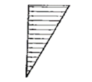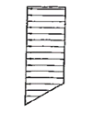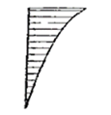
Triangular distribution
Distribution corresponding to higher modes
Uniform distribution

Fig 1- Lateral load distribution in the incremental analysis method
3. The lateral load intensity is gradually increased and the deformations and internal forces of the members are calculated until one of the members deforms so much that its material yields and its stiffness changes. The stiffness of the yielded member is modified and the lateral load is increased again. The stiffness correction is accomplished by placing a joint in the place where the member yields, for example at the end of the beam or column.
4. The third step is repeated until more members reach their ultimate strength. Although the load is gradually increasing, its distribution is assumed to be fixed.
5. The deformations and internal forces are calculated in each step of increase of the lateral forces and added to those of the previous step.
6. Increase in the load intensity continues until the structural performance becomes undesirable or the lateral displacement at the roof level (control point) exceeds the predicted displacement for the design earthquake.
7. The displacement curve of the control point is plotted with respect to the base force. This curve illustrates the nonlinear behavior of the structure [21].
IV-FRAME MODELING IN OPENSEES SOFTWARE
4.1. Introduction and modeling of frames under study
Three 3-storey reference frames with a height of 3.2 m were designed in the plans of one with a bending frame and the other two frames, one with a combined eccentric brace and the other with a combined concentric brace. The number of spans in the three sets of frames was considered to be 2, 3, and finally 4 spans in the first, second, and third time, respectively. The structures were considered to be of the residential use and the soil of the site was considered to be Type 3 in accordance with the 2800 Iranian Code [26], besides, the design base acceleration ratio, the very high relative risk zone (PGA = 0.35), was considered for all structures.
The IPB sections were used for the columns. As demonstrated in Figure 2 (a), the IPB 200 cross-section which forms the columns of stories 1 to 3 of the short-rise 4-span structures with a CBF bracing frame, has a top and bottom flange width of 200 mm, a top and bottom flange thickness of 15 mm, a web thickness of 9 mm, and an overall height of 200 mm. Meanwhile, the IPE section has been used for the beams. As shown in Figure 2 (b), the IPE270 cross section has a top and bottom flange width of 135 mm, a top and bottom flange thickness of 10.2 mm, a web thickness of 6.6 mm, and an overall height of 270 mm. Moreover, the UNP sections have also been used for the brace sections. As depicted in Figure 2 (c), the 2UNP120 section has a total width of 120 mm, a flange thickness of 10 mm, a web thickness of 10 mm, and an overall height of 120 mm. Other dimensions of the beam, column, and brace sections are represented in Tables 2 to 4.
First, the linear modeling of the structures was performed three-dimensionally in Etabs 2015 software. Then the modeling and the nonlinear static pushover and nonlinear IDA analyses for the lateral frame A of All structures were carried out in Opensees finite element software version 2.4.0, which is a very robust software for nonlinear analyses. An equivalent damping of 5% was considered. The steal material 01 was utilized as Figure 3, which is a single-axis bilinear material with optional kinematic hardening and isotropic hardening described by a nonlinear evolutionary equation [27].
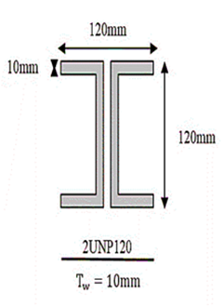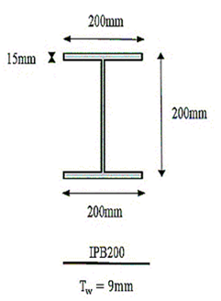
- (b)
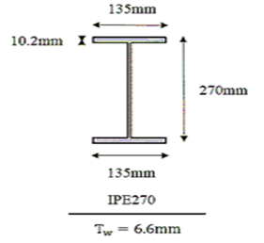(c)
Fig 2- Structural sections with bending frame and brace in Sap and Opensees software a) IPB200 section, b) IPE270 section, c) 2UNP120 section
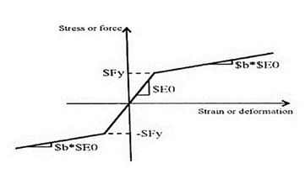
Fig 3- Steel material 01
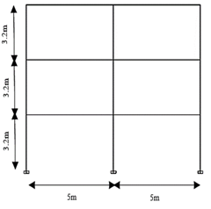
(a)
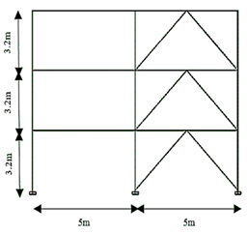
(b)
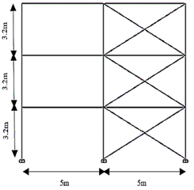
(c)
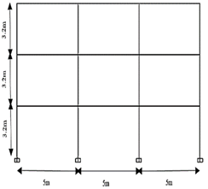
(d)
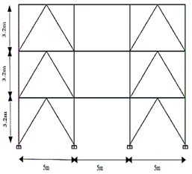
(e)
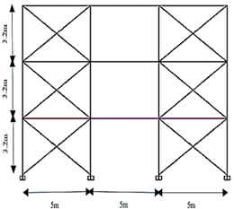
(f)
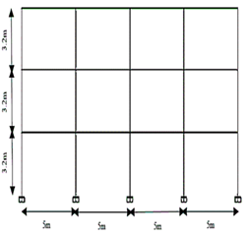
(g)
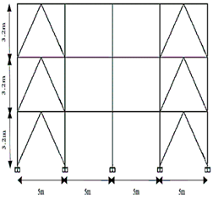
(h)
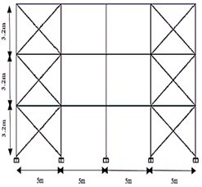
(i)
Fig 4- Modeling of short-rise structures with bending frames and braces in Etabs and Opensees software a) Two-span bending frame, b) Two-span Chevron frame, c) Two-span CBF frame, d) Three-span bending frame e) Three-span Chevron frame, f) Three-span CBF frame, g) Four-span bending frame, h) Four-span Chevron frame, i) Four-span CBF frame
Table 1. Dimensions of structures with 2 spans
Bending frame
Brace dimensions | Beam dimensions | Column  dimensions | Stories
- | IPE330 | IPB 220 | 2-1
- | IPE300 | IPB 220 | 3
CBF brace frame
2UNP 100 | IPE270 | IPB 180 | 3-1
Chevron frame
2UNP 100 | IPE270 | IPB 180 | 3-1
Table 2. Dimensions of structures with 3 spans
Bending frame
Brace dimensions | Beam dimensions | Column dimensions | Stories
- | IPE360 | IPB 220 | 1
- | IPE330 | IPB 220 | 2
 | IPE300 | IPB 220 | 3
CBF brace frame
2UNP 100 | IPE270 | IPB 200 | 3-1
Chevron frame
2UNP 100 | IPE270 | IPB 180 | 3-1

Table 3. Dimensions of structures with 4 spans
Bending frame
Brace dimensions | Beam dimensions | Column dimensions | Stories
- | IPE360 | IPB 220 | 1
- | IPE330 | IPB 220 | 3-2
CBF brace frame
2UNP 120 | IPE270 | IPB 200 | 3-1
Chevron frame
2UNP 100 | IPE270 | IPB 200 | 3-1

V- CHARACTERISTICS OF FAR-FIELD RECORDS
In this study, 10 far-field earthquake records were used in accordance with the FEMA-P695 guidelines as Table 4, which were obtained from the Pacific Earthquake Engineering Research Center (PEER) site [28]. The soil type of the records was considered to be type 3 according to the Iranian Code 2800 [26]. These records were employed to perform nonlinear IDA and the behavior of the regular short-rise structures in the plan was obtained under the far-field records.

Table 4. Seismic characteristics of the far-field records
Number | Earthquake name | Year of occurrence | Magnitude | R (Km) PGA (g) |  | PGA (g)
1 | Northridge | 1994 | 6/7 | 17/2 0/52 |  | 0/52
2 | Northridge | 1994 | 6/7 | 12/4 0/48 |  | 0/48
3 | Duzce, Turkey | 1999 | 7/1 | 12 0/82 |  | 0/82
4 | Hector Mine | 1999 | 7/1 | 11/7 0/34 |  | 0/34
5 | Imperial Valley | 1979 | 6/5 | 22 0/35 |  | 0/35
6 | Imperial Valley | 1979 | 6/5 | 12/5 0/38 |  | 0/38
7 | Kobe, Japan | 1995 | 6/9 | 7/1 0/51 |  | 0/51
8 | Kobe, Japan | 1995 | 6/9 | 19/2 0/24 |  | 0/24
9 | Kocaeli, Turkey | 1999 | 7/5 | 15/4 0/36 |  | 0/36
10 | Tabas | 1978 | 7/7 | 10 0/2 |  | 0/2
VI- NONLINEAR IDA AND STATIC ANALYSIS
IDA was carried out for the three sets of medium bending steel frames under the far-field records. The intensity index was considered corresponding to the spectral acceleration of the first mode S_{a} (T₁,5%) and the damage index was regarded corresponding to the maximum interstory drift (θ_{max}), then IDA was performed on the frames.
6.1. Limit states of IDA curves
According to the FEMA-350 guide for the medium bending steel frames, the CP limit state was considered to be either the point equivalent to the 20% of the initial mean slope corresponding to the starting point of smoothing of the IDA curves or θ_{max}=10%, each occurring earlier (in terms of (IM)).
6.2. Drawing and summarizing IDA curves
The IDA curves were plotted by performing the IDA analysis for the bending and short-rise braced frames under the 10 far-field records and obtaining the damage values (DM) in each intensity level (IM), with the sample curves demonstrated in figures 5 and 6. For plotting, the 16%, 50%, and 84% summarization corresponding to the dispersion index (standard deviation) and median were calculated and drawn, with examples of these curves shown in figures 7 and 8. As it can be observed in figures 7 and 8, the CBF brace with four spans has a higher capacity to accommodate more accelerations and larger deformations compared to the three-span brace.
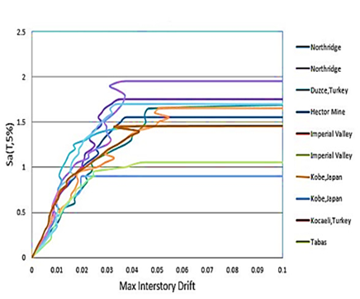
Fig 5- Multiple incremental dynamic analysis (IDA) curves of the four-span concentric bracing frame (CBF)
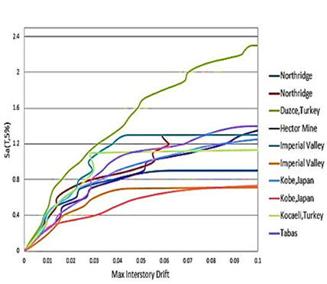
Fig 6- Multiple incremental dynamic analysis (IDA) curves of the three-span concentric bracing frame (CBF)
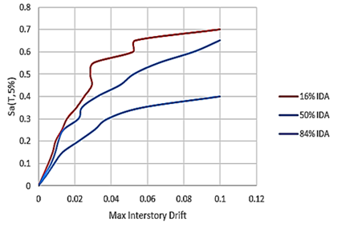
Fig 7- Summarization of the multiple incremental dynamic analysis (IDA) curves of the four-span concentric bracing frame (CBF)
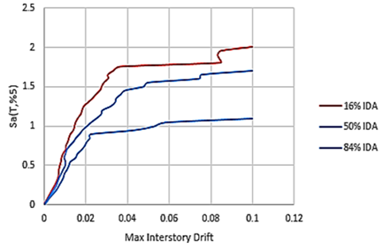
Fig 8- Summarization of the multiple incremental dynamic analysis (IDA) curves of the three-span concentric bracing frame (CBF)
6.3. Base shear and roof displacement
The pushover curves were plotted by performing the nonlinear static analysis for the bending and short-rise braced frames with triangular lateral load distribution and obtaining the roof displacement against the base shear, the samples of which are depicted in Figure 9 for comparison. As shown in this figure, the slope of the force-displacement curve has increased in the elastic region with increasing the number of spans from 2 to 3 and from 3 to 4, indicating increased lateral stiffness of the studied frames.

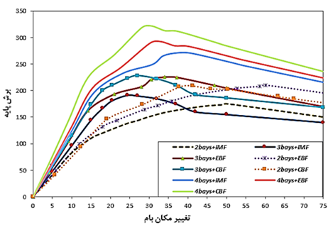
Base shear-Roof displacement
Fig 9- Pushover graph for all structures studied
VII- FRAGILITY CURVES
The fragility curves are obtained from the probabilistic functions derived from the intensity values for different limit states. These curves are derived from the following function [29].
$$F_{i}\left(im\right)=P\left(D>\left.d_{i}\right|IM=im\right)\left(2\right)$$
Where, F_{i} (im) is the probability of further damage (D) from a particular damage state (d_{i}) for the earth motion intensity IM = im. The intensity parameter of an earthquake can be defined by the peak ground acceleration (PGA), peak ground velocity (PGV), peak ground displacement (PGD), and so on.
The damage modes “I” can vary from no damage mode (i-0) to damage mode (i-n). Taking into account the damage index, Equation 2 changes as follows.
$$F_{i}\left(im\right)=p\left(DI>\left.{di}_{i}\right|IM=im\right) (3)$$
In which,${di}_{i}$ is the damage index for the damage states. Given the probability density function DI or the cumulative distribution function for each “im” (${ f}_{im}(di)$) and ($F_{im}(di)$), from the probability theorem, Equation 3 can be written as follows:
$$F_{i}\left(im\right)=P\left(DI>\left.{di}_{i}\right|IM=im\right)=1-\int_{-∞}^{{di}_{i}}{f_{im}\left(di\right)d\left(di\right)\left(4\right)}$$
The fragility values in each $S_{a}(F_{i}\left(S_{a}\right))$were calculated changing the symbols of Equation 4 and replacing the damage distribution index $f_{im}(di)$ by the inter-story drift normal distribution $f\left(isd\right)=∅[\overline{{ISD}_{Sa}} , σ_{Sa}]$, where $\overline{{ISD}_{Sa}}$ and $σ_{Sa}$are the mean and standard deviation (SD) values of the drifts.
$$F_{i}\left(Sa\right)=P\left(D>\left.d_{i}\right|SA=Sa\right)=1-P\left(D≥\left.d_{i}\right|SA=Sa\right) (5)=1-∅\left(\overline{{ISD}_{Sa}} , σ_{Sa}\right)$$
7.1. Drawing fragility curves
In this study, RT software was exploited to plot the fragility curves for the collapse prevention (CP) performance levels. According to the FEMA350-273 guidelines, a 5% drift was considered for the CP limit state. The horizontal and vertical axes of the fragility curve correspond to IM and the damage exceedance probability, respectively. As shown in Figure 10, the Sa value corresponding to a 10% damage exceedance probability of the Chevron braced frame with 4 spans is more than that of the other structures, indicating that the structure is capable of accepting more accelerations and larger deformations, so it has a safer capacity compared to the other structures. In addition, as shown in Figure 10, the Sa value corresponding to the 10% damage exceedance probability of the CBF frame with 4 spans, the IMF frame with 3 and 4 spans, and the Chevron frame with 2 spans is approximately the same in CP limit state, indicating that these structures fail almost simultaneously.
The results obtained from the fragility curves for the bending and braced short-rise structures under the far-field records are presented in Table 5.
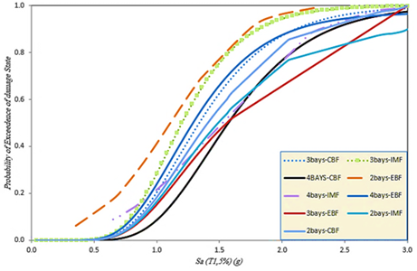
Fig 10- Fragility curves of structures with bending frames and braces for collapse prevention (CP) limit state
Table 5. Seismic characteristics of far-field records
Chevron | IMF | CBF | Number of spans
1/04 | 0/89 | 0/86 | 4
0/9 | 0/85 | 0/7 | 3
0.84 | 0/73 | 0/45 | 2

VIII- CONCLUSION
In this study, three regular 3-storey reference frames with a height of 3.2 m in the plans of one with a bending frame and the other two frames, one with a combined eccentric brace and the other with a combined concentric brace were modeled. The number of spans in the three sets of frames was considered to be 2, 3, and finally 4 spans in the first, second, and third time, respectively. Initially, the linear modeling of the structures was performed three-dimensionally in Etabs 2015 software. Then the nonlinear static pushover and nonlinear IDA analyses for the lateral frame A were carried out in Opensees software version 2.4.0. To perform the nonlinear IDA, the structures were subjected to 10 far-field records on the basis of the FEMA-P695 guidelines. Examining the results of the short-rise frame considering the effect of the number of spans showed that:
- Increasing the number of spans and subsequently reducing the vulnerability of the structures, the 10% probability of failure of the Chevron braced frame structure with 4 spans is higher than the other structures and as 1.04, indicating that the frame with the Chevron braced frame with 4 spans has the highest capacity of collapse, however the CBF braced frame with 2 spans has the lowest capacity of collapse.
- Based on the results of this study, it was found that as the number of spans increased, the frame strength and the area under the force-lateral displacement graph increased, indicating an increase in the capacity of the earthquake energy absorption and hence, a decrease in the structural vulnerability. It was also found that the effect of the number of spans on the seismic response of the structural frame can depend on various issues, including the type of lateral load- bearing system, design assumptions, etc. However, the general trend indicates that the increase in the number of spans from 1 to 2 and from 3 to 4 in all CBF and Chevron braced frame systems increased the structural safety as well as the seismic intensity corresponding to the structural failure.
- For the structures investigated in this study, the spectral acceleration corresponding to the 10% damage exceedance probability from the CP performance level was in the range of 0.45 to 1.4 the gravitational acceleration.
- Furthermore, the results revealed that the seismic intensity corresponding to the CP threshold for the frames with 4 spans can be greater as 20% compared to the values corresponding to the frames with 2 spans. For the frames with 3 spans, a mediocre state governs.
- Based on the results, the Chevron bracing frames had a better performance in comparison to other bracing systems and the seismic intensity corresponding to the CP threshold was higher for this system.

REFERENCES
- Beheshti Avval, Seyed Bahram (2015) Seismic improvement of existing buildings. Khaje Nasir al-Din Toosi University of Technology Publications.

- Shih, Ho Chao., and Subhash, C.Goel. (2006) A Seismic Design Method for Steel Concentric Braced Frames for Enhanced Performance. International Journal of 4th International Conference on Earthquake Engineering Taipei, (227).

- Rai, D.C., and Goel, S.C. (2003) Seismic Evaluation and Upgrading of Chevron Braced Frames. Journal of Constructional Steel Research, 59, 971-994.

- MacRae, Gregory A., Yoshihiro Kimura, M.ASCE., and M.ASCE, Charles Roeder. (2004) Effect of Column Stiffness on Braced Frame Seismic Behavior. Journal of Structural Engineering ASCE/MARCH.

- Dicleli, Murat., and Mehta, Anshu. (2007) Effect of Near-Fault Ground Motion and Damper Characteristics on the Seismic Performance of Chevron Braced Steel Frames. Journal of Earthquake Engineering and Structural Dynamics, 36, 927-948.
- Shih, Ho Chao., Bayat M, Reza., and Goel, Subhash C. (2008) Performance-Based Plastic Design of Steel Concentric Braced Frames for Enhanced Confidence Level. Journal of The 14Th World Conference on Earthquake Engineering October 12-17, 2008, Beijing, China.

- Farshchi, Hamid Reza. Sarvghad Moghaddam, Abdolreza and Watar, Mohammad Ghasem (2008) An experimental study of the effect of joint strength on cross-bracing frames. Structural and Steel Journal, (3) 4, 62-73.
- Ariyaratana, Christopher., and Fahnestock, Larry A. (2011) Evaluation of Buckling-Restrained Braced Frame Seismic Performance Considering Reserve Strength. Journal Of Engineering Structures, 33, 77-89.

- Amini, M., and Alirezaei, M. (2013) Response Evaluation Of Braced Frames With Suspended Zipper Struts and Chevron Braced Frames in Near-Fault Earthquake Ground Motions. American Journal Of Sustainable Cities and Society, 1, 151-164.

- Abdollah Zadeh, Gholamreza., and Mohammadi, Shahrouz. (2013) Behaviour Factor of Double Steel Frame with Concentric Braces of Large Scale. Journal of Modeling in Engineering, 10(31), 1-13.

- Rahmani, Z., Naghipour, M., Vaseghi Amiri, J., and Karimnezhad, R. (2013) Comparing Seismic Parameters in Dual Systems Equipped with Concentric and Eccentric Braces and Side Plate Connection. Middle-East Journal of Scientific Research 14(3), 300-308.

- Mahin, Stephan., Uriz, Patxi., Aiken, Ian., Field, Caroline., And Ko, Eric. (2004) Seismic Performance Of Buckling Restrained Braced Frame Systems. International Journal of 13 th World Conference On Earthquake Engineering Vancouver, 1-14.

- Deylami, Ardeshir., and Islamic, Ghazaleh. (2014) Evaluation the Effect of Number of Floors and the Number of Spans of Steel Frames Structure to Resistance for Progressive Destruction. Journal of Seventh National Civil Engineering Congress of Zahedan University of Sistan and Baluchestan.

- Erfani, Saeed,. and Mulla Mohsen Almasi, Ali. (2015) Evaluation theEffect of Number of Floors, Length, and Number of Spans on the Seismic Behaviorof Steel Moment Resistance Frames. International Journal of Eighth National Civil Engineering Congress.

- Kalani Sarokolayi, Leila., Gholampour dehkordi, Sirous., and Shafaghati sefidab, Masoud. (2015) Evaluating Response Modification Factors of Concentrically Braced and Special Moment Steel Frames in Duplex Buildings. Journal of Structural Engineering and Geotechnics, 5(1), 31-38.
- Rahgozar, Navid., Rahgozar, Nima., And Moghadam, Abdolreza. (2016) Probabilistic Safety Assessment Of Self-Centering Steel Braced Fram. International Journal of Front. Struct. Civ. Eng. 1-20.

- Gholhaki, Majid and Ahmadi, Seyed Meysam (2016) The effect of thin steel plate filler on the inverted-V eccentric brace behavior. Sharif Civil Journal, (32) 2, 67-78.

- Cornell, C.A., and Vamvatsikos, D. (2002) Incremental Dynamic Analysis. International Journal of Earthquake Engineering & Structural Dynamics, 31(3), 491-514.

- Yazdani, Azad,. Baharmast, Hesam and Razmiyan, Sanaz (2016). Estimation of the mean curve in incremental dynamic analysis using seismic ratings in the region. Amirkabir Civil Journal, (4) 48, 419-427.

- Whan Han, Sang,. and K.Chopra, Anil. (2006) Approximate Incremental Dynamic Analysis Using the Modal Pushover Analysis Procedure. International Journal of Wiley Inter Science-Earthquake Engng Struct, 1853-1873.

- Dordai Joughan, Sadegh., Badri, Hamed., and Daneshjoo, Farhad. (2009) Comparison of Resistant Moment Steel Frames by Modal Pushover (Nonlinear Static) and Incremental Dynamic Analysis. Eighth International Civil Engineering of Conference.

- Shafei, B., Zareian, F., and Lignos, D.G. (2011) A Simplified Method for Collapse Capacity Assessment of Moment-Resisting Frame and Shear Wall Structural Systems. Journal Of Engineering Structures. 1107-1116.

- Chopra, A.K., and Goel, R.K. (2002) A modal pushover analysis procedure for estimating seismic demands for buildings. Journal Of Earthquake Engineering and Structural dynamics, 31(3), 561-582.

- Paraskeva, T.S., Kappos, A.J., and Sextos, A.G. (2006) Extension of modal pushover analysis to seismic assessment of bridges. Journal Of Earthquake Engineering and Structural Dynamics, 35(10), 1269-1293.

- Moshtagh, Amin., Saberi, Vahid., and Saberi, Hamid. (2018) Seismic Performance Evaluation of Knee and EBF Braced Frames Using Nonlinear Static Analysis. International Journal of Science and Engineering Applications, 7(12), 483-488.

- Seismic Structural Design Regulations Standard 2800 Revision 4 (2014). Building and Housing Research Center.
- Hosseini, Seyed Mojtaba., Kanaraki, Hadi (2014) Application of Opensees software in structural modeling and analysis. Azade Publications.

- Next Generation Attenuation of Ground Motion (Nga) Project. (2006). http://Peer. Berkeley. Edu\nga\(Accessed 10 October 2006).

- Soltangharaei, V., Razi, M., and Vahdani, R. (2016) Seismic Fragility of Lateral Force Resisting Systems Under Near and Far-fault Ground Motions. International Journal of Structural Engineering, 1-12.

