Seismic retrofitting of Under-designed Indian RC building using Jacketing of Members
Saif Usmani ¹, Prof. Kuldeep R Dabhekar ²
¹Student
Dept. Of Civil Engineering , G.H Raisoni College of Engineering, Nagpur,India ,440016
²Assistant Professor
Dept. Of Civil Engineering, G.H Raisoni College of Engineering, Nagpur, India,440016

Abstract – The buildings constructed prior to the development of seismic codes are vulnerable to earthquakes and have inferior seismic performance. These buildings can be viability retrofitted to improve their performance at very reasonable cost in comparison with the increase in land development and new building costs. Several strategies are involved in seismic retrofitting; one of these is concerned with the increment in stiffness. This paper attempts to apply this method to an existing under-designed reinforced concrete building by jacketing of elements. A comparison is made between bare frame and that with retrofitting for various performance parameters including target displacement, capacity and non-linear static pushover. The increase in stiffness improves the seismic performance, resulting in reduction of target displacement, increase in capacity and better performance under non-linear static pushover.

Keywords- Performance Objectives, Pushover analysis.
INTRODUCTION
Seismic retrofitting of reinforced concrete buildings is practised with an aim to improve the performance of building. The various methods developed for improving performance include, mass reduction techniques, use of energy dissipation devices, stiffness increment and base isolation methods. Every method is suitable for a known class of building and performance level. According to ATC-40 there are structural as well as non-performance levels, the buildings are generally evaluated according to structural performance levels. The structural performance levels are defined as an ensemble of performance objectives for a particular building type. The performance levels are designated as SP-1(Immediate occupancy), SP-2(Damage control), SP-3(Life Safety), SP-4(Limited Safety), SP-5(Structural Stability), SP-6 (Not Considered). A Combination of these structural and non-performance levels is sought after to get a safe functional building in practice. The paper discusses the basics of building performance and adopted methodology for analysis, it then tries to study the definition of parameters which form the basis of comparison between bare & retrofitted RC frame.
II. Related Work
Various studies have been forwarded to explain the relation between different performance objectives and the retrofitting strategies suitable to achieve desired performance. Some studies emphasize on energy dissipation devices to modify the drift profile of building; they study the effect of different strategies on the behaviour of building. Some of them investigate the use of memory alloys, or shear linkages in braces for dissipation of energy. While the effectiveness of these methods cannot be overlooked, they may lead to significant increase in costs and functionality which might not always be desired from a retrofitting project. Other alternatives have also been discussed which study effects on experimental models, the scope of such studies is somewhat limited as all scenarios and building types cannot be effectively modelled. Analytical studies however focus on more realistic and performance oriented goals.
III. Methodology
The paper focusses on analytically comparing the two models, so as to evaluate performance parameters affected by the use of retrofitting strategy. The main objective of the study is to study the increase in capacity and the change in target drift due to jacketing of elements. The models are evaluated using a computer based tool and the results are compared analytically. The modelling work is carried out on SAP2000, and a non-linear pushover curve is plotted for the yield displacement of h/20 as per ASCE 41-17. The sections are jacketed and the capacity of the retrofitted section is assessed through moment curvature. Non-linear static procedure is adopted and the hinges are assigned as per FEMA 356. The material defined for jacketing of elements is of M25 grade and the reinforcement of grade Fe415 is taken for design.

IV. Analysis
Non-Linear static Pushover analysis
Pushover analysis is a non-linear static procedure (NSP) where the lateral force is incrementally increased in a predefined pattern. It gives better insight as to which member in the structure acts as a weak link, the trends in formation of hinges help in identifying weak members. Pushover analysis helps in estimating base shear and displacement capacity of structure along with sequential formation of hinges in the hinges under analysis. The result is displayed in the form of pushover curve which is essentially a curve of base shear vs. roof displacement. This curve can also be used as capacity curve of the structure. To incorporate the effect of inelastic behaviour of structural elements lumped plasticity models has been used and assigned in the form of moment rotation capacity ( i.e Plastic hinge )to individual element. In the present study default properties of plastic hinges in SAP2000 as per FEMA 356 have been used.
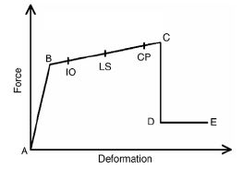
Fig.1 Ideal pushover curve from ASCE 41-17

Fig. 2 Validation curve for Pushover analysis
The results have been verified by Inel & Ozmen paper, it was observed that the procedure was correct and the same procedure was followed in further analysis. Monitored roof displacement at the center of mass is used in pushover analysis of buildings. The non-linearity in case of beams is provided by uncoupled moment hinges (M3) and for columns coupled axial force and biaxial bending moment hinges (P-M2-M3).
The pushover curve for bare and jacketed element building is thoroughly studied and compared, following parameters are calculated.
Target displacement,
As per 7.4.3.3.2 from ASCE/SEI 41-17 Target displacement can be calculated as follows,
⸹_{t}=C₀C₁C₂ .S_{a} . (T_{e}²/4ℼ²).g
⸹_{t}= Target displacement
C₀=Modification factor to relate the spectral displacement model to an equivalent single degree of freedom system (SDOF) to the Multiple degree of freedom (MDOF) system.
C₁=Modification factor to relate expected maximum inelastic displacement to displacements calculated for linear elastic response. For periods less than 0.2s, C₁ need not be taken, for periods greater than 1.0s C₁=1.0.
C₂=Modification factor to represent the effect of pinched hysteresis shape ,cyclic stiffness degradation, and strength deterioration on the maximum displacement response.
S_{a}= Response spectrum acceleration at the effective fundamental period and damping ratio of the building under consideration.
T_{e}=Effective fundamental period of the building in the direction under consideration.
Target displacement gives a vague idea regarding the performance level of building, the members failing under these hinge conditions can be easily identified.
From ATC-40, the following performance levels are formulated to analyse buildings for retrofitting requirements and performance levels,
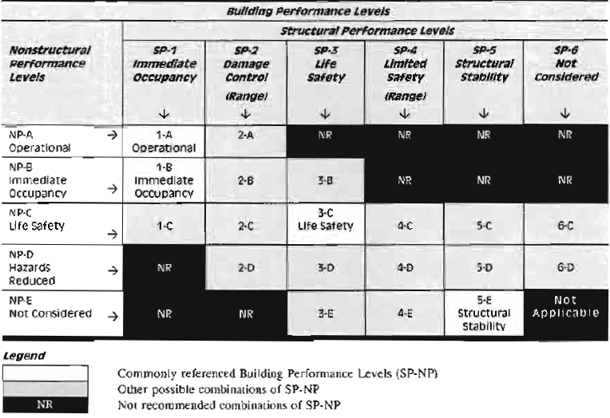
Fig 3. Performance levels defined as per ATC-40
The combination of structural performance and non-performance levels are considered as building performance levels.
Calculation of capacity from pushover curve
The target displacement when plotted onto the pushover curve gives capacity of the building under analysis, as per ASCE 41-17. The capacity gives a vague idea regarding
Model
The modelling work is done on SAP2000 package; the model has a plan dimension of 12x14m with three bays on either side of the structure. The building is a six-storeyed building with a storey height of 3m; the building is situated in seismic zone V. The soil condition is hard rock and soil, the model is subjected to lateral loads in the form of earthquake loads which are self-generated by the software. The load cases are defined as per IS 1893-Part-1-2016. The models are evaluated based on their target displacement, performance-point & hinge formation characteristics.
First mode is predominantly used to perform pushover analysis on the building. Bare frame and retrofitted frame are inserted with auto hinges compliant with FEMA 356-2000, uncoupled moment hinges (M3) are used for beams and coupled force-biaxial bending and moment hinges (P-M2-M3).
Response spectrum load case is defined in accordance with table 7 of IS 1893 (Part 1)-2016.The mass source is defined to include dead load , 25 per cent of live load as well as other participating load combinations. The scale factor is calculated as follows,
Scale factor = (Z/2)x(I/R)x g
Where,
Z=Zone factor
R=Response reduction factor
I=Importance factor .
g= Acceleration due to gravity.
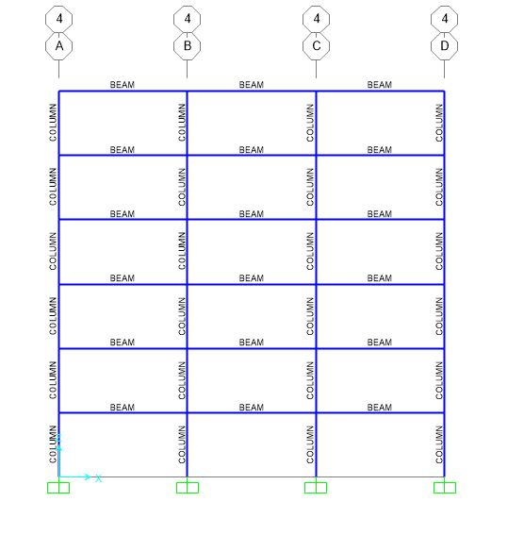Fig 4. Typical Frame in the X-Z Direction
The model has similar beams on each floor, the beam dimensions are 230x450 mm. Building is designed for gravity as well as earthquake loads and the requirement for reinforcement is checked, this helps in identifying critical members.
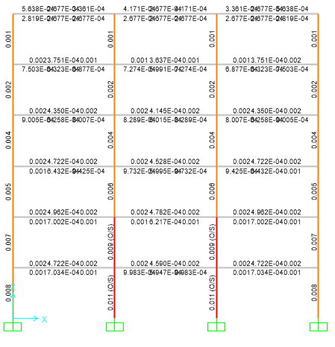
Fig 5. Frame at Y=5 along X-Z direction
The members shown in red have failed due to greater than maximum requirement of reinforcement; the columns failed are identified as GC-6, GC-7 at the ground storey and FC-6, FC-7 at first storey.
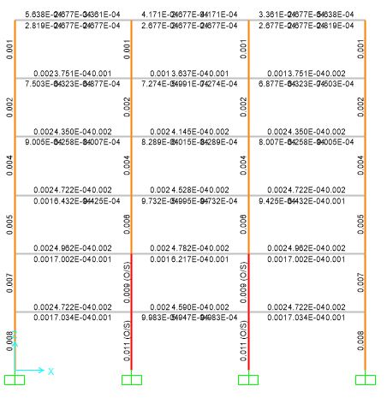
Fig 6. Frame at X=9 along X-Z direction
The members shown in red have failed due to greater than maximum requirement of reinforcement; the columns failed are identified from left to right as GC-10, GC-11 at ground storey and FC-10, FC-11 at first storey.
The following table identifies Summarizes the critical members,
Table 1 Critical members
Name/designation of member | Location | Percentage of reinforcement Required
GC-6,GC-7 | Ground storey | >6%
FC-6,FC-7 | First floor | >6%
GC-10,GC-11 | Ground storey | >6%
FC-10,FC-11 | First floor | >6%
The identified critical members fail in design itself due to greater than maximum reinforcement requirement. It should be noted that C stands for column in this naming system. The columns in other stories are also beyond the practical limit of reinforcement provision. Flexural members are marginally safe, although ultimate safety is dependent on the strength of compression members.
These critical members need to be retrofitted to make them safe, this is done by increasing the cross sectional area and providing additional reinforcement required.
The members are jacketed using RC jacketing by defining the material as M25 and Fe415.SAP2000 has a section designer utility for defining retrofitted sections. The sections adopted for retrofitting are as follows,
Table 2 Dimensions of retrofitting sections
Description | Dimension | Location
R-Beam | 300x600 | All stories except roof
G-Column | 500x850 | Ground floor
1-Rcolumn | 400x700 | All stories except top storey
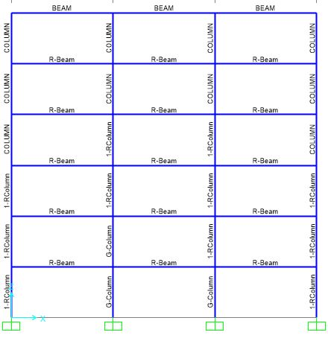
Fig 7. Typical frame for model with jacketed elements
The model is analysed by pushover analysis using displacement control same as bare frame.
Results
The pushover curve is also known as pushover capacity curve, as per ASCE 41-17. The bare frame and retrofitted frame are analysed and pushover curve is plotted for both of them, we will discuss each of them one by one.

Fig.6 Pushover curve for bare curve
The bare frame has been found to have a target displacement of 0.654 m. The hinges at this displacement are exhibiting the performance level of LS (Limited safety). The hinges at this point are completely yielded and the building is unsafe beyond occupational safety. The beams begin to form B-IO hinges at the 3rd step, in the 4th step beams at the third storey show IO-LS hinge formation. A step 13 almost all columns show formation of C-D hinges. Step 17 marks the beginning of hinge formation in base columns. The hinges at all base story columns begin to yield completely at step 27 ,this is the point of total collapse.

Fig Pushover curve for model with Jacketed elements
The retrofitted frame has a target displacement of 0.120 m. The IO hinges begin forming in beams immediately after the target displacement is exceeded. Step 10 denotes formation of LS-IO hinges in first and second storey. However almost all beams remain intact until step 38 or 0.6511m. After this step all flexural members begin to form LS-CP hinges and the structure completely yields at 0.863 m.
Conclusion
The building exhibits a higher performance level after retrofitting as compared to bare frame. The overall vulnerability is reduced after jacketing of columns. Target displacement has reduced substantially, making the building more safe as compared to the bare frame.
References
[1] Hugo Rodrigues,André Furtado ,Nelson Vila‑Pouca Humberto Varum, André R. Barbosa,International Journal of civil engineering,,Springer (2018).

[2] Innovative seismic retrofitting strategy of added stories isolation system, Min-Ho Chey , J. Geoffrey Chase, John B. Mander, Athol J. Carr, Springer (2013).

[3] Analytical study on seismic retrofitting of reinforced concrete buildings using steel braces with shear link, Cengizhan Durucan, Murat Dicleli, Journal of Engineering structures, Elsevier (2010).

[4] Design Methodology for Seismic Upgrading of Substandard Reinforced Concrete Structures, Georgia E. Thermou, Stavroula J. Pantazopolou,& AMR S. Elnashai,Journal of earthquake engineering,Taylor and francis (2007).

[5] Global Interventions for Seismic Upgrading of Substandard RC Buildings, G. E. Thermou, S. J. Pantazopoulou, and A. S. Elnashai,ASCE (2012).

[6] Seismic performance of buildings retrofitted with nonlinear viscous dampers and adjacent reaction towers, Nicola Impollonia, Alessandro Palmeri,Wiley (2017).

[7] Alternative retrofitting strategies to prevent the failure of an underdesigned reinforced concrete frame, Marco Valente, Gabriele Milani, Engineering Failiure Analysis 89 271-289,Elsevier (2018).

[8] Analytical Study of Moment-Resisting Frames Retrofitted with Shear Slotted Bolted Connection

[9] Displacement-based seismic design of hysteretic damped braces For retrofitting in elevation irregular r.c. framed structures, FabioMazza, Mirko Mazza,Alfonso Vulcano, Soil Dynamics and Earthquake Engineering 115-124,Elsevier (2015).

[10] Seismic retrofit design method using friction damping systems for old low- and mid-rise regular reinforced concrete buildings, Ki Hoon Moon , Sang Whan Han , Chang Seok Lee, Engineering Structures 105-117,Elsevier (2017).

[11] Base-isolation systems for the seismic retrofitting of RC framed buildings with soft-storey subjected to near-fault earthquakes, Fabio Mazza, Mirko Mazza, Alfonso Vulcano,Soil Dynamics and Earthquake Engineering,209-221,Elsevier (2018).

[12] Seismic Resistance and Sustainable Performance of Retrofitted Buildings by Adding Stiff Diaphragm SeismicIsolation,Y.Ribakov,I.Halperin,S.Pushkar,ASCE (2015).

