Covid 19 Monitoring System Using Social Distancing and Face Mask Detection Using YOLOv5 Algorithm

Prof. Rahul Bhandekar¹ Miss. Neha Lokhande²
Computer Science Engineering Department, Wainganga College of Engineering & Management, Nagpur
rahulbhandekar@gmail.com

Received on: 30 March, 2022 Revised on: 02 May ,2022, Published on: 04 May, 2022

Abstract – The World Health Organization (WHO) recommends maintaining social distance and using face masks to prevent the spread of COVID 19 in public places. Government and national health authorities have made physical distances of 2 meters and wearing face masks a mandatory safety measure in crowded or public areas [1]. In this study, a popular CCTV surveillance camera was used to develop a collaborative deep learning network-based neural model for automatically detecting, tracking, and estimating distances between people in a crowd. increase. The proposed model includes social distance monitoring and a YOLOv5-based facial recognition framework under difficult conditions such as human disability, restricted visibility, and lighting changes [8]. Determine if the location is at high risk of virus infection and spread. This will help authorities redesign public spaces and take precautions to escalate high-risk areas.
- INTRODUCTION

In late December 2019, the first case of coronavirus disease (COVID19) was reported in Wuhan, China. Only a few months later, the 2020 virus was hit by global outbreaks. In May 2020, the World Health Organization (WHO) declared a pandemic. According to WHO estimates released on August 26, 2020, there are 23.8 million people vitiate in 200 countries. The death toll from the virus is, a staggering 815,000. As

the number of patients grows, there is still no effective treatment or treatment for the virus. Scientists, health officials, and researchers are constantly working to provide the right drugs and vaccines for the deadly virus, but no clear success has been reported at the time of this study. There are no specific treatments or recommendations to stop or cure this new illness. As a result, the entire world is scrambling to limit the spread of the infection. These harsh conditions required the global community to look for other ways to stop the spread of the virus. To prevent transmission of the disease, maintain social distance and wear masks to avoid the proximity of human physical interactions in covered or crowded public spaces (schools, workplaces, gyms, auditoriums, etc.) Reduce precautionary measures such as. consistent with the defined conditions by the WHO, the minimal distance between individualities must be a minimum of 6 bases (18. measures) so as to watch an acceptable social distancing among the people (3). Recent inquiries have verified that folks with mild or no symptoms can also be carriers of the new Coronavirus infections (4). Thus, it's important to all or any individualities maintain controlled actions and observe social distancing and wearing mask. Many research papers such as [5], [6], [7] have been an efficient non-pharmacological approach to social distance and wearing masks in crowded areas, such as H1N1, SARS, COVID19, etc. It has proven to be an important inhibitor that limits the transmission of infectious diseases. that is. Monitoring social distance standards and physically checking people's face masks is not only inefficient with limited resources, but can also lead to human error. Containing the virus epidemic requires swift action by learning the norms of perfect social distance that the general public should follow. This includes the mask classification for assessing civil safety by detecting social distance violations and determining whether proper distance is maintained and whether face masks are worn. increase. This technology offers a wide range of connection in colorful public places equipped with cameras. This allows processing technology to use closed TVs for a variety of additional purposes. This white paper introduces an efficient and lightweight COVID-19 monitoring system. This helps identify authorities using video recordings and ensure that everyone complies with social distance and safety standards to contain the spread of the virus. I suggest. The sections of the document are categorized as follows: Section II contains recent work that clarifies this area, and Section III contains datasets and implemented video labels used to extend the dimensions of datasets to measure system performance. Includes attachment techniques. This section describes it. Section IV covers pretreatment techniques, and Section V provides methods for human detection, social distance violation detection, facial recognition, and mask classification. Section VI contains the achievements of the system, and Section VII reflects the long-term scope of the system. Finally, Section VIII concludes.

- LITERATURE REVIEW

One of Mohamed Loey et al. [10] integrates deep transfer learning (ResNet50) with traditional machine learning algorithms. To improve model performance, the last layer of ResNet50 has been removed and replaced with three traditional machine literacy classifiers Support Vector Machine (SVM), Decision Tree, and Ensemble. Of the four datasets used, one dataset contains the most important number of images in the dataset consisting of real face masks and artificial face masks during the training process. It also takes longer than other datasets. No matching accuracy has been reported for related work on this type of dataset. In datasets with real face masks, the Choice Trees classifier didn't reach the honest bracket delicacy (68) of fake face masks during training. A discovery network with a backbone, neck, and head is enforced, conforming of a backbone, FPN (Point Aggregate Network) as a neck, and Resnet similar as classifiers, predictors, and estimators [11]. Still, due to the limited size of the mask dataset, it's delicate to learn the algorithm to find better functionality. Research dedicated to mask detection is limited and there is a need to achieve better detection accuracy.
Another approach is a homemade model called SocialdistancingNet19 by Rinkal Keniya [12] that recognizes a person's frame and displays a label to determine if it is safe or dangerous if the distance is less than a particular value. increase. When using a webcam, the person must be in motion at all times. Otherwise, the detection is fallacious. This may be due to a network detection algorithm that detects the entire image and uses the center of gravity to calculate the distance between people (brute force approach).
For social distance and mask detection, Shashi Yadav proposed a single-shot object detection (SSD) deep learning solution using MobileNet V2 and OpenCV [13]. The challenge with this approach was to classify people with forks on their faces or people with hidden objects as masked. These scenarios are not suitable for this model. SSDs can detect multiple objects in a frame, but here they are limited to detecting one person in this system. Most of the publications focus on the difficulty of social distance monitoring or mask detection, and even if both are implemented, there is room to use better models to achieve better accuracy. I have. Our article mentions the importance of predicted time. This is a feature not found in other articles and is an important criterion for the practicality of the system. This study proposes a YOLOv5 model for detecting people, a state-of-the- art object discovery model, followed by using DBSCAN to calculate the distance between people and perform clustering to move people far down. Detects if it is. This is effectively better than others. You must specify this number of clusters before performing clustering, or a clustering technique such as brute force distance calculation or kmeans. Face detection includes DSFD, a powerful feature extractor with honest accuracy for face detection. Also, MobileNet V2, which is the simplest compared to ResNet 50, was used to classify masks. Finally, the mask dataset was created using data extension tactics and annotated video datasets for examin the system by annotating the frames of the video.

- DATASET

For Face Mask
The dataset collected from unmasked and masked face recovery turned out to be inadequate. Next, using the new information addition method, we described masking an unmasked face and the characteristic blurry image of the. As shown in Figure 1, data addition for unmasked faces was performed on a dataset containing four mask feathers. Mask for augmentation. The set of rules begins to evolve by connecting the determinants of face shape. The highest part of the mask is reached by searching the bottom of the nostrils, so that the bottom, left, and right sides are assigned using the search for the chin element of the face. The left and right halves of mask each have an economical size. The mask rotation pose is calculated based on the face exposure. The bright statement value of the face mask is calculated, and as a result, the mask is also placed on the face.

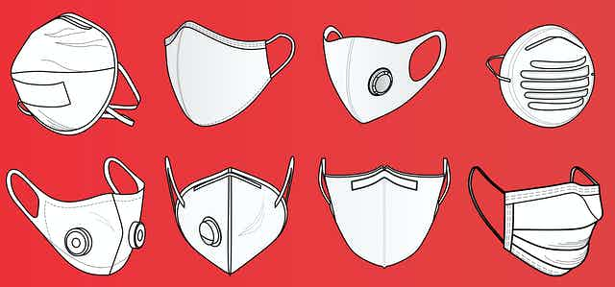
Fig 1- Types of Masks used for augmentation

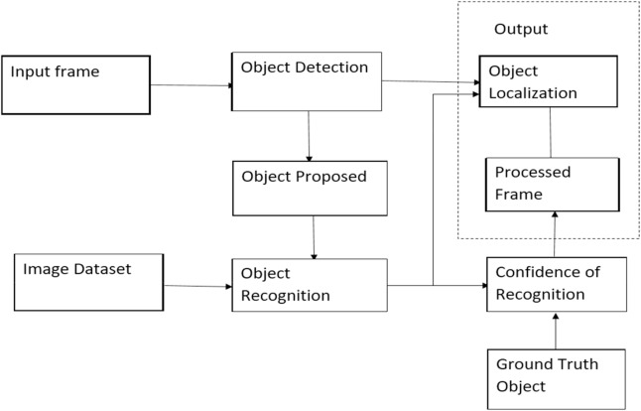
Fig 2-Steps for dataset generation for face mask detection
The set of rules begins to evolve by connecting the determinants of face shape. The highest part of the mask is reached by finding the bottom of the nostrils, and thus the underside. The facial chin element is used to attach the left and right corridors. The set on the left and right sides of the mask are economical in size. The rotation position of the mask is calculated based on the exposure of the face. The same is calculated for the face mask overlay, so that the mask is also placed on the face.
For Social Distancing

When a person coughs or sneezes, he sprays small droplets that may contain the virus through his nostrils and mouth. If you get too close, you will inhale droplets such as the COVID19 virus when you cough, but you will not be ill. The best way to combat the spread of the virus is to stay at the front desk, stay away from friends, and interact online. If you need to travel outdoors or meet someone in person, keep yourself at least 1.5 meters away from others.
Capture Image
Preprocess Image
Extract Feature
Locate Person potions
Calculate distance
Push alert notification

Fig 3-Data flow diagram for social Distancing

For a total social distance tracking solution, we recommend a three-step version that includes human detection, tracking, distance estimation, and zone-based hazard analysis of complete pollution. The gadget is frequently incorporated and implemented on all form of CCTV surveillance cameras with any decision from VGA to FullHD, with Realtime overall performance

People Detection

Figure 3 shows the general structure of Stage 1. The pretensions are clothing changes, position, distant, short- distance, blockages, and colorful lighting conditions. To achieve this, we're inspired by the power of slice- edge exploration. Still, we will develop our own mortal classifier and train the models supported by a comprehensive and different set of datasets. Before probing into further specialized details, we'll give you an overview of state-of-the- art object discovery technology, followed by a mortal discovery model. The rearmost DNN- grounded sensors have two sections, head and backbone, for rooting features and prognosticating the class and position of objects. The point extractor tends to render model inputs by representing specific features that help it to find out and find out the applicable patterns associated with the query object (s). samples of point birth infrastructures are frequently seen in VGG1646, ResNet5047, CSPResNeXt5048, CSPDarknet5348, and EfficientNetB0/ B749. The top of a DNN is responsible for relating objects (e.g., people, bikes, chair persons, etc.) as well as calculating their size and therefore the equals of the bounding boxes.

People Tracking

The next step after the discovery phase is personal tracking and identity assignment for each individual. It uses a simple online and real-time tracking method (SORT) 73 as a framework for the Kalman filter 74, along with a Hungarian optimization method for tracking individuals. The Kalman filter predicts the position of a human at time t+1. It supports current measurements at time t and thus supports mathematical modeling of human movement. This is often an efficient way to locate a human only when an obstruction occurs. Hungarian algorithms help assign a single ID number to a particular object in a series of frames by determining if the person in the current frame is the same as the person recognized in the previous frame. Combinatorial optimization algorithm.

Inter-distance Estimation:
Stereovision can be a not unusual place distance estimation method, however in our research, if we goal to combine a green answer that may be carried out to all public locations the usage of simplest easy CCTV cameras, this is regularly now no longer a feasible approach. Therefore, we keep on with the cyclopia answer.
On the opposite hand, projecting a 3-D international scene onto a 2D attitude picture aircraft the usage of a unmarried digital digicam makes the pixel spacing among items unrealistic. This is regularly called the attitude effect, and also you can't see a uniform distribution of distance at some point of the picture. For example, parallel traces overlap close to the horizon, so humans away from the digital digicam will appearance smaller than humans close to the middle of the digital digicam`s coordinates.
In 3-D area, the middle or reference factor of every bound-box is related to three parameters (x, y, z), however withinside the picture obtained from the digital digicam, the primary 3-D area is two of (x, y). Associated with one dimension. Therefore, the intensity choice isn't always available. Applying the Euclidean distance criterion immediately to the estimation of residing distance among humans might be incorrect in such a discounted dimensional area.

IV-ADVANTAGES AND LIMITATIONS
It slows and reduces transmission of influenza which limits the consequences on individuals plus schools, workplaces and therefore the health care system. To avoid Corona spread this technique are going to be simpler. it's wide area applications.Limitation is merely the point of view position.

V-EXPERIMENTAL RESULT

We trained two models, one with two classes — Unmasked face, masked face and the other with all three classes — Unmasked, Masked faces and The Distance Between Them. The models were trained on 6,120 images.

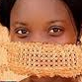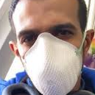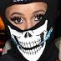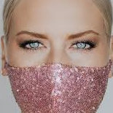
Fig 4: Train Dataset with Mask Faces

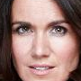
Fig 5- Train Dataset with Unmasked Faces

As you can see in the above figures the model is trained on two classes on masked and unmasked faces. In fig-4 the model is trained with different types of masks where all the four-person wearing four different types of masks this will help the model to realize about different mask and it can easily differentiate between masked and unmasked faces.

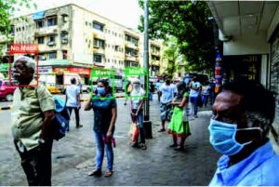

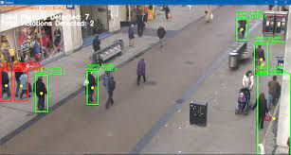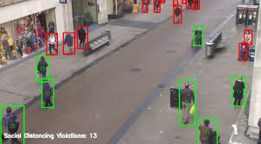
Fig 6- Social Distancing violation

The term "kept" in Figure 5 refers to the minimum social distance that must be maintained between the participants. The term "violated" refers to when the measured distance between a person and everyone else is less than the required minimum social distance. If someone is caught breaking the social distancing norms, they will be placed in a red bounding box; if they are not, they will be placed in a green bounding box.

FUTURE SCOPE

The system performance is excellent in terms of accuracy and predicted time, but the following improvements have been identified: First, the person detection engine takes up most of the video processing time. You can develop simpler human detection algorithms that require less prediction time with accuracy comparable to current models. Second, the social distancing calculation and mask classification are performed independently, so they are often performed in parallel. Third, there are few datasets available for such systems and it is not possible to cover all situations. For example, the system may confuse beards with masks because there are not enough negative examples of beards. When such datasets become available, more powerful models are often trained.

CONCLUSION

This document provides an efficient solution for publicly monitoring social distance practices in areas where manual monitoring is extremely difficult. Human detection, distance detection, face detection, and mask classification are all designed as separate modules. With labeled data, the system works reasonably well with an accuracy of 91.2 percent and an average F1 score of 90.79 percent. A video dataset with an average predicted time of 7.12 seconds for a 1 second video (50-90 frames) and 5.24 seconds spent detecting humans.
It also includes an approach to data expansion to address the data shortages of the community.

REFERENCES

- Mohamed Loey, Gunasekaran Manogaran, Mohamed Hamed N Taha, Nour Eldeen M Khalifa; COVID19 Hybrid deep transfer learning model using machine learning techniques to detect face masks during pandemics (2020)
- Mingjie Jiang ∗, Xinqi Fan *, Hong Yan, RETINAFACEMASK: A FACE MASK DETECTOR (2020)
- Shashi Yadav, Goel Institute for Technology and Management, Dr. APJ Abdul Kalam Institute of Technology, Deep Learning Based on Safe Social Distance and Face Mask Detection in Public Areas to Comply with COVID19 Safety Guidelines
- (2020)
- Rinkal Keniya Ninad Mehendale, Socialdistancing Net19 Deep Learning Network Real-time social distance detector by (2020)
- Indhu Jain, Mr. SudhirGoswami; International Journal of Research in Computer Applications and Robotics (2015), a comparative study of different image restoration techniques using different types of blur.
- Kaiming He, Xiangyu Zhang, Shaoqing Ren, Jian Sun; Deep Residual Learning for Image Recognition (2015).
- 7 Joseph Redmon, Ali Farhadi, University of Washington. YOLOv3: All mähliche Verbesserung. (2018)
- "MobileNetV2: Inverted Residuals and Linear Bottlenecks", IEEE Conference on Computer Vision and Pattern Recognition (CVPR), 2018
- Weltgesundheits organization. WHO Coronavirus Disease Dashboard (August 2020). It is available at https://covid19.who.int/table.
- 10.OpenCV document (background subtraction) http://docs.opencv.org/3.1.0/db/d5c/tutorial_py_bg_subtraction.html
- 11. Khandelwal, P. et al. Use computer vision to improve post-COVID safety for
- manufacturing workers worldwide. Calculation. Vis. Pattern recognition. DOI: 10.1016 / S01406736 (20) 301859 (2020).
- 12. Sandler, M., Howard, A., Zhu, M., Zhmoginov, A. & Chen, L. MobileNetV2: Inverted residuals and linear bottleneck. IEEE Conference on Computer Vision and Pattern Recognition (CVPR), DOI: 10.1109 / CVPR. 2018.00474 (2018).
- 13. Yang, D., Yurtsever, E., Renganathan, V., Redmill, K. & Özgüner, U. A visual-based social distance and critical density detection system for COVID19. Image video process. DOI: arXiv: 2007.03578 (2020).
- 14. Wang, C.Y. et al. CSPNet: A new backbone that can improve the learning ability of CNN. IEEE CVF Conference on Computer Vision and Pattern Recognition Workshop (CVPRW), 390391, DOI: 10.1109 / CVPRW50498. 2020.00203 (2020).
- 15. Nguyen, T. Artificial Intelligence in the Battle of T. Coronavirus (COVID19): Research Direction and Future Research. arXivPrepr. 10, DOI: 10.13140 / RG.2.2.36491. 23846/1 (2020).
- 16. Choi, W. & Shim, E. Optimal
- vaccination and social distance strategies in game theory epidemiological models. J theory. biol. 110422, DOI: https: //doi.org/10. 1016/j.jtbi.2020.110422 (2020).
- 17. C, E., K, P. & S, W.J. Systematic bias in disease prediction-the role of behavioral change. J Epidemics 96–105, DOI: 10.1016 / j.epidem.2019.02.004 (2019).

