Color Blindness Test By Using LMS Algorithm

Mrs. Kaveri Deosarkar¹,Ms. Rupali Saha² ,Bina Rewatkar³

*^{1, 2} Professor, Department of Computer Science and Engineering, Wainganga College Of Engineering And Management, Nagpur, Maharashtra, India.
*³ Student , Department of Computer Science and Engineering, Wainganga College Of Engineering And Management , Nagpur, Maharashtra, India. Maharashtra, India.

Abstract - Color blindness is a type of disease in which a person cannot differentiate between some colors like red-green blue-yellow. A color blindness test helps to detect the correct type of color blindness. If you cannot pass the test you suffer from color vision deficiency. It is also called color blindness. Most color blindness tests can specify that children who have problems identifying colors such as Red green and blue yellow can be treated easily if they are below 5 years. This could be A characteristic in specific activities in school and at home. Color blindness is a very common condition: out of 10 people one color blindness patient has some level of color blindness of visual impact, however there are many tasks in daily life that require the ability of color recognition and visual discriminate.
Keywords- Color blindness, test, colors.
INTRODUCTION
Color blindness causes many problems that cannot be neglected in a person's day to day life. individuals with specific color blindness raised so many challenges in performing everyday tasks. Many kinds of information are completely based on Colors and transmit information through colors, such as traffic signals in which there is the appearance of red, green and yellow. suppose some cannot perceive color difference due to red-green color blindness or other color blindness or other color blindness. In that case it will be hard or even impossible for them to identify the accurate color and to perform a color based task. Color blindness is a genetic condition that is passed down through the generations. It is passed on by the female parent, with the deficiency being more prevalent in males, implying that the majority of patients who suffer from color blindness are males (approximately 8% of males suffer from color blindness, compared to 0.5 percent of females), indicating that this is a rare condition
The goal of the study is to simulate various degrees of color blindness, which are divided into three categories: red, green, blue, and yellow, as well as complete color blindness. We designed a virtual reality application that conveys the experience of embodiment of a colorblind person to better comprehend the challenges that colorblind persons confront in everyday life. The RGB color distance calculation from the cone cell color cluster is used in this study to help patients with partial color blindness recognize the color. The third type of color blindness is completely color blindness, also called monochromacy, in which a person with total color blindness can't see color at all, which is rare. The goal of this study is to replicate different levels of color blindness, which are split into three categories: red-green, blue-yellow, and total color blindness. The four types of red-green color blindness are Deuteranomaly, Protanomaly, and Protanopia. Similarly, there are two types of blue-yellow color blindness: tritanomaly and tritanopia. Third type of color blindness Is complete color blindness is also called as monochromacy in which the person with complete color blindness can't see color at on which is very rare.

LITERATURE SURVEY

Color blindness Bartender: The bartender Application is designed with color based tasks that require the user to correctly recognise the distinguish difference color to make cocktails according to the customer orders. The background information about color blindness and implementation detail are described above. Users of the game construct colors for cocktails for customers based on their preferences, which necessitates switching between different modalities of color blindness in order to detect colors and finish the tasks. The color Blindness Plates are often used to examine human vision. Dichromate may not distinguish the Red and Green color which will result in an error of pattern recognition. To investigate such a vision problem in this paper we have developed an approach male including pattern, attention, thresholding, maximal practical information, and gray thinning to perceive the stroke information successfully. The feasibility of our practice has been presented and confirmed with the red-green from the often-used Ishihara test plates.
Chrovision And True Color: chrovision allows the user to specify their type of color blindness and gamma correction level. An image of their choice is adjusted to distinguish color better. Daltonization and gamma correction are used to do this, both of which are computationally intensive and so take longer to complete depending on the resolution. resizing the image and using an online service allowed quicker response time, which is a key factor in mass adoption. True color is another helpful tool that displays the color name of a target object being pointed with a smartphone application. It has been observed that the color temperature would also be beneficial apart from the color name.
RGB Color Cluster Recoloring Algorithm For partial color- blind people: The method we proposed can help people with partial color blindness to get color information from the coloured object for his strategy is not the same as other proposed techniques. The main difference is this method will provide an individual unique result while another II method will give a Universal result. The recoloring function in our method will follow the result of the RGB color test cluster where each person's result will be individually different. It happened because the RGB color test measures our cone sale ability and the cone sale of each individual is unique.
By analyzing all papers related to this work, it is concluded that the following are steps observed
.
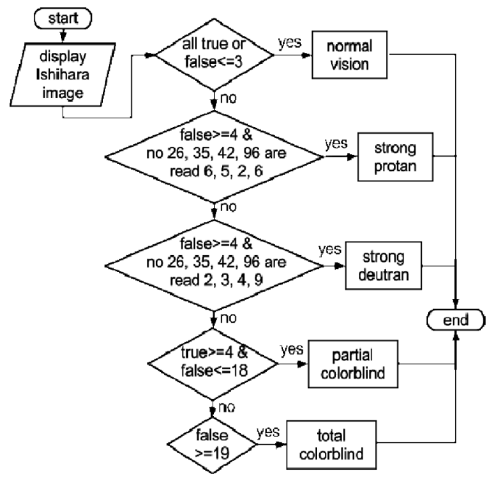

Fig 1: Flow diagram
CLASSIFICATION
Red-green color blindness: the most common color blindness caused by family and causes is damaged or reduced red con or green con pigment function. Red-green color blindness is divided into four categories. The red-green color blindness categories as Deuteranomaly, protanopia, protanomaly and deuteranopia.
Red green color blindness :Deuteranomaly : In this type of color blindness, The green color looks more red.
Protanomaly: In this type of color blindness, red looks more green in color.
Protanopia and Deuteranopia: In this type of color blindness makes you unable to distinguish between red and green color.
There are two types in blue-yellow color blindness: Tritanomaly & Tritanopia. In tritanomaly color blindness it is hard to tell the difference between blue-green, and yellow-red. In Tritanopia Color blindness it is hard to tell the difference between green-purple-red and yellow-pink. Individuals with full-partial blindness don't see tones, and their clearness of vision can likewise be impacted. There are two sorts of monochromacy- 1. Cone monochromacy 2. Rod Monochromacy Cone monochromacy: In this, a few of the three cone cell colors don't work. individuals with cone monochromacy experience issues recognizing color on the ground that the mind needs flags from various cones to see the shadings.
Rod Monochromacy: It is present from birth and does not contain any of the available pigment on cone cells. Individuals with pole monochromacy see the world dressed in dark, white and dim. individuals with bar monochromacy are photophobic and entirely awkward in brilliant conditions.
IMAGE SEGMENTATION
In computer vision image segmentation is the process of partitioning a digital image into multiple segments of pixel also known as superficial like played in a small bubble of ishihara plates.
The goal of image segmentation is to simplify and change the representation of an image into computer vision image segmentation is typically used to locate objects at boundaries in images in svg format full stop the image segmentation method is generally based on one of two fundamental properties of the intensity value of an image pixel similarity and discontinuity.
Result of image segmentation is a set of components that collectively cover the entire image of the group of contours extracted from the image. every pixel in discrete is comparable concerning some Trademark of processed property like tone, force or surface.

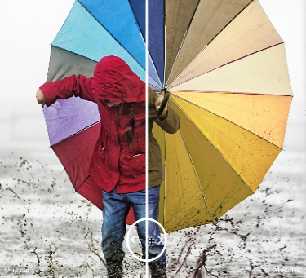 | 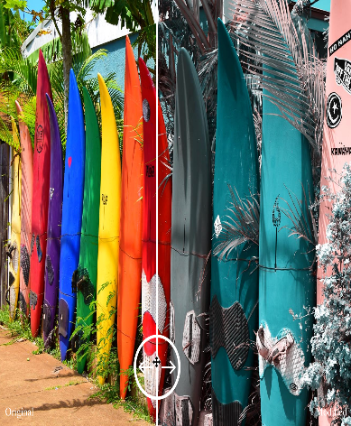 | 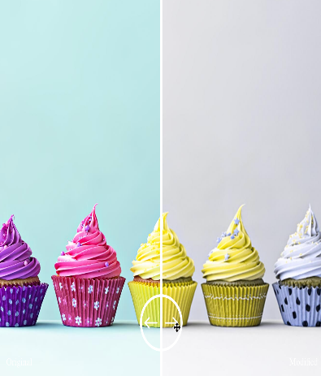
Deutan  A Deuton is a patient who has either deuteranopia or deuteranomaly. This color blindness or deficiency affects green cones. | Tritan  In tritan is a patient who will have either tritanomaly or tritanopia. This color blindness affects blue cone cells and it is very rare. | Protan  A proton is a patient who has either protanopia or protonomaly. This albinism or deficiency affects the red cones.

Table 1 : Image Segmentation Table

FEATURE EXTRACTION

In Ishihara blind test there are 38 plates, every plate has dots of different shapes and colors. All dots on plates are organized in specific patterns to form multiple numbers or figures that people with normal color blindness vision can see. Person with color deficiency will not see the numbers of figures on these colored plates. Some Ishihara plates are visible only for people who suffering from color vision deficiency, and invisible to those with normal color vision. The standard Ishihara test has 36 colored plates, but there is more Ishihara test with 10, 14, or 24 plate.

Sr. No | Plates | Plates | Description
1. | Demonstration plate | 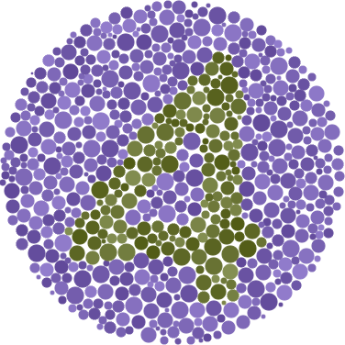 | The first plate in the Ishihara test is the demonstration plate is with the number "12" and can be "16". This demonstration plate is seen by people having a normal color vision or deficient color vision. These is used for demonstration purposes and it isn’t considered in creating a score for screening purposes.
2. | Transformation plates | 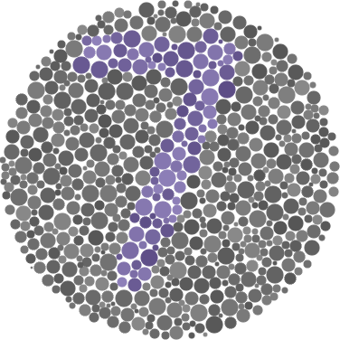 | People with normal color vision can differentiate multiple  figures or numbers from the people who suffering from color vision defects.
3. | Vanishing plates | 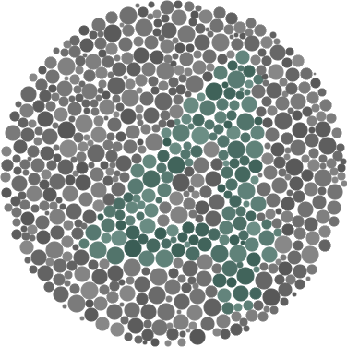 | Vanishing plates can seen by only people with normal color vision. i.e. Figures or numbers on the plates seen by color vision defective people.
4. | Hidden digit plates | 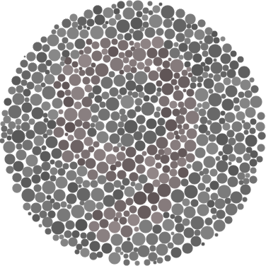 | Only color vision defects people can see the Figures and numbers on these plates.
5. | Diagnostic plates | 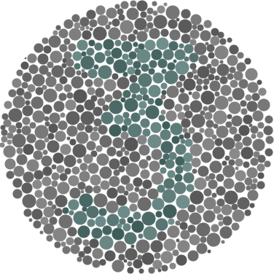 | Diagnostics plates help to find he type of color vision defect protanopia (red deficiency) or deuteranopia (green deficiency) and its severity.

Table 2 : Feature Extraction Table

CONCLUSION

Finally the color blind test may help in daily life like selecting cloth with perfect pattern of color it also allows people to grow in their color related professions such as graphic designing and working profile requiring various electrical wiring with lots of color depending on correct color perception. As we know we can overcome color blindness in our childhood so we made this test available for all people and recognise if they have color blindness or not without spending the money thank you.
REFERENCES
1] Zhiquan Wang, Huimin Liu, Yucong Pan, Christos Mousas ,” Color Blindness Bartender : An Embodied VR Game Experience” IEEE Conference on Virtual and 3D user Interface Abstract and Workswhops (VRW), 2020.
2] Charleston Attard, Frankie Inguanez, “ Chrovision and True colour: Applications for Colour Imparaed Persons” 2019 11th International Symposium on Image and Signal Processing and Analysis(ISPA).
3] Muhammad Waseem Iqbal; Syed Khuram Shahzad; Nadeem Ahmad.” Adaptive interface for color-blind people in mobile-phones”(ICACS) International Conference on Advancement in Computational science 2018.
4] A. Chaparro and M. Chaparro.,” Applications of color in design for color-deﬁcient users.” ergonomics in design, IEEE 25(1):23–30, 2017.

5] S. Di, J. Jin, G. Tang, X. Chen, and R. Du. The fabrication of a multi-spectral lens array and its application in assisting color blindness. International Journal of Optomechatronics, 10(1):14–23, 2016.

6] Latifah R. Menko, Richard Menko, “Color Blindness test Quantification using RGB primarycolor cluster” (ICITSI) Internal Conference on Tnformation Technology Systems and Innovation ,2016.

7] Kurnia Rahmadi, "Color Blind Level Determination Based on Image Ishihara HIS", Department of Electrical Engineering Faculty, University of Andalas, Padang, 2009.

8] Widianingsih, Ratri, et al, "Color Blind Test Application Method Based Ishihara Computer", Program of Computer Science, State University of Mulawarman 2010.

9] Rolly Yesputra, "Learn Visual Basic.NET with Visual Studio 2010", Royal shavings Press, Range, 2017.

10] Agusta, S., Noble, et al. 2012. Automatic Color Blind Test Instruments. Elite Electro Scientific Journal, Vol. 3 No. 1. University of Indonesia, Jakarta. Arikunto, Suharsimi. 2006. Research Practice Approach Procedures. Jakarta: Rineka Reserved.

11] M. Fareed, M. A. Anwar, and M. Afzal, “Prevalence and gene frequency of color vision impairments among children of six populations from north indian region,” Genes & Diseases, vol. 2, no. 2, pp. 211 – 218, 2015

