Security For Centralized Information, Mail & Food Service System

Prof. Nilesh Vani¹, Harish Koli², Shubham Gajeshwar², Vishakha Tawade², Harshada Patil²
- Assistant Professor, Computer Engineering Department,
GF’s Godavari College of Engineering, Jalgaon , India, 425003
- Student of Computer Engineering Department,
GF’s Godavari College of Engineering, Jalgaon , India, 425003
harishkoli370@gmail.com

Abstract:- website is mainly developed to satisfy the customers on their selection of the picnics. It is during summer weekend (Friday, Saturday and Sunday). Various types of food items are prepared and different types of Menus are made ready based on the special orders given by customers. Customer can order the picnic by registering in PRU and pay the amount by cheque or direct cash by filling the total form details. That request is send to the admin and if he accepts the request customer will get scheduled picnic information or confirmation of picnic to enjoy.
Keywords- Centralised Information System, Database, HTML,ORACLE,Apache..
- INTRODUCTION

Website is mainly developed to satisfy the customers on their selection of the picnics. It is during summer weekend (Friday, Saturday and Sunday). PRU caters six picnics of 5-50 people/participants each. Two staff members are needed for small picnics and based on the participant’s staff will be increased to serve the participants. Various types of food items are prepared and different types of Menus are made ready based on the special orders given by customers. Different types of food items are displayed with buffet lines and materials (plates, table coverings ,plastic utensils ,glasses ,napkins etc.,) are provided bases on the customer orders for any parties. Customer can order the picnic by registering in PRU and pay the amount by cheque or direct cash by filling the total form details. That request is send to the admin and if he accepts the request customer will get scheduled picnic information or confirmation of picnic to enjoy.[2]

- LITRATURE SERVEY
- The existing system is not providing secure registration and profile management of all the users properly.
- The manual system gives us very less security f or saving data and some data may be lost due to mismanagement.
- The system doesn’t provide any facility to maintain any mails options.
- The system doesn’t provide any functionality for online queries/reply.
- The system doesn’t provide different types of food items, menus and dishes.
- The system doesn’t provide food items based on customer orders.
- Only one or two staff members are assigned to maximum number of participants.
- There is no centralized database
- PROPOSED SYSTEM
The development of this new system contains the following activities, which try to automate the entire process keeping in the view of database integration approach.

- The proposed system is a web application.
- This proposed system provides secure registration and profile management of all the users properly.
- This system gives us security for saving data in centralized database.
- The system provides facility to maintain any mails options.
- The system provides functionality for online queries/reply.
- The system provides different types of food items, menus and dishes.
- The system provides food items based on customer orders.
- Staff members are assigned based on the number of participants.

- OBJECTIVES
- It is mainly developed to satisfy the customers on their selection of the picnics.
- There six picnic spots of 5-50 people or participants each.
- Two staff members are needed for small picnics and based on the participant’s staff will be increased.
- Various types of food items are prepared and different types of Menus are made ready based on the special orders given by customers.
- Increasing the efficiency of college record management.
- pay the amount by cheque or direct cash by filling the total form details.
- That request is send to the admin and if he accepts the request customer will get scheduled picnic information or confirmation of picnic

- REQUIRMENT ANALYSIS :-
5.1 FEASIBILITY REPORT
5.1.1 TECHNICAL FEASIBILITY:

Evaluating the technical feasibility is the trickiest part of a feasibility study. This is because, at this point in time, not too many detailed design of the system, making it difficult to access issues like performance, costs on (on account of the kind of technology to be deployed) etc. A number of issues have to be considered while doing a technical analysis

5.1.2 OPERATIONAL FEASIBILITY:

Proposed projects are beneficial only if they can be turned into information systems that will meet the organizations operating requirements. Simply stated, this test of feasibility asks if the system will work when it is developed and installed. Are there major barriers to Implementation? Here are questions that will help test the operational feasibility of a project:[4]

- Is there sufficient support for the project from management from users? If the current system is well liked and used to the extent that persons will not be able to see reasons for change, there may be resistance.
- Are the current business methods acceptable to the user? If they are not, Users may welcome a change that will bring about a more operational and useful systems.
- Have the user been involved in the planning and development of the project?
- Since the proposed system was to help reduce the hardships encountered. In the existing manual system, the new system was considered to be operational feasible.

5.1.3 ECONOMIC FEASIBILITY:

Economic feasibility attempts 2 weigh the costs of developing and implementing a new system, against the benefits that would accrue from having the new system in place. This feasibility study gives the top management the economic justification for the new system.

A simple economic analysis which gives the actual comparison of costs and benefits are much more meaningful in this case. In addition, this proves to be a useful point of reference to compare actual costs as the project progresses. There could be various types of intangible benefits on account of automation. These could include increased customer satisfaction, improvement in product quality better decision making timeliness of information, expediting activities, improved accuracy of operations, better documentation and record keeping, faster retrieval of information, better employee morale.

5.2 SOFTWARE REQUIRMENT
- Operating System : Windows XP/2003 or Linux
- User Interface : HTML, CSS
- Client-side Scripting : JavaScript
- Programming Language : Java, Servlets, jsp
- IDE/Workbench : My Eclipse 8.6
- Database : Oracle 10g
- Server Deployment : Tomcat 6.x
- Browser : IE, Mozilla, google Chrome…

5.3 Hardware Requirement
- Processor : core 2 duo
- Hard Disk : 80 GB(maximum)
- RAM : 1GB

- TECHNICAL OVERVIEW
6.1 JAVA SCRIPT
We used the browser i.e Chrome. JavaScript is considered to be one of the most powerful scripting languages in use today world. It is often used for the web development. JavaScript is used to make web pages more interactive and dynamic[1]. JavaScript is a light weight programming language and it is set in directly into the HTML code.
JavaScript is measured to be one of the most popular scripting languages of all the time. JavaScript by the definition, it is a Scripting Language of the World Wide Web. The main usage of JavaScript is to add various Web functionalities, Web form validations, browser detections, creation of cookies and so on. JavaScript is one of the most popular scripting languages and that is why it is supported by almost all web browsers available today like opera.

6.2 HTML

HTML is a hypertext markup language which is in reality a backbone of any website. Every website can’t be structured without the knowledge of html. If we make our web page only with the help of html, than we can’t add many of the useful features in a web page, for making a web page more effective we use various platforms such as CSS. So here we are using this language to make our web pages more successful as well as efficient. And to make our web pages dynamic we are using Java script[1].

6.3 Java:-
Java is a programmer’s language. Except for those constraints imposed by the Internet environment, Java gives the programmer, full control.[3]
6.4 Eclipse IDE
Eclipse is an open-source software framework written primarily in Java. In its default form it is an Integrated Development Environment (IDE) for Java developers, consisting of the Java Development Tools (JDT) and the Eclipse Compiler for Java (ECJ). Users can extend its capabilities by installing plug-ins written for the Eclipse software framework, such as development toolkits for other programming languages
, and can write and contribute their own plug-in modules. Language packs are available for over a dozen languages.

- ARCHITECTURE :-

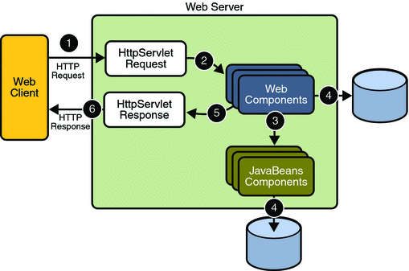

Fig.7.1: Architecture

- SNAPSHOT
  - Login page:
The user details should be verified against the details in the user tables and if it is valid user, they should be entered into the system.

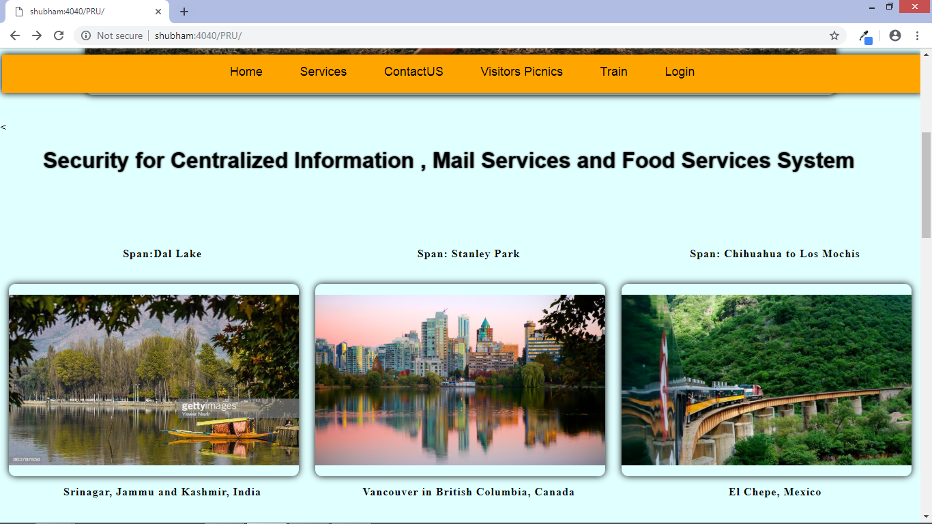
Fig-8.1: Login page

  - Admin Module:
Here admin can register new Employees and store their details in database.

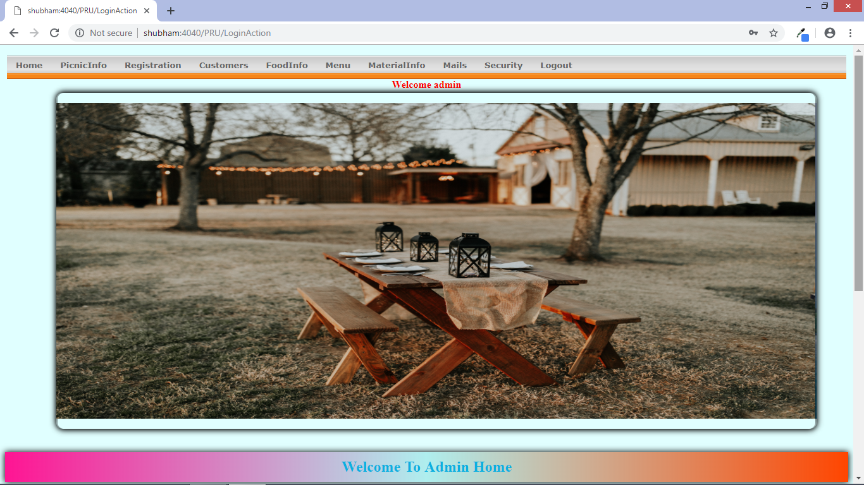
Fig-8.2: Admin model

8.3 Staff model:
In this Module the Staff checks for the picnics for which they are assigned and they will do the duties what they are assigned like cleaning, displaying the food items, menus, dishes and so on.

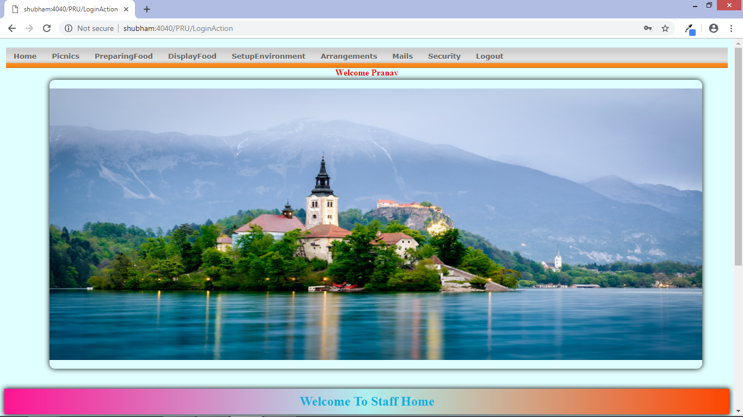
Fig 8.3 Staff model

  - Employee Model:
In this module Employee can add, update, delete, and view the staff members. He has the facility to view customers and picnics. He can add food items, menus, dishes, etc., He can view the customers’ requests and send the confirmation for them about the picnics.

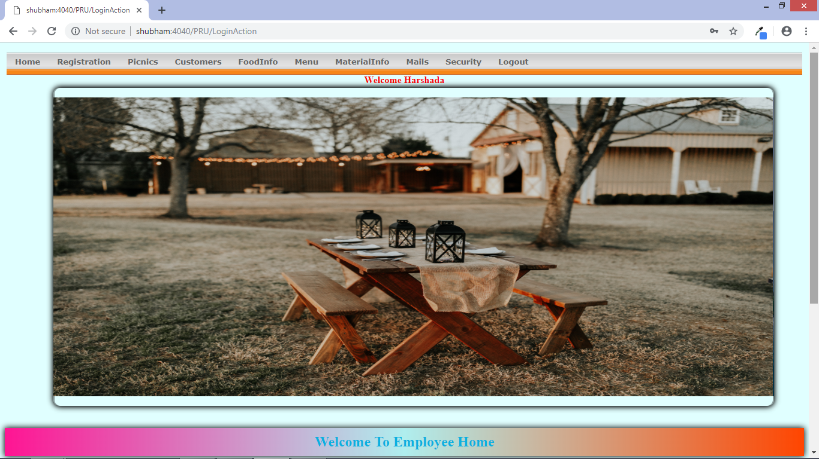
Fig 8.4 Employee model

8.5 Customer Module
In this Module the Customer will register and login the website and checks what are the picnics spots are arranged by the website people, based on that they will order for the picnic by viewing what are the activities kept by them. They can select different types of menus, dishes, food items, materials provided by the website.

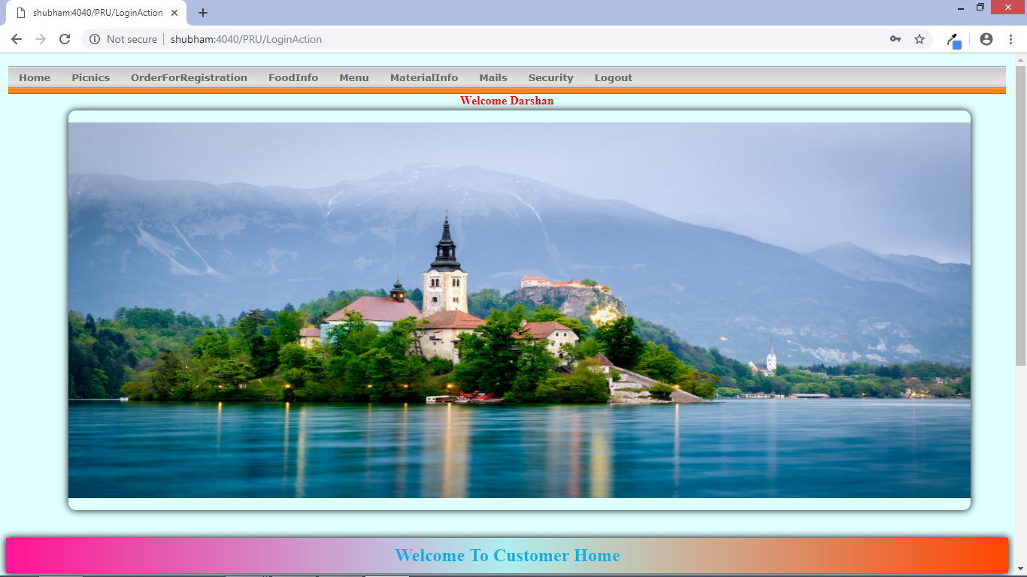
Fig 8.5 Customer model

- ADVANTAGES
- Estimates(i.e. budget, schedule etc .) become more relistic as work progresses, because important issues discoved earlier.
- It is more able to cope with the changes that are software development generally entails.
- Software engineers can get their hands in and start woring on the core of a project earlier.

- CONCLUSION
The “Security for Centralized Information , Mail Services and Food Services System” was successfully designed and is tested for accuracy and quality.
During this project we have accomplished all the objectives and this project meets the needs of the organization. The developed will be used in searching, retrieving and generating information for the concerned requests.

REFERENCES

[1] International Journal of Advanced Research in Computer and Communication Engineering Vol. 2, Issue 6, June 2013.

[2] Volume 5, Issue 2, February (2014), pp. 09-18 © IAEME: www.iaeme.com/ijcet.asp Journal Impact Factor (2014): 4.4012 (Calculated by GISI) www.jifactor.com
[3] Java Complete Reference by Herbert Shield
[4] Database Programming with JDBC and Java by George Reese
[5]International Conference on Economic Management and Trade Cooperation (EMTC 2014) © 2014. The authors - Published by Atlantis Press
[6] Sauer, C (1993) Why Information Systems Fail: A Case Study Approach Alfred Waller Ltd, Henley-on-Thames, Oxfordshire.

