Prototype Design of Static VAR Compensator Using Thyristorzed Controlled Reactor

Rani Gaikwad¹, D.R.Tutakne², Yuvraj Chavan³, Kalyani Sawarkar⁴
¹M.Tech Student, Wainganga College of Engineering & Management, Nagpur, Maharashtra, India, 441108
² Professor, Wainganga College of Engineering & Management, Nagpur, Maharashtra, India, 441108
^{3,4}Assistant Professor, Wainganga College of Engineering & Management, Nagpur, Maharashtra, India, 441108
Received on: xxxx,20xx, Revised on: xxxx,20xx, Published on: xxxx,20xx

Abstract –Electricity Comes In Our Home Is Not Stable In Nature. with Increase In Electricity Demand, The Voltage Stability Of Buses Is Affected, Requires Fast Reactive Power Compensation. with The De-regulated Environment, which Excess The Amount Of Line Flow. There Are Many Fluctuation, Raise And Spikes In This Current This Unstable Current May Damage Instruments. In This Condition effect Of Static VAR Compensator (SVC) Has Been Investigated Under Dynamic Situation To Maintain Voltage Stability. SVC Is An Automated Impedance Matching Device, Designed To Bring The System closer To Unity Power Factor. The Main Purpose of This Paper Is To Get Static Voltage Compensation Under Flexible Alternating Current Transmission system In Shunt. This Helps In Lowering The Voltage At The Load end That May Draw Leading Current either during charging the Transmission Line Or During Low Loads.
Keywords- SVC, electricity, transmission, voltage
INTRODUCTION
In electrical engineering, the Ferranti effect is an increase in voltage occurring at the receiving end of a long transmission line, above the voltage at the sending end. This occurs when the line is energized, but there is a very light load or the load is disconnected. The capacitive line charging current produces a voltage drop across the line inductance that is in-phase with the sending end voltage considering the line resistance as negligible[1]. Therefore both line inductance and capacitive are responsible for this phenomenon. The development of any country depend to a large extent on availability and usage of electricity. Conservation of electricity has now become a vital element of economic growth giving benefits to state’s treasury and its conservation is more essential due to the concern for fast depletion of non-renewable source of energy in the country. The main aim of this paper is to construct a control system that controls power loss by varying reactive power by firing angle method.
- SVC is a combination of controllable shunt reactor and a shunt capacitor. The controlled shunt reactor is series combination of reactor and anti parallel connected pair of thyristor which is known as TCR (Thyristor Control Reactor)[2].
- The thyristor-controlled reactor (TCR) or thyristor switched reactor (TSR) for absorbing reactive power and thyristor-switched capacitor (TCS) for supplying the reactive power. Due to its Fast acting and continuous compensation, SVC is used in transmission line to enhance power transfer capability[3].

METHOLOGY
Static VAR compensator is a set of electrical devices for providing for providing fast-acting on networks. Typically, an SVC comprises one or more banks of fixed or switched shunt capacitors or reactor ,of which at least one bank is switched by thyristors[4]. Elements which may be used to make an SVC typically include:
- Thyristor Controlled Reactor (TCR), where the reactor may be air or iron-cored.
- Thyristorised Switched Capacitor (TSC).
- Mechanically Switched Capacitor or reactor (Switched by a circuit breaker).
By means of phase angle modulation switched by the thyristors, the reactor may be variably switched into the circuit and so provide a continuously variable VAR injection (or absorption) to the electrical network. Controllable range of the TCR firing angle, extends from 90 degree to 180 degree. A firing angle of 90 degree results in full thyristor conduction with a continuous sinusoidal current flow in the TCR. The current reduces to zero for a firing angle of 180 degree. thyristor firing at angles below 90 degree introduces dc components in the current, disturbing the symmetrical operation of the anti parallel valve branches.

Prototype Design of SVC Using Thyristorised Controlled Reactor
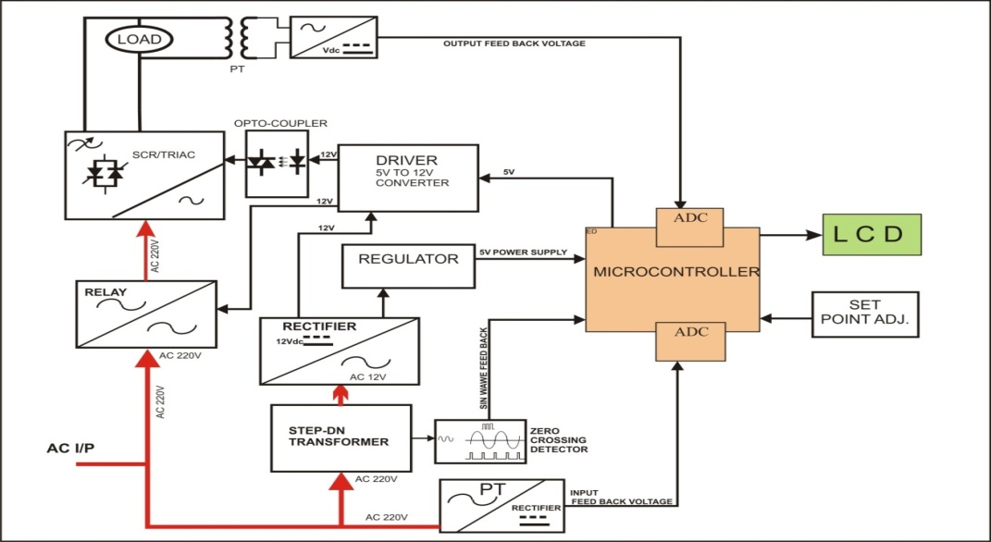
Power Manager works on the principle of phase angle controlling method. Power savers work on straightening this unstable electric current to provide a smooth and constant output. The fluctuation in voltage is unpredictable and cannot be controlled. However, the power severs utilize current fluctuation to provide a usable power by acting like a filter and allowing only smooth and constant current to pass through the circuit. Power savers use capacitors for this purpose .When there is a surge of current in the circuit[5].
In this paper I explained that when we reduce down the voltage across the load upto a certain limit until current starts increases. As most of the devices can work on 190v AC, When model gradually decreases the voltage and measures the current, whenever it observes that the current increases, the power electronics circuit will stop decreasing the voltage. Use of power electronics reduces the mechanical arching and fast reaction time.

Block Diagram of Prototype of SVC
In this model use a power electronics devices, like TRIAC to control the power. Use of power electronics reduces the mechanical arching and fast reaction time[8]. In addition to this we also make a provision for under/over voltage protection, which doesn’t have any existing energy meters.
The main aim of this project is to control and keep balance of the voltage across the load. Initially controller checks the incoming voltage coming from line with the help of ADC ( Analog to digital converter ) present inside the microcontroller. Aim is to control a positive as well as negative. Half cycle of incoming AC for that a firing angle control method is used. For controlling a firing angle of any AC voltage it is necessary to monitor every positive/negative half cycle, hence a Sine Wave Cycle Monitor ( Zero Crossing Detector ) block is used which informs a controller about start point of every cycle[7]. Once controller knows the voltage across the load and signals from sine wave cycle monitor, controller calculate the firing angle and gives firing pulse to the AC to AC converter in which a static switch formed by a TRIAC is used.
Static switch can be operated on high voltage and high frequency as compared to the mechanical switches like relay. The output of AC to AC converter is further give to reactor which is nothing but a type of single core step-up transformer. ( 220V to 300V transformer ), which gives a 220V output at 140 VAC input. The output of 220V is further used by various loads. The voltage across load is measured by the controller with the help of PT[6]. Potential transformer is used to step down the voltage across the load to be measured and rectified to DC, because microcontroller can read a voltage in case of very high voltage and low voltage which is beyond controllable limits.

Fig.1 Block diagram of Power Optimization using SVC to reduce energy consumption.

The relay used in our project is of 12V and controller can give maximum of 5V, hence it is necessary to amplify the 5V, hence it is necessary to amplify the 5V to 12V for which a driver circuit is used. Microcontroller requires a 5V DC to work, and same will be generated with the help of power supply which comprises of a step down transformer, rectifier, filter and regulator. Transformer step down the 220V AC to 12V AC, rectifier and filter convert this 12V AC to 12 V DC, and regulator converts a 12V DC to a constant of 5V DC.

Circuit diagram of svc prototype
The 220V input supply is given to triac through relay which is operated on 12 V given to 5 V DC. The load is connected to the triac output terminal. The triac output is measured through P.T. The micro-controller requires 5V DC, hence input 230V AC is step down to 12 V ac & 12 V ac converted to DC with the help of full wave rectifier. Capacitor is used to get pure DC output.
The Micro- Controller requires constant 5V DC. Hence this unregulated supply given to regulator IC 7805 is constant. This 5V DC is given to micro-controller, LCD, This 5V DC is given to micro-controller, LCD, Opto-coupler, Driver & Zero Crossing Detector. The IC 7805 is loaded and output of IC is reduced to 4V then Micro-Controller will reset or restart. So that in such condition the current will not work properly.
When capacitor is connected, it stores the charge, available in its potential. When output of IC is less than 5V then capacitor is electrolytic capacitor gives fractional output, i.e. 200 to 300 nF. The capacitor is electrolytic capacitor having polarity. Two suppressor capacitors (C₃ & C₄) are connected to crystal oscillator which maintain 50% duty cycle of crystal oscillator. It means ON time is equal to OFF time exactly 50% symmetrical output of frequency. The crystal oscillator is use to provide clock frequency to the microcontroller.
The microcontroller controls every positive and negative cycle of sine wave, hence zero crossing detector is used in our project. The zero crossing detectors consist of two NPN transistors and three diodes. The snubber circuit is used to suppress the rapid rise in voltage across the TRIAC.
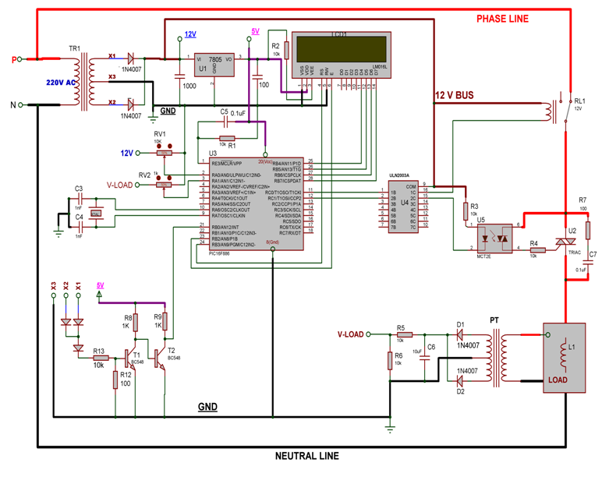

Fig.2 Circuit diagram of svc prototype design

LCD PROGRAMMING

#Include<16F886.h>
LCD_DTPin=PORTB.4
LCD_ENPin=PORTB.3
LCD_RSPin=PORTB.2
LCD_Interface=4
LCD_Lines=2
LCD_Types=Alphanumeric
DelayMS 100
Cls
Constant TR=PORTC.3
Constant RLY=PORTC.2
Ton=800
Print $fe,$d0,”REDUCE POWER”
Print $fe,$d8,”LOAD CONTROLL”
DelayMS 2000
Output TR:Output RLY
Low TR:Low RLY
MAIN()
High RLY
GoTo Main
Main:
On_Hardware_Interrupt Call Thy_Trigg
While 1 =1
OV=Analog_read 1 : OV=OV/64
DelayMS 50
i=Analog_read 2:i=i/64
iaf=(i*5)/1023
iaf=iaf/2.3
Print $fe,$d0,”O:”,OV,”v,I:”,2iaf,”A”
Print $fe,$d8,$0”:”,ton,” ”
P=iaf*OV
Print $fe,$d8,”p:”,P,”W”, ton,” “
If S1=1Then
Print $fe,$d8,”p:”,P,”W+”
If ton<9000 Then//if firing angle is <90 degree
Ton=ton+100
END If
END If
If S2=1 Then
Print $fe,$d8,”P:”,P,”W-”
If ton>800 Then// if firing angle is >8 degree
ton=ton-100
END If
END If
DelayMS 100
While_end
GoTo Main

CONCLUSION
The concept can be applied to places where proper measure and preventive steps cannot be easily taken, especially for villages and interiors areas. The present systems has to undergo lots of modification and sufficient R & D has to be done to make the system more compact, handy as economical. With implementation of this kind of system in the real time, the need for regular vigilance can be avoided and power can be supplied at the economical rates, hereby improving the economy of country.

REFERENCES
- Ilon, B. E. (1975). Wheels for a Course Stable Selfpropelling Vehicle Movable in any Desired Direction on the Ground or Some Other Base. U.S. Patent. U.S.A.
- Hyin Sang Choand hong Soon Chang Energy Saving Management Center Korea Polytechnic University Siheung-si,Gyeonggi,Korea
- Corinna Fischer Received: 3 December 2007 / Accepted: 28 March / Published online: 6 May 2008 Springer Science + Business Media B.V. 2008

- RamRajamonyPower Computing Reacherch Center Rutgers University “Power and Energy Management for Server Systems Ricardo Bianchiniy and Report DCS-TR-528, June2003”.
- Hand Talk Gloves for Gesture Recognising” for International Journal of Engineering Sciences & Management Research (IJESMR), ISSN: 2349-6193,Vol. 2, Issue. 5, pp. 9-14, May 2015.
- N. Rangnathan, A.K. Murugavel, “A Microeconomic Model For Simultaneous Gate Sizing And Voltage Scaling For Power Optimization 13-Oct-2003”.
- Kalyani U. Chafle , B. M. Faruk , R. S. Shrivas, N.S.Sawarkar, International journal paper on “Coin based mobile charger on solar energy” for International Journal of Research- Granthaalayah (IJEG), ISSN- 2350-0530(O) ISSN- 2394-3629(P), (Vol.3, Issue.1, January 2015), page no. 13-18.
- Kalyani U. Chafle, Manoj K. Demde, International journal paper on “Design of Vision based Lane Departure Warning System”, for International Journal of Emerging Technologies and Innovative Research(JETIR), ISSN:2349-5162, Vol.5, Issue.5, pp.80-83, April2018.

