Review on the accuracy of computer aided design of customizes dental implant.
Piyush Mohanrao Pawar¹, Dr. S. B. Jaju², Dr. Nakul H. Rathi³
¹Student, M. Tech, CAD/CAM, Department of Mechanical Engineering, GHRCE, Nagpur, India
²Professor, Department of Mechanical Engineering, GHRCE, Nagpur, India
³Director, Advanced Dental Hospital, Nagpur, India

---------------------------------------------------------------------***---------------------------------------------------------------------
Abstract –
Background: The historical backdrop of dental inserts can be gone back to 600 AD in Mayan human advancement. Dentistry science took tremendous jump when Swedish specialist, Bran marks; presented strung titanium embeds in 1952. Presently a-days zirconia is utilized as biomaterial for root undifferentiated from zirconia dental inserts. This study implies that fundamentally changed zirconia dental inserts is a superior option for customary quick embeds.
Methodology: The Google Scholar, Research gate, Science Direct, Pub Med database was looked electronically with the utilization of watchwords like titanium versus zirconia, zirconia dental inserts, surface geographies of dental inserts and root similar to zirconia dental inserts and zirconia inserts. Accessible articles were gotten and at whatever point conceivable inaccessible articles were asked for from the comparing authors. After examining the exploration papers their references were additionally looked and asked.

Key Words: Titanium vs. Zirconia, Dental Implants, Surface Topographies, Root Analogous Zirconia Dental Implants, Macro Retentions.

1.INTRODUCTION

The historical backdrop of dental inserts can be gone back to 600 AD in Mayan human progress. Archeologists additionally found the foundations of dentistry in Greek and Egyptian history. The diverse archeological studies demonstrated that the dental materials incorporate cut stones, pieces of ocean shell, elephant tusk, wood and different metals also.[1]

Maggito [2] embedded gold roots in tooth attachments around mid nineteenth century (1809). Dentistry science took tremendous jump when Bran mark, presented strung titanium embeds in 1969. From that point forward titanium has been the most favored dental material for more than 4 decades. Zirconia started its part as biomaterial in 1969 when Hekmer &Driskell [3] portrayed biomedical utilizations of zirconia. Additionally the materials, for example, Tetragonal Zirconia Polymers (TZP or Y-TZP), poly-crystalline alumina, and glass earth unaware production denoted their infant ventures in dentistry around last one and half decade [4], Last decade likewise saw the presentation of more up to date preparing advancements like CAD, CAM, and Rapid Prototyping and so forth. Presently a day’s zirconia is utilized as biomaterial of furthest decision in the field of prompt implantation i.e. - for root similar to zirconia dental inserts. Scientists and practioners have demonstrated that altogether changed root indistinguishable zirconia dental inserts is a better option for routine prompt inserts, i.e.- root similar to titanium inserts. This survey is an endeavor to toss some more light upon
1) Titanium versus zirconia dental inserts,
2) Zirconia as a biomaterial,
3) Surface geologies of inserts and
4) Clinical achievement of root practically equivalent to zirconia dental inserts.

1.1 Material and Method
The Google Scholar, Research gate, Science Direct, Pub Med database was looked electronically with the utilization of catchphrases like titanium versus zirconia, zirconia dental inserts, surface geographies of dental inserts and root closely resembling zirconia dental inserts and zirconia inserts. Accessible articles were gotten and at whatever point conceivable inaccessible articles were asked for from the comparing writers. In the wake of examining the exploration papers their references were likewise looked and asked.

The articles found were incorporated into study on the premise of taking after criteria:
1) Studies identified with examination of titanium and zirconia as dental embed materials,
2) Studies and clinical trials edifying points of interest of zirconia as biomaterial,
3) Studies concentrated on dental embed surface harshness/geographies and full scale/small scale maintenance designs,
4) Clinical trials of root comparable to zirconia dental inserts set into people.
Results
The predefined seek finished with around 260 articles. The greater part of which were survey articles, clinical trials, in vitro and in vivo contemplates. On watchful audit, 23 of which were found to exist in the criteria indicated. Out of which 5 were identified with titanium versus zirconia dental inserts, 4 underscored zirconia as a biomaterial, 9 articles exhibited distinctive surface geographies of dental inserts, 5 were clinical studies edifying clinical accomplishment of root practically equivalent to zirconia dental inserts.
Hans J Wenz et al[5] assessed osseointegration and clinical achievement of zirconia inserts. On associate survey of 96 articles identified with clinical and creature considers, he found that osseointegration of Y-TZP (zirconia) inserts is as high as that of titanium inserts. Additionally surface alterations can prompt improved bone recuperating. It was reasoned that zirconia has capacity to go about as swap for titanium inserts.
Rehman B Osman et al [6] concentrated on different dental embed materials. They surveyed different properties of embed materials and issues connected with them. They watched that titanium comes up short under high cyclic stacking and then again comparative or shockingly better bone development of zirconia surface contrasted with titanium surface. So conclusion was, manufacture of dental inserts can be represented by zirconia inserts.
Rahul Patil [7] in 2015 inferred that in spite of the fact that titanium has achievement and survival rate, its destructiveness and individual sensitivities to it makes it less well known. Then again zirconia achievement rate and feel demonstrates zirconia, a suitable option.
Gabrial Marques et al [8] embedded titanium and zirconia inserts into right and left tibia of 15 rabbits for up to 60 days. They found that, up to 30 days bone mending was same however following 45 days early bone development happens. So they inferred that zirconia and titanium has practically identical bone mending.
In an in vivo correlation of osseointegration of zirconia and titanium inserts, Rita Depprich et al [9] presented an aggregate of 48 embeds in 12 minipigs. Out of 48, 24 were screw sort zirconia inserts and 24 were immaculate titanium inserts. Despite the fact that BIC was higher for titanium inserts, it was closed from the histological results that adjusted zirconia Inserts has osseointegration similar with titanium-inserts. Favorable circumstances of zirconia as biomaterial
C Piconi [3] et al in 1997 checked on the different properties of zirconia in view of the articles distributed. They examined micro structural properties, mechanical properties, wear, natural security and so on. Upon study among zirconia pottery Tetragonal Zirconia Ceramics (TZPs) can be favored as biomaterial of decision for dental inserts.
Zeynep Ozkurt et al [10] in 2011 took a shot at zirconia dental inserts (TZP). The investigation of articles identified with Bone to Implant Contact (BIC), surface examination, evacuation torque consider (RTQ), mechanical quality and push examination reasoned that osseointegration of zirconia dental inserts might be tantamount with that of titanium inserts. They likewise have low, very much conveyed and comparative push dispersion contrasted and titanium inserts.
Xavi Oliva et al [11] in 2013 amid histomorphometric concentrate on in sheep embedded eight zirconia inserts (Y-TZP) into hip of a grown-up sheep. Following 2 months BIC was seen to be 75.6 to 79.9%. It was finished up on from the outcomes that zirconia has amazing biocompatibility and osseointegration. Additionally RTQ test exhibited inflexible obsession amongst embed and bone.
Scarano et al [12] probed rabbits so as to study bone reaction to zirconia clay implants(Y-TZP). The test included 5 rabbits each with 4 inserts, 2 in left tibia and 2 in right tibia. The BIC was observed to be 68.4% ± 2.4%. No holes, sinewy tissue and invade were seen at bone embed contact. Surface unpleasantness/geologies and large scale/miniaturized scale maintenance.
Isabel de Monserrat et al [13] considered the embed surface harshness and distinctive geographies. They investigated around 30 articles comprising of in vivo considers in human, in vivo examines in creatures and in vitro concentrates on. The normal achievement rate watched for unpleasant surfaced inserts was 93.48% and 83.42% for inserts with other than harsh surfaces.
Rama Krishna Alla et al [1] in their article introduced the surface harshness attributes and their impact on osseointegration of dental inserts. Their study demonstrated that reaction of the tissues to the embed is generally controlled by the nature and surface of the surface of the embed. Contrasted with smooth surfaces, finished inserts surfaces display more surface range for coordinating with bone by means of osseointegration process.
Additionally different in vivo thinks about by Buser D et al[14], Gotfredson K et al[15], Puleo D An et al[16] showed that upgraded surface range of the embed enhances BIC after the embed arrangement.
Athur Belem Novaes Jr. et al [17] in 2010 looked into the quantitative and subjective results on the investigation of bone-embed interface utilizing miniaturized scale and nano surface geographies. They presumed that the embed surfaces with miniaturized scale and sub smaller scale (nano) geography present advantages to the procedure of communication between bone cells and embed surfaces, quickening and expanding the nature of BIC.
Rafael Arcesio Delgade-Ruiz et al [18] inside their study presumed that expansion of microgrooves on the surface of zirconia dental inserts upgrades essential and auxiliary embed steadiness, advances bone tissue in growth and jam Cristal bone level.
Radhika B Parekh et al [19] in their study, on associate survey, expressed that surface organization, surface geography, surface unpleasantness and surface vitality influences the mechanical solidness of inserts and osseointegration.
Kishorkumar Khandare et al[20]in 2013 investigated the diverse small scale maintenance designs for root similar to zirconia dental inserts. They found the stretch qualities for level rectangular, vertical rectangular, even oval, vertical oval molded miniaturized scale maintenances in canine furthermore premolar teeth. On the premise of examination performed they presumed that the stretch conveyance in canine teeth is least for vertical oval maintenances and for premolar vertical rectangular maintenances produces least push. Root undifferentiated from zirconia dental inserts
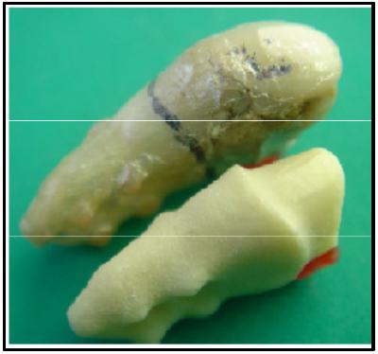
In 2008 W Pirker et al[21] initially endeavored to utilize pull similar to zirconia inserts for tooth substitution. They supplanted the primary maxilliary right premolar of a 63 year old patient with a prompt, non-submerged, root closely resembling zirconia embed. This study exhibited that before root comparable to titanium inserts, zirconia inserts yields amazing results.

FIGURE 1 – RIGHT PREMOLAR TEETH
A. Kocher et al [22] contemplated the conduct of root undifferentiated from zirconia embed with two unique surfaces. After extraction the root was laser filtered and one-piece root simple zirconia dental inserts with maybe a couple distinctive surfaces were made. On the clinical investigation of the inserts they found that inserts with maintenances has higher survival rate than roughened inserts.
W. Priker et al[23]described the system for prompt, really practically equivalent to, zirconia embed put into right parallel maxilliary incisor. The surface was roughened by sandblast and large scale maintenances were given on interdentally spaces, and was set into attachment, 7 days after extraction. The adjustments showed essential dependability and magnificent osseointegration. 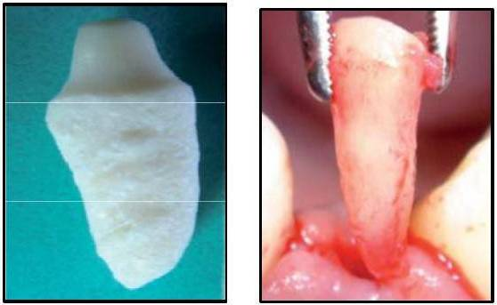
FIGURE 2 – RIGHT INCISOR TEETH

W. Priker et al [24] in 2009 adjusted the extricated base of right maxilliary molar tooth of a female patient by utilization of small scale and full scale maintenances. The conduct of the same was studied more than 2 years after arrangement in the tooth attachment. This examination was first proof of effective utilization of root comparable to zirconia inserts for a three established tooth. 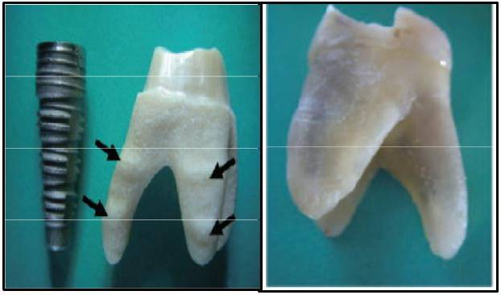
FIGURE 3 – RIGHT MAXILLIARY MOLAR TEETH
D. Wiedemann et al [25] investigated the utilization pull undifferentiated from zirconia inserts for first mandibular left molar teeth. The tooth was extricated from a fifty year old female patient and a root undifferentiated from zirconia embed with small scale maintenances was set into the attachment. On two year follow up creators presumed that root comparable to zirconia can be utilized for molar teeth substitution. 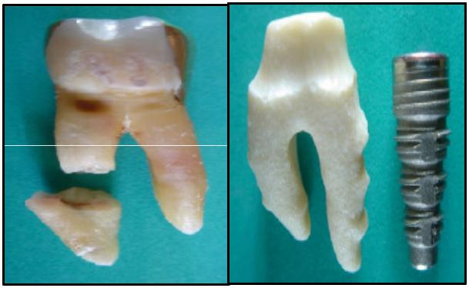
FIGURE 4 – LEFT MOLAR TEETH
Conclusion:
Based on the review it are often over that
1. Tetragonal Polycrystals (TZP) are higher various for gold normal atomic number 22 implants. They supply higher aesthetic results and safety.
2. Among oxide ceramics polygonal shape oxide Poly-crystals tried higher as a biomaterial. The BIC (bone-implant contact) values are abundantly like that of atomic number 22 implants.
3. Surface roughness should be provided so as to extend implant success rate newer macro retention patterns will enhance BIC and stress distribution.
4. Root analogous oxide is a wonderful choice for replacement of lost teeth with virtually 100% success rate.
This reveals that any analysis work have to be compelled to be done on the macro/micro retention patterns of root analogous oxide dental implants. Analysis and clinical trials has got to be tired order to extend the distribution. Potency of the implants and to decrease stress distribution.
References
1] Rama Krishna Alla, Kishore Ginjupalli, Nagaraja Upadhya, Mohammed Shammas, Rama Krishna Ravi, Ravichandra Sekhar, “Surface Roughness of Implants: A Review”, Trends Biomater. Artif. Organs, 25(3), 112-118, 2011.
2 ]Kenneth J. Anusavice, Dental Implants in Philips, Science of Dental Materials, 11edition, Elsevier, 759-781, 2006.
3 ]C Piconi, G. Maccauro, Review: Zirconia as a ceramic biomaterial, Biomaterials. 20, 1-25, 1999
4] Takashi Miyazaki, Takashi Nakamura, Hideo Matsumura, Seiji Ban, Taira Kobayashi, Review: Current Status of Zirconia Restoration, Journal of Prosthodontic Research, 57, 236–261, 2013.
5] Hans J. Wenz, Johannes Bartsch, Stefan Wolfart, Matthias Kern, “Osseointegration and Clinical Success of Zirconia Dental Implants: A Systematic Review”, Int J Prosthodon, 21:27–36, Vol 1, 2008
6 ]Reham B. Osman, Michael V. Swain, “A critical review of dental implant materials with an emphasis on titanium vs zirconia”, Material, 8, 932-958, 2015.
7 ]Rahul Patil, “Zirconia versus Titanium Dental Implants: A Systematic Review”, Journal of Dental Implants, Vol 5, Issue 1, Jan-Jun 2015.
8 ]Gabriel Marques, Luis Eduardo Marques Padovn, Mariza Akemi Matsumoto, Paulo Domingos Ribeiro Júnior, Elisa Mattias Sartori, “Bone healing in titanium and zirconia implants surface: a pilot study on the rabbit tibia”, RSBO ; 10(2), 110-5, 2013
9 ]Rita Depprich, Holger Zipprich, Michelle Ommerborn, Christian Naujoks, Hans-Peter Wiesmann, Sirichai Kiattavorncharoen. Hans-Christoph Lauer, Uirich Meyer, Norbert R Kubler, Jorg Handschel, Osseointegration of zirconia implants compared with titanium: an in vivo study, Head & Face Medicine, 4:30, 2008
10] Zeynep Ozkurt, Ender Kazazoglu, Zirconia Dental Implants: A Literature Review, Journal of Oral Implantology, Vol XXXVII, No three, 2011
11] Xavi Olivia, Josep Olivia, Josep D Olivia, Hari S Prasad, Michel D Rohrer, Osseointegration of Zirconia (Y-TZP) Dental Implants: A histologic, histomorphometric and removal torque study in the hip of sheep, International Journal of Oral Implantology and Clinical Research, 4(2), 55-62, May-August 2013
12] Scarano A, Manlio Quaranta, Adriano Piattelli, bone response to zirconia ceramic implants: an experimental study in rabbits, Journal of Oral Implantology, Vol. XXIX, No. One, 2003.
13] Isabel de Monserrat, Osorio Bernal, Ito Risa, Katagi Hiroki, Tsuboi Ken-Ichiro, Yamada Naoko, Tanabe Toshi-Ichiro, Nagahara Kuniteru, Mori Masahiko, “Dental Implant Surface Roughness and Topography : A Review of Literature”, J. Gifu. Dent. Soc, 35(3), 89 – 95, Feb. 2009.
14] Buser D, Schenk RK, Steinemann S, Fiorellini JP, Fox CH, Stich S, –Influence of surface characteristics on bone integration of titanium implants : A histomorphometric study on miniature pigs”, Journal of Biomedical Materials Research, 25, 889-902, 1991.
15 Gotfredsen K, Wennerberg A, Johansson CB, Skovgaard LT, Hjorting-Hansen, E, “Anchorage of TiO2-blasted, HA coated and machined implants : An Experimental study in rabbits”, Journal of Biomedical Materials Research, 29, 1223–1231, 1995.
16 Puleo D.A., A. Nanci, “Understanding and controlling the bone–implant interface”, Biomaterials, 20, 2311– 2321, 1999.
17] Arthur Belem Novaes Jr., Sergio Luis Scombatti de Souza, Raquel Rezende Martins de Barros, Karina Kimiko Yamashina Pereira, Giovanna Iezzi, Adriano Piattelli, “Influence of Implant Surfaces on Osseointegration”, Braz Den0t J, 21(6), 471-481, 2010.
18] Rafael Arcesio Delgado-Ruiz, Aleksa Markovi, Jose Luis Calvo-Guirado, Zoran Lazi, Adriano Piattellis, Daniele Boticell, Jose Eduardo Mate-Sanchez, Bruno Negri, Maria Piedad Ramirez-Fernandez, Tijana Misi, “Implant stability and marginal bone level of micro grooved zirconia dental implants : A 3-month experimental study on dogs”, Vojnosanitetski Pregled, 71(5), 451–461, 2014.
19] Radhika B Parekh, Omkar Shetty, Rubina Tabassum, Surface Modifications for Endosseous Dental Implants, International Journal of Oral Implantology & Clinical Research, 3(3), 116-121, 2012.
20] Kishorkumar K. Khandare, Dr. S. B. Jaju, Dr. P. G. Patil, “FEM Analysis for Stress Distribution of Root Analogue Zirconia Dental Implant: A Review”, International Journal of Innovative Research in Science, Engineering and Technology, Vol. 2, Issue 6, June 2013.
21] W. Pirker, A. Kocher, “Immediate, Non-submerged, Root-analogue Zirconia Implant in Single Tooth Replacement”, International Journal of Oral Maxillofacial Surgery, 37, 293–295, 2008.
22 ]A. Kocher, W. Pirker, “Immediate, Non-submerged, Root-analogue Zirconia Implants placed into Single-rooted Extraction Sockets: 2-year follow-up of a clinical study”, International Journal of Oral Maxilloacial Surgery, 38, 1127–1132, 2009.
23 ]W. Pirker, A. Kocher, “True Anatomic Immediate Dental Implant Method”, International Magazine of Oral Implantology, Vol 10, Issue 4, 2009.
24 ]W. Pirker & A. Kocher, “True Anatomical Zirconia Implants for Molar Replacement: A Case Report from an ongoing clinical study with a 2-year follow-up”, Oral Surgery 2, 144–148, 2009.
25 ]D. Wiedemann, W. Priker, A. Liuader, A. Kocher, “Immediate, single stage, truly anatomic zirconia implant in lower molar replacement: A case report with 2.5 years follow-up”, International Journal of Oral Maxillofacial Surgery, 40(2), 212-216, Feb 2012.

