Underwater Image Processing

Mohammed Aquib, Naresh Shahare, Niketan Gaikwad, Varsha Khandelwal

Prof. Rahul Naitam
Wainganga College of Engineering and Management, Nagpur, Maharashtra, India (Pin:-441108)

Email:- niketanvg@gmail.com

Received on: xxxx,20xx, Revised on: xxxx,20xx, Published on: xxxx,20xx

ABSTRACT
This paper focuses its attention towards underwater image processing in order to

OVERVIEW

INTRODUCTION

improve the image quality. As most of the images of offshore installations, drinking water reservoir etc. are captured and inspected manually by divers. And manual intervention in this regard is dangerous, costly, time- consuming and yet does not often enable a full assessment. Hence camera based inspection is used to capture the images under water. Using cameras underwater poses major technological challenges. The objects in the underwater images are faint, difficult to view and analyze because the images of such environment loses the details of the object. The underwater images usually suffer from non-uniform lighting, low contrast, skew, blurs and diminished colors. And hence in this research work, a novel method has been proposed for handling underwater image skewing and blurring in case of unidirectional cyclic waves and circular ripples to enhance the visibility of underwater images. The geometric distortion such as skew is caused by the time variant refraction over the dynamic fluids. And this distortion is associated with motion blur depending on the exposure time of camera. The proposed work develops a mathematical model for image restoration from these distortions with good accuracy.
Underwater environment offers many rare attractions such as marine animals and fishes, amazing landscape, and mysterious shipwrecks. Besides underwater photography, underwater imaging has also been an important source of interest in different branches of technology and scientific research, such as inspection of underwater infrastructures and cables, detection of man- made objects, control of underwater vehicles, marine biology research, and archaeology. Different from common images, underwater images suffer from poor visibility resulting from the attenuation of the propagated light, mainly due to absorption and scattering effects. The absorption substantially reduces the light energy, while the scattering causes changes in the light propagation direction.
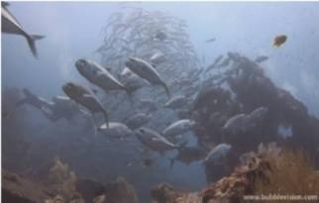
Fig. 1.1: Original Image [1]

result in foggy appearance and contrast degradation making distant objects misty. Practically, in common sea water images, the objects at a distance of more than 10 meters are almost unperceivable, and the colors are faded because their composing wavelengths are cut according to the water depth. There have been several attempts to restore and enhance the visibility of such degraded images. Since the deterioration of underwater scenes results from the combination of multiplicative and additive processes Despite of their valuable achievements, these strategies suffer from a number of issues that reduce their practical applicability. In contrast, this paper introduces a novel approach to remove the haze in underwater images based on a single image captured with a conventional camera. Our approach builds on the fusion of multiple inputs but derives the two inputs to combine by correcting the contrast and by sharpening a white-balanced version of a single native input image. The white balancing stage aims at removing the color cast induced by underwater light scattering, so as to produce a natural appearance of the sub-sea images. The multi-scale implementation of the fusion process results in an artifact-free blending.
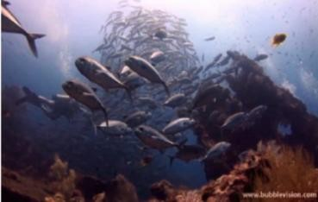

Fig. 1.2: Final Enhanced Image [1]

1.2 MOTIVATION

These days there is an extensive extent of research in the region of underwater image processing with the end goal to investigate and examine underwater exercises of images. However, the caught underwater images need in the quality and visibility. Thus, there is a need to
enhance the nature of underwater images and improve its
visibility. Underwater image processing discovers its application in the zones, for example, the assessment of plants, seabed investigation, and scan for wrecks up to the investigation of characteristic assets as e. g. manganese knobs. Because of the poor visibility conditions the earth of the world's sea is as yet not very much investigated. What's more, a great deal of underwater image improvement systems are accessible these days, as the earth is an oceanic planet having 70% of its surface secured with water. Also, researchers demonstrate their unmistakable fascination in comprehending what lies in underwater, and in addition, this field has made a significance to the utilization of underwater arrangements to screen marine species, underwater mountains and plants, to accomplish this reason it is completely important to utilize the reasonable and subjective underwater images.

1.2 SCOPE
Underwater image pre-processing is extremely essential because, under water images suffer from quality degradation due to low transmission of light. When an underwater image is captured, pre-processing is necessary to correct and adjust the image for further processing. Different filtering techniques are discussed in the literature for pre-processing of underwater images. The filters used normally improve the image quality, suppress the noise, preserves the edges in an image, enhance and smoothen the image. Therefore, an effort has been made to evaluate the performance of histogram equalization, contrast weighting and white balancing to improve the quality of image with deblurring and noise removal.

METHOLOGY

EXISTING METHODOLOGY

Deconvwnr: The least square solution can be generated. Noise amplification can be reduced by using the gained information regarding the noise during the process of deblurring, for which the wiener filter is helpful.

Deconvreg: A constrained least squares solution is generated for locating the constraints on the output image. Here regularized filter is helpful for deblurring process.

Deconvlucy: It generates an accelerated damped Lucy- Richardson algorithm. Optimization techniques and Poisson statistics can be used for generating multiple iterations in this function. Information about the additive noise is not provided in corrupted images.

Deconvblind: Without the awareness of the PSF, the deblurring process can be undergone by the blind deconvolution algorithm, which gets generated by deconvblind. Along with the restored image it returns a restored PSF. The dampling and iterative model are used by this function.

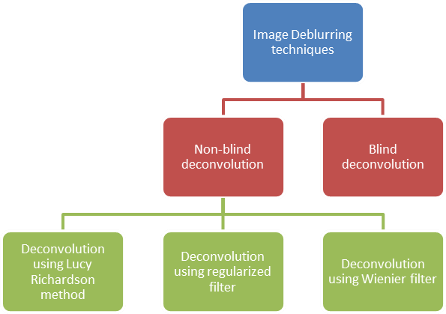

Fig. 5.1: Classification of Image Deblurring Techniques

PROPOSED METHODOLOGY

The system architecture of the proposed method describes the basic procedure for estimating the illumination directions of underwater images and cope
with the problem of illumination by normalization. Secondly deblurring of the underwater image using histogram equalization algorithm and finally by fusing both the results the restored image is acquired. The system architecture of the proposed method describes the basic procedure for estimating the illumination directions of underwater images and cope with the problem of illumination by normalization. Secondly deblurring of the underwater image using histogram equalization algorithm and finally by fusing both the results the restored image is acquired.
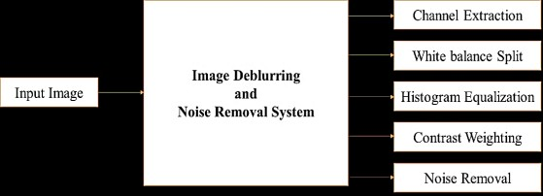

Fig. 5.2: Proposed System Architecture

UNDERWATER WHITE BALANCE

As depicted in Fig. 5.2, our image enhancement approach adopts a two steps strategy, combining white balancing and image fusion, to improve underwater images without resorting to the explicit inversion of the optical model. In our approach, white balancing aims at compensating for the color cast caused by the selective absorption of colors with depth, while image fusion is considered to enhance the edges and details of the scene, to mitigate the loss of contrast resulting from backscattering.

White balancing aims at improving the image aspect, primarily by removing the undesired color castings due to various illumination or medium attenuation properties. In underwater, the perception of color is highly correlated with the depth, and an

important problem is the green-bluish appearance that needs to be rectified. As the light penetrates the water,

the attenuation process affects selectively the wavelength spectrum, thus affecting the intensity and the appearance of a colored surface.
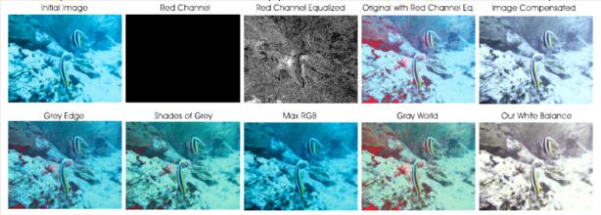

Fig. 5.3: Underwater White Balancing

HISTOGRAM EQUALIZATION

Histogram equalization is used to enhance contrast. It is not necessary that contrast will always be increase in this. There may be some cases were histogram equalization can be worse. In those cases, the contrast is decreased. Let’s start histogram equalization by taking this image below as a simple image.
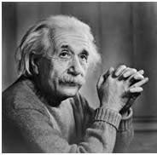

Fig. 5.4: Original Image

The histogram of this image has been shown below.
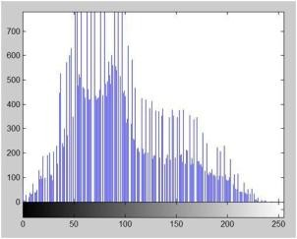

Fig. 5.5: Histogram of Original Image

Now we will perform histogram equalization to it. 1.PMF - First we have to calculate the PMF (probability mass function) of all the pixels in this image. If you do
not know how to calculate PMF, please visit our tutorial of PMF calculation.
2.CDF - Our next step involves calculation of CDF (cumulative distributive function). Let’s for instance consider this, that the CDF calculated in the second step looks like this.

Gra y Lev el Val ue | 0 | 1 | 2 | 3 | 4 | 5 | 6 | 7
CD F | 0.1  1 | 0.2  2 | 0.5  5 | 0.6  6 | 0.7  7 | 0.8  8 | 0.9  9 | 1

Table 5.1: Cumulative Distributive Function

Then in this step you will multiply the CDF value with (Gray levels (minus) 1). Considering we have a 3 bpp image. Then number of levels we have are 8. And 1 subtracts 8 is 7. So, we multiply CDF by 7. Here what we got after multiplying.

Gray Level Value | CDF | CDF * (Levels-1)
0 | 0.11 | 0
1 | 0.22 | 1
2 | 0.55 | 3
3 | 0.66 | 4
4 | 0.77 | 5
5 | 0.88 | 6
6 | 0.99 | 6
7 | 1 | 7
Table 5.2: New gray Level Values

Now we have is the last step, in which we have to map the new gray level values into number of pixels. Let’s assume our old gray levels values has these number of pixels.

Gray Level Value | 0 | 1 | 2 | 3 | 4 | 5 | 6 | 7
Frequency | 2 | 4 | 6 | 8 | 10 | 12 | 14 | 16
Table 5.3: Frequency of Old Grey Level Values

Now if we map our new values to, then this is what we got.

Gray Level Value | New Gray Level Value | Frequency
0 | 0 | 2
1 | 1 | 4
2 | 3 | 6
3 | 4 | 8
4 | 5 | 10
5 | 6 | 12
6 | 6 | 14
7 | 7 | 16
Table 5.4: New Values

Now map these new values on to histogram, and you are done. Let’s apply this technique to our original image. After applying we got the following image and its following histogram.
Histogram Equalization Image:
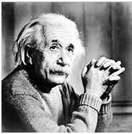
Fig. 5.6: Histogram Equalized Image

Cumulative Distributive function of this image is shown below:
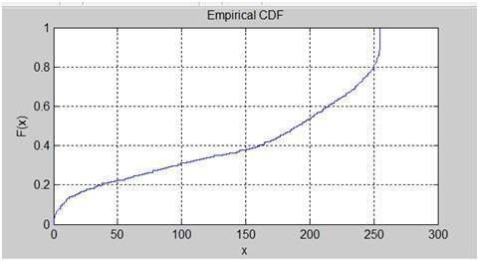
Fig. 5.7: Cumulative Distributive Function of Image

Histogram Equalization histogram:
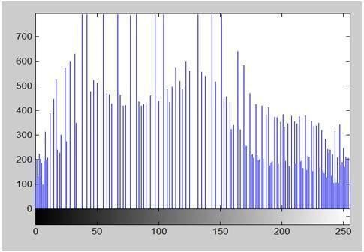
Fig. 5.8: Histogram Equalization Histogram

Comparing both the histograms and images:
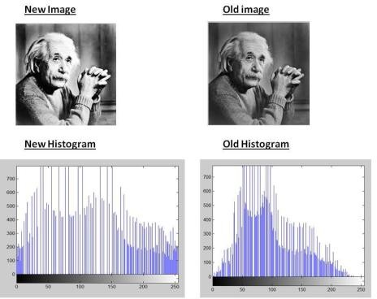
Fig. 5.9: Comparing Both the Histograms and Images
ALGORITHM
Proposed algorithm for underwater image enhancement: 1.Input image
2.Extract Individual color channels makecform function 3.Convert image to gray scale
4.Perform image edging using BW conversion 5.Call cformlab for image contrast enhancement 6.Call white balance for dual split
7.Call histeq function for both images 8.Perform contrast weight using threshold 9.Call cformfuse for color fused image

FLOW CHART
Flow chart of proposed algorithm for underwater image enhancement:
Enter Input Image

Read Image via

Extract color

Convert image into

Perform white
Fig. 5.10: Flow Chart

CONCLUSION

A novel method for deskewing and deblurring is proposed for distorted images by the dynamic nature of water surface. Existing methods typically need multiple observations to address this problem. In this work, it is possible to perform deskewing and deblurring using a single blurred observation under certain modest constraints on the water flow. Initially, the blur induced is considered as space invariant in nature and proposed a unified framework to deskew and deblur a distorted image.

ACKNOWLEDGMENT

This project arose in part out of months of efforts that have been done since we came to final year. By that time, we have worked with a great number of people whose contributions in different ways to the research and the making of this thesis deserved special mention. It is our great pleasure to convey gratitude to them all in our humble acknowledgment.

In the first place we would like to record my gratitude to our guide, Prof. Rahul Naitam, Department of Computer Science & Engineering WCEM, Nagpur for his supervision, advice, and valuable guidance. He provided us unflinching encouragement and support in various ways. It is because of her that we could synchronize our effort.

We are also thankful to Prof. Kaveri Dewsarkar, Head, Department of Computer Science & Engineering, WCEM, Nagpur for his support and dynamic supervision, which exceptionally inspire and enrich our growth as a student.
Using Dark and

Perform contrast
Fused both enhanced

We also thank to respected Director. Bharat Chede, Principal, WCEM, Nagpur for his constant support.

REFERENCES

- The Source of Images Which Are Used in This Project Is “bubblevision.com”

- Bidyut Saha, “A Comparative Analysis of Histogram Equalization Based Image Enhancement Technique for Brightness Preservation”, International Journal of Scientific Research in Computer Science and Engineering, Vol.3, Issue.3, pp.1-5, 2015.

- Hussam Elbehiery, “Optical Fiber Cables Networks Defects Detection using Thermal Images Enhancement Techniques”, International Journal of Scientific Research in Computer Science and Engineering, Vol.6, Issue.1, pp.22- 29, 2018.

- J. Chiang, Y. Chen, “Underwater Image Enhancement by Wavelength Compensation and Dehazing,” IEEE Transaction on Image Processing, vol. 21, Issue.4, pp. 1756–1769, 2012.

- K. He., J. Sun, X. Tang, "Single Image Haze Removal Using Dark Channel Prior, "IEEE Transactions on Pattern Analysis and Machine Intelligence, vol. 33, Issue. 12, pp. 2341-2353, 2011.

- Adrian Galdran, David Pardo, ArtzaiPicón, and Aitor Alvarez-Gila, “Automatic Red-Channel underwater image restoration”, Science Direct, J. Vis. Commun. Image R. 26132–145, 2015.

- H. Wen, Y.Tian, T. Huang, W. Gao, “Single underwater image enhancement with a new optical model,” Proc. IEEE Int. Symp. Circ. & Syst. (ISCAS), pp. 753-756, 2013.

- Xinwei Zhao, Tao Jin, Song Qu, “Deriving inherent optical properties from background color and underwater image enhancement”, Lists available at Science Direct, Ocean Engineering 94163–172, 2015.

- R. Sathya, M. Bharathi, G. Dhivyasri, “Underwater Image Enhancement by Dark Channel Prior”, IEEE sponsored 2nd International Conference on Electronics and Communication System (ICECS), 2015.

- C.Y. Cheng, C.C. Sung, H.H. Chang, "Underwater image restoration by red-dark channel prior and point spread function deconvolution," IEEE International Conference on Signal and Image Processing Applications (ICSIPA), Kuala Lumpur, pp. 110-115, 2015.

