**Optimization of Mechanical Properties of Epoxy Based On Reinforced Green Composite**

Nagesh Kalge1, Manoj Biradar2, Saurabh Salunkhe3, Pradip Kamble4

JSPM’s Imperial College Of Engineering And Research, Wagholi,Pune (412207)

Department of Mechanical Engineering

**Abstract:**

The coir industry plays a significant role in many countries, particularly in areas where coconut cultivation is widespread. Coir, derived from the husk of the coconut fruit, has versatile applications, ranging from agricultural uses to manufacturing textiles and home furnishings. The process of extracting coir fibres from coconut husks traditionally involves manual labour, which is time-consuming and labour- intensive. The success of this project hinges on thorough engineering design, fabrication, and rigorous testing of the coir making machine. Additionally, economic feasibility studies, market analysis, and environmental impact assessments should be conducted to evaluate the viability and sustainability of the machine. By implementing the coir making machine, the coir industry can potentially achieve higher production rates, reduce costs, and improve the overall quality of coir fibres. This project contributes to the advancement of automation in traditional industries, fostering economic growth and sustainability in coconut-producing regions.

Keywords: Coir fibre; combined ;tensile strength ;factorial analysis.

**Introduction:**

The coir industry has been a significant contributor to the economies of many countries, especially those with extensive coconut cultivation. Coir, derived from the husk of the coconut fruit, is a versatile natural fibre with diverse applications in agriculture, textiles, and other industries. The extraction of coir fibres from coconut husks is traditionally a labour-intensive and time-consuming process, hindering the industry's growth and productivity. To address these challenges, this project focuses on the design and development of a coir making machine that automates the process of extracting coir fibres. The machine aims to revolutionize the coir industry by increasing efficiency, improving fibre quality, and reducing the dependency on manual labour.

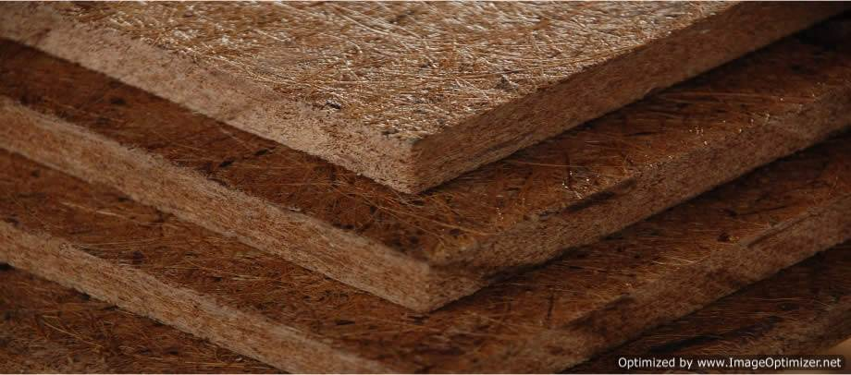**Fig.1 coir Board**

The primary objective of this project is to create a reliable and efficient coir making machine that streamlines the fibre extraction process. By automating the process, the machine will significantly reduce the time and effort required to produce high-quality coir fibres. This will ultimately enhance the productivity and profitability of coir manufacturers and enable them to meet the growing demand for coir products in domestic and international markets. The coir making machine consists of various integrated components that work together to extract fibres from coconut husks. These components include a conveyor belt system, a husk feeding mechanism, a decorticator unit, a fibre extraction unit, and a storage unit. Each component is designed to perform specific tasks in the fibre extraction process, ensuring a seamless and continuous operation. Overall, the development of a coir making machine holds great promise for the coir industry, enabling it to overcome traditional limitations and capitalize on the growing demand for coir fibres. This project represents a significant step towards automating the coir extraction process, fostering economic growth, and promoting sustainability in coconut-producing regions.

**Motivation:**

The motivation behind optimizing the mechanical properties of epoxy-based reinforced green composites is to produce stronger, more durable, and environmentally friendly materials. Epoxy resins are widely used in the manufacturing industry due to their excellent mechanical and thermal properties. However, the production of epoxy-based composites often involves the use of non-renewable and toxic materials, making them harmful to the environment.

To overcome these challenges, researchers have been developing green composites, which are made from renewable and eco-friendly materials. These composites can offer a more sustainable solution for various applications such as home furnishing, packaging industry , and construction. However, to ensure their widespread use, it is crucial to optimize their mechanical properties.

The optimization of mechanical properties can be achieved through various methods such as using different reinforcement materials, modifying the manufacturing process, and adjusting the composite's composition. By doing so, researchers can enhance the strength, stiffness, toughness, and durability of the composite material.

**Problem Definition:**

Labour Intensity: The traditional method of extracting coir fibres involves manual labour, which is labour-intensive and time-consuming. Skilled workers are required to manually separate the fibres from coconut husks, resulting in increased production costs and limited scalability. The lack of mechanization hinders the industry's ability to meet the growing demand for coir fibres. Low Productivity: The manual process of extracting coir fibres restricts the industry's productivity. The dependence on manual labour slows down the production rate, limiting the volume of coir fibres that can be processed within a given timeframe. As demand increases, it becomes challenging to meet market requirements efficiently.

**Related Work:**

Optimization of mechanical behaviour: Based on the results of the mechanical testing, optimize the composite material's mechanical properties by adjusting the fibre content, fibre orientation, and fibre treatment.

Mechanical testing: Perform mechanical testing on the composite material to evaluate its performance in terms of strength, stiffness, and toughness. Identify the areas where the composite material needs improvement.

Material selection: Select the organic fibre to be used in the composite material and optimize their characteristics, such as fibre orientation, fibre content, and fibre treatment, to achieve the desired mechanical properties.

**Methodology**:

Standard coir available in the market will be purchased, coir sheets will be cut n specific size. The chopped sheet will be mixed with chemical and hardener. The mixture will be put in desired shape die, and then it will be pressed under hydraulic press. The hydraulic press will press the material under high pressure and will remove the excessive binder. The pressed material is then removed and allowed to dry. Here 210x270x100 mm rectangular block of coir board will be made, the size of construction brick is taken for reference. The coir board made will be tested for impact test and test. So, for testing which coir board is having maximum strength we will use three different binding materials



Fig.2 Longitudinal and cross-section of a fibre cell

Fig.3 Working Methodology

**Results:**

A composite coir making machine is a device used for processing coconut husk into coir fibre, which is commonly used for making various products such as mattresses, ropes, and carpets. The machine consists of several components, including a shredder, a defibering machine, and a dryer.

To undertake a project on composite coir making machine, you will need to follow these steps:

Define the scope of the project: Identify the key objectives of the project, such as the type of coir product you want to produce, the production capacity required, and the budget available.

Research and design the machine: Conduct thorough research on the coir-making process, and design a machine that will meet your project objectives. This will involve selecting the appropriate materials, components, and technologies needed for the machine.

Overall, a well-executed project on a composite coir making machine should result in a functional, efficient, and cost-effective machine that can produce high-quality coir products

**Conclusion:**

The development of a coir making machine represents a significant advancement in the coir industry. By addressing the labour-intensive and time-consuming process of extracting coir fibres from coconut husks, the machine offers numerous benefits and opportunities for the industry's growth and sustainability. The coir making machine streamlines the fibre extraction process, automating tasks that were traditionally performed manually. This automation significantly reduces labour requirements and increases productivity, allowing coir manufacturers to meet the growing demand for coir fibres more efficiently. One of the key advantages of the coir making machine is its ability to produce high-quality coir fibres consistently. By minimizing human error and variations, the machine ensures uniform fibre length, thickness, and quality. This enhanced fibre quality enhances the market value of coir-based products and improves the competitiveness of the industry. Further research and development in this field can focus on refining the machine design, optimizing the production process, and exploring new applications for coir fibres. By continually improving and innovating in the coir making machine domain, the industry can unlock its full potential and contribute to a greener and more sustainable future.

**Summary:**

In summary, optimizing the mechanical behavior of epoxy-based reinforced green composites is key to develop high-performance and eco-friendly materials for various industrial applications. This can help reduce the environmental degradation while providing a more sustainable and cost-effective solution.

By optimizing the mechanical behavior of epoxy based on reinforced green composites, manufacturers can create more sustainable and eco-friendly materials that still meet the performance demands of the industry. This not only benefits the environment but also satisfies the growing demand from consumers for eco-friendly and socially responsible products.

**Reference:**

1] Rahul Kumar, Kausik Kumar, Prasanta Sahoo, Sumit Bhowmik “Study on the tensile and flexural properties of wood dust -filled epoxy composite ”(ICMPC2014).

[2] Fairuz I. Romli1, Ahmad Nizam Alias2, Azim Shakrine Mohd Rafie3 “Characterization of the Tensile Strength behavior in Coir Fiber-Reinforced hybrid composite material using a factorial study design” 2012AASRI Conference on modelling, identification and control

[3] Temesgen Batu1, Hirpa G. Lemu2, “Investigation of mechanical properties of false banana/glass fiber reinforced hybrid composite materials”(2020)

[4] Sathimurthi P.1, Karthi Vinit K.S2, Sathish Kumar T.P3 “Fiber extraction and mechanical properties of Agave American/composite material with kenaf fiber and poxy matrix”.(2021)

[5] Bowen Fenge1, Jiesheng Liu2, Zhenzhen Lu3, Man Zhang4, “Evaluating the mechanical and durability properties if alkali -activated rice straw fiber-reinforced cementitious composites” 2022 www.elsevier.com/locate/jobe.

Top of Form

Bottom of Form