A Review On Plant Leaf Disease Detection Using Image Processing

C.K.Rane¹, Nilesh Vani ²
¹PG Student, ²Associate Professor
GFG’S Godavari College of Engineering, Jalgaon, India, 425001

ckrane.87@gmail.com

Received on: 15 April,2023 Revised on: 15 May,2023 Published on: 17 May,2023

Abstract –Agribusiness is crucial to every nation's economy and is dependent on the vast majority of Indians to exist. The disease has invaded certain plants. Diseases must be recognized as soon as feasible. The development of disease detection models necessitates careful monitoring of every plant. This is important because we may use the parameters to impose limitations. Thus, healthy cropping is crucial for the developing agricultural industry. One of several elements that affect crop productivity is the early detection of illnesses.
Keywords-Image Acquisition, Image Pre-possessing, Image Segmentation, Image Processing, Feature Extraction, NB Classifier, KNN Classifier, DT Classifier, SVM Classifier.
I. INTRODUCTION
When opposed to former times, when plants were largely employed to feed people and other animals, agriculture has recently gained greatly in importance. This is due to the fact that plants are now used to generate electricity and other forms of energy to improve the level of living for humanity. Yet, a wide range of economies and communities can experience major disruptions as a result of several plant diseases. It could even cause substantial ecological damage. It is therefore preferable to detect infections precisely and quickly in order to avoid such losses. Plant diseases can be detected in a variety of ways, including manually and digitally. Most plant diseases show up as spots on the leaves, which are simpler for people to see. On the other hand, while some illnesses only show up on the leaves after the plants have already sustained severe harm, others do not show up on the leaves at all. It is recommended that in these situations, computerized systems would be the only way to quickly detect the scenario, utilizing a variety of complex algorithms and analytical tools, preferably through the use of potent microscopes and other equipment. In other instances, electromagnetic technology which generates additional, visually unseen images is the only means of detecting the signs. Around 70% of the population of India, a developed country, is dependent on agriculture. Farmers can select the ideal insecticides for their plants from a wide range of qualifying crops. Plant disease results in a significant decline in the quantity and quality of agricultural goods. Plant disease research is the study of patterns on plants that can be seen visually. Monitoring plant health and disease is essential for growing crops sustainably on a farm. A specialist in that field would initially manually track and evaluate plant ailments. This is labor-intensive and takes a long time to process. Techniques for image processing can be used tofind plant diseases. Disease symptoms are typically visible on the fruit, stem, and leaves. The plant leaf is taken into consideration for disease identification since it exhibits disease signs.
II- LITERATURE REVIEW
Fatma Marzougui et al. (2020) suggested a computerized method based on DL (Deep Learning) systems to predict plant ailments [21]. As a result, ResNet, a CNN (convolution neural network), was employed. Photos of both healthy and injured leaves were added to an existing dataset for this operation. The images were separated into two categories: impacted and unaffected. Anaconda 2019.10 was used to implement the suggested solution, and its performance was evaluated. The outcomes demonstrated that the suggested approach was superior to the ones that were already in use. A CNN (convolution neural networks) method was presented by Marwan Adnan Jasim et al. (2020) for classifying and identifying plant leaf diseases [22]. Plant illnesses that affected leaves were divided into twelve classes for diseases that affected different types of plants and three classes for healthy leaves. 20636 images of plants and the diseases that harm them were included in the Plant Village collection. The results showed that during training and testing, the new algorithm's accuracy was roughly 98.29%.
From the Plant Village dataset [23], G. Madhulatha et al. (2020) presented a CNN (Convolution Neural Network) for identifying various plant illnesses. 38 distinct classes of plant diseases were created using the Alex Net model. A perfect solution was also developed for diagnosing and locating the plant diseases. The results demonstrated that the anticipated algorithm produced results with an accuracy of about 96.5%. In order to recognize the plant illness, Akshay Kumar et al. (2019) tested a Convolution Neural Network (CNN) model for photo classification [24].
On the studied model, studies were carried out to detect diseases in tomato leaves. The PlantVillage dataset, which included 14,903 images of both healthy and damaged plant leaves, was used to train this model. The results demonstrated that the computed accuracy for the investigated model was 99.25%. A technique to track the plant and spot plant diseases in their early stages was provided by N. Radha et al. in 2021 [25]. The automated plant disease detection technique assisted in anticipating disease symptoms in large fields. This method for detecting plant diseases was created using CNN (convolution neural network) training. The collection included a number of images of both healthy and sick leaves. The suggested method generated accuracy up to 85% while incurring a very slight loss of 0.25. In 2020 [26], MonuBhagat et al. created a computationally efficient method for diagnosing plant leaf diseases and categorizing plant leaves as healthy or diseased. This strategy was planned using a Support Vector Machine (SVM), and it was then optimized using the Grid Search method. The authors were able to develop a significant way to precisely detect diseases with the least amount of computational work thanks to this tactic. The accuracy of the latter method was 84% as opposed to the SVM algorithm's 80%.K-means clustering approach was developed by F.A. Princi Rani, et al. (2019) to recognize and classify the leaf disease [27]. The image was divided into categories using the color median filter. During the segmentation process, focus was placed on converting the RGB model into the L*a*b model. The extracted color texture data was used in the SVM (Support Vector Machine) method. MATLAB 2015a was used to create these models. The results showed that the SVM algorithm provided up to 95% accuracy. Through the use of an SVM (Support Vector Machine) technique, SelimHossain, et al. (2018) aimed to identify the disorders [28].The categorizing procedure involved eleven qualities. These characteristics were utilized to select the disease that best matched each image that was uploaded to the SVM database. 90% of the time, the targeted algorithm was accurate. This method improved the accuracy with which plant illnesses could be identified and recognized, lowering leaf disease losses and raising overall output. To discover and classify tomato infections, Meghanav Govardhan et al. (2019) created an ML (machine learning) technique called Random Forest [29]. The created technique was trained by pre-processing the pictures and extracting the properties. This technique worked well for the identification of tomato diseases such early blight, late blight, septoria leaf spots, and pider mites. The trials' findings demonstrated that every test image provided appropriate image class discrimination, and the devised technique's accuracy was 95%.
III- METHOLOGY
1)PLANT LEAF DISEASE DETECTION PROCESS:
The process for identifying plant diseases essentially consists of four stages, as shown in Fig. 1. During the initial stage, images are gathered online, with a mobile device, or with a digital camera. In the second stage, the image is separated into various numbers of clusters that can each be processed differently. The methods for feature extraction are discussed in the next stage, and the classification of illnesses is discussed in the last stage.
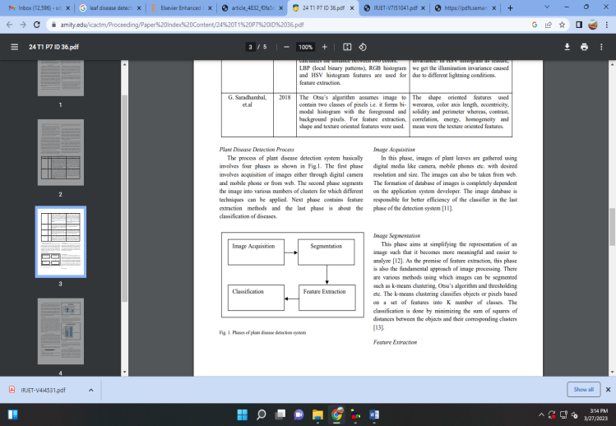
Fig. 1-Image Acquisition
Plant leaf images are gathered during this stage using digital cameras, smart phones, and other devices with the required resolution and size. In addition, images from the internet can be used. The photo database is entirely the responsibility of the application system developer. The image database helps the detection system's classifier's final stage be more productive [11].
Image Pre-processing
The pre-processing of an image has a significant impact on a model's performance. The symptoms of viral, bacterial, and fungal infections commonly overlap, making them difficult to distinguish from one another. One of these signs is any measurable alteration in color, shape, or functioning that occurs as the plant reacts to the infection. Utilizing RGB images could assist in overcoming this constraint. Although training may take longer than for a grayscale image, it provides sharp, demonized photos. When attempting to remove noise from an object or image, a number of pre-processing tasks are taken into consideration. The leaf image is cropped in image clipping to make an inclined section of the image. A smoothing filter is used to achieve image smoothing [6].The popular image filtering schemes are discussed as below:
• Adaptive Median filter: The main problem with the median filter is that it makes it impossible to distinguish between normal and damaged pixels. The adaptive median filter is applied to deal with this constraint. When a pixel can be recognized from the pixels around it based on its structure and features, it is said to be noisy. The median values are assigned to the noisy pixels. The noise classification test performs worse than these neighborhood-based medians.
• Apha-Trimmed Mean Filter: A mean filter is used to obtain all of the kernel's pixels equally and to influence even the noisy pixels. This is where mean filter has the most problems. To remove this restriction, the distribution of pixels is performed before taking the mean in trimming. Additionally, some of the locations with the highest and lowest values are also eliminated. The median and mean filters are combined in the alpha-trimmed mean filter. • Gaussian filtration The weight is regulated and the current pixel is given more importance when the distance is modified by the Gaussian filter in terms of the Gaussian distribution. The edges are preserved while using this filter. The two phases make up this filter's two stages.
Image Segmentation
This process aims to simplify analysis and increase comprehension of an image's representation [12]. Since it forms the basis for feature extraction, this step is crucial to the image processing process. Several methods, such as thresh holding, Otsu's algorithm, and k-means clustering, can be used to segment images. The k-means clustering splits objects or pixels into K number of classes based on a set of features. Classification is achieved by reducing the sum of the squares of the distances between the items and their related groups [13].
Feature Extraction
The result of segmentation thus far is the area of interest. Therefore, it is necessary to extract the properties of this area of interest at this point. These qualities are necessary in order to interpret a sample image. Features may be based on color, form, or texture [14]. Most academics now favor using textural characteristics to spot plant diseases. A number of feature extraction methods, such as histogram-based feature extraction, the grey-level co-occurrence matrix (GLCM), the color co-occurrence approach, and the spatial grey-level dependence matrix, can be used to build the system. A statistical method for classifying textures is the GLCM approach.
Classification
The categorization step is to determine if the input image is healthy or unhealthy. If it is found that the image is ill, it has been further categorized into several illnesses in certain previously published works. To accomplish classification, a MATLAB software procedure called as a classifier must be created. Naive Byes, Support Vector Machines (SVM), Artificial Neural Networks (ANN), Back Propagation Neural Networks (BPNN), and Decision Tree classifiers are just a few of the classifiers that researchers have lately used. The most common classifier is discovered to be the SVM classifier. Although each classifier has advantages and disadvantages, SVM is a simple and dependable method [15].
2) MACHINE LEARNING TECHNIQUES FOR PLANT LEAF DISEASE DETECTION:
2.1. NB classifier
Gaussian The distribution of each attribute's continuous values, which are generated, using Naive Bayesian, is governed by a Gaussian distribution, sometimes referred to as the Normal Distribution. The results of the Gaussian distribution serve as an illustration of the bell-shaped bell curve that demonstrates the regularity of the mean values.
2.2. KNN classifier
Both classification and regression problems can be solved with the KNN classifier, but it usually helps with classification issues. A distribution tree algorithm for diagnosis is KNN. When there is no creative thought put into the distribution of the data, non-parametric analysis, or the structure obtained from the characteristics of the data collection, is applied. When data sets don't adhere to imaginary mathematical theories, KNN is employed for prediction. No training data is necessary for KNN to continue. Since all training data is useful for testing data, the Slow Learning (SL) technique is known as such.
2.3. DT classifier
The DT classifier is the most often used and preferred method for categorizing and producing predictions. Every internal node in the DT describes a feature test, every branch describes a test result, and every terminal node has a data label. Decision trees can quickly generate clear rules. A decision tree is an approachable and practical value-based technique because of its straightforward flowchart estimation. An illustration is the DT flowchart in Fig. 2.
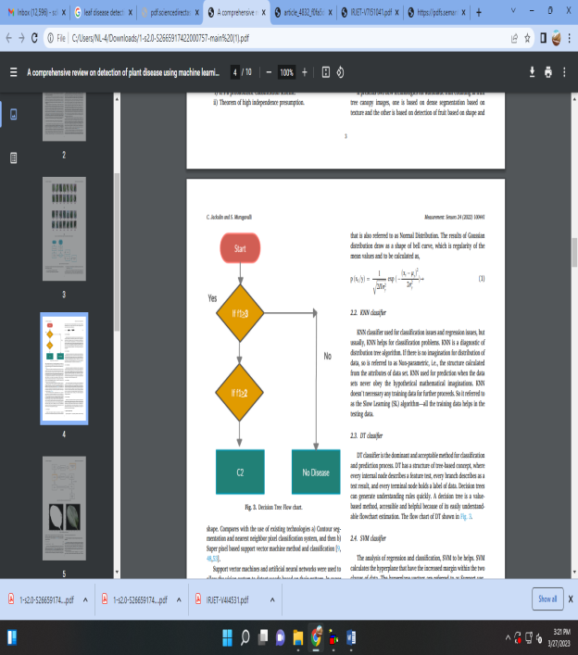
Fig. 2-2.4. SVM classifier
SVM analysis for regression and classification can be useful. SVM determines the hyper plane with the increasing margin between the two classes of data. The hyper plane vectors serve as the support vectors. SVM can produce a margin of hyper plane that completely divides the hyper plane vector into two classes that don't intersect by taking into consideration important factors. This classifier will search for support vector hyper planes with greater margins and less classification errors because this is not always the case.
2.5. RF classifier
RF is a supervised algorithm that can manage regression and classification methods. It is largely concerned with classification issues. A strong forest has a lot of trees since it is a regulated group of trees. The dataset-based decision tree approach is also discovered by the RF, exactly like the decision trees. Before choosing the best course of action, it gathered the forecast results from each branch of the tree. It is referred to as an ensemble technique, and because average performance lessens over-fitting, it outperforms a single DT classifier. Classifier MLP (3.6) An MLP is a theory that relies on regression. This method transforms non-linear based learners, modifying the input dataset. A quality that is linearly distinct is changes from the input data. The input data layer is transformed into a hidden layer. The MLP Classifier only uses one hidden layer; otherwise, it behaves like a synthetic neural network. Even using numerous hidden layers to achieve classification works effectively.
CONCLUSION
This paper reviews and summarizes the image processing techniques that have been used to detect plant diseases. K-means clustering, SGDM, BPNN, and SVM are the principal techniques for detecting plant diseases. These techniques are used to evaluate both healthy and diseased plants' leaves. The effect of background information on the final image, technique optimization for a specific plant leaf disease, and technique automation for continuous automated monitoring of plant leaf diseases in actual field settings are only a few of the challenges with these techniques. The analysis found that while this approach of disease detection has significant drawbacks, it shows great promise for detecting ailments in plant leaves. As a result, the existing research has potential for improvement.
REFERENCES
- Sunil S. Harakannanavara, Jayashri M. Rudagi, Veena I. Puranikmath, Ayesha Siddiqua, R. Pramodhini, Plant leaf disease detection using computer vision and machine learning algorithms” Global Transitions Proceedings 3 (1) (2022) 305–310.
- R. Sujatha, J.M. Chatterjee, N. Jhanjhi, S.N. Brohi, Performance of deep learning vs machine learning in plant leaf disease detection, Microprocess. Microsyst. 80 (2021), 103615.
- C.K. Sunil, C.D. Jaidhar, N. Patil, Cardamom plant disease detection approach using EfficientNetV2, in: IEEE Access, vol. 10, 2021, pp. 789–804, https://doi.org/ 10.1109/ACCESS.2021.3138920, 2021.
- M. Bhagat, D. Kumar, I. Haque, H.S. Munda, R. Bhagat, Plant leaf disease classification using grid search based SVM, in: 2nd International Conference on Data, Engineering and Applications (IDEA), 2020, pp. 1–6.
- J. Cui, X. Zhang, W. Wang, L. Wang, Integration of optical and SAR remote sensing images for crop-type mapping based on a novel object-oriented feature selection method, Int. J. Agric. Biol. Eng. 13 (2020) 178–190.
- V. Ananthi, Fused segmentation algorithm for the detection of nutrient deficiency in crops using SAR images, in: Artificial Intelligence Techniques for Satellite Image Analysis, Springer, 2020, pp. 137–159.
- T. Baidar, Rice Crop Classification and Yield Estimation Using Multi-Temporal Sentinel-2 Data: a Case Study of Terrain Districts of Nepal, 2020. [8] K.P. Panigrahi, H. Das, A.K. Sahoo, S.C. Moharana, Maize leaf disease detection and classification using machine learning algorithms, in: Progress in Computing, Analytics and Networking, Springer, 2020, pp. 659–669.
- Y. Majeed, J. Zhang, X. Zhang, L. Fu, M. Karkee, Q. Zhang, et al., Deep learning based segmentation for automated training of apple trees on trellis wires, Comput. Electron. Agric. 170 (2020), 105277.
- S. Das, S. Sengupta, Feature extraction and disease prediction from paddy crops using data mining techniques, in: Computational Intelligence in Pattern Recognition, Springer, 2020, pp. 155–163.
- K. Feng, R.S. Tian, Forecasting Reference Evapotranspiration Using Data Mining and Limited Climatic Data 54, Taylor Francis, 2020, pp. 363–371.
- T.K. Fegade, B. Pawar, Crop prediction using artificial neural network and support vector machine, in: Data Management, Analytics and Innovation, Springer, 2020, pp. 311–324.
- M. Loey, A. ElSawy, M. Afify, Deep learning in plant diseases detection for agricultural crops: a survey, Int. J. Serv. Sci. Manag. Eng. Technol. 11 (2020) 41–58.
- S.H. Bhojani, N.J.N.C. Bhatt, Applications, Wheat Crop Yield Prediction Using New Activation Functions in Neural Network, 2020, pp. 1–11.
- P. Sharma, P. Hans, S.C. Gupta, Classification of plant leaf diseases using machine learning and image preprocessing techniques, in: 2020 10th International Conference on Cloud Computing, Data Science & Engineering, Confluence), 2020, pp. 480–484.
- S. Ashok, G. Kishore, V. Rajesh, S. Suchitra, S.G. Sophia, B. Pavithra, Tomato leaf disease detection using deep learning techniques, in: 2020 5th International Conference on Communication and Electronics Systems, ICCES), 2020, pp. 979–983.
- R.G. Hammer, P.C. Sentelhas, J.C.J.S.T. Mariano, Sugarcane Yield Prediction through Data Mining and Crop Simulation Models, vol. 22, 2020, pp. 216–225.
- R. Chaudhari, S. Chaudhari, A. Shaikh, R. Chiloba, T. Khadtare, Soil fertility prediction using data mining techniques, International Journal of Future Generation Communication and Networking 9 (Issue 6) (2020).
- M. Champaneri, D. Chachpara, C. Chandvidkar, M. Rathod, Crop yield prediction using machine learning, Int. J. Sci. Res. 9 (2020)
- Fatma Marzougui, Mohamed Elleuch, MonjiKherallah, “A Deep CNN Approach for Plant Disease Detection”, 2020, 21st International Arab Conference on Information Technology (ACIT) 2
- Marwan Adnan Jasim, Jamal Mustafa AL-Tuwaijari, “Plant Leaf Diseases Detection and Classification Using Image Processing and Deep Learning Techniques”, 2020, International Conference on Computer Science and Software Engineering (CSASE)
- G. Madhulatha, O. Ramadevi, “Recognition of Plant Diseases using Convolutional Neural Network”, 2020, Fourth International Conference on ISMAC (IoT in Social, Mobile, Analytics and Cloud) (I-SMAC)
- Akshay Kumar, M Vani, “Image Based Tomato Leaf Disease Detection”, 2019, 10th International Conference on Computing, Communication and Networking Technologies (ICCCNT)
- N Radha, R Swathika, “A Polyhouse: Plant Monitoring and Diseases Detection using CNN”, 2021, International Conference on Artificial Intelligence and Smart Systems (ICAIS)
- Monu Bhagat, Dilip Kumar, Isharul Haque, Hemant Singh Munda, Ravi Bhagat, “Plant Leaf Disease Classification Using Grid Search Based SVM”, 2020, 2nd International Conference on Data, Engineering and Applications (IDEA)
- F.A. Princi Rani, S.N Kumar, A Lenin Fred, Charles Dyson, V. Suresh, P.S Jeba, “K-means Clustering and SVM for Plant Leaf Disease Detection and Classification”, 2019, International Conference on Recent Advances in Energy-efficient Computing and Communication (ICRAECC)
- Selim Hossain, RokeyaMumtahanaMou, Mohammed Mahedi Hasan, Sajib Chakraborty, M. Abdur Razzak, “Recognition and detection of tea leaf's 1967 diseases using support vector machine”, 2018, IEEE 14th International Colloquium on Signal Processing & Its Applications (CSPA)
- Meghana Govardhan, Veena M B, “Diagnosis of Tomato Plant Diseases using Random Forest”, 2019, Global Conference for Advancement in Technology (GCAT)
- Arnawa, I.K., Sapanca, P.L.Y., Martini, L.K.B., Udayana, I.G.B., Suryasa, W. (2019). Food security program towards community food consumption. Journal of Advanced Research in Dynamical and Control Systems, 11(2), 1198- 1210.

