Phase Shifted PWM Technique For Five
Level Flying Capacitor Multilevel Converter

Miss. Netra Manwatkar¹,Prof.Avantika Y. Fadnis² ,Prof Gaurav Gondhlekar³
¹Mtech Student, Y.C.C.E,Nagpur,India
²Associate Professor, Y.C.C.E.,Nagpur,India.
³Assistant Professor, Y.C.C.E.,Nagpur,India.

Abstract – Multilevel converters have a variety of configurations depending on the power conversion and type of application. They are mainly categorized into three types such as Flying capacitor(FC)converter ,Cascaded H-bridge (CHB) converter, Neutral point clamped (NPC) converter and multilevel converter. This paper presents the phase shifted pulse width modulation techniques for five level flying capacitor multilevel converter operating under different loads. The loads under consideration are linear, non-linear , unbalanced load and a proportional controller that balances the capacitor voltage .The number of parameters required to decide the levels are based on certain formulae. The current and voltage waveform under different loads are observed under different modulation indices.
Keywords- Multilevel inverter,harmonics,PWM technique,flying capacitor.
INTRODUCTION
The basic operation of multilevel inverter is to convert an input DC to output AC with several levels. The multilevel inverters are classified based on number of levels, switching operation,power semiconductor switches and efficiency. Depending on the operation of the inverters the topologies have certain merits and demerits. Out of these topologies the flying capacitor multilevel inverter is the most renowned topology, in this inverter balancing the capacitor voltage is a major issue, a proportional controller is required to balance the capacitor voltage for optimal operation by reducing the

voltage ripples and ensuring safe and secure operation of the semiconductor devices[1].
The multilevel modulation is classified based on switching frequencies under different modulation indices. The phase shifted PWM is classified as high switching frequency under multicarrier PWM[2][3]. There are two techniques for multicarrier PWM they are phase shifted pulse width modulation and level shifted pulse width modulation.The level shifted is again classified into three sub-groups as In-phase disposition, phase opposition disposition, alternate phase opposition disposition.The multilevel modulation flowchart is shown in the Fig.1.
In this paper a flying capacitor converter is considered for analysis with phase shifted PWM as it has certain advantages .As there are many storage capacitors it provides extra ride through capabilities when there is a power outage, provides redundancy in switching, robustness when they are operated under different levels according to the desired output. During the operation for various levels, the need of filter gets eliminated as the level increases it reduces the harmonic content,which makes it possible for its operation in DC transmission[4][5].
The FC is mainly used in DC-DC application in plug-in hybrid electric vehicles as it improves the quality of output voltage and provides higher efficiency[6][7].

Fig 1:Flowchart of Multilevel Modulation Scheme
METHODOLOGY
The circuit diagram of three phase five level flying capacitor converter is shown in the Fig 2.When the converter is operating under normal condition, the mean voltage values should be maintained at $0,\frac{V_{dc}}{4},\frac{V_{dc}}{2}, \frac{3V_{dc}}{4},V_{dc}$.The switching of the power semiconductor devices takes two values (0,1) and operates in a complementary manner
Fig 2:Circuit Diagram of three phase five level flying capacitor converter

DESIGN

A five level FCC topology is usually designed based on certain specifications such as number of voltage source,number of switching devices,number of balancing capacitors,number of DC bus capacitors.The formulae are given below:
a) Number of voltage sources=(p-1)=(5-1)=4
b) Number of switching devices=2(p-1)=2(5-1)=8
c) Number of balancing capacitors=(p-1)(p-2)/2
=(5-1)(5-2)/2=6
d) Number of DC bus capacitors=(p-1)=(5-1)=4
where p=Number of levels
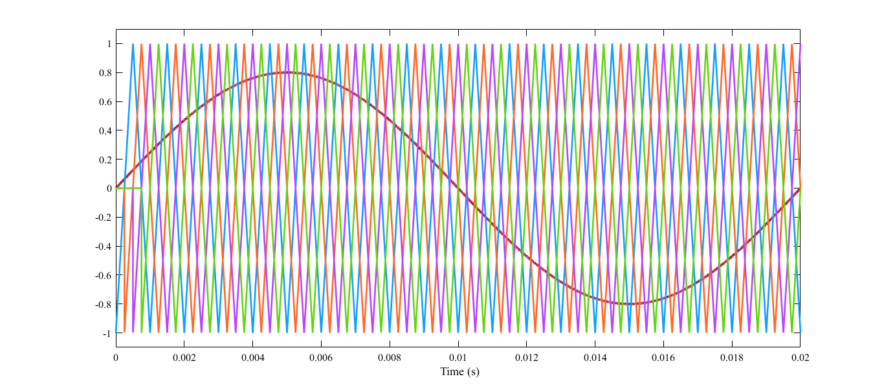
Fig 3:PWM waveform for single phase
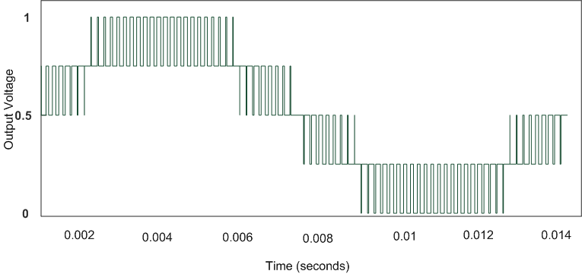
Fig 4: Output voltage waveform for single phase
The Fig 3.shows the PWM waveform in which there are 4 carriers and 1 reference in the waveform. The carriers are phase shifted by 90°.Fig 4.shows the output voltage waveform for single phase in five level inverter. In this method voltage balancing is achieved naturally but it is slow and depends upon the loading conditions. Hence, a new method is implemented to balance the capacitor voltage using a proportional controller.
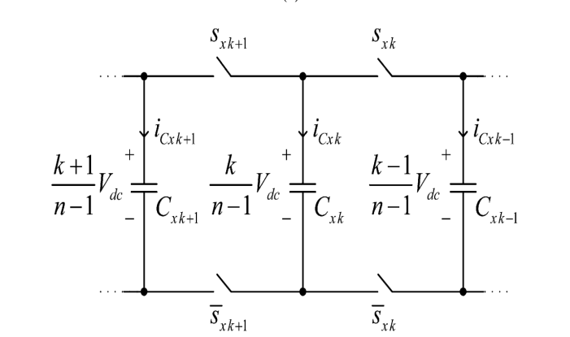
Fig 5:Basic representation of single leg of converter
The Fig.5 is a general representation of a particular phase leg of an FC converter.It consist of 3 capacitors and 4 switches, they are$C_{xk}$ ,$C_{xk}+1$,$C_{xk}-1$ and the current flowing through the capacitor $C_{xk}$ ,is impacted by the control signals with the two adjoining switches $C_{xk}+1$and $C_{xk}-1$. The current through the capacitors are $i_{cxk}$ $,i_{cxk+1 },i_{cxk-1}$ respectively where n represents the number of level K represents the number of switch in a particular phase.
The capacitor current flowing through the capacitor $C_{xk}$is represented by $i_{cxk}=\left(S_{xk+1}-S_{xk}\right)i_{x}$ …… (1)
It can be seen that the adjoining switches have some impact on the current flowing through the capacitor $C_{xk}$.
The relation between the capacitor current and the duty cycle is calculated using the formula $\overline{i_{cxk}}=\left(d_{xk+1}-d_{xk}\right)$….…..(2)
Where $i_{cxk}$and $i_{x}$ are locally averaged currents of capacitor $C_{xk}$ and the output current respectively and $d_{xk+1}$ and $d_{xk}$ are the duty cycles of the switch $S_{xk+1}$ and${ S}_{xk}$ ,respectively.
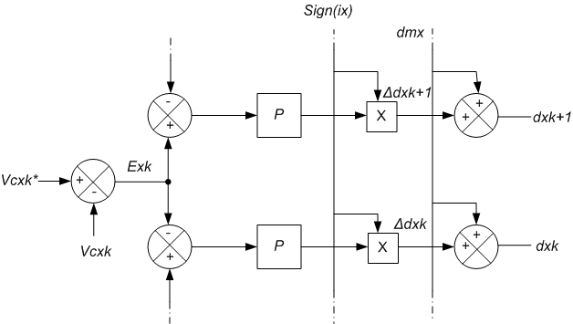
Fig 6: Generalized proportional controller
When the current 𝑖𝑥>0 i.e.positive , the duty cycle 𝑑𝑥𝑘+1 will increase, increasing the current through the capacitor whereas there will be a contradictory effect when 𝑑𝑥𝑘 increases. When the voltage of the capacitor 𝐶𝑥𝑘 becomes greater than its reference value, a negative current flows through this capacitor.This method is used to balance the capacitor voltages.
When the output current 𝑖𝑥<0 i.e. negative,the duty cycles should be changed in the reverse direction so as to achieve the voltage balance.
SIMULATION RESULTS
The following parameters have been considered for the FC converter:
Table 1- Specifications of the circuit
Circuit Parameter | Value
DC Link Voltage | 100V
Flying Capacitors | 220$μF$
Load Resistance | 22$Ω$
Load Inductance | 6mH
Carrier Frequency | 2kHz
Fundamental Frequency | 50Hz
Control parameter | 0.015

- The Fig.7a shows the basic diagram of the inverter with resistor-inductor load,Fig 7b. line-to-line voltage waveform and Fig 7c. current waveform of five level three phase converter with linear load RL (diode-rectifier) the modulation index changes from m = 0.4 to 0.7 at 30 ms.[1] Fig 7a: Three phase five level inverter with RL load
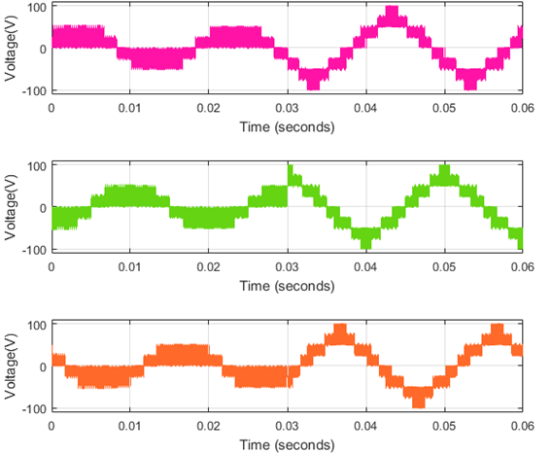
Fig 7b: Simulation of line-to-line voltage
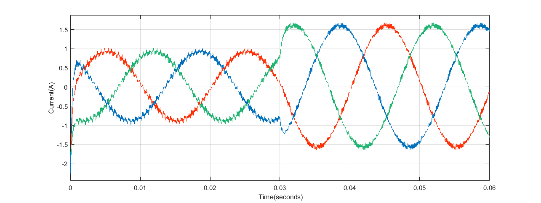
Fig 7c: Simulation of current waveform
- The Fig 8a. is the inverter diagram with a non-linear load Fig.8b.shows the line-to-line voltage waveform and Fig 8c. current waveform of five level three phase converter with non- linear load (diode-rectifier) there is a change in modulation index from m = 0.4 to 0.7 at 30 ms.[1]
Fig 8a: Three phase five level inverter with NL load

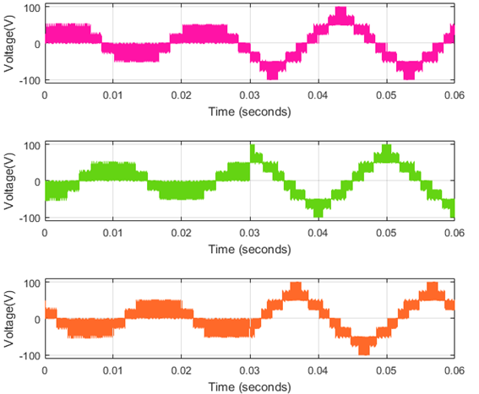
Fig 8b: Simulation of line-to-line voltage
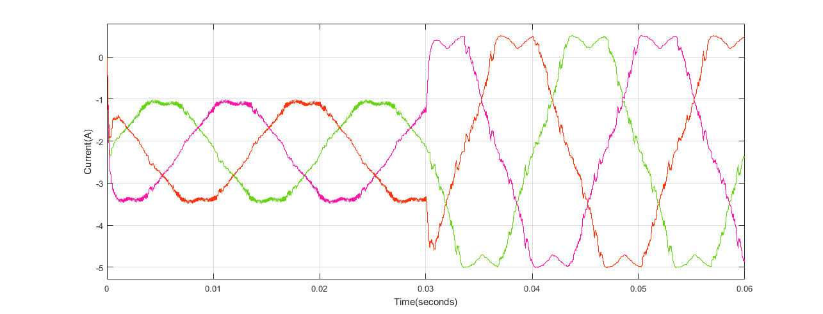Fig 8c: Simulation of current waveform
- The Fig.9a.is the diagram of inverter with linear as well as non-linear load. Fig.9b.shows the line-to-line voltage waveform and Fig 9c. current waveform of five level three phase converter with a linear load and at 30ms non- linear load (diode-rectifier) is added[1] Fig9a: Three phase five level inverter with RL-NL load
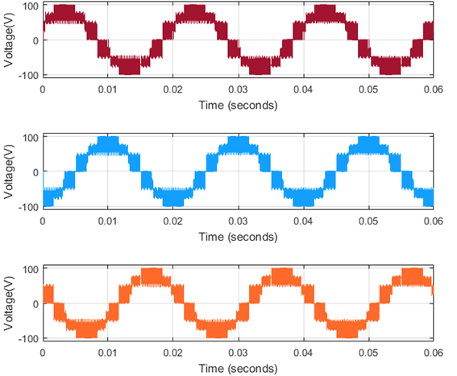
Fig 9b: Simulation of line-to-line voltage
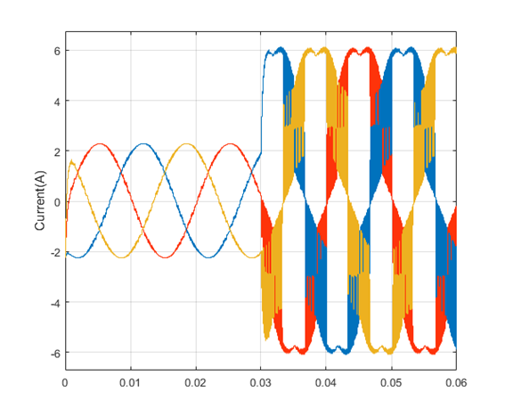Fig 9c: Simulation of current waveform
- The Fig.10a is an inverter which is connected to an unbalanced load.Fig.10b.shows the line-to-line voltage waveform and Fig.10c.current waveform of five level three phase converter with unbalanced load and steady-state condition.[1]

Fig 10a: Three phase five level inverter with unbalanced load.
Fig 10b: Simulation of line-to-line voltage
Fig 10c: Simulation of current waveform
- The Fig 11a is an inverter with unbalanced load and changing modulation index.Fig11b.shows the line-to-line voltage waveform and Fig 11c. current waveform of five level three phase converter operating at a low modulation index(m = 0.15),and after 120ms , it changes to high modulation index (m =1)[1] Fig 11a: Three phase five level inverter with unbalanced load and change in modulation index.

Fig 11b: Simulation of line-to-line voltage
Fig 11c: Simulation of current waveform
CONCLUSION
When the modulation index changes it is observed that during transients the capacitor voltage in the flying capacitors remains unaffected especially in non-linear loads.Naturally there is a high deformation in the current waveform curve and also they become unstable because they increase when the modulation index increases.It proves that the voltage balancing method is most rugged as it is able to maintain the capacitor voltage at the reference values and this method provides good results for low as well as high modulation indices.Moreover,it is also applicable to any number of levels as it is fast in operation.
REFERENCES
[1] A. M. Y. M. Ghias, J. Pou, M. Ciobotaru, and V. G. Agelidis, “Voltage balancing method using phase-shifted PWM for the flying capacitor multilevel converter,” IEEE Trans. Power Electron., vol. 29, no. 9, pp.4521-4531, Sep. 2014.

[2] S. Lee, D. Kang, Y. Lee, and D. Hyun, “The carrier-based PWM method for voltage balance of flying capacitor multilevel converter,” in IEEE PESC, June. 2001, vol.1, pp. 126–131.

[3] Amer M. Y. M. Ghias, Member, IEEE, Josep Pou, Senior Member, IEEE, Gabriel J. Capella,Pablo Acuna, Member, IEEE, and Vassilios G. Agelidis, Fellow, IEEE, “On improving Phase-shifted PWM for flying capacitor multilevel converter.”pp.1-6.

[4] S. Thielemans, A. Ruderman, B. Reznikov, and J. Melkebeek, “Improved natural balancing with modified phase-shifted PWM for single-leg fivelevel flying-capacitor converters,” IEEE Trans. Power Electron., vol. 27,no. 4, pp. 1658–1667, Apr. 2012.

[5] C. Feng, J. Liang, and V. G. Agelidis, “Modified phase-shifted PWM control for flying capacitor multilevel converters,” IEEE Trans. Power Electron., vol. 22, pp. 178–185, Jan. 2007.
[6] M. Khazraei, H. Sepahvand, K. A. Corzine, and M. Ferdowsi, “Active capacitor voltage balancing in single-phase flying-capacitor multilevel power converters,” IEEE Trans. Ind. Electron., vol. 59, no. 2, pp. 769– 778, Feb. 2012.

[7] B.P. Mcgrath and D. G. Holmes, “Analytical determination of the capacitor voltage balancing dynamics for three phase flying capacitor converters,” IEEE Trans. Ind. Appl., vol. 45, no. 4, pp. 1425–1433, Jul.2009.

