Overheating Fault Protection of Motor Using
Temperature Sensor Ds 1820

Mr. Akash Itankar, Mr. Joshua Daniel, Mr. Ashvini Nagare

Department of Electrical Engineering, DBACER, Nagpur University.
Email: dbacerngp@gmail.com

ABSTRACT

This paper provides an overview of the recent work of protection system of motors. The paper describe the development in protection system of different motors. Overheating protection of motor means protect the motor from overheating of its winding. This overheating in motor is generally caused by overloading of motor. For sensing the temperature DS1820 sensor is used for this purpose. This sensor is connected to the ARDUINO Nano controller. With the help of these sensor we sense the temperature of winding and its temperature exceeds to some particular level then DS1820 sends the signal to ATmega328P which is high performing 8-bit, 32KB Flash, microcontroller, part of the AT mega AVR MCUs series, developed by Atmel.

INTRODUCTION

This project is about the fault occur in motor due to overheating. Motor is the backbone for every industry. However like any other machine, they will eventually fail because of heavy duty cycle, poor grounding environment, installation and manufacturing factors etc. With escalating demand for reliability and efficiency, the field of fault diagnosis in induction motor is gaining importance .If the fault are not divine, it may result in large revenue losses as well as pose threat to reliability and safety of operation. DS1820 sensor we are using to eliminate the overheating fault. We are using ARDUINO Nano controller which is AT mega328P which occupies less space and it operates with an high speed. DS1820 sends the signal to ATmega328P which is high performing 8-bit, 32KB Flash, and microcontroller.

Purpose

Our first priority is to eliminate the different faults in the motor like overheating, under voltage, over current, etc. and to run motor without any problem also our aim is to increase lifespan of motor.

Working

Overheating protection of motor means protect the motor from overheating of its winding. For sensing the temperature DS1820 sensor is used for this purpose. This sensor is connected to the ARDUINO Nano controller. With the help of these sensor we sense the temperature of winding and its temperature exceeds to some particular level then DS1820 sends the signal to ATmega328P which is high performing 8-bit, 32KB Flash, microcontroller with the help of this controller we can stop the motor when it exceeds the temperature.

BLOCK DIAGRAM

MOTOR
DS1820
ARDUINO Nano328P

SUPPLY

OUTPUT

ARDUINO Nano

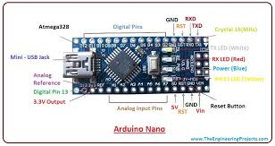

Arduino Nano is a small, compatible, and flexible and breadboard friendly Microcontroller board, developed by Arduino.cc in Italy, based on ATmega328p.It comes with exactly the same functionality as in Arduino UNO but quite in small size. It comes with an operating voltage of 5V, however, the input voltage can vary from 7 to 12V.
Arduino Nano Pinout contains 14 digital pins, 8 analog Pins, 2 Reset Pins & 6 Power Pins each of these Digital & Analog Pins are assigned with multiple functions but their main function is to be configured as input or output.
They are acted as input pins when they are interfaced with sensors, but if you are driving some load then use them as output.
There is one limitation using Arduino Nano i.e. it doesn’t come with DC power jack, means you cannot supply external power source through a battery.This board doesn’t use standard USB for connection with a computer, instead, it comes with Mini USB support.

Microcontroller 328P

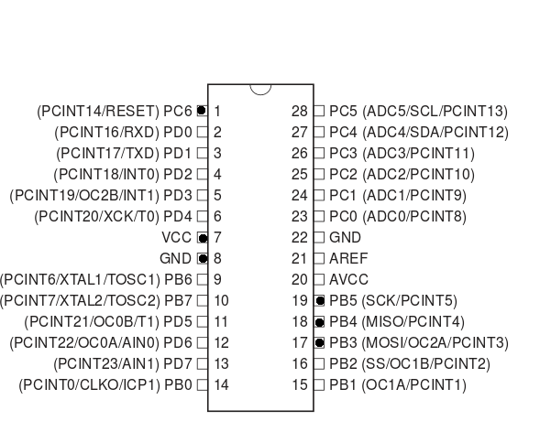

Atmega328 is the Microcontroller Chip used in Uno, its a 8 Bit AVR Microcontroller from ATMEL(Now Microchip). ... the number 328 is for 32KB code space, and the last digit 8 for 8bit architecture and the p is for picopower. Picopower is the new class consuming lowest power both in standby and sleep mode.
DS1820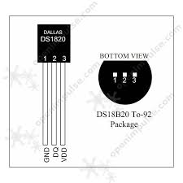

The DS1820 digital thermometer sensor provides 9-bit Celsius temperature measurements. The DS1820 communicates over a 1-Wire® bus that by definition requires only one data line (and ground) for communication with a central microprocessor. Provide the output DC current to the load when the diode is off.
In a boost converter the output voltage is greater than the input voltage. The boost converter required for the Solar Powered BLDC Driven Electric Vehicle needs 24V (from batteries connected in series) to 48V (required rated voltage of BLDC motor) the designed boost converter for the vehicle application.

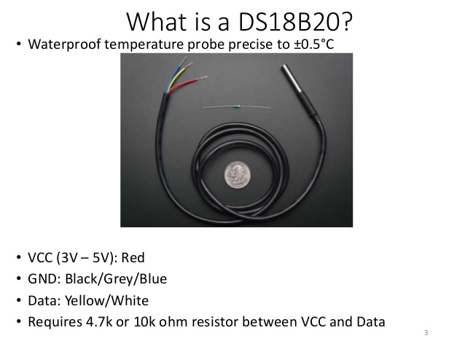

.this this solar energy .This solar energy is freely available in nature. Also an alternator is used in addition to solar panel to run the BLDC motor .This increases the generation of energy as well as the efficiency of motor.

Application & Advantages

- Noiseless and no fuel is required, hence pollution less operation.
- Low maintenance.
- With the help of natural resources electric vehicle is driven.
- It is ecofriendly.
- Using BLDC motor so, there are less losses as compared to other motors.

Result

Hence Overheating Fault protection of motor
is successfully overcome by using DS1820.

Conclusion

In this project we have to studied and implement the electric motor and it run successfully.

Future Scope

- We can implement this in three phase induction motor.
- Also we can implement this on large scale industries for safety protection purpose.

References

[1] Gagan Garg, Dr. Amrita Sinha, “An Improved Method for Protection of Three Phase Induction Motor using Microcontroller” 978-1-4799-5912-9/14/ ©2014 IEEE

[2] Kersting W.H., "Causes and effects of single-phasing induction motors," IEEE Transactions on Industry Applications, vol. 41, no. 6, pp. 1499-1505, Dec. 2005.

