A Complete Review of Distribution Static Synchronous Compensator: Controlling, Compensation strategies & its Application

Bhavna V. Dhandole¹, Ujwala V. Dongare²
¹M.Tech. Student, ² Associate Professor
Government College of Engineering, Amravati, India, 444 604

Abstract –In distribution system, need of reactive power compensation device is must. Because of sudden growth in utilization of power electronics, appliances used in energy distribution and generation, traditional devices provide degraded performance, which pave the path for advanced compensated devices. Distribution Static Synchronous Compensator (DSTATCOM) is one of such power custom device which is connected in shunt configuration at the load bus. Distribution Static Synchronous Compensator (DSTATCOM), which can be dynamically controlled and helps to improve power quality (PQ) problems. This paper discusses the various control strategies required to improve dynamic capabilities of DSTATCOM along with its modes of operation for various applications. Many research papers have been reviewed and applications of DSTATCOM are categorized. Typical applications are also presented in this paper.
Keywords- Distribution static synchronous compensator (DSTATCOM), voltage control, current control, power factor, power quality, voltage-source inverter.
I. INTRODUCTION
In Present days in distribution system, major power consumption is due to reactive loads like induction motor which is used in industrial, commercial and domestic sectors. Inductive loads draw more currents at lagging power-factor and hence it gives rise to reactive power burden in the distribution system. Whenever there is an increase in large inductive load, line current increases causing increase in line voltage drop and power loss. This causes a decrease in bus voltage. As other loads connected on the same bus get lower voltage, their performance is affected. Hence it is necessary to maintain the bus voltage constant. Hence need of reactive power compensation device is must. Among all controllers, Distribution compensator is the most effective and powerful device to address the issues related to power quality. [3-4]. It provides stability in the voltage by controlling reactive power, suppresses flicker noise and does compensation. The DSTATCOM can operate in two modes namely: voltage and current. The control algorithm which is used for voltage source inverter (VSI) switching [3] decides the effect of compensation. The DSTATCOM’s performance depends upon the control algorithms which are generally used to generate source current. An overview of recent control techniques which are available in literature used for DSTATCOM is described in this paper.
The structure of the paper is described. The classification of DSTATCOM is described in section II. The operating principle of shunt compensator is described in Section III and controlling & compensation techniques in Section IV. In section V, application of DSTATCOM are reviewed. The Future trends & conclusion of the literature are reviewed in section VI & VII respectively.
II. CLASSIFICATION BASED ON POWER QUALITY PROBLEMS MITIGATION
To compensate the PQ problems, DSTATCOM comes into picture. This includes voltage and current quality, harmonics distortion and load unbalanced problems like currents reactive component, unbalance and neutral current at PCC. The DSTATCOM can be made to operate in two modes: single and dual. In this paper, two modes of operation are used. The single mode provides compensation either current or voltage while dual mode provides compensation for both current and voltage. Thus DSTATCOM can be used in voltage control mode and in current control mode.
III. OPERATING PRINCIPLE OF DSTATCOM
DSTATCOM is one of the shunt connected custom power devices and consists of an inverter (voltage source inverter [VSI] is commonly preferred), DC-link energy storage device, output filter and a coupling transformer as shown in Fig. 1 [4]. VSI converts the DC voltage across the storage device into a set of three-phase AC output voltages. The generated voltages are in phase and interconnected with the utility grid through a coupling transformer. Proper adjustment of the phase and magnitude of the DSTATCOM output voltages allows effective control of active and reactive power flow between the DSTATCOM and the utility grid. The single phase equivalent circuit of a power system with a DSTATCOM is shown in Fig. 2. V1, V Coupling, VPCC and VS represent the inverter output voltage; the voltage drop caused by coupling impedance, the voltage at point of common coupling (PCC) and source voltage, respectively. If V1 is equal to VPCC, the reactive power exchange between DSTATCOM and utility grid is zero and the DSTATCOM does not absorb or generate any reactive power. When V1 is greater than VPCC, DSTATCOM performs an inductive reactance connected at its terminal. The current, flows through the transformer reactance from the DSTATCOM to the utility grid, and the device generates capacitive reactive power. If VPCC is greater than V1, DSTATCOM performs a capacitive reactance connected at its terminal. Then the current flows from the utility grid to the DSTATCOM, resulting in the device absorbing inductive reactive power [4-5].
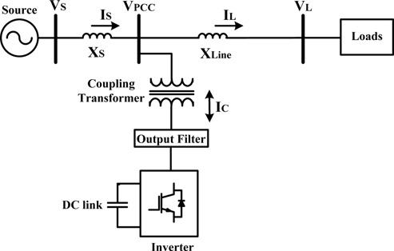
Fig.1- Distribution Static compensator schematic diagram
DSTATCOM can manage active power flow with the utility grid by adjusting the phase angle between the DSTATCOM output and the utility grid voltages. This exchange can be used to mitigate the internal losses of the inverter and to maintain the DC capacitor charged to the proper DC voltage and thus DSTATCOM output voltage magnitude can be adjusted. Fig. 3 illustrates the vector diagram of DSTATCOM at fundamental frequency for the transition states from inductive to capacitive mode and vice versa. The transition from capacitive to inductive mode is achieved by shifting the angle δ from zero to a positive value. The active power is transferred from the DC capacitor to the utility grid and causes a voltage drop in the DC-link. The transition from inductive to capacitive mode is obtained by shifting the angle δ from zero to a negative value. The active power is transferred from the utility grid to the DC capacitor and this case causes a voltage rise in the DC-link [6]. In practical applications, power losses are not negligible. The losses on transformer windings and inverter switches are the main types of losses encountered in DSTATCOM. A small phase angle difference between VPCC and VC is added to the compensation signal to suppress these losses [7]. The power flow between the DSTATCOM and utility grid is related with DSTATCOM output voltage VC, the utility grid voltage VPCC and their phase angle differences as illustrated in Table 1 [6].
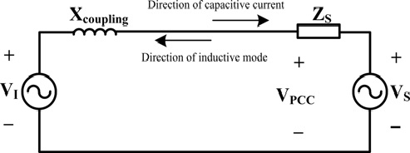
Fig. 2 -DSTATCOM in a single phase power system
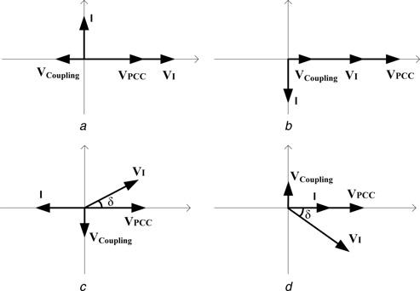
Fig.3- Vector diagram of DSTATCOM in 4 modes:
1) Capacitive mode 2) Inductive mode 3) Active power released 4) Active power absorption
Voltage Relation | Power exchange
 | Dstatcom | $$↔$$ | Utility grid
$$\left|V1\right|>\left|VPCC\right|$$ | Q | $$→$$ | Q
$$\left|V1\right|<\left|VPCC\right|$$ | Q | $$←$$ | Q
$$δ<0$$ | P | $$→$$ | P
$$δ>0$$ | P | $$←$$ | P
Table 1. Specified conditions for power exchange between DSTATCOM and utility grid
IV. CONTROLLING & COMPENSATION STRATEGIES
a. Voltage control Strategies
A voltage control strategy uses multiple DSTATCOMs applied to a low voltage (LV) network in order to boost voltage support. The multiple DSTATCOMs shared the required reactive power; the approach is promising as it requires minimum reactive power [8]. A voltage controlled hybrid DSTATCOM of reduced rating, multiple features and with the ability of a single shunt compensator to alleviate several PQ problems are investigated in [9]. There is a connection of an external inductor between source and the load, which reduces the current requirement for mitigation of voltage sag and enhances the DSTATCOM voltage regulation bandwidth. An algorithm is proposed which is multi- functional and has an indirect control of the source currents while operating normally in order to mitigate PQ problems arise due to current and load terminal voltage. It is constant at the instances of voltage disturbances.
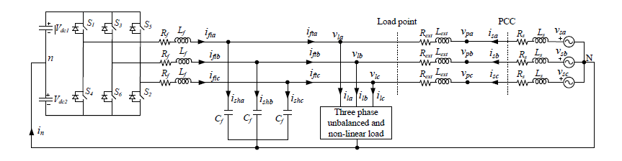
Fig. 4 – Equivalent circuit of Distribution static compensator in three phase distribution system.
A stiff source connected load using a DSTATCOM is likely to have voltage disturbances. This is done by joining source, an external inductance and the load of suitable value in series. A multiple feature DSTATCOM with stiff source and which operates in voltage control mode. Also, it provides fast regulation of voltage at the time when disturbance in voltage appear across load terminals defined in [10]. It protects critical loads and during normal operating conditions, source currents can also be controlled by generated reference load voltages. In order to achieve source power factor to unity, DSTATCOM also provides the load current reactive and harmonic components. The outcomes are able to address PQ issues related to voltage and current.
In order to produce DSTATCOM reference voltage in voltage control mode operating condition, a new control scheme is proposed in [11]. There are several advantages of this scheme over existing DSTATCOM, which is voltage controlled, DSTATCOM for which 1.0 p.u is taken randomly as the reference voltage. The injection of lower currents in compensator and at the load terminal, unity power factor (UPF) under normal condition can be achieved. The later leads to reduce losses of the feeder and VSI. An uphold in the DSTATCOM rating is achieved resulting in increase of its ability in mitigating voltage sag. The scheme has advantages of providing correction in power factor, elimination in harmonics, balancing loads and regulation of voltage proportional to the load requirement.
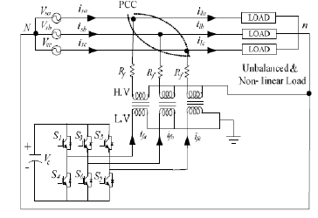
Fig. 5 - DSTATCOM (Three leg three phase inverter with a single dc capacitor) [14]
A three phase DSTATCOM which is based on modular multilevel converters (MMC), uses voltage control strategy, is described in [12]. The method to solve the unknown modulation index and circulation current of the electrical quantities is also illustrated in this paper. The sets of phase messages are used as compared to output current across each in voltage control loop which leads in reduction of number in data communication resources and current sensors. It is advantageous as number of MMCs module increases in the actual engineering application. An adaptive control system is developed in [13] for a standalone power generation system (distributed) fed by an induction generator (self-excited). This is applied to regulate voltage. A four-leg shunt compensator is connected to the AC bus, used to perform the voltage regulation.
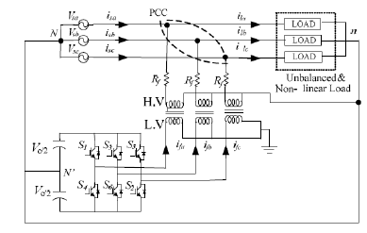
Fig. 6-DSTATCOM with two separate dc capacitor [14]

The proposed adaptive controller provides voltage regulation with respect to parameters variations like connecting and disconnecting of load, also variation of induction generator's parameters.
The paper in [8, 10] uses multiple DSTATCOMs to share the reactive power and for providing the voltage control. Multiple feature DSTATCOM are proposed in [8-9] which provides both voltage and current source control in order to mitigate PQ problems and voltage control for three phase is provided in [10] using single DSTATCOM to generate reference of a voltage controlled [11] source.
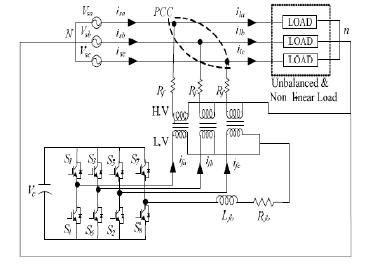
Fig.7- Three phase equivalent circuit of DSTATCOM with four leg inverter [14]

b. Current Control Strategies

An id-iq based control algorithm is proposed in [15] for the active and the reactive power control in time varying environment. The load fluctuations are compensated by DSTATCOM. This scheme of control algorithm enhances steady state performance and useful elimination of PQ disturbances. In order to regulate time varying active and reactive power control, an extra current control loop system is used under the fluctuations of load.
A DSTATCOM (3-phase 4-wire) configuration in current control mode containing an inverter and neutral points (three level) clamped is proposed in order to compensate load and to enhance the PQ [16]. The synchronous detection method is used to analyze the shunt compensator characteristics. This scheme provides complete sinusoidal source currents, in presence of distorted conditions. All three different approaches are analyzed for both unbalanced and non-linear load conditions with equal power, equal current and modified equal current. This modified equal current approach is better as compared to others even in the presence of highly distorted and unbalanced source voltages.

Inverter Technologies for DSTATCOM
The paper in [16] and [17] implements different inverter topologies under non-linear load conditions for high voltage distribution system. The high voltage and low voltage distribution system using single dc capacitor are not capable of providing full compensation with three phase and three legs VSI as shown in Figure 5. This drawback is overcome by using neutrally clamped DC capacitor topology. It still suffers from unbalanced capacitor that brings the requirement of an extra circuit for balancing and affects the overall cost of compensator cost given in Figure 6. The load neutral current is compensated using a 3-phase 4-leg VSC with the requirements of coordination between third leg and fourth leg as shown in Figure 7.
The DSTATCOM, five level inverter configuration uses a fuzzy logic controller that improves the PQ as done in [18]. The inverter with five level switching signals is generated using space vector modulation (SVM) method. The fuzzy controller uses operator’s knowledge which is different from conventional controller that uses mathematical equations that significantly increases the stability of power system.

V. APPLICATIONS OF DSTATCOM

This is classified into following categories-
1. Harmonic reduction;
2. Voltage control;
3. Load balancing and
4. Reactive power compensation
Predictive current control strategy is developed for DSTATCOM to improve power quality in distribution system [18]. DSTATCOM has two modes of operation, namely current control mode (CCM) and voltage control mode (VCM). Interactive DSTATCOM provides smooth transfer of modes of operation while remaining connected in the distribution system [19]. Use of DSTATCOM to control voltage in distribution system in an interactive manner is contributed [19]. Reactive power compensation in distribution network is also studied by various researchers.
VI. FUTURE TRENDS
The DSTATCOM can solve voltage and current related power quality problems such as harmonic elimination, load balancing, voltage regulation, power factor correction and neutral current compensation in distribution system. However, the high cost of DSTATCOM is the main obstacle for its wide implementation especially for developing countries trying to improve power quality of power system. Hence in future extensive research work needs to be undertaken by researchers to reduce the cost of DSTATCOM without affecting the performance efficiency. Also use of neural networks in control techniques of DSTATCOM is likely to be widely used in the future. Renewable energy (RE) penetration into the electric utility grid is increasing day by day and intermittent nature of these resources affects the quality of supplied power. The weather conditions such as wind speed variations and variable solar insolation affect the power output of RE sources. Implementation of DSTATCOM in RE based power system are required to be explored more. In future an important area of research would be the deployment of DSTATCOM in charging stations for hybrid and electric vehicles.

VII. CONCLUSION
The paper is a comprehensive review on the DSTATCOMs in order to improve the PQ problems. The review of DSTATCOM papers in literature are valuable to reduce both current and voltage generated PQ problems. The voltage control strategies, current control strategies are reviewed. Evolution of control strategies and their execution with multiple function compensation potential are the areas on which research can be focused in future to mitigate the various PQ problems using DSTATCOMs. Literature review of applications of DSTATCOM in distribution system is presented in this paper. It can be concluded from this paper that DSTATCOM is a versatile equipment for power quality improvement in distribution system. The future trends in applications of DSTATCOM are also included.

REFERENCES
- M. Bollen, Understanding Power Quality Problems. NewYork, NY,USA: IEEE Press, 2000, ch. 1, pp. 1–35.
- Akagi, Y. Kanazawa and A. Nabae," Instantaneous reactive power compensator comprising switching devices without energy storage components," IEEE trans. Industry Application Vol. IA20, pp. 625- 631, May 1984.
- Mahesh K. Mishra , Arvind joshi and Arindam ghosh, " A new Algorithm for active shunt filters using Instantaneous reactive power theory, " in proc. IEEE power engineering review, December 2000, pp .56-58.
- Masdi, H., Mariun, N., Bashi, S.M., Mohamed, A., Yusuf, S.: „Construction of a prototype DSTATCOM for voltage sag mitigation‟, Europ. J. Sci. Res., 2009, 30, (1), pp. 112–127
- Mahyavanshi, A., Mulla, M.A., Chudamani, R.: „Reactive power compensation by controlling the DSTATCOM‟, Int. J. Emerg. Technol. Adv. Eng., 2012, 2, (11), pp. 212–218
- Acha, E., Agelidis, V.G., Anaya-Lara, O., Miller, T.J.E.: „Power electronic control in electrical systems‟ (2002), Newnes, 464 p.
- Gupt, S., Dixit, A., Mishra, N., Singh, S.P.: „Custom power devices for power quality improvement: A review‟, Int. J. Res. Eng. Appl. Sci., 2012, 2, (2), pp. 1646–1659 [33] Mohammed BarghiLatran ,AhmetTeke, YelizYoldas: „Mitigation of power quality problems using distribution static synchronous compensator: a comprehensive review‟, IET Power Electron., 2015, Vol. 8, Iss. 7, pp. 1312–1328
- G. Mokhtari, G. Nourbakhsh and A. Ghosh, “ A Coordinated Voltage Support Strategy for LV Network with Multiple DSTATCOMs”, Australasian Universities Power Engineering Conference, AUPEC 2013, Hobart, TAS, Australia, 29 September - 3 October 2013, pp.
- C. Kumar and M. K. Mishra,“A Multi-Functional DSTATCOM Operating in Voltage Control Mode”, 2013 IEEE 8th International Conference on Industrial and Information Systems, ICIIS 2013, Aug. 18-20, 2013, Sri Lanka, pp. 271-276.
- C. Kumar and M. K. Mishra, “A Multifunctional DSTATCOM Operating Under Stiff Source”, IEEE Transactions On Industrial Electronics, vol. 61, no. 7, July 2014, pp. 3131-3136.
- Chandan Kumar and Mahesh K. Mishra, “A Voltage-Controlled DSTATCOM for Power-Quality Improvement”, IEEE Transactions on Power Delivery, VOL. 29, NO. 3, JUNE 2014, pp. 1499-1507.
- Chen Xu, Ke Dai, Yong Kang and Cong Liu, “Characteristic Analysis and Experimental Verification of a Novel Capacitor Voltage Control Strategy for Three-Phase MMC-DSTATCOM”, pp. 1528-1533.
- Lucas G. Scherer, Rodrigo V. Tambara, Fernando Botteron, Robinson F. de Camargo, Hilton A. Grundling, “Discrete-time Adaptive Control Applied to Voltage Regulation of Induction Generator Based Systems”, pp. 4940-4946.
- NiveditaPande , ReshamTondare, S.P.Gawande, M. R. Ramteke and P. D. Debre “Analysis of Conventional Inverter Topologies for High Voltage Distribution System in Shunt Applications”, 2015 IEEE Power, Communication and Information Technology Conference (PCITC) Siksha ‘O’ Anusandhan University, Bhubaneswar, India,
- Mohit Bajaj, Mukesh Pushkarna, Ankur Singh Rana, Mohd. Tauseef khan, “A Modified Algorithm for Time Varying Reactive Power Control and Harmonics Compensation by D-STATCOM”, IEEE INDICON 2015, pp. .
- [27] Nivedita S. Pande, S. P. Gawande, M. R. Ramteke, “ Control of D-STATCOM under Unbalanced and Distorted Voltages using Synchronous Detection Method for Load Compensation”, IEEE International Conference on Recent Advances and Innovations in Engineering (ICRAIE-2014),May 09-11, 2014, Jaipur, India, pp. 1-6.
- R. P. Tondare, S. P. Gawande and M. R. Ramtek, “Analysis of Conventional Inverter Topologies in Shunt Applications for Unbalanced and Non-linear loads”, 2013 Third International Conference on Advances in Computing and Communications
- N. Henini, F. Benzerafa A. Tlemçani, “Design and Simulation of Five-level Inverter based DSTATCOM Using Fuzzy Logic”, 2015 6th International Renewable Energy Congress (IREC). J. Rodríguez, J. Pontt, C. Silva, P. Correa, P. Lezana, P. Cortés, and U. Ammann, “Predictive current control of a voltage source inverter,” IEEE Trans. Ind. Electron., vol. 54, no. 1, pp. 495–503, Feb. 2007.
- Chandan Kumar and Mahesh Mishra, “Operation and control of an improved performance interactive DSTATCOM”, IEEE Transactions on Industrial Electronics, 2015.
- Chandan Kumar, Mahesh K. Mishra, and Marco Liserre: „Design of External Inductor for Improving Performance of Voltage-Controlled DSTATCOM‟,IEEE Transactions On Industrial Electronics, Vol. 63, No. 8, August 2016

