IOT BASED SMART AGRICULTURE SYSTEM
Mohammad Aaquib Mohd Javed¹, A. D. Vishwakarma², Shafeeque Ansari³, V. D. Chaudhari⁴
¹PG Scholar, VLSI and Embedded System Design, ^{2,3,4} Faculty, E&TC department
^{1, 2,3,4} E&TC Engg department, GF’s Godavari College of Engineering, Jalgaon, Maharashtra, India
a.aaquib18@gmail.com¹, anil18vishwakarma@gmail.com ²

Received on: xxxx,20xx, Revised on: xxxx,20xx, Published on: xxxx,20xx

Abstract — In this paper a new kind of device is proposed to an area of farming which is a smart agriculture system using IOT, in a existing system, our farmers uses a traditional methods like manual distribution of seeds, manually gives the water to seeds and also there are the chances of theft, all this leads to low productivity of products. So by using this proposed system our farmers can increase the productivity, avoid the theft chances and increases the quantity and quality of agricultural products.This system uses the various sensors like temperature sensor, moisture sensor, Motion sensor and water level sensor. The data collected from these sensors are provided to the controller, in control section, the received data from various sensors is compared with the threshold values in the program and based on that the controller will take the required action and updating the status of water pump and soil moisture will take place and information will be displayed.
Keywords - Temperature Sensor, Moisture Sensor, Motion Sensor, Water Level Sensor, Atmega328P Controller
- introduction
Agriculture plays a very important role in the growth of our country, in the recent time it has observed that we need to double our food productivity, thus it is required to place a new technologies to improve the food production. This system proposed a smart farming method in a limited area by using sensor nodes like temperature & humidity sensor and soil moisture sensor. we have developed this system by keeping in mind minimum cost and provide a platform through which we can monitor the different parameters of the field through the internet over IOT.
This proposed system consists of various sensors like temperature sensor, moisture sensor, motion sensor and water level sensor based on the data given by these sensors to controller, if moisture level is low then the controller switches on water pump to provide water to the plant. When the soil moisture sensor sense enough moisture in the soil then water pump gets automatically turn off and a message will send to the genuine person through IOT module and the status of a water pump and soil moisture get automatically updated.. This system also consists of theft detection facility by using Motion detector sensor that will detect the entering of any unknown person if the person enters into the field.
- LITERATURE REVIEW
The existing method and one of the oldest ways in agriculture is the manual method of checking the parameters. In this method the farmers they themselves verify all the parameters and calculate the readings. [1] a paper in which makes use of wireless sensor networks for noting the soil properties and environmental factors continuously. This concept is created as a product and given to the farmer’s welfare. [2] a paper in which the Microcontroller transmits that information on the internet through a network of IOT in the form of Wi-Fi module. This enhances automated irrigation as the water pump can be switched on or off through information given to the controller. [3] A paper in which proposed wireless robot is equipped with various sensors for measuring different environmental parameters. The main features of this novel intelligent wireless robot is that it can execute tasks such as moisture sensing, scaring birds and animals, spraying pesticides, moving forward or backward and switching ON/OFF electric motor. [4] It focuses on developing devices and tools to manage, display and alert the users using the advantages of a wireless sensor network system. [5] The highlighting features are smart GPS based remote controlled robot to perform tasks like weeding, spraying, moisture sensing, human detection and keeping vigilance. [6] The cloud computing devices that can create a whole computing system from sensors to tools that observe data from agricultural field images and from human.[7] This idea proposes a novel methodology for smart farming by linking a smart sensing system and smart irrigator system through wireless communication technology.[8] It proposes a low cost and efficient wireless sensor network technique to acquire the soil moisture and temperature from various location of farm and as per the need of crop controller to take the decision whether the irrigation is enabled or not. [9] it proposes greenhouse farming through a wireless sensors which is simple and low cost system. [10] It proposes soil moisture measuring technology to measure the amount moisture presents through the wireless technology.
- PROPOSED SYSTEM
The system is aimed to have two different sections or blocks, and a central computer or mobile application to control and monitor the entire system. Each of these blocks/nodes comprises of different sensors and devices and they are further connected to one central server via wireless ESP8266 WIFI modules. The central device sends and receives information from user end using internet connectivity. The system operates mainly on two modes, namely: automatic mode and manual mode. In the automatic mode, the system takes its own decisions while controlling the various devices, while in manual mode, the user can himself operate the system with the help of a mobile app or PC commands. This Proposed system allow to monitor and control different parameters of a field such as temperature, Moisture, motion detection of a person and water level detection in the tank and based on the defined values in the software of different sensors system will control these parameters and data will be sent to the user
- SYSTEM STRUCTURE AND PROTOTYPE DESIGN

- hardware Structure:
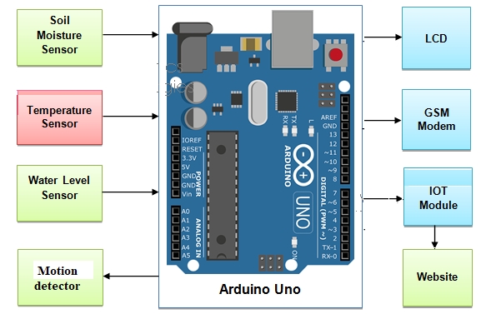
Fig. 1 - fig shows the diagram of proposed system
- Controller Arduino uno (LPF328P): Arduino is an open-source electronics platform which is based on easy-to-use hardware and software. In this system Atmega LPF 328P controller is used to control all the parameters of the system.

- Temperature sensor and Humidity sensor (DHT11):
The DHT11 humidity and temperature is a type of sensor which is used to measure the humidity and temperature of environment with accuracy. After sensing the respective parameters it provides output to controller.
Humidity Range: 20-90% RH, Temperature Range: 0-50 °C
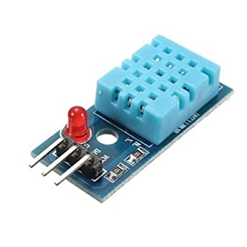
Fig. 2 - fig shows the Temperature and Humidity sensor
- Soil Moisture Sensor: Soil moisture sensor is a sensor which senses the moisture content of the soil. The sensor has both the analog and the digital output. The digital output is fixed and the analog output threshold can be varied. It works on the principle of open and short circuit. The output is high or low indicated by the LED.

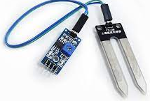
Fig. 3 - fig shows the Soil moisture sensor

- Motion detector sensor (PIR): All objects with a temperature above absolute zero emit heat energy in the form of radiation. It is invisible to the human eye since it radiates infrared wavelengths. It is used to detect the movement of people, animals or other objects. When a human passes in the field, the temperature at that point will rise from room temperature. The sensor converts the resulting change into a change in the output voltage and this triggers the detection.

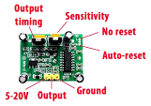
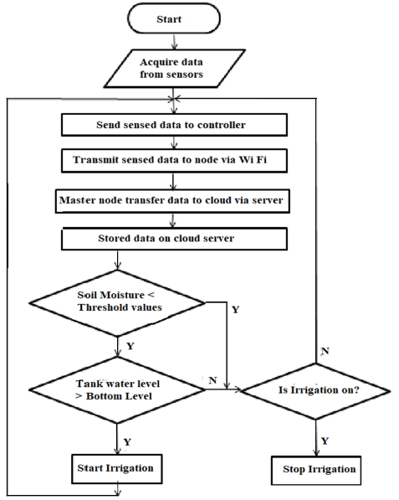

Fig. 4- fig shows the Motion detector sensor
- Water Level Sensor:
HC-SR04 is an ultrasonic sensor mainly used to determine the distance of the target object. It measures accurate distance using a non-contact technology – A technology that involves no physical contact between sensor and object.

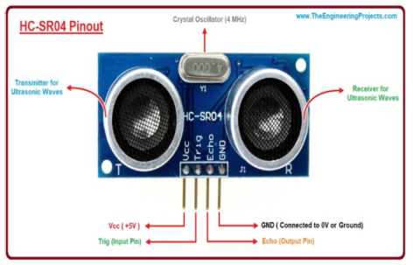.
Fig. 5- fig shows the Water Level Sensor
- GSM Module: It provides a communication channel to transmit product tag messages, temperature, geography location messages or emergency rescue messages, and receives commands from the transport company or the remote monitor centre.
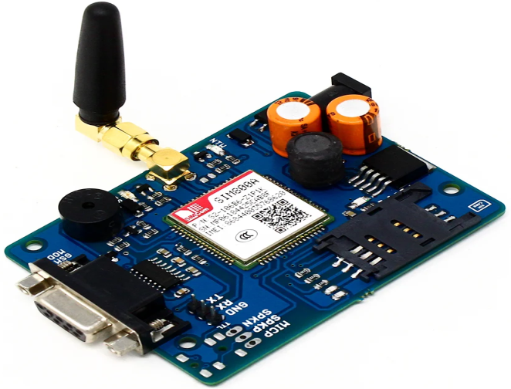
Fig. 6- fig shows the GSM Module

- Operational Flow Chart:

Fig. 7- fig shows the Flow Chart

- INTERNET OF THINGS

The Internet of Things (IOT) is an environment in which objects, animals or people are provided with unique identifiers and the ability to transfer data over a network without requiring human-to-human or human-to-computer interaction. IOT has evolved from the convergence of wireless technologies (MEMS) and the Internet. Concept may also be referred to as the Internet of Everything. A thing, in the Internet of Things, can be a person with a heart monitor implant, a farm animal with a biochip transponder, an automobile that has built-in sensors to alert the driver when tire pressure is low. Android application is used that will shows the entire information about the field in terms of temperature soil moisture and water level in the tank. Also we use C language programming to write the codes of system.
- result & DISCUSSION

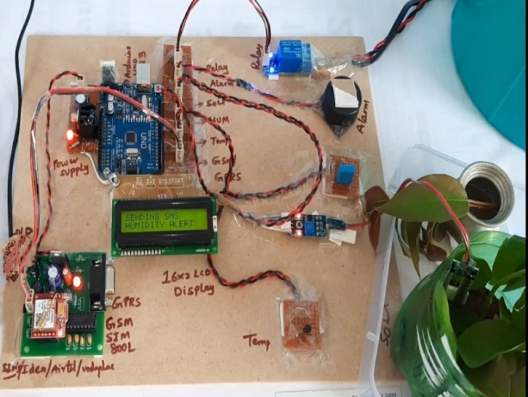
Fig. 7: Sensors attached with plant

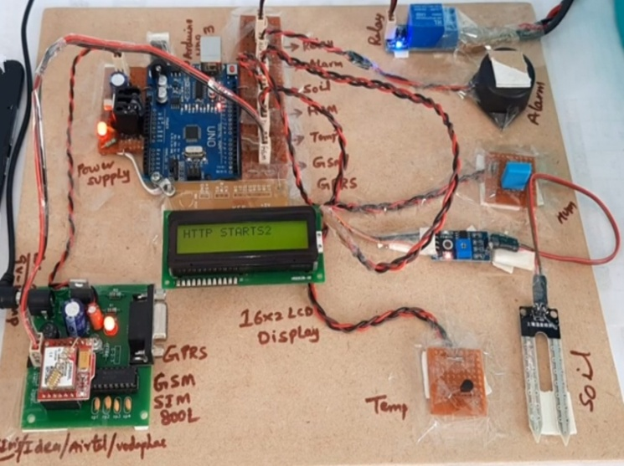
Fig. 8 - fig shows Actual Images of Proposed System

This system is useful to monitor the parameters for agriculture such as temperature, humidity, moisture, leaf growth, spray the water and pesticides through the motor pump via IOT module. The system reduces the manual work, man power. This set up was carried out using Arduino UNO, Temperature and Humidity sensor, soil moisture sensor, ultrasonic sensor and IOT module. The Thing Speak page can be developed to control the system through the mobile. Damage caused by predators is reduced and also be used to increase the productivity. The system is integrated with ultrasonic sensor to monitor the health of the plants; one can observe their plants anytime, anywhere in the web.
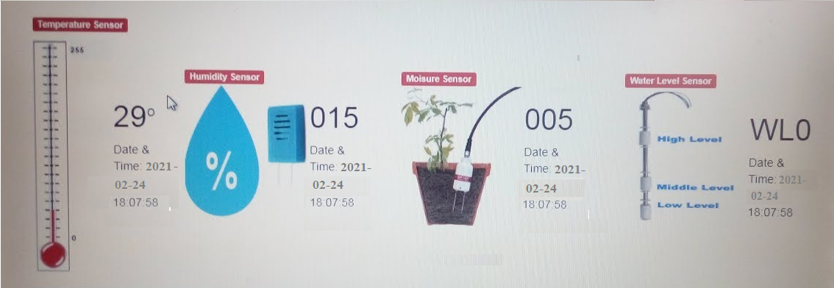
Fig. 9 - fig shows the message form system
- IMPORTANT FEATURES
1. Smart agro-logistic:
It is all about smart flooding and agri-business. It focuses on servicing fresh product quality and natural production process with flexible chain- and compassing tracking and tracing system.
2. Smart Farming:
Using data mining and big data analysis, we can collect data for different parameter helping us to answer which crops are better suited for this particular places and which season. Using sensors and device on the livestock can maintain the health which directly benefits farmers.
3. Crop Monitoring:
Using IOT technique we can monitor the quality of crop which thus increases the food production. It introduces the use of appropriate method into agriculture sector and better crop production by collecting real-time quality of crop and informing farmers about their crop growing status.

- FUTURE SCOPE
In Future, new hardware like the corn-tending robot is making strides by pairing Data-collecting software with robotics to fertilize the corn, apply seed cover-crops, and collect information in order to maximize yields and minimize wastes. IOT sensors capable of providing farmers within formation about crop yields, pest infestation and soil nutrition are invaluable to production and offer the precise data.

- CONCLUSION
Through the smart farming concept it is making beneficial to get important information which will increase the quality the crop. Many land owners must comprehend the capability of Iot usage for farming by introducing smart innovation to increase output. The need for increasing productivity can be fulfilled if the user can uses IoT technology in a proper manner.The sensors and microcontroller interfaced and wireless communication can be achieved between various nodes. This project is a complete solution to required field activities and all irrigation problems. Implementation of such a system in the field can definitely help to improve the yield of the crops, overall production and reduces the man power in the field

REFERENCES

[1] N.Suma, Sandra Rhea Samson, S.Saranya, G.Shanmugapriya, R.Subhashri “IOT BasedSmart Agriculture Monitoring System” International Journal on Recent and Innovation Trends inComputing and Communication , Volume: 5 Issue: 2, pages: 177 – 181 .
[2] Muthukumaran. N and Ravi. R, 'Hardware Implementation of Architecture Techniques forFast Efficient loss less Image Compression System', Wireless Personal Communications,Volume. 90, No. 3, pp. 1291-1315, October 2016, SPRINGER.
[3] V.VinothKumar, R.Ramasamy “Implementation of Iot In Smart Irrigation System UsingArduino Processor” International Journal of Civil Engineering and Technology (IJCIET).
[4] K.Lakshmisudha, Swathi Hegde, Neha Kale, Shruti Iyer, “Smart Precision BasedAgriculture Using Sensors”, International Journal of Computer Applications (0975- 8887), Volume 146-No.11, July 2011
[5] Nikesh Gondchawar, Dr. R.S.Kawitkar, “IoT Based Smart Agriculture”, International Journalof Advanced Research in Computer and Communication Engineering (IJARCCE), Vol.5, Issue6, June 2016.
[6] M.K.Gayatri, J.Jayasakthi, Dr.G.S.Anandhamala, “Providing Smart Agriculture Solutions toFarmers forBetter Yielding Using IoT”, IEEE International Conference on Technological Innovations in ICTfor Agriculture and Rural Development (TIAR 2015).
[7] Chetan Dwarkani M, Ganesh Ram R, Jagannathan S, R. Priyatharshini, “Smart FarmingSystem Using Sensors for Agricultural Task Automation”, IEEE International Conference onTechnological Innovations in ICT for Agriculture and Rural Development (TIAR 2015).
[8] S. R. Nandurkar, V. R. Thool, R. C. Thool, “Design and Development of PrecisionAgriculture System UsingWireless Sensor Network”, IEEE International Conference on Automation, Control, Energy andSystems (ACES), 2014.
[9] D.D.Chaudhary1, L.M.Waghmare, “Application of wireless sensor networksfor greenhouse parameter control in precision agriculture”, International Journal of Wireless &Mobile Networks (IJWMN) Vol. 3, No. 1, February 2011.
[10] Q. Wang, A. Terzis and A. Szalay, “A Novel Soil Measuring Wireless Sensor Network”, IEEE Transactions on Instrumentation and Measurement, pp. 412–415, 2010
[11] Ji-woong Lee, Changsun Shin, Hyun Yoe, ”An Implementation of Paprika Green house System Using Wireless Sensor Networks”, International Journal of Smart Home Vol.4, No.3,July, 2010.
[12] Mahesh M. Galgalikar, “Real-Time Automization Of Agricultural Environment for SocialModernization of Indian Agricultural System”, 978- 1-4244-5586- 7/10/$26.00 C 2010 IEEE.

