Online Challan Generation System Based On Machine Learning

Dr. Sonali Ridhorkar¹, Khushi Gupta², Kalyani lokhande³, Prachi Bhanarkar⁴, Vijeta Meshram⁵, Venuhemane⁶

¹HOD, ^{2,3,4,5,6} UG Student Department of Computer Science & Engineering, G H Raisoni Institute of Engineering & Technology, Nagpur, India,

sonali.ridhorkar@raisoni.net

Received on: 11 June ,2022 Revised on: 02 August ,2022, Published on: 06 August ,2022

Abstract – This paper is centred on traffic e-challan system, as for the number of traffic rules violations, there are traffic police on every square to control the traffic, even after many accidents due to traffic rules violation, overspeed of vehicles, triple seats, without helmets, drunk drivers, etc. every day. This problem needs to be resolved and there should be strong supervision on violators to stop further accidents and violations of traffic rules. To overcome this major issue here system with the idea of the E-Challan Generation System which will help the traffic police department to catch the violators using licence plate detection (number plate detection) and face detection of the person violating the traffic rules. In this proposed system OpenCV and Python along with Convolutional Neural Network (CNN), KNN algorithms are used to classify the image captured by the webcam to generate the required output for an e-challan generation. The challan will be generated instantly against the violator after detecting the vehicle’s licence plate (number plate), then the challan will besent online to the person and can pay it via any payment method. If the fine dues were not cleared within the stipulated period, the vehicles could be seized and ownership transfers or selling of vehicles would become difficult. This will reduce the workload of the government and help in reducing corruption.

Keywords - e-challan, licence plate, traffic, rules violations.
I - INTRODUCTION
Due to vast increase inthe urbanisation or population day by day and hence the vehicles are also increasing as per the human needs. More vehicles on the road, the more traffic jams and accidents will take place. Corruption has also increased due to cash transactions on road, paper wastage due to challans no strict action against violators. The growing wide variety of motors in cities can motivate a high extent of traffic and means that site visitors violations become extra essential these days in Bangladesh and also around the sector. This causes excessive destruction of property and more injuries which can endanger the lives of human beings. To resolve the alarming hassle and prevent such unfathomable outcomes, site visitors' violation detection systems are wished. For which the machine enforces right site visitor’s rules always, and recognizes those who no longer comply.
A traffic violation detection machine should be realised in actual time because the government tunes the roads all the time. Consequently, site visitor’s enforcers will now not only be cosy in enforcing safe roads appropriately but also efficiently; as the visitor's detection system detects violations faster than humans. This gadget can stumble on visitors' mild violations in real-time. A consumer-friendly graphical interface is associated with the system to make it simple for the consumer to function the machine, monitor traffic, and take motion in opposition to the violations of visitor’s policies

II -LITERATURE REVIEW

In this paper, it is discussed about the online platform for E challan system, which is a web-application the system allows the access to stakeholders, vehicle and license details for challan. This system provides three users that are traffic police person, drivers and system administrator in this the traffic police have been provided login details by the administrator. The drivers of the vehicles can sign-up with their details asked and can generate the login ID and password for self and the system administrator also can login using their ID and password, the administrator can get the details of personnel. The system provides personnel login page, challan page and payment by driverpage[1].The aim of this paper is to develop challan by using Optical Character Recognition (OCR) which is an android application as well as a web application. The system detects the violations and creates the e-challan then it stores and transfers the data to the readers and the owner of vehicle can pay the fees either to RTO office or online payment. So, therefore for carrying out the management for the system the database is kept for reducing paper work and corruption of traffic police. In android application the system provides login page for officer and to create a challan it catches the image of violator’s number plate then collects data from database and creates challan, the violator can pay online as well as going to RTO. In web application system provides dashboard page for the officers.[2].
There is rapid growth in urbanisation and causes a vast migration to the cities. And so that gradually growing population results in growing vehicle numbers. And due to the increasing number of vehicles there are increasing in traffic and violations will occur more. This result in a lot of accidents on road and grief in society. So to reduce such a type of problem in our city we can make an automatic e challan generation system by detecting no plates of vehicles. And it helpsto be more careful about driving and strictly allow to follow the traffic rule and will reduce the number of accidents on roads. So, thispaper presents a discussion of various no plate detection,object detection and e challan generation methods [3]. In the digitization process we can converts anything which is in hardcopy into digital format. means that, it can convert a format of moving paper copies of patient records into a digital format which can be processed by machine orthecomputer. Onother hand automation improves the processes which are already offered.it holds the devices such as software and count it in a series of rules which are written by experts (business subject matter) to fulfil the various tasks without any human involvements.[4]. This project of Our E-challan generation system is based on PLC (programmable logic controller). the main of our project is to control the violation of vehicles correctly penalising the vehicles violators.so this will reduce the workload of traffic police departments. In this proposedsystem, there are two types of vehicles violation.one is traffic signal violation and another is Toll collection lane rule violation.in the first step the vehicles which will run red light will be detected by using RFID (radio frequency identification) readerand by using this RFID reader it will input the PLC by scanning that tag placed on vehicles. The database will be created in the programwhenever RFID scanner inputs the vehicles,then PLC will suddenly compare the detected barcode with that input which is fill in the databaseand in the second stepthose vehicles will breaking the toll-collection line rule will be accurately detected.so likewise the first step the difference will be started with the data which will inputted in the database.The Database contains the details of the Vehicles.[5].In this paper,in daily life people face many problems, caused due to Traffic Rule violations by Public, traffic rule neglected. The major reason of road accidents is people not following traffic rules. The road side corruption also increases and the receipt which is used by police is also fake. They are not used as Government receipts. Lots of paper is wasted. Our E-challan systemsolves all those problems. The automatic E-challan is generated and sent to that owner who breaks the traffic rules, in this process no man power is used. They are fully automatic so the aim of our system is to reduce them. Accident, to reduce corruption and to reduce the paperwork [6]. The E-challan systemis focusing efforts on characterising these violations in India cities. In this work,system present characterization of the traffic violation and Automated E-challan. Generating this system for police department and our own use. It can be easily installed in any system. It is easy to use against public who violate the traffic rules and it can store details of traffic rules and it can store details of traffic rules and fines collected from public. We can get the total fines collected per day or week. In this system we can get direct challan to mobile number and owner of vehicle can pay online and they receive receipt online. It reduces paper work.[7]. The E-Challan Generation System project is about paying online challan. Manual challan includes paperwork which is difficult to provide challan to driver and maintain the records. So, here comes the E-challan platform which has a very effective amount, violation record of the driver and monitoring the other traffic penalties. This results in reducing difficulties faced by the manual process and increasing the effectiveness of the user-friendly E-challan platform [8].This system involves automatic detection of vehicle that break the rules of traffic at signals. Thenthe registration number of every vehicle is recognized. And the number plates of vehicle are detected will searched in the database for the vehicles types and information of the owners. And this information will be used to generate the e-challan in the respective name of that particular person. And directly send the appropriate WhatsApp message to the vehicle owner. It will be more efficient and require the less human involvements [9].Traffic rules is only name no one can follow it. People not carry helmet, travel three person in one bike, in signal they break the rules. All things arehappened in road no one can care about it. Traffic police are corrupt in area they give fake receipt. Paper also was in it. E-Challan solve the problem. The E-Challan is fully automatic no manpower required. When someone break the rules than E-Challan is generated and with the help of Email and WhatsApp send the Challan E-Challan help to reduce corruption in road, reduce accident. E- challan is solution for traffic rules breaks.
[10].

The methodology discussed in research papers, carry out the detailed study of e-challan systems to work on automated online challan systems. Licence number plate detection technique using OCR (Optical Character Recognition). Research paper about the gradually growing number of population results in an increasing number of vehicles. Study of automated systems. The system proposed by the author works on controlling traffic violations and generating online challan that help to faster workflow and reduce paperwork. This system based on the generating automated challan against violators by capturing in webcam and send the WhatsApp massage and e-mail to the violator.

III - METHODOLOGY

Existing System:

Before selecting this project title as per the study all the aspects of the ongoing e-challan generation system and found advantages as well as disadvantages of this particular system by asking people’s experience and observing it closely.

After the research and study, it is found that the system is 80% manual with 20% automatic working. Where the system is depending on human surveillance. The CCTV cameras are to record live videos and the person in the operator room will keep an eye on the activities going on in the cameras. If the operator notices something suspicious or someone violating traffic rules, he/she instantly takes a screenshot and then checks for the RTO database to find out the violator information related to the licence number of the person, name, mobile number and email id and then sends an e-challan on his/her registered mobile number via text message.

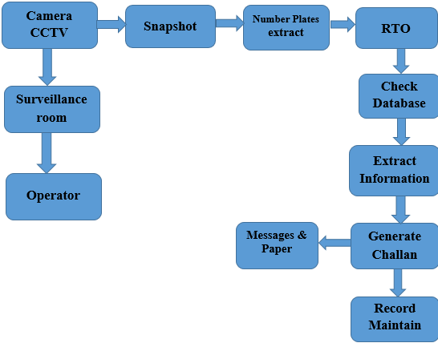
Fig. 1 -Existing System of E-Challan

Suggested System:

As shown within the below discern of system structure the whole gadget will paintings as follows:
First of all, the machine will activate and all of the sensors get activated then utilising the webcam pictures of the motors get captured. Then the selection-making component could be achieved in which the device will find if the vehicle has violated the site visitors rule or no longer. If the detected result is true then the OpenCV library will help to crop the range plate of the car so that most effectively the essential element ought to be uploaded for similar processing. After the cropping and detection of the wide variety plate, the process for proprietors' popularity will begin. The machine will take a look at the database and as soon as the statistics are found it's going to generate an e-challan within the call of the owner. In this manner, the whole process of producing an e-challan will take place.

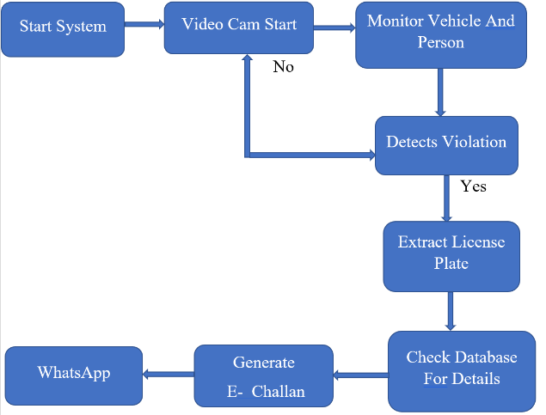
Fig. 2 - Block diagram of e-challan generation system

There are three modules performing different tasks,

1 Violators:
The first one is violators who are responsible for violating traffic rules and paying e-challan online before the due date.

2 Admin:
Second is one of Admin. Admin can be anyone who is owning the e-challan generation system. It's the admin’s responsibility to create, maintain, remove databases from the system, and check for system bugs.

3 System:
Third one is the system which is the main module of the project where the complete operation will take place for example: traffic signal monitoring, vehicle monitoring on every signal, detecting vehicle with violations, check for licence details in case of violation detected.

E-Challan Modules:

This project is divided into three modules, and they are:

Module 1-Capture Violator:
First module is to turn on the system with the webcam open to record the live videos, and to detect the number plate, triple seats etc.

Module 2 - Number Plate Detector:
Second module is to extract the licence number on the detected number plate, after extracting the numbers search for details of the user in the database.

Module 3 - Generate E-Challan:
The third module is to check the violation details as well as generate e-challan with all the information like violators name, date, time, kind of violation, with mobile number, etc. And at the end send the e-challan on the registered mobile number of the violator as well as on the registered email also.

IV-RESULT
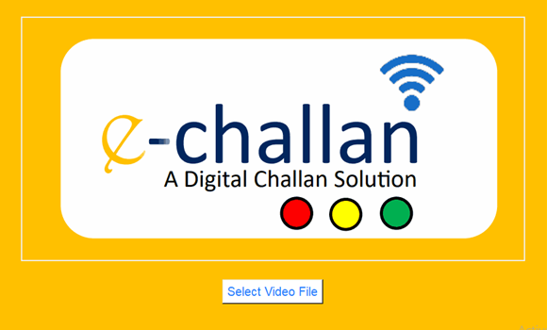
Fig. 4.1- Upload video file
Tap on Upload video file button to upload video.
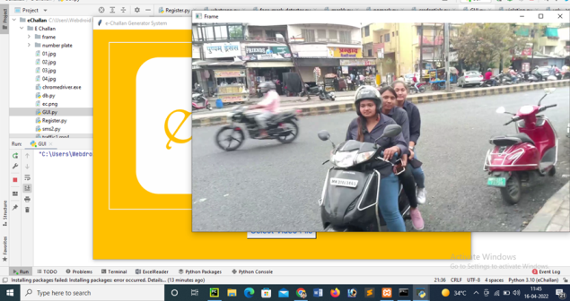
Fig. 4.2- Video Frame
Uploaded Video to detect the violators.
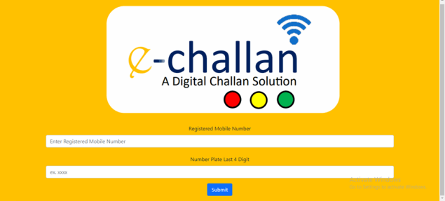
Fig.4.3 E- Challan Login
Login into E-Challan to access further details and to proceed.
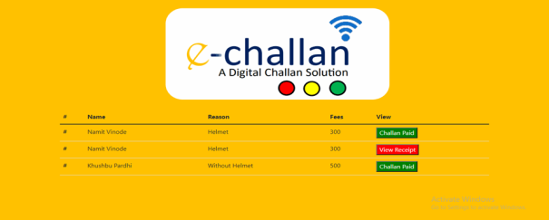
Fig. 4.4 Generated E-Challan Details
After Login user, this shows portal generated E- Challan details and can view paid challan (Green in colour) and unpaid receipt (Red colour).
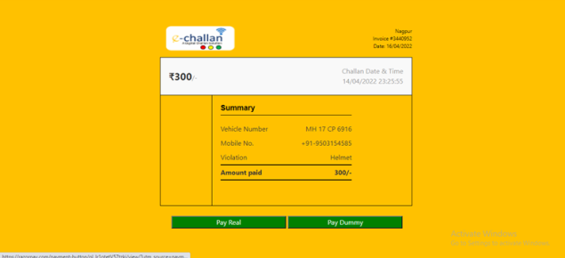
Fig. 4.5E-Challan Receipt
This a E-Challan Receipt that generated for violators.
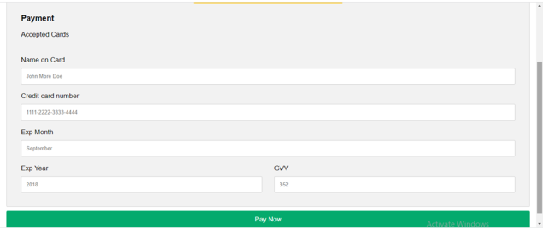
Fig. 4.6 Pay Dummy for E-challan
Fig. 4.7 Pay Real for E-Challan
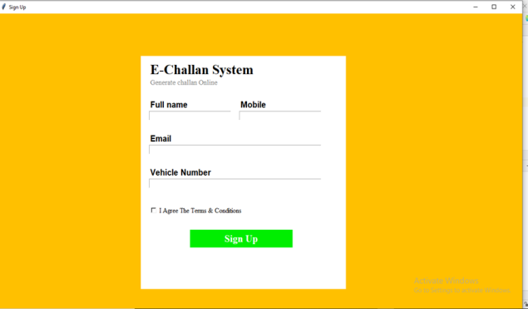
Fig. 4.8 Generate E-Challan Online
Signup for Generating E-challan online, where full name, Mobile number, Email, Vehicle Number necessary and User need to agree on all terms and conditions.
V- CONCLUSION

This paper emphasizes the suggested system above is to develop an automatic e-challan generation system with accurate results and functionality. The system is using python which is a great advantage as it can be elaborated in future with other features like security measures, sending help in emergency just after the detection and many more. This is a prototype of the project and hence we are using web cams of our systems instead of external cameras for recording live videos. Automatic recognition of licence plates(number plate) is the basis of effective management in traffic, the automatic detection and localization of licence plates(number plate) is an important part. Licence plate detection and containing how to extract or segment the number plate region from the number plate image a new deep learning network structure was designed, and designed network structure was used to detect and locate the number plate automatically.

REFERENCES

- AllokikPranshu, Sanjay Kumar Ijju, Swarnalatha P., “E-Challan: Online Traffic Rules Violation Penalty and Management System”, International Journal of Computer Applications (0975 – 8887) Volume 176 – No. 37, July 2020

- Prof. Amit R.Welekar, Rajesh S. Dahake, Shubham M. Bodhane, Tanvee B. Wawre, Rashmi P.Umbarkar, Priyanka S. Ghormode, “Analysis of Rules Violation &amp;Efficient E-Challan Generation Using OCR In Real Time Traffic”, International Journal of Scientific Research in Science, Engineering and Technology (ijsrset.com)

- Fabian Barreto, Nesline D. Almeida, Premraj Nadar, Ravneet Kaur, Sanjana KhairnaR, “Object Detection and e-challan system for traffic Violation: A Review”, International Journal of Research in Engineering, Science and Management Volume 4, Issue 5, May 2021

- Siddhant Shivam, Tushar Teotia, Shubham Mishra & Himanshu Mittal, “IOT based E -challan Automation for RTO using RFID”, International Research Journal of Engineering and Technology (IRJET) Volume: 06 Issue: 03 | Mar 2019

- Avinash Shinde, Rounak Sathe, Prakash Sutar, Prof. R. Sadakale, “E- Challan Generator For Traffic Violation”, International Journal Of Advanced Engineering and Recharge Development Volume4, Issue8, August-2017

- Chirag Patel, Dipti Shah, Atul Patel, “Automatic Number plate Recognition system”, International Journal of Computer Application(0975-8887),May2020

- Ritwik Mishra, Rajiv Ratn shah, AanshulSadaria, “Analysing Traffic Violations through e-challan System in Metropolitan Cities”, 2020 IEEE Sixth International Conference on MultimediaBigData (BigMM),20October2020

- Raghunandan Srinath, Y.R. Sumukh, L. Yashaswini, “Smart Vehicle Recognition And E-Challan Generation system”, 2020 International Conference for Emerging Technology (INCET),03August2020

- Manish R. Dhage, Prathamesh N. Tambe ,ShrayankJ.Mistry , Gaurav V. Patil, Parag H Nankar, “Automatic Traffic E-Challan Generation Using Computer Vision ”, Department of computer Engineering ,sinhgad college of Engineering Pune,India, Volume39,Issue,07 November 2019

- Vanshika Rai and Deepali Kamthania, ”AUTOMATIC NUMBER PLATE RECOGNITION”,School of Information Technology, Vivekananda Institute of Professional Studies, New Delhi 110034, 09July2021

