Academic Information Management System
Kanchan Hedau¹, Mayank Khandelwal², Akansha Bansod³, Anagha Venu⁴, Abhishek Sharma⁵
¹Assistant Professor, Hirkani Padwad
S.B.Jain Institute of Technology, Management & Research, Nagpur, India, 441501

Abstract – Academic Information Management System(AIMS), is a web application designed initially for CSE department to manage and store all academic data of students under one roof. AIMS stores information of different formats providing easy classifications as needed. The purpose of AIMS is to evaluate and process this information to provide statistics of students’ academic growth. We will apply engineering knowledge to analyze technical problems in profession caused to faculties and students while handling the documents and information.
INTRODUCTION

A management information system (MIS) is a computerized database of financial information organized and programmed in such a way that it produces regular reports on operations for every level of management in a company. It is usually also possible to obtain special reports from the system easily. The main purpose of the MIS is to give managers feedback about their own performance; top management can monitor the company as a whole. Information displayed by the MIS typically shows "actual" data over against "planned" results and results from a year before thus it measures progress against goals.
Academic Information Management System(AIMS), is a web application designed initially for CSE department to manage and store all academic data of students under one roof. AIMS stores information of different formats providing easy classifications as required. The purpose of AIMS is to evaluate and process this information to provide Statistics of students’ academic growth.
The following are some of the justifications for having an MIS system

- MIS systems facilitate communication within and outside the organization – employees within the organization are able to easily access the required information for the day to day operations. Facilitates such as Short Message Service (SMS) & Email make it possible to communicate with customers and suppliers from within the MIS system that an organization is using.

- Record keeping – management information systems record all business transactions of an organization and provide a reference point for the transactions.

LITERATURE SURVEY
- Real Time Survey:
Consulted Faculties:
We consulted department faculties responsible for handling the different management systems initially in the department. Faculty profiles managed by Prof. Swapnili Karmore who guided us about attributes required to manage faculty details. We found out it was complex to maintain and keep updating data, Head of computer Science department Prof. Animesh Tayal put forth the problem of referring more than one management systems to take an over view of the department. Prof. Nisarg Gandhewar advised us to gather all achievements in scanned form under one roof.

ii. Research Papers:
1) “A Research Paper on Student Information and Score Management System (SISMS) 2016” -Prof. D. M. Dalgade(H.O.D), Aishwarya Pandey, Garima Negi, Neeti Popat.
The management of student related information in an educational institute gets more tedious with every passing year as all systems in today’s world are being computerized, there is need for an automated system for managing such information. Student Information and Score Management System (SISMS) provides a simple interface for maintenance of student information. It can be used by educational institutions or colleges to maintain the records of students easily. The creation and management of veracious, state of the art information regarding a students’ academic career is critically important in the university as well as colleges.
2) “Management Information Systems Survey 2011” - Darran Goddard, Württemberg, London Branch)
The results of the Management Information Systems Survey will be presented for the first time at the Association of Foreign Banks (AFB) Operations Conference in September 2011 entitled “After the Storm”. The storm to which the title refers is, of course, the one associated with the 2008 credit crunch and not the new maelstrom being experienced by the financial world in 2011. After the 2008 event banks’ shareholders, their management teams and their regulators rightly demanded more information about banking operations to mitigate the risk of a similar event occurring again. The new requirements, including information about liquidity, large exposures and stress testing, presented a challenge to the financial officers and IT departments of all banks, including the UK offices of foreign banks, whether they were branches or subsidiaries.
3) “Impact of management information systems (MIS) on school administration 2013”-Madiha Shah University of Malaya, 50603 Kuala Lumpur, Malaysia Published by Elsevier Ltd,
The use of information technology in educational management has rapidly increased due to its efficiency and effectiveness. In the initial stages of its development, management information systems (MIS) main purpose and usage was to improve the efficiency of school office activities. It was used to store student and personnel data. The most concern was being focused on data entry and collation, rather than upon data transfer or analysis. The value of management information was recognized during its integration stages. Overall review of literature highlighted positive impact of MIS on school administration and management including better accessibility to information, more efficient administration, higher utilization of school resources, reduction in workload, better time management, and improvement in the quality of reports. A number of inhibitors to MIS use are evident in the literature; foremost among these are lack of time, lack of confidence or skills, lack of training, lack of senior management support, and lack of technical support. MIS can provide administrators and teachers with the information required for informed planning, policy-making, and evaluation. MIS have changed school management in the areas of leadership, decision making, workload, human resource management, communication, responsibility, and planning.
4) “Survey Paper on Student-Department Interface System 2016”- Kirti Sharma, Mayuri Barapatare, Krati Nawlakhe, Pranjali Manmode, Shweta Shende, DR. Narendra Bawane (SBJITMR),
The creation and management of accurate, up-to date information regarding a student’s academic career is an acute part of any educational institutes in which most of the work till now is being done manually. The main aim of this system is to automate the existing manual system. In the proposed system student has to get registered and validated in case of fake student in order to access the website. This system provides a simple interface for the better interaction between students, faculties of the department. The system deals with all kinds of student details, academic related reports, curriculum, batch details and other related details too. It tracks all the details of student from the first day to the end of course which can be used for all reporting purpose, progress in the course, exam details, coming semester details, project details, training and internship details, account details, and all other details available through a secure, online interface. It will also have faculty details, students details in all aspects, various academic notifications generated by college staff. The administrator of the college will manage and update the entire system. This system helps in reducing the paperwork and time required for accessing the student information.

METHODOLOGY
Academic Information Management System(AIMS), is a web application designed for CSE department to manage and store all academic data of students under one roof.
A. Flow of the system

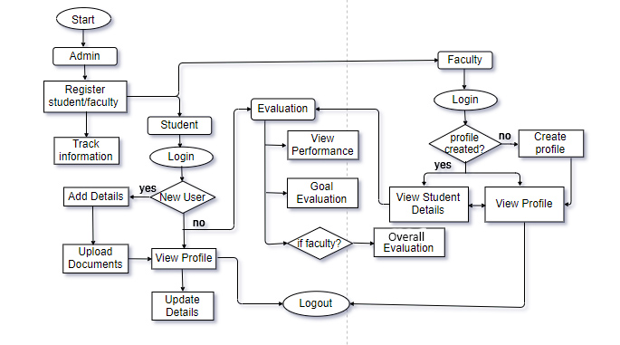 Fig. flow of academic information system

B. Functional Modules
We plan to develop this project in below mentioned modules.
- Admin module:
Admin creates all the authenticated logins with respective passwords for student and faculty module. Admin helps to authenticate and handle uploads and data of students module and details of faculty module. It keeps a track of complete management process.
- Student module:
Student needs to login with the admin provided username and password to enter this module. This module allows student to enter academic data and achievements and required scan documents. Student can re-login and edit or add new details in the profile whenever required. Student can view his/her profile OTG (on the go).
- Faculty module:
Faculties of the department have to login and enter required details. Faculty can re-login and edit or add new details in the profile whenever required. Faculties after creating profile can access student details.
- Evaluation module:
This module processes and evaluate all the student details. It performs three main functions are as follows: Track student performance, evaluate goal and carries out topper evaluation. Evaluation can only be access by entering faculty login details.
CONCLUSION
Academic information management system (AIMS) is a web based application being designed for managing departmental data. It will process the data stored to generate analytical information about academic growth of students. AIMS also aims at storing data in systematize manner. It will permit legitimate user profiles with the option to view information regarding student and also provide a sight of overall class performance. The web based system will build up to a diligent structure for management of academic information all under one roof. The systematic categorization of data will make it easy to access on the go.
REFERENCES

[1] “Management Information Systems Survey 2011”- Darran Goddard (Head of Finance & Tax Landesbank Baden-Württemberg, London Branch)

[2] “A Research Paper on Student Information and Score
Management System (SISMS) 2016”-Prof. D. M. Dalgade(H.O.D), Aishwarya Pandey, Garima Negi, Neeti Popat.

[3] “Impact of management information systems (MIS) on school administration 2013”-Madiha Shah University of Malaya, 50603 Kuala Lumpur, Malaysia Published by Elsevier Ltd

[4] “Survey Paper on Student-Department Interface System 2016” -Kirti Sharma, Mayuri Barapatare, Krati Nawlakhe, Pranjali Manmode, Shweta Shende, DR. Narendra Bawane(SBJITMR)

