Image Processing for Secure ATM

Mayur Gadge¹, Dr. Madhura Chinchamalatpure ²

Department of MCA SEM lV, G. H. Raisoni Institute of Information and Technology Nagpur, India

mayursgadge27@gmail.com

Received on: 11 June ,2022 Revised on: 03 August ,2022, Published on: 06 August,2022

Abstract - Image Processing is Secure structure. Image Processing structure contains picture check, finger inspect. Image recognition presents a challenging problem in the field of image analysis and computer vision. The security of information is becoming very significant and difficult. The image planning is progressively balanced system. Secure Automated Teller Machine by picture taking care of is assume control over a huge segment of the bank ATMs. In private and government territories. The image taking care of is very frustrated structure incorporated many numbers of mixed technique. The image planning from admiting the information to presentation of the screens. This present system's essential target is to develop a structure that is used for ATM security applications. Dealers are gathering customer fingerprints in these systems Nowadays, there has been wide advancement in oneself organization banking structure with the component offering splendid 24/7 customer organization. Though banking becomes easier today with the support of ATMs, it also became vulnerable. There have been countless cases of abuse that have occurred in banking transactions. Thus, there is an essential need to provide high security for banking transactions. This paper proposes an improvement computation for the affirmation and planning of one-of-a-kindimprints structures. An essential development in customized novel finger impression organizing is to normally and constantly definitely arrange the finger impression picture redesign estimation input finger impression, apply a great deal of transitional steps to the information picture, finally yield the improved picture.

Keywords - Face Recognition Software (FRS), Security, Image Processing, fingerprints, Biometric framework .

1. INTRODUCTION
The rise of technology has brought into force several types of tools that aspire at more customer pleasure. ATM is a machine which has made money transactions effortless for customers. But it has both advantages and disadvantages. Current ATMs make use of not more than an access card and PIN for uniqueness confirmation. This exposes ATMs to a lot of fake attempts to use them by means of card theft, PIN theft, stealing and hacking of customer’s account details. Using Face Recognition System in ATMs can show the way to deal with such cases.

Biometrics innovation permits persistence and demonstrate of onece personality through physical qualities. It transforms your body into your secret key. We talked about different biometric procedures. That is all are retina filter, finger examine, facial output, hand check and so on there are two calculations have been configuration by taking biometric systems to verification an ATM account holder or the record client, empowering a safe ATM by picture handling. Biometrics is currently accessible in any resembled in different open and private segments moreover.
No more issues if passwords and I'd codes have been overlooked, biometrics is the innovation that deals with it, making your body your secret key. Typically To make your mystery word assurance and advancement controls logically exhaustive, the more problematic it will be for customers to review their passwords. Unfortunately, to stop essential software engineer strikes on the framework, serious mystery key rules are required. The current accessible age security issue is viewed as the fundamental TCP/IP encryptions and different variables that are given by the utilizing system. Be that as it may, there was a considerable lot of predictable distinguishing proof of each one separately, at that point the recently created innovation is Biometrics, came into picture. Biometrics can be utilized to evade the unapproved access to ATM, PDAs, home security frameworks, entryway locks, keen cards, work area PC's workstations. This paper bound the data respecting the 'picture preparing'. What's more, there is one of the significant use of picture handling is the 'biometrics'.

II -LITERATURE SURVEY

Arunkumar, Vasanth Kumar, Naveenly King, Aravindan[1] have observed that the growth in the electronic transactions has resulted in a greater demand for fast and accurate user identification and authentication. Users have been largely depending on and trusting the Automatic Teller Machine (ATM) to conveniently meeting their banking needs. The ATM fraud has recently become more widespread. This system is used to avoid the ATM robberies and wrong person misuses the ATM...
A S Tolba [2] et al have proposed an overview of face recognition and its applications.
Divyarajsinh N. Parmar [3] remarks that, Face recognition presents a challenging problem in the field of image analysis and computer vision. The security of information is becoming very significant and difficult. Face recognition is a biometric system used to identify or verify a person from a digital image.
The utilization is the no more issues if client overlooked there passwords and id codes additionally, In truth of the biometrics is the innovation that deals with it. which is transforms your body into the your passwords. The all the more requesting you make your own secret key decision and development the guidelines done the more trouble to the clients can have in recalling their passwords. However, severe and hard secret word rules are important to keep away from simple programmer assaults on the system.
The essential downside with secret key is two folds. And furthermore They are assignable, that can be recorded onto the paper and that can exchanged to somebody who shouldn't have them. Furthermore, they will overlooked. As of late examination proposes that the overlooked secret phrase will prize as much as US$ 340 for each occasion, the possibility and expenses of course of action passwords are a central point. In the reality the significant and principle requirement for additional dimension of security has offered ascend to field of "BIOMETRICS" Biometric

ATM authentication system based on fingerprint[1 ]. We can refer to fingerprint scanning technology with the help of this paper. Biometric technology used in a wide range of physical access and logical access applications is most commonly used in finger scanning technology. The characteristics and patterns of all fingerprints are unique. A normal fingerprint consists of spaces, lines. These lines are called ridges, while valleys are called the spaces between the ridges.
This provides a summary of the techniques of recognition of the human or user face. And that applies a lot to the front faces, there are advantages and disadvantages of each method are also given. The methods considered are individual features and semantic networks, as well as the dynamic link architecture used to verify the face of the person, hidden Markov model, matching computational features, and matching disorder. These approaches are analyzed in terms of the image processing facial representations they used.

III -METHODOLOGY

The two classes of biometric strategies are:- Physiology- based procedures that measure the physiological qualities of an individual. These incorporate unique mark confirmation, iris examination, facial investigation, hand geometry vein designs, ear recognition, smell discovery, and DNA design examination. The social procedures which measure the conduct of an individual. These incorporate written by hand signature check and discourse examination.

No more issues if passwords and I d codes have been overlooked, biometrics is the innovation that deals with it, making your body your secret word. Typically. To make your secret key determination and development runs progressively thorough, the more troublesome it will be for clients to recall their passwords. Sadly, To stop basic programmer assaults on the system, severe secret key standards are required.
Fig. shows the types of biometrics
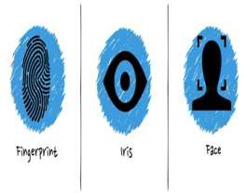

finger print scan

The basic intention of fingerprint-recognition is to carry on with authentication using fingerprint-impressions. This is mostly done by minutiae-features of fingerprint images. And the general flowchart is shown in Fig.1.

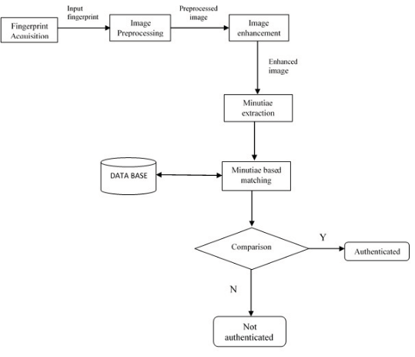

Fig. 1. Fingerprint Recognition System - General Methodology

- Iris Scan

The iris has colored streaks and lines radiating from the eye's pupil. After DNA, the iris provides the most complete biometric data. The iris has information that is more unique than any other organ in the body.

The iris scan is safe than the fingerprint. ordinary camera can take a picture of users iris. Use users iris picture can use for one code of that user. and that code user can use after for using the system. In the iris scan capture a 240 points are scan.

The iris is the hued ring of muscle that opens and closes the student of the eye like a camera screen. The shaded example of our irises is resolved hereditarily when we're in the belly however not full fledged until we're matured around two. It originates from a color called melanin— more melanin gives you browner eyes and less creates bluer eyes. In spite of the fact that we talk about individuals having "blue eyes," "green eyes," "darker eyes," or whatever, in all actuality the shading and example of individuals' eyes is incredibly mind boggling and totally interesting: the examples of one individual's
two eyes are very unique in relation to one another and even hereditarily indistinguishable twins have distinctive iris designs. In the first place, every one of the general population the framework has to think about must have their eyes examined. This irregular procedure is called enlistment. Every individual stands before a camera and has their eyes carefully shot with both standard light and undetectable infrared (a kind of light utilized in night vision frameworks that has a somewhat longer wavelength than customary red light). In iris acknowledgment, infrared shows up the one of a kind highlights of dimly shaded eyes that don't emerge obviously in standard light. These two advanced photos are then broke down by a PC that expels superfluous subtleties, (for example, eyelashes) and recognizes around 240 extraordinary highlights (around multiple times more "purposes of examination" as unique mark frameworks use). These highlights, remarkable to each eye, are transformed into a basic, 512-digit number considered an IrisCode® that is put away, close by your name and different subtleties, in a PC database. The enlistment procedure is totally programmed and as a rule takes close to two or three minutes.

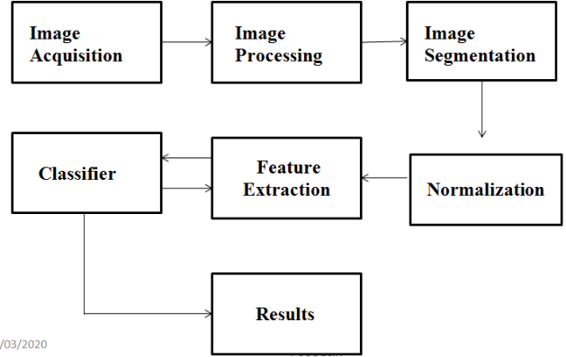

- Face Scan

FRS is an application that mechanically identifies a person from a digital image or a video outline from a video source. One of the processes to do this method is by matching chosen facial features from a facial database and the image
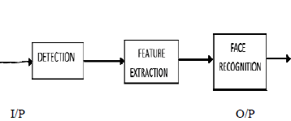

Fig 1: Basic flowchart of FRS
Working:

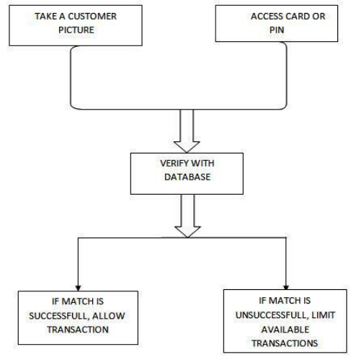
Fig 3: Flowchart of an ATM using ImageProcessing

• Initially the customer’s picture is taken when the account is opened and the user is allowed to set non-verified transaction limits.
• At ATM, access card and PIN are used to per verify the user.
• User’s snap is taken and an attempt is made to match it to the record image.
• If the match procedure becomes successful, allow the transaction.
• If the match is unsuccessful, limit the available transactions.
• When a match is complete with the PIN but not the imagery, the bank could limit the transactions in a way contracted by the user when the account was opened, and could store thephotograph of the user for later
examination by the bank official. In the case of using credit card at ATMs, confirmation system would not presently be feasible without revamping the entire credit card issuing industry.

Table.- Comparison of biometrics types.

Types | Accuracy | Ease Use | Acceptance
Fingerprint | High | Medium | Low
Face | Low | High | High
Iris | High | Medium | Medium

IV – CONCLUSION

Access card / PIN provide insufficient ATM security. Adding facial verification to the process can greatly decrease fraudulent transactions. Current ATM’s have the power to perform verification locally, given a software change.
We have developed a rapid fingerprint enhancement algorithm that can adaptively improve the clarification of ridge and furrow structures based on the estimated local ridge orientation and ridge frequency from the images input. Bank uses fingerprint readers for ATM authorization and becomes more common in grocery stores where they are used to automatically recognize a registry customer and bill their credit card or debit account Enhancement algorithm using the minutiae's goodness index and input fingerprint verification accuracy. The Enhancement algorithm is an input fingerprint verification technique. The algorithm also identifies, and removes from further processing, the unrecoverable corrupted regions in the fingerprint.

REFERENCES

- Arunkumar, Vasanth Kumar, Naveenly King, Aravindan, “ATM Security using Face Recognition”, International Journal of Current Engineering And Scientific Research- Volume- 5, Issue-4, 2018.
- A S Tolba, A.H. El-Baz, and A.A. El-Harby, “Face Recognition: A Literature Review”, International Journal of Signal Processing, Volume 2 Number 2, 2014.
- Divyarajsinh N.Parmar1, Brijesh B. Mehta2, “Face Recognition Methods & Applications”, International Journal of Computer Applications in Technology, January 2014.
- KresimirDelac, Sonja Grgic&MislavGrgic, “Image Compression in Face Recognition” - A Literature Survey, October 2008.
- Mourad Moussa, MahaHmila& Ali Douik, “A Novel Face Recognition Approach Based on Genetic Algorithm Optimization”, https://doi.org/10.24846/v27i1y201813.
- Priyanka, Research Scholar, Department of Computer Science and Engineering, “A Study on Facial Feature Extraction and Facial Recognition Approaches”, International Journal of Computer Science and Mobile Computing, May 2015.
- T.Suganya, T.Nithya,C.Sunita, B.Meena& Preethi, “Securing ATM by Image Processing”–FacialRecognition Authentication, International Journal of Scientific Research Engineering & Technology
- J. G. Daughman, "How iris recognition works," IEEE Transactions onCircuits and Systems for Video Technology, vol. 14, no. 1, 2004.
- J. G. Daugman, "High Confidence Visual Recognition of Persons," IeeeTransactions On Pattern Analysis And Machine Intelligence, vol. 15,1993.
- Rai, Himanshu, and Anamika Yadav. "Iris recognition using combinedsupport vector machine and Hamming distance approach." ExpertSystems with Applications.
- K. Gulmire, S. Ganorkar, " Iris Recognition Using IndependentComponent Analysis “July 2012.
- Mayank Vatsa, Raja V Singh, AfzelNoore- “Reducing the falserejection rate of iris recognition using topological features” 2008

