SEMANTIC SEGMENTATION FOR BRAIN TUMOUR MRI IMAGE SEGMENTATION

Kajal, Mohd Shariq Ansari, Mohd Salman, Nimisha Sachan,Upasana Pandey

Department of Computer Science and Engineering, IMS Engineering College,
Ghaziabad,​Uttar Pradesh,​India

Abstract- Among​ brain tumors, gliomas are the most common and aggressive, leading to a very short life expectancy in their highest grade. So, treatment planning is a key stage to improve the quality of life of oncological patients. MRI is a widely used imaging method to assess these tumors, but the large amount of data produced by MRI prevents manual segmentation in fair-minded time, limiting the use of precise quantitative measurements in the clinical use. So, we need an automatic and reliable segmentation method; though, the large spatial and structural variability among brain tumors make automatic segmentation is a difficult problem.

Accurate tumor segmentation is a crucial step for surgical planning and computer-aided brain tumor diagnosis.

INTRODUCTION

The analysis of a picture using methods that can recognize shades, color & relationship that can't be perceived by the human eye.[1]Image processing is used to solve identification problems such as in forensic medicine or in creating weather maps from satellite images. [2]It deals with images in bit-mapped graphics format have been scanned in or captured with digitalized cameras.

A brain tumor is a collection of mass, of abnormal cells in your brain.[3]Our skull, which

encloses your brain, is very rigid. Any growth inside such are restricted space can cause

problems.

Keywords

Brain tumor, brain tumor segmentation, convolutional neural network, deep learning, glioma, magnetic resonance imaging.

Design and Operation

The brain tumor can easily get into the knowledge of doctor by using the method known as segmentation in which several images of the brain are used and examined by the various deep learning algorithm of soft computing.

Pre-Processing
MRI pictures are altered by the bias field distortion. [2]This makes the intensity of the same tissues varying across the image.[1]To correct it, we applied the N4ITK method. Though, this is not enough to ensure that the intensity distribution of a tissue type is in a similar intensity scale across different subjects for the same MRI sequence, which is an explicit or implicit assumption in most segmentation technique.

CONVOLUTIONAL NEURAL NETWORK

CNN was used to achieve some breakthrough results and win well-known contests. The application of convolutional layers consist of convolving a signal or an image with kernels to Obtain feature maps.[3] So, a unit in a feature map is connected to the previous layer through the weights of the kernels.

POST-PROCESSING

Some small clusters may be erroneously classified as a tumor. To deal with that, we improve volumetric constraints by removing clusters in the segmentation obtained by the CNN that are smaller than a predefined threshold.

Model Used

Convolutional Neural Networks (CNNs) are popular, state-of-the-art, deep learning approach to computer vision with a wide range of application in domains where data can be represented in terms of three-dimensional matrices. [1]However, there are increasingly larger datasets to which we wish to apply deep learning and, in the case of deep learning, a growing desire to increase the depth of the networks used in order to achieve good results. [2]This not only increases memory utilization requirements but also computational complexity. Using Fourier Convolutional Neural Networks images are processed and represented using the Fourier domain to which a convolution technique is applied in a manner similar to that used in the context of more traditional CNN techniques.[3]The proposed approach of the advantage that it reduces the complexity, especially in the context of larger images.
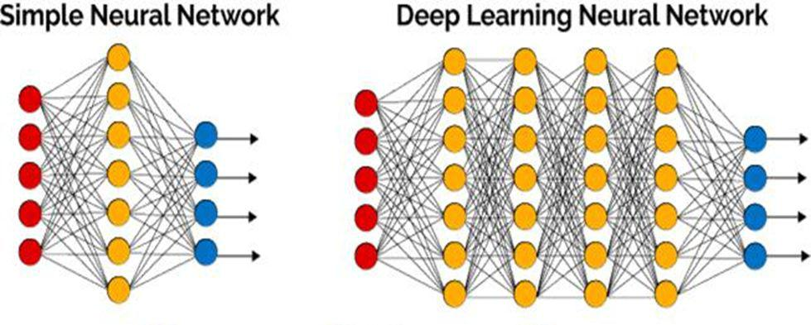

IMAGE PROCESSING THROUGH ANN

Auto -Encoder is one type of Artificial Neural Network. It consists of the three layers input layer, hidden layer, output layer. [4]Every layer in ANN is trained to minimize a reconstruction cross
Entropy . The user have to provide the input vector x€[o,1]^d, and first map it to a latent representation y€[0,1]^d through a deterministic mapping y=f(x) =sigma(wx+ b), parameterized by Θ={W, b}. W is weight matrix & bis bias vector.

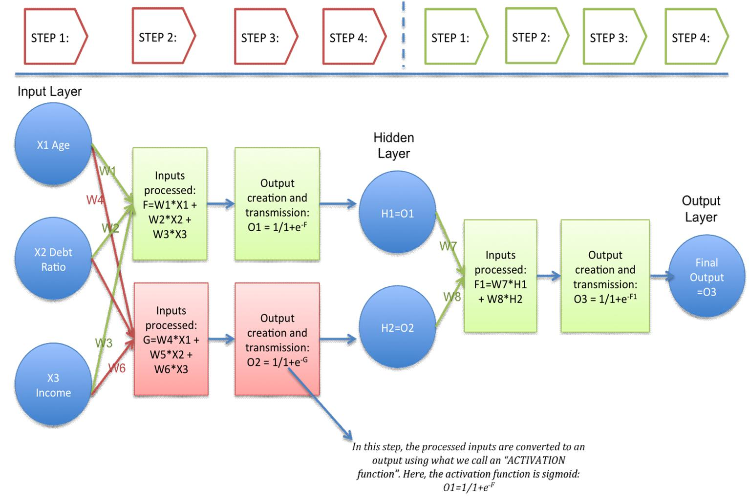
Result

It will provide perform segmentation in following steps.

An input image is provided.

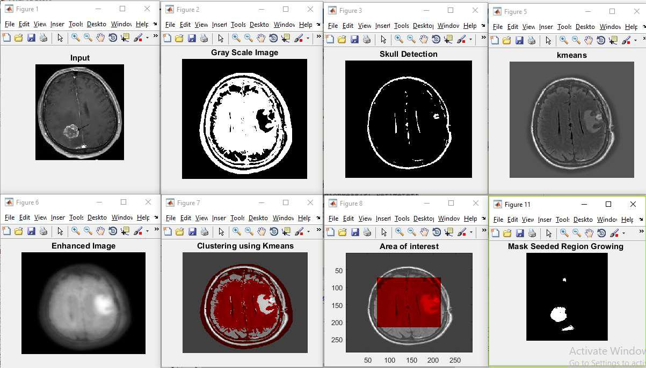

Final detection is as follows:

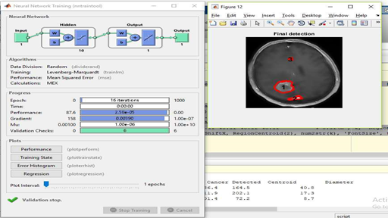

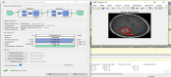
Conclusion

Segmentation of brain image is essential in surgical planning and treatment planning in the field of medicine.[1]In this work, we have proposed a computer-aided system for brain MR image segmentation for detection of tumor position using K - means clustering algorithm followed by morphological filtering.[3]We were able to divide the tumor from different brain MRI images from our database.

Future Work

In order to improve the method and to apply the provided prototype into the real situation of segmenting the brain tumor, there are some future works need to be done.[4]First of all, only the gray level is put into the deep network as the input, in future, we can employ more features, such as texture features, as the input of the deep network. In addition, more brain tumor MRI data is needed to be continuously collected.[3]More data benefit not only our proposed technique, but also for other tumor classification system. After all, a clinical validation should be further given.

Related Researches

- A Neural Conversational Model, Research Paper by- Oriol Vinyals and Quoc Le https://arxiv.org/abs/1506.05869

- Selvakumar, Lakshmi, A; Arivoli, T. In Brain tumor segmentation and its area calculation in brain MR images using K-mean clustering and Fuzzy C-mean algorithm, Advances in Engine ring, Science and Management (ICAESM), 2012 International Conference

on, IEEE: 2012;p 186-190.

- Rao, M. Sharifi, and A. Jaiswal, “Brain tumor segmentation with deep learning, ”MICCAI Multimodal Brain Tumor Segmentation Challenge (BraTS), p . 56– 59, 2015.

