Farmer Buddy
Monali Nimje¹,Pranali Wankhede²
^{1,2}UG Scholars, Department of Computer Science & Engineering, Tulsiramji Gaikwad Patil College of Engineering & Technology, Nagpur
Prof. Rajesh Babu¹
¹Professor, Department of Computer Science, Tulsiramji Gaikwad Patil College of Engineering & Technology, Nagpur

Abstract – Farmer Buddy is an open discussion portal develops using Android programming language with the system database. This project is useful for farmers and agricultural student to obtain information regarding various crops, tools used by the farmers, also provide one of the platforms for online selling and buying of the different types of grains and the tools. Also provide the desire cost to the user or farmer. The cost is decided by the expert system. By using this application the tools can be available on second hand also. One expert system is organized to decide the proper cost of the grains that are selling by the farmer. Due to this, desire cost will provided by the farmer. Also the application will help in transportation.
Keywords Agriculture, Android, Database
INTRODUCTION
This is an application based project which is useful for farmers and agricultural students. This is an open discussion portal providing solutions to small farmers and agricultural students. We know that various farm related tools are needed to the farmer but the because of money problem they cannot afford this so this application will help to farmer. It helps to provide the equipment which is needed in the farm. It also helps to make decisions on market and best prices. Information about major crop markets and their current price for the crop will be published daily. This also includes training scheduled by agricultural officers. Training is requested

by students, general public. One expert system is organized to decide the proper cost of the grains that are selling by the farmer. Due to this desire cost will be provided to the farmer. This module provide the information about the various expert team which are analyze and study the average marketing value of the crops and it will be helpful to the farmer to decide the desire marketing value of the product.
PROPOSED SYSTEM
The current application can be accessed by two types of users (buyers and sellers). As farmer is illiterate, he accesses this application with the help of another trusted party. Buyers can demand their desired crops using this application. Buyers can submit their feedback regarding the crops which they won in auction. It provides the farming equipment either new or second hand. Also we can buy the tools on rent. Information about schemes given by government for farmers can be uploaded in this application.
- Current system provides different access levels for security.
- Rich user interface is provided in order to interact with application.
FORMULATION OF MODULES

Main Page: This module is our front page simply gives the title of our project that is “Farmer Buddy”. It conveys that farmer is using a Farmer Buddy application.

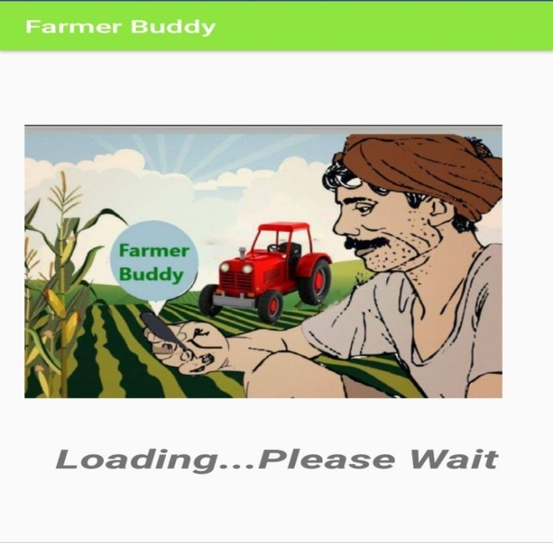

Fig1. Main Page

Registration Module: This module is used by the unauthenticated users who are unregistered. The users must register themselves such that they can login into the Farmer Buddy application.

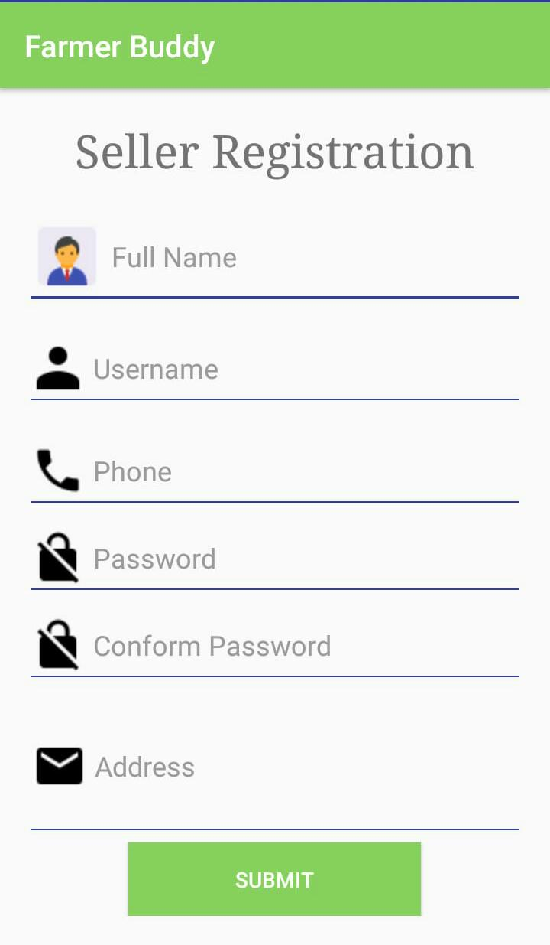
Fig2. Registration Page

Tool Module: This module is used by the users, it provide the various farm related equipment information. We can buy the new equipment by this application also the equipment are available on rent. Second hand tools also available for farmers.
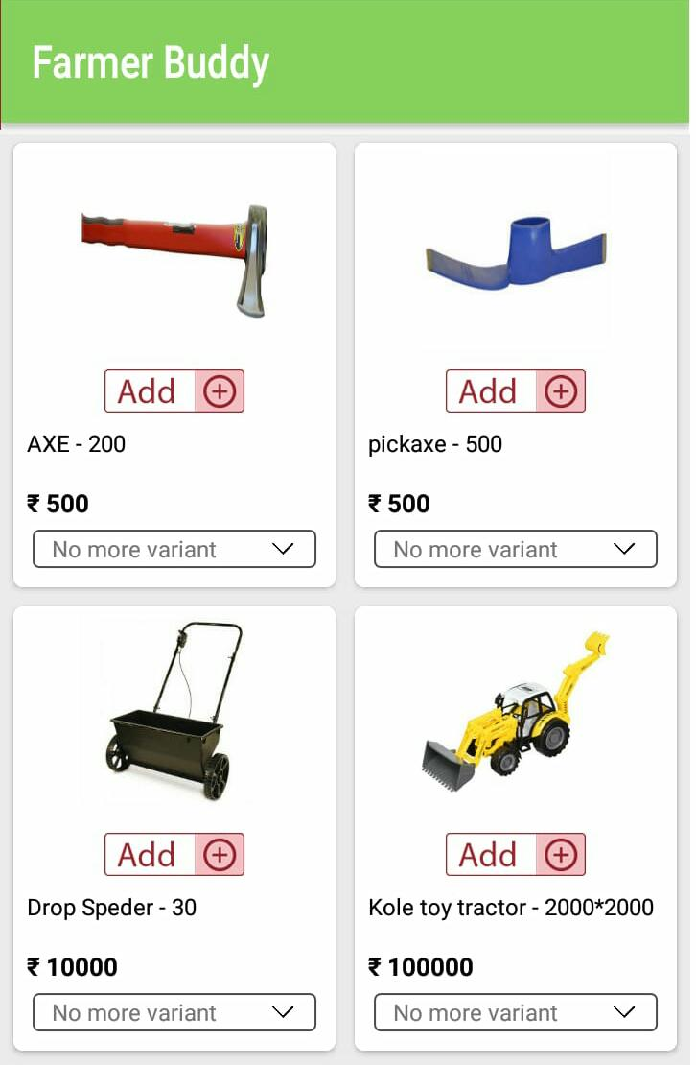
Fig3. Tool Module
Expert Team Module: This module provide the information about the various expert team which are analyze and study the average marketing value of the crops and it will be helpful to the farmer to decide the desire marketing value of the product.
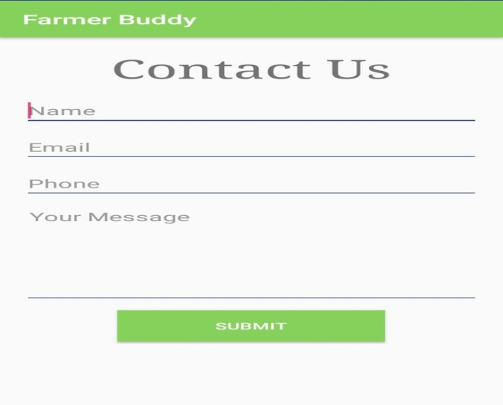
Fig4. Expert Team Module

CONCLUSION
The By this project, we provide various information required for farmers, agricultural students and also providing solutions to them about queries posted by them. This makes agriculture more eco-friendly and this portal is very useful to farmers and agricultural students. This application provide the one the platform for marketing for the farmers
ACKNOWLEDGMENT
With profound feeling of immense gratitude and affection, we would like to thank our guide Prof. Rajesh Babu, Department of Computer Science and Engineering for his continuous support, motivation, enthusiasm and guidance. His encouragement, supervision with constructive criticism and confidence enabled us to complete this project.
We also wish to extend our reverences to Prof. R.B.Talmale, Head of Computer Science and Engineering for providing necessary facilities to complete our project. We are also thankful to all the faculty members and all non teaching staff of the department & college for their cooperation throughout the project work.
We also put fourth our deepest sense of gratitude towards Principal for constant motivation and providing necessary infrastructure.
REFERENCES
[1] Viraj Patodkar1, Sujit Simant2, ShubhamSharma3, Chirag Shah4, Prof. Sachin Godse5, “EAgro Android Application (Integrated Farming Management Systems)”2015[1]
[2] Prof.P.B.Gaikwad, Pallavi Malode, Pooja Pawar, Sangita Darade, “E-Farming an Interface for Indian Farming” 2015[4]
[3] O. O. Mazhara, S. I. Shapovalovam ,“Production System for Express Diagnostics of the Agriculture and Natural Resources Objects for Portable Devices”2016[7]
[4] Aniket Bhave, Rahul Joshi, Ryan Fernandes, “Mahafarm An Andriod based solution for remunerative Agriculture” 2014[2]
[5] Methodology: AMS-I.E.: Switch from Non-Renewable Biomass for Thermal Applications by the User Version 2.0 https://cdm.unfccc.int/methodologies/DB/4AWU125UNQLOC5JAMXQFU60KDCJNUA/vie w.html
[6] Cool Farm Alliance (2014): Cool Technical Documentation for the online Cool Farm Tool Cool Farm Institute (2013): Cool Farm Tool Online Manual https://app.coolfarmtool.org/static/doc/CFT_Online_Manual_-_beta.pdf
[7] FAO (n.d). Farming Systems and Poverty. http://www.fao.org/farmingsystems/description_en.htm
[8] Gold Standard Agriculture Requirements, version 0.9 (2014): http://www.goldstandard.org/resources/agriculture-requirements
[9] IPCC (2006): Guidelines for National Greenhouse Gas Inventories. Volume 2, Chapter 1: Introduction http://www.ipccnggip.iges.or.jp/public/2006gl/pdf/2_Volume2/V2_1_Ch1_Introduction.pdf
[10] IPCC (2006): Guidelines for National Greenhouse Gas Inventories. Volume 2, Chapter 2: Approaches to Data Collection http://www.ipccnggip.iges.or.jp/public/2006gl/pdf/1_Volume1/V1_2_Ch2_DataCollection.pdf
[11] IPCC (2006): Guidelines for National Greenhouse Gas Inventories. Volume 2, Chapter 2: Stationary Combustion http://www.ipccnggip.iges.or.jp/public/2006gl/pdf/2_Volume2/V2_2_Ch2_Stationar y_Combustion.pdf
[12] VCS Agriculture, Forestry and Other Land Use (AFOLU) Requirements, version 3.4. (2013). http://www.v-c-s.org/program-documents
[13] VCS Methodology VM0017 version 1.0 (2011): Adoption of Sustainable Agricultural Land Management. http://www.v-c-s.org/methodologies/adoption-sustainable-agricultural-landmanagement-v10

