EMOTION ANALYSIS BY FACIAL FEATURE DETECTION
Rupali Katratwar, Prof. P.A. Ghonge.

Abstract
Emotion analysis from the face image is very interesting and challenging task in real time application. Various technique have been developed in last few years .Emotion Analysis is very complex method because of variability of faces including face structure, nose, eyes, lips, color of skin etc. By using various modeling technology it is possible to recognize various facial expression. By using image processing and neural network technology it is possible to recognize the emotions for different faces. This paper review various technology of facial expression recognition system using MATLAB (neural network) toolbox.
- Introduction
Emotion analysis is very interesting topic as emotion is one of the most powerful, natural and immediate mean for human being to communicate their feelings and intentions. Every emotion of an individual is being revealed out with his or her facial expression. Mild change in facial expression could convey a meaning which is very difficult to explain verbally. This will establish a personal rapport among individuals. Automatically recognizing such expression from the information available in a digital image or video file is a highly challenging task. Emotion detection has attracted internet of many computer version researcher. Emotions of a person can be communicated by auditory or by visual. Visual communications is possible only because of specific emotions like Happy, Sad, Angry, Surprise and neutral.
Facial expressions, body movement and psychological reactions are the basic unit of visual communication. Facial expression is one of the most powerful, natural and immediate mean for human being to communicate their emotions.
Human computer interaction will be much more effective if a computer knows the emotional state of human. Emotion analysis in real time contains detail information about emotion.
Facial expression recognition problem has undergo various stages that may be divided in two main categories static and motion dependent images. In the static approaches the performance and generalization of different low dimensional representation for facial emotional classification from static faces images showing Happy, Angry, Sad, Surprise and neutral expression. Three general strategies are compared:
The First approach uses the average faces for each class as a generic template and classifies the individual facial expression according to the best match of each template. The second strategy uses multilayered perception trend with the back propagation of error algorithm on a subset of all facial expression and tested on unseen face images. The third approach introduces a pre processing step prior to the learning of an internal representation by the perceptions. The feature extraction stage computes the oriented response to six odd-symmetric and six even-symmetric Gabor-filters at each pixel position in the image. For the implementation of emotion analysis involve image processing and neural network toolbox of METLAB.
- Emotion Analysis - An Overview
Tracking faces and identifying expression from video files is a complex meaning application due to fact that even a delicate change in the emotion of face could convey a great variation as an expression. This paper conveys present robust novel method to track and recognize the facial expression. Face localization in a digital image which is being grabbed from a digital source is performed using the Hue-saturation and YCbCr method. Morphological algorithm over this region signal the eyes and mouth position in this region. Lips, eyebrows and eyelids are then identified. Distance between eyebrows and eyelids and the slope of the curvature of lips are derived which facilitated in deciding the facial expression of given digital image.
Among many personal feature, face is the most acceptable and intuitive one for human perception. Recent algorithm proposed to search, track and recognize faces are most robust and effective. This makes the face reorganization system trustworthy for high security demand applications such as entrance access, video surveillance etc. besides because digital camera are gradually become popular and identity authentication is applied to electronics devices to provide personalized control and entertainment such as ATM, PDA, cell phone etc by integrating these face understanding technology to reach a real tile and robust system is a challenge.
- Methodology
In this article, system proposed following stages
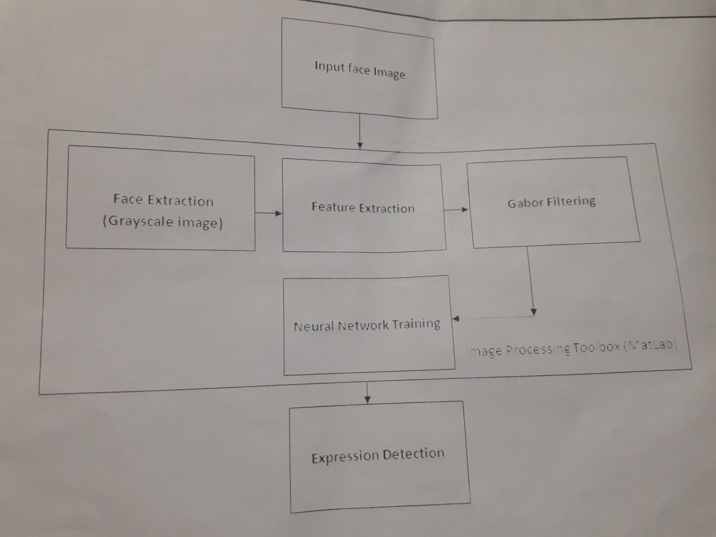.
Face detection, preprocessing, principle component analysis and classification as shown in fig.
- Image selection
The emotion to be recognized is based on the feature extracted from the image. These images are stored in a database so, to scan the image and to extract the feature first it is important to select one of the image from the database. For this select the database folder and choose any one image whose emotion is to be recognized.
- Image processing
Image processing is basically converting the colored image in the database into equivalent grey scale image. This is done, so that the intensity value of each pixel can be extracted which is further use for feature extraction. As intensity in image is at its maximum value so the extracted feature value has less error in them. In most of the cases we have a random variation in intensity values, noise, in the image with individual pixels corrupted.

- Gaussian Smoothing
The Gaussian smoothing operator is a convolution operator that is used to blur images and removes details and noise. In this sense it is similar to the mean filter, but it uses a different kernel that represent shape of Gaussian hump (Bell Shaped) the index of Gaussian smoothing is to use this 2-D distribution as a point spread function. This is achieved by convolution. Since the image is stored as a collection of discrete pixels. We need to produce a discrete approximation to the Gaussian function before we perform the convolution.
- Converting in Grey scale
The Gaussian smooth color image is then converted into YCbCr image using standard metlab function which convert RGB values to the YCBCR color image.YCBCR is a M-by-3 matrix that contain the YCBCR luminance(Y) and chrominance(cb and cr) color values as columns.
Each row represents the equivalent color to the corresponding row in the RGB color map. Then extracting the luminance(Y) column gives the corresponding grayscale image of the given RGB image.
- Feature Extraction using neural network

For recognizing facial expression Neural network plays a very important role. The artificial neural network is an information processing unit .Which is inspired by biological nervous system .Neural network has specific application such as pattern recognition and data classification through learning process. The neural network has an ability to perform the task for given input and given train output.

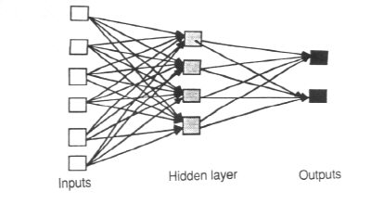
Artificial neurons is a device with many input and one output .After getting input from preprocessing block the neural network train the network by using different modeling technique and gives recognized output .For implementation of face detection and neural network involve the image processing toolbox and neural network toolbox of MATLAB.

Conclusion

Image processing and neural network using MATLAB, it has numerous application which include, reading aid for blind, bank cheques and conversion of any handwritten document into structural text form. Using MATLAB Neural network toolbox. We tried to recognize handwritten characters by projecting them on different sized grids. The first step is image acquisition which acquires the scanned image followed by noise filtering. Smoothing and normalization of scanned image, rendering image suitable for segmentation where image is decomposed into sub images.
Reference
[1] J. L. Raheja and U. Kumar “Human Facial Expression Recognition from Detected in Captured Image Using Back Propagation Neural Network” International Journal of Computer Science and Information Technology, February 2010.
[2] M. Agrawal, N. Jain, M. Kumar and H. Agrawal “Face Recognition using Eigen Faces and Artificial Neural Network” International Journal of Computer Theory and Engineering, August 2010
[3] A. R. Nagesh-Nilchi and M. Roshanzamir “An Efficient Algorithm for Motion Detection Based Facial Expression Recognition using Optical Flow” International Journal of Engineering and Applied Science 2006.
[4] C.C. Chibelushi and F. Bourel “ Facial Expression Recognition: A Brief Tutorial overview”, 2002.
[5] Yu-Ting Pai, Shanq-Jang Ruan, Mon-Chau Shie and Yi-Chi Liu, ―A Simple And Accurate Color Face Detection Algorithm In Complex Background‖, Low Power Systems Lab, Department of Electronic Engineering, National Taiwan University of Science and Technology, No.43, Sec.4, pp. 1545 – 1548.
[6] Nicolas Eveno, Alice Caplier and Pierre-Yves Coulon, ―A Parametric Model for Realistic Lip Segmentation‖, 7th International Conference on
[7] H. E. Cetingul, Y. Yemez, E. Erzin and A. M. Tekalp, ―Robust Lip-Motion Features For Speaker Identification‖, Multimedia, Vision and Graphics Laboratory, pp. 509 – 512.
[8] Enrique Gomez, Carlos M. Travieso, Juan C. Briceno and Miguel A. Ferrer, ―Biometric Identification System Using Lip Shape‖, pp. 39 – 42.
[9] Ojala T., Pietikainen M., and Harwood D., ”A comparative study of texture
measures with classification based on feature distributions”, Pattern
Recognition, Vol 29, No. 1, pp.5159, 1996.
[10] Field D.J. statistics of natural,”Relations between the images and the
Response properties of cortical cells”, our. of the Optical Society of
America, pp. 2379-2394, 1987.
[11] Ojala T., Pietikainen M., and Maenpaa M., Multiresolution gray-scale and
Rotation invariant texture classification width local binary patterns,IEEE
Transactions on Pattern Analysis and Machine Intelligence, Vol 24, No.
7, pp.971987, 2002.
[12] QUAN ZHAO, BAO-CHANG P., JIAN-JIA P., YUAN-YAN T.,”Facial
Expression Recognition Based on Fusion of Gabor and LBP Features”,
Proceedings of the 2008 International Conference on Wavelet Analysis
And Pattern Recognition, Hong Kong, 2008

Author

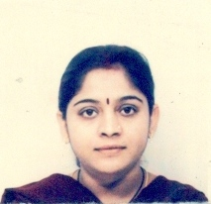Rupali G. Katratwar received the B.E. degree in Electronics and Telecommunication from the B.N. college of Engineering, Amaravati Univeristy in 2005 and she is currently perusing the M.E. degree in Electronics and Telecommunication at Yadavrao Tasgaonkar Institute of Technology & Science at DIKSAL in Mumbai University.
- Associate Professor P.A. Ghonge received M.E, Phd. working as a associate professor at at Yadavrao Tasgaonkar Institute of Technology & Science at DIKSAL in Mumbai University.

