Review of IS 1893:2016 with IS 1893:2002 for high rise structure with irregularities

Rakeshkumar Gupta ¹, Prof. D.L.Budhlani ²
¹M-tech student(Structural Engineering)
Guru Nanak Institute of Technology, Nagpur
Dahegaon, Nagpur-441501
²Associate Professor
Guru Nanak Institute of Technology, Nagpur
Dahegaon, Nagpur-441501

Abstract – The national building code of India(NBC)2015 was released by bureau of Indian standards during December 2016/january2017. The various sections of this NBC have undergone changes as per latest technologies and user requirements. It is necessary to identify the performance of the structures to withstand against disaster for both new and existing one. The paper discusses the performance evaluation of RC (Reinforced Concrete) Buildings with various irregularities. Structural irregularities are important factors which decrease the seismic performance of the structures. This study as a whole makes an effort to evaluate the effect of various irregularities on RC buildings using IS 1893:2002 and IS 1893:2016 in terms of dynamic characteristics.
Keywords- Seismic performance, Plan, vertical, mass, stiffness, weak storey irregularities, IS 1893:2002, IS1893:2016.
INTRODUCTION
Earthquake is known to be one of the most destructive phenomenon experienced on earth. It is caused due to a sudden release of energy in the earth’s crust which results in seismic waves. When the seismic waves reach the foundation level of the structure, it experiences horizontal and vertical motion at ground surface level. Due to this, earthquake is responsible for the damage to various man-made structures like buildings, bridges, roads, dams, etc. It also causes landslides, liquefaction, slope-instability and overall loss of life and property.
During an earthquake, failure of structure starts at points of weakness. This weakness arises due to discontinuity in mass, stiffness and geometry of structure. The structures having this discontinuity are termed as Irregular structures. Irregular structures

contribute a large portion of urban infrastructure. Vertical irregularities are one of the major reasons of failures of structures during earthquakes. For example structures with soft storey were the most notable structures which collapsed. So, the effect of vertically irregularities in the seismic performance of structures becomes really important. Height-wise changes in stiffness and mass render the dynamic characteristics of these buildings different from the regular building.
IS 1893 definition of Vertically Irregular structures: The irregularity in the building structures may be due to irregular distributions in their mass, strength and stiffness along the height of building. When such buildings are constructed in high seismic zones, the analysis and design becomes more complicated.
There are two types of irregularities-
1. Plan Irregularities
2. Vertical Irregularities.
Vertical Irregularities are mainly of five types
i a) Stiffness Irregularity — Soft Storey-A soft storey is one in which the lateral stiffness is less than 70 percent of the storey above or less than 80 percent of the average lateral stiffness of the three storeys above.
b) Stiffness Irregularity — Extreme Soft Storey-An extreme soft storey is one in which the lateral stiffness is less than 60 percent of that in the storey above or less than 70 percent of the average stiffness of the three storeys above.
ii) Mass Irregularity-Mass irregularity shall be considered to exist where the seismic weight of any storey is more than 200 percent of that of its adjacent storeys. In case of roofs irregularity need not be considered.
iii) Vertical Geometric Irregularity- A structure is considered to be Vertical geometric irregular when the horizontal dimension of the lateral force resisting system in any storey is more 2 than 150 percent of that in its adjacent storey.
iv) In-Plane Discontinuity in Vertical Elements Resisting Lateral Force-An in-plane offset of the lateral force resisting elements greater than the length of those elements.
v) Discontinuity in Capacity — Weak Storey-A weak storey is one in which the storey lateral strength is less than 80 percent of that in the storey above.

METHODOLOGY
RCC Frames with G+10 is considered in the study. Fundamental period of vibration of the frame with fixed support using codal formula in IS 1893(Part I):2002 and IS 1893(Part I):2016 and model analysis is evaluated. In order to understand the effect of irregularities in structures, modeling is done using STAAD.Pro software. Response spectrum method of seismic analysis of the models are performed using STAADPro.

PROBLEM STATEMENT
The building is analyzed is G+10 R.C framed building of symmetrical rectangular plan configuration. Complete analysis is carried out for dead load, live load & seismic load using STAAD-Pro software. Response Spectrum Method of seismic analysis is used. All combinations are considered as per IS 1893-(part I).

Site Properties:
Details of building:: G+10 RC framed structure
Plan Dimension:: 35m x 20m , 5m span in each direction.
Outer wall thickness:: 230mm
Inner wall thickness:: 230mm
Floor height ::3 m
Parking floor height :: 3m
Material Properties
Material grades of M35 & Fe500 is used for the design.
Loading on structure
Dead load :: self-weight of structure
Weight of 230mm wall :: 13.8 kN/m²
Live load:: Floor:: 2.5 kN/m²
Roof :: 1.5 kN/m²
Seismic load:: Seismic Zone IV

Table 1- Preliminary Geometric & Seismic data
 | As per IS 1893:2002 | As per IS 1893:2016
Column size | 850mmX400mm | 950mmX400mm
Beam size | 600mmX300mm | 600mmX300mm
Slab thickness | 120mm | 120mm
Seismic Zone Z | IV=0.24 | IV=0.24
Importance factor I | 1.0 | 1.2
Response Reduction factor R | 5 | 5

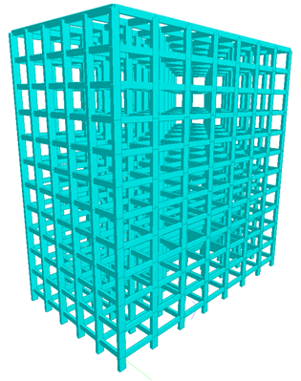
Fig.1- 3D view of G+10 RC building

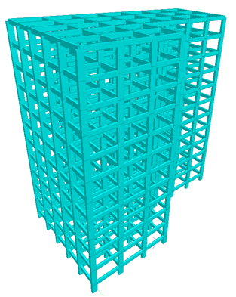
Fig.2- 3D view of G+10 RC building with plan irregularity
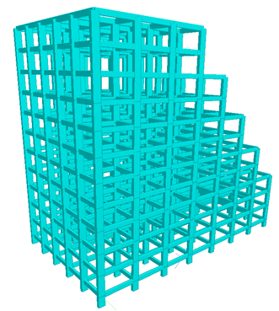
Fig.3- 3D view of G+10 RC building with vertical irregularity
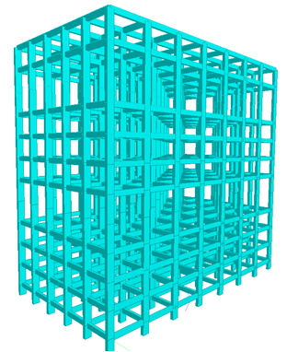
Fig.4- 3D view of G+10 RC building with stiffness irregularity
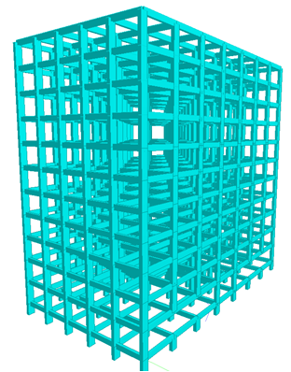
Fig.5- 3D view of G+10 RC building with weak storey irregularity
RESULTS
Table 2- Base shear (kN) in X-direction
Type of Model | IS 1893:2002 | IS 1893:2016
Regular | 5786.01 | 8307.57
Plan Irregularity | 5465.6 | 6634.29
Vertical Irregularity | 5084.51 | 6152.26
Mass Irregularity | 6909.64 | 8389.46
Stiffness Irregularity | 5657.1 | 6975.1
Weak storey | 6769.97 | 8423.52

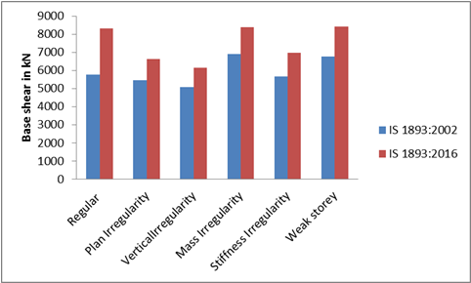
Fig.6-Base shear (kN) in X-direction
Table 3- Base shear (kN) in Z-direction
Type of Model | IS 1893:2002 | IS 1893:2016
Regular | 5722.98 | 6944.72
Plan Irregularity | 5007.98 | 6062.15
Vertical Irregularity | 4507.57 | 5651.94
Mass Irregularity | 6319.35 | 7678.22
Stiffness Irregularity | 5226.11 | 6365.39
Weak storey | 6219.56 | 7640.47

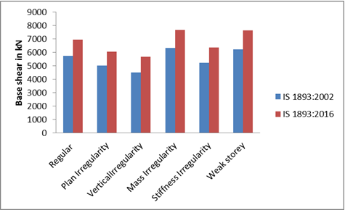
Fig.7-Base shear (kN) in Z-direction

Table 4- Maximum Lateral Displacement (mm) in X-direction
Type of Model | IS 1893:2002 | IS 1893:2016
Regular | 49.85 | 81.326
Plan Irregularity | 49.863 | 84.244
Vertical Irregularity | 42.462 | 73.704
Mass Irregularity | 50.453 | 84.926
Stiffness Irregularity | 54.486 | 92.734
Weak storey | 53.037 | 93.968

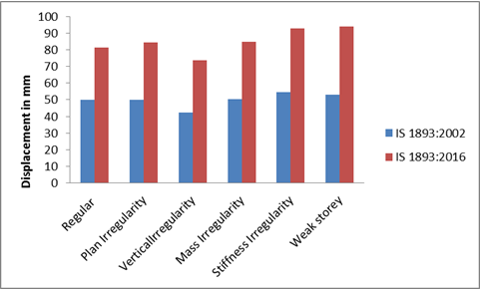
Fig.8-Maximum Lateral Displacement (mm) in X-direction
Table 5- Maximum Lateral Displacement (mm) in Z-direction
Type of Model | IS 1893:2002 | IS 1893:2016
Regular | 65.255 | 110.531
Plan Irregularity | 72.907 | 128.677
Vertical Irregularity | 81.001 | 136.697
Mass Irregularity | 66.083 | 115.905
Stiffness Irregularity | 81.426 | 146.157
Weak storey | 89.414 | 170.734

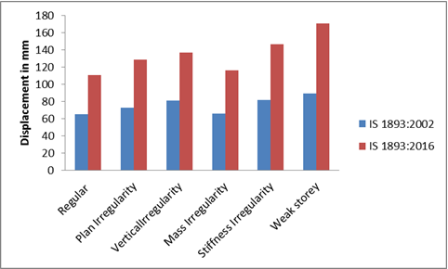
Fig.9-Maximum Lateral Displacement (mm) in Z-direction
Table 6- Maximum axial force (kN) in columns
Type of Model | IS 1893:2002 | IS 1893:2016
Regular | 4409.52 | 5452.28
Plan Irregularity | 4524.18 | 5755.75
Vertical Irregularity | 4450.9 | 5657.1
Mass Irregularity | 4426.21 | 5563.72
Stiffness Irregularity | 3674.96 | 4718.07
Weak storey | 8721 | 11045.2

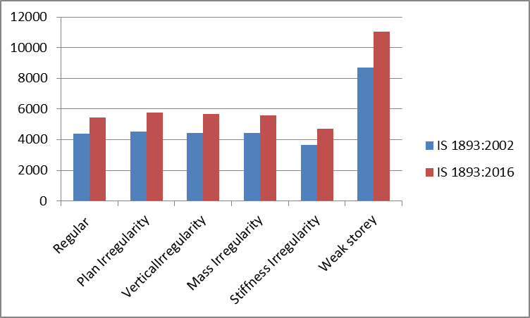
Fig. 10- Maximum axial force (kN) in columns

Table 7- Maximum shear force Y (kN) in columns
Type of Model | IS 1893:2002 | IS 1893:2016
Regular | 244.721 | 432.068
Plan Irregularity | 243.969 | 356.98
Vertical Irregularity | 200.185 | 438.581
Mass Irregularity | 248.922 | 375.499
Stiffness Irregularity | 207.338 | 1080.05
Weak storey | 801.195 | 423.661

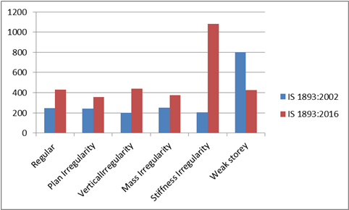
Fig.11-Maximum shear force Y (kN) in columns
Table 8- Maximum shear force Z (kN) in columns
Type of Model | IS 1893:2002 | IS 1893:2016
Regular | 239.06 | 475.381
Plan Irregularity | 255.938 | 531.566
Vertical Irregularity | 302.143 | 445.811
Mass Irregularity | 242.986 | 379.235
Stiffness Irregularity | 201.316 | 904.912
Weak storey | 455.708 | 666.208

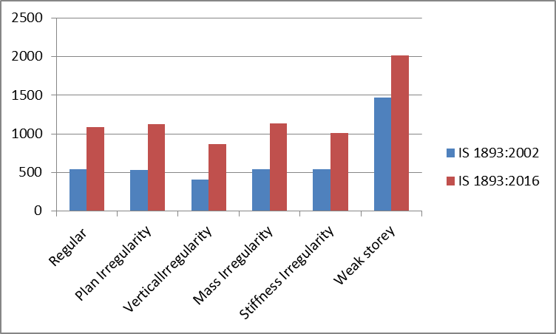
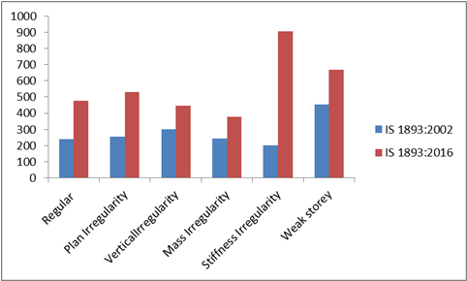
Fig.12-Maximum shear force Z (kN) in columns
Table 9- Maximum moment Y (kNm) in columns
Type of Model | IS 1893:2002 | IS 1893:2016
Regular | 370.935 | 666.208
Plan Irregularity | 392.576 | 736.731
Vertical Irregularity | 468.698 | 834.926
Mass Irregularity | 377.129 | 701.31
Stiffness Irregularity | 488.377 | 934.892
Weak storey | 709.518 | 1423.33

Fig.13-Maximum moment Y(kNm) in columns

Table 10- Maximum moment Z (kNm) in columns
Type of Model | IS 1893:2002 | IS 1893:2016
Regular | 537.995 | 1082.54
Plan Irregularity | 536.513 | 1120.87
Vertical Irregularity | 408.965 | 871.491
Mass Irregularity | 546.83 | 1135.72
Stiffness Irregularity | 545.523 | 1006.91
Weak storey | 1466.03 | 2017.62

Fig.14-Maximum moment Z (kNm) in columns
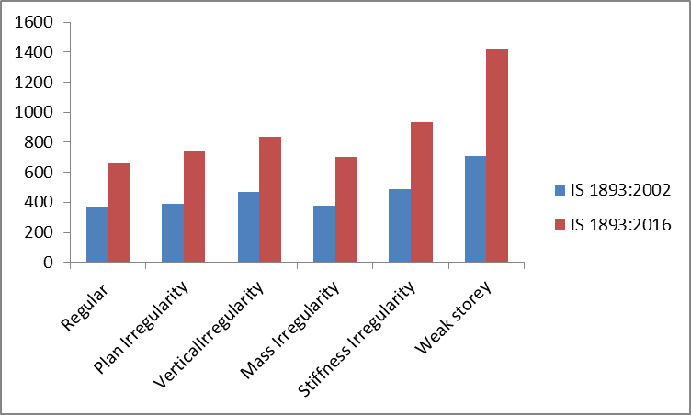
CONCLUSIONS
- Base shear for mass irregularity is highest. Approximately 20% increase in base shear is calculated after using IS 1893:2016.
- Storey shear and base shear in both the directions i.e. along X-direction and along Z-direction are increased by nearly same amount i.e. approximately 20% when using IS 1893:2016.
- Models using IS 1893:2016 shows 10% - 20% rise in axial force in columns when compared with models using IS 1893:2000.
- Models using IS 1893:2016 shows 15% - 25% rise in shear force in columns when compared with models using IS 1893:2000.
- Models using IS 1893:2016 shows 30% rise in moments in columns when compared with models using IS 1893:2000.

REFERENCES
- Sagar R Padol, Rajashekhar S. Talikoti,(2015) “Review paper on seismic responses of multistored rcc building with mass irregularity”, IJRET: International Journal of Research in Engineering and Technology eISSN: 2319-1163 | pISSN: 2321-7308 Volume: 04 Issue: 03 |
- Kusuma B,(2017) “Seismic Analysis of a High-rise RC Framed Structure with Irregularities”, International Research Journal of Engineering and Technology (IRJET) e-ISSN: 2395-0056 Volume: 04 Issue: 07 | www.irjet.net p-ISSN: 2395-0072 © 2017, IRJET | Impact Factor value: 5.181 | ISO 9001:2008 Certified Journal | Page 1338
- Akhil R, Aswathy S Kumar,(2017) “Seismic analysis of regular and irregular buildings with vertical irregularity using STAAD.Pro”, International Research Journal of Engineering and Technology (IRJET) e-ISSN: 2395 -0056 Volume: 04 Issue: 06 | | Impact Factor value: 5.181 | ISO 9001:2008 Certified Journal | Page 1863
- Arvindreddy, R.J.Fernandes,(2015) “Seismic analysis of RC regular and irregular frame structures”, International Research Journal of Engineering and Technology (IRJET) e-ISSN: 2395-0056 Volume: 02 Issue: 05 | IRJET ISO 9001:2008 Certified Journal Page 44
- Mangesh S. Suravase, Prashant M. Pawar,(2017)”Effect of Geometrical Plan Irregularities on RCC Multi-Storey Framed structure”, International Journal of Engineering Trends and Technology (IJETT) – Volume 47 Number5.
- Ravindra N. Shelke,(2017) “seismic analysis of vertically irregular RC building frames” International Journal of Civil Engineering and Technology (IJCIET) Volume 8.
- Ashvin G. Soni, Prof. D. G. Agrawal, Dr. A. M. Pande,(2017)” Effect of Irregularities in Buildings and their Consequences”,International Journal of Modern Trends in Engineering and Research.
- Dr. S.K. Dubey, Prakash Sangamnerkar, ankit agrawal,”(2015) dynamics analysis of structures subjected to earthquake load “,International Journal of Advance Engineering and Research Development Volume 2,Issue 9.
- A S Patil* and P D Kumbhar,(2013)” time history analysis of multistoried rcc buildings for different seismic intensities”,Int. J. Struct. & Civil Engg. Res.
- IS: 1893(part-1)-2002 “Code of practice for criteria for Earthquake design of structures.”
- IS: 1893-(part-1)-2016 “Code of practice for criteria for Earthquake resistant design of structures.”
- IS: 875(part-1)-1987 “Code of practice for Design loads (other than earthquake) for building structures-Dead loads.”
- IS: 875(part-2)-1987 “Code of practice for Design loads (other than earthquake) for building structures-Imposed loads.”

Details of authors
Sr.No | Photo | Details
1 |  | Rakeshkumar Fupta is Mtech - student appearing (Structural Engineering) from Gurunanak Institute of Management and Technology, kalmeshwar road, Nagpur (RTM Nagpur University), Maharashtra State, India
2 |  | Prof. D.L.Budhlani is working as Associate Professor, Department of Civil Engineering,Guru Nanak Institute of Technology (Formerly known as Guru Nanak Institute of Engineering & Management )Dahegaon, Nagpur and Dean,Research &Development,Guru Nanak Institutions,Nagpur, Maharashtra State, India.

