Future based Self learning Hybrid Model of Automatic Manless Smart City with Implementation of Remote access Using Automation.
Miss. Prajakta Malakwade
Guru Nanak Institute of Engineering and Technology, Nagpur India 441502..
Email: prajaktamalakwade@gmail.com
Mobile: 9373925032

ABSTRACT : The objective of an “AUTOMATED SMART CITY” is system-based approach for the design of this services, and the related protocols and technologies, discussing their suitability for the current environment. The aim is to convert the system in a fully auto-self diagnosed unmanned level which is user friendly and work with not only in support with the current technology but which also care for the user safety.
Keywords: Automation, Building automation, transport automation and Medical/safety automation, Remote access automation.

INTRODUCTION:
Automation is a recent communication paradigm that envisions a near future, in which the objects of everyday life will be equipped with microcontrollers, transceivers for digital communication.
The concept of smart city is the ability of the system to work, diagnose, and troubleshoot in its own required way as per the requirement of the user
The application makes the identification of solutions capable of satisfying the requirements of all possible application scenarios a formidable challenge.

METHODOLOGY:
The method adopted here is to work the system in a micro level just like the technology used previously but the main difference here is to combine the different system like home automation, transport automation and medical/safety automation to achieve the smart city concept.
Home Automation: The city can never be called a smart city unless it has proper automated house which is equipped with automated devices which supports the user in a day today life.
Transport Automation: Transport is the main lifeline of any city to keep the city up and running to an automated approach with perfect traffic control is necessary.
Safety Automation: The city without safety and precaution can never be smart. So as a safety measure it is equipped with proper alarm system and emergency devices which is done remotely.

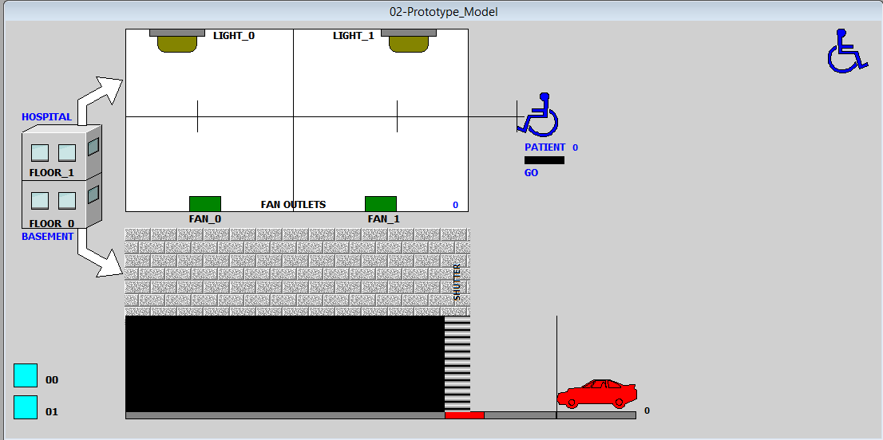
Figures and Tables:
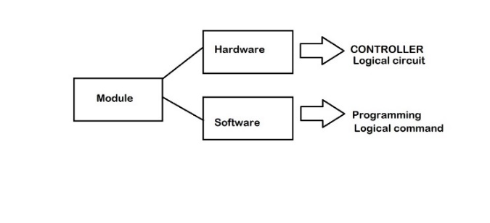
Fig. Medical Automation

The project consist of three major part as the smart city is a big idea: It is the combination of Building automation, transport automation and Medical/safety automation.

Program Code:
IF START==1 THEN OWNER=OWNER + 2; ENDIF;
IF OWNER==250 THEN START=0; ENDIF;
IF OWNER==250 AND START==0 THEN SENSORWB=1; ELSE SENSORWB=0; ENDIF;
IF SENSORWB==1 THEN LAMP=1; ELSE LAMP=0; ENDIF;
IF RETURNB==1 THEN OWNER=OWNER - 2; ENDIF;
IF OWNER==0 THEN RETURNB=0; ENDIF;
IF START_X==1 THEN OWNER_X=OWNER_X + 1; ENDIF;
IF OWNER_X>=50 AND OWNER_X<=150 THEN DOOR=1; ELSE DOOR=0; ENDIF;
IF OWNER_X==200 THEN START_X=0; ENDIF;
IF RETURN_X==1 THEN OWNER_X=OWNER_X - 1; ENDIF;
IF OWNER_X==0 THEN RETURN_X=0; ENDIF;
IF SEC>=1 AND SEC<=10 THEN GRN1=1; RED2=1;
ELSE GRN1=0; RED2=0;
ENDIF;

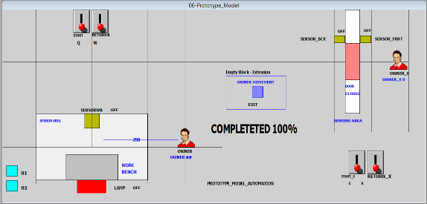

Fig. Home Automation
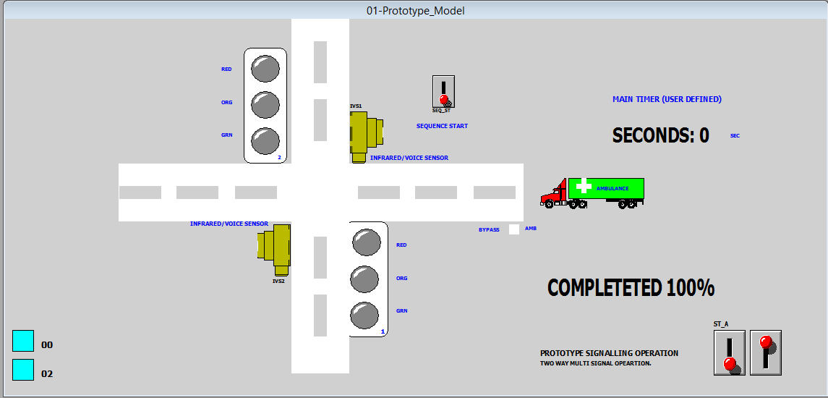

Fig. Traffic Automation

IF SEC>=10 AND SEC<=15 THEN ORG1=1; ORG2=1; ELSE ORG1=0; ORG2=0; ENDIF;
IF SEC>=15 AND SEC<=25 THEN RED1=1; GRN2=1;
ELSE RED1=0; GRN2=0;
ENDIF;
IF SEC==25 THEN SEC=0; ENDIF;
IF AMB==1 THEN AMB_CAR=AMB_CAR + 1; ENDIF;
IF AMB_CAR==50 THEN IVS1=1; IVS2=1; ENDIF;
IF IVS1==1 OR IVS2==1 THEN SEQ_ST=0; SEC=0; BYPASS=1;
ELSE BYPASS=0; ENDIF;
IF GO==1 THEN PATIENT=PATIENT + 2; ENDIF;
IF PATIENT==150 THEN GO=0; ENDIF;
IF PATIENT==150 AND GO==0 THEN LIGHT_1=1; FAN_1=1; ELSE LIGHT_1=0; FAN_1=0; ENDIF;
IF TIME==10 THEN GO=1; ENDIF;
IF PATIENT==400 THEN GO=0; ENDIF;
IF PATIENT==400 AND GO==0 THEN LIGHT_0=1; FAN_0=1; ENDIF;
IF GO_==1 THEN VEHICLE=VEHICLE + 2; ENDIF;
IF VEHICLE==100 THEN GO_=0; ENDIF;
IF VEHICLE==100 AND GO_==0 THEN PRESSURE_SENSOR=1; ENDIF;
IF VEHICLE==100 AND GO_==0 AND PRESSURE_SENSOR==1 THEN SHUTTER=SHUTTER - 2; ENDIF;
IF SHUTTER==0 THEN GO_=1; ENDIF;
IF VEHICLE==300 THEN GO_=0; ENDIF;
IF VEHICLE==300 AND GO_==0 THEN PRESSURE_SENSOR=0; ENDIF;
IF VEHICLE==300 AND GO_==0 AND PRESSURE_SENSOR==0 THEN SHUTTER=SHUTTER + 2; ENDIF;

Conclusion
The result is promising as the whole system is working under as single loop which continuously compares the the data and auto adjust the the whole system as per the user and also make the user aware of the changes required for his own safety and precaution.

References
Journal Papers:
- Point-n-Press: An Intelligent Universal Remote Control System for Home Appliances
Kuen-Min Lee, Wei-Guang Teng, Ting-Wei Hou
An intelligent universal remote control system for home appliances named Point-n-Press is proposed, which addresses the directionality feature, which enables easy and intuitive control by pointing to the target device to display the target's control interface on the screen of the remote controller.
- Design of Smart Home System Based on ZigBee S. Zhihua
A ZigBee wireless sensor network for home control subnet and home PC machine as the family gateway and home control center is proposed and WiFi wireless data communication technology access home subnet on the Android platform is proposed to achieve the ranking system for remote monitoring.
- An Intelligent Power Outlet System for the Smart Home of the Internet of Things
- T. Fernández-Caramés
An intelligent power outlet system that can be controlled wirelessly and that has been specifically designed to monitor electrical events in low-current loads is presented, being able to make the next generation of homes safer and smarter.

