Design and Development of the S-Wheel Suspension System

Devam Salunke¹, Om Navrange², Chaitesh Salvi³, Vinit Patil⁴

^{1,2,3}Students, ⁴Associate Professor,
Mechanical Engineering, Lokmanya Tilak College of Engineering, Koparkhairane, India

Received on: 01 May, 2023 Revised on: 24 May 2023 Published on: 26 May 2023

Abstract--In this paper, designing a self-suspension wheel for cycle or motorcycle. This idea come out as we see in daily life cycle or motorcycle upgrade with new technologies and many more but nothing much consideration for suspension or tyres wheels .After that we decided to accommodate some ideas about suspension and modified with wheel of two wheeler and the small jerks of road that cannot be minimised by the suspension forks of two wheeler that can be eliminated or absorbed by that suspension arms which are arranged radially in wheel rim There is uncomfortable for Rider and pain from this small jerks and this suspension definitely absorbed this jerks and eliminate them and give comfort for rider.
I-INTRODUCTION
This concept is put forward after considering all the forces acting on the human body and the cycle during motion. The wheel is one of the oldest inventions of humankind after the discovery of fire. There have not been many changes made to the wheel geometry or engineering itself. In the modern time where science has made improvements in leaps and bounds, there have been changes made to everything, from material to the design of a cycle. The focus has now shifted to the innovation of a spoke-less wheel. Just like the soft wheel and the Loop wheel, the initiative is to introduce shock-absorbers in the wheels of a cycle. The integration of shock-absorbers was loosely named Spring wheel. The wheel combines three shock absorbers for better suspension and shock absorbing performance. Spring wheel provides better vibration absorbing quality that leads to elevated comfort while cycling. The Spring wheel maintains better contact with the ground to deal with bumps and shocks. This design is specialized and tested in such a way that it performs well in different terrains. It is strong and durable enough to run on uneven terrains, rough tracks, streets, and highway. With the use of the Spring wheel, the vibration generated in cycles with spokes is shortened by 2/3 rds. Spring wheels can better overcome wear and tear as compared to a spoked one. The central hub of the Spring wheel is a floating type hub. The forces that act on the wheel compress the shock-absorbers. Then the hub shifts corresponding to the force applied and recoils back to its original position after the energy gets dispersed. The three shock absorbers are fitted in a self-locking angle to transmit better torque. The Spring wheels made and tested to give better comfort to the cyclist while traveling terrestrially. While cycling, various forces travel through the structure of the cycle and act on the cyclist, which can then lead to back pain and other medical problems. Spring wheel could be the answer to this problem as it provides a better cushioning effect to the cyclist. To design and fabricate in-wheel suspension system for bicycles in low cost and for better suspension In two wheeler riding the rider always get some small jerks and uncomfortable while riding cycle or motorcycle because there is no limitations for uneven roads and small jerks they cannot eliminate with the suspension provided at front(telescopic forks).Our design gives you the practical method for eliminating that dumps and this radially arranged suspension arms help to absorb that small dump and gives you comfort riding Due to different 7 arrangements of forks it provides the total force transfer of vehicle Rider and uneven bumps from road surfaces and comfort matters so that it is very helpful to you in your riding experience.
II -LITERATURE REVIEW
Shock Absorber in Cycle Wheels. Utkarsh Dubey1, Salahuddin Khan2, Rohan Rana3, Rajeev Kumar Singh4, Dhruv Kumar5 This concept is put forward after considering all the forces acting on the human body and the cycle during motion. The wheel is one of the oldest inventions of humankind after the discovery of fire. There have not been many changes made to the wheel geometry or engineering itself. In the modern time where science has made improvements in leaps and bounds, there have been changes made to everything, from material to the design of a cycle. The focus has now shifted to the innovation of a spoke-less wheel. Just like the Soft wheel and the Loop wheel, the initiative is to introduce shock-absorbers in the wheels of a cycle. The integration of shock-absorbers was loosely named Spring wheel. The wheel combines three shock absorbers for better suspension and shock absorbing performance. Spring wheel provides better vibration absorbing quality that leads to elevated comfort while cycling.
III-METHODOLOGY

We begin our work and project by studying many other research papers related to our topic and work on a different mechanism that can be useful to our project. The main target is to achieve the desired suspension. The desired stiffness of the shock-absorbers is achievable by adjusting the nuts on the shock absorber by tightening and loosening it. The wheel design takes into consideration the impact of forces from the ground and the lateral forces while turning the direction of the cycle. Using more shock absorbers in the wheel will increase the load carrying and shock absorbing ability but also increase the weight, which will require more effort to drive it. We also design a custom hub, design to accommodate the rim, and shock absorber.
Fig 3.1 It shows normal condition of three suspension forks and runs on smooth surface.
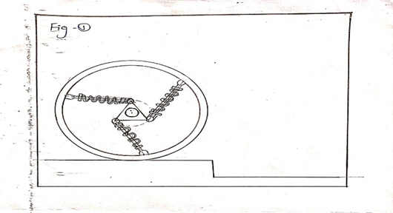
Fig. 3.1 Actual Working Of S-Wheel
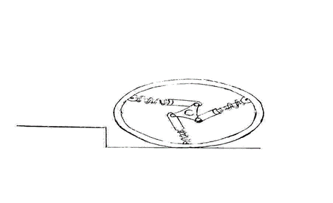
Fig 3.2. It shows the actual working action of forks and how it acts and transfer the jerk and divide it in that suspension arms.
Fig 3.2 Working Of S-Wheel
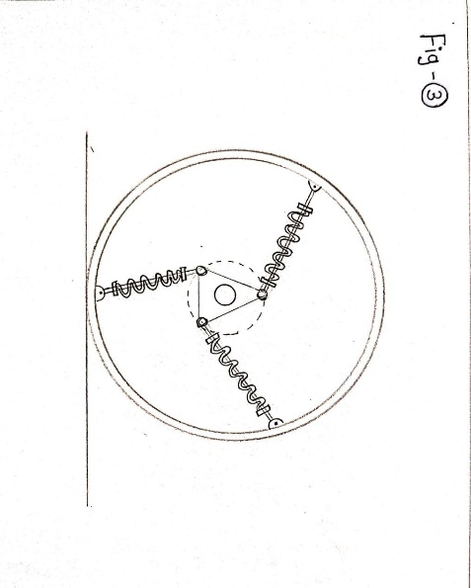
Fig 3.3. This figure shows how it retracts its original shape and runs like normal wheel again.

IV-DESIGN CALCULATIONS AND OBSERVATION

Design Calculations: -
• Design of shock absorber spring
Material Selection: Alloy Steel,
Modulus of rigidity G = 80000 N / mm²
Shear stress (Z) 364 MPa
Spring index =6,
Wahl's stress factor =1.184
Person weight +Bicycle weight= 2000 N
Max deflection=50mm (Assume)

• Wire dia. (d)
Shear stress =Kw [8max * C] /πd²
364=.184(8*2000*6/πd²)
d=10
• Mean diameter (D)
D=C*d
= 6*10
D=60mm
• Number of coils:-(n’)
Spring stiffness k = Fmax/Max deflection
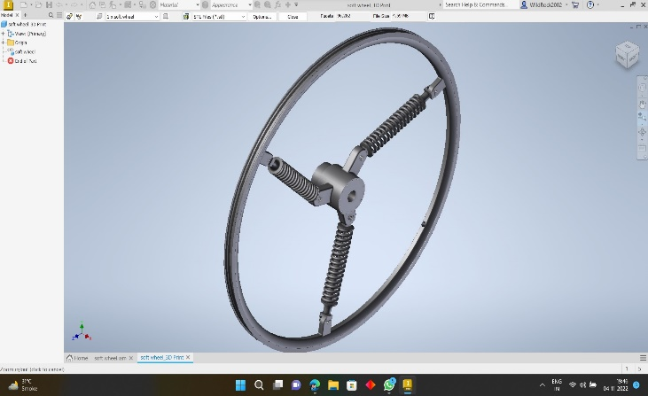
2000/50= 40 N/mm
K= Gd/8C^3 *n
40 = 80000*10/8*6^3*n
n = 12 turn
• Total number of coils= (n’)
n’= n +2
=12 +2
(n’) =14
• Solid length (Ls)=
Ls= (n +2) *d
= (12 +2) *10
Ls = 140 mm
• Free length (Lf) Lf =
Ls + Max deflection + (n’-1) *1
= 140+50+(14-1) *1
Lf= 203 mm
• Pitch of spring (P)=
Lf=Pn +2d 203
= P*12+2*10 P
(P)= 15.25 mm

V-COMPONENT USED
5.5 Wheel Rim:
In the bicycle wheel, the rim is a large hoop attached to the outer ends of the spokes of the wheel that holds the tire and tube. In cross-section, the cycle-rim is depressed in the centre and shallow at the outer edges, thus forming a "U" shape that provides support for the bead of the tire casing.
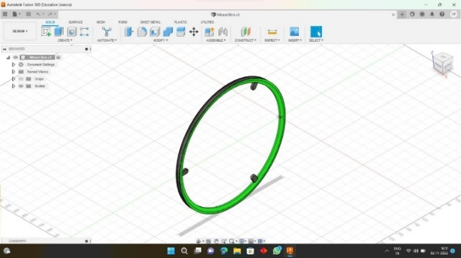

5.2 Wheel Hub

A hub is the centre part of a bicycle wheel. It consists of an axle, bearings and a hub shell. The hub shell typically has two machined metal flanges to which spokes can be attached.
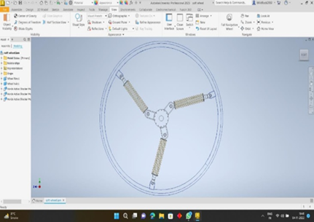
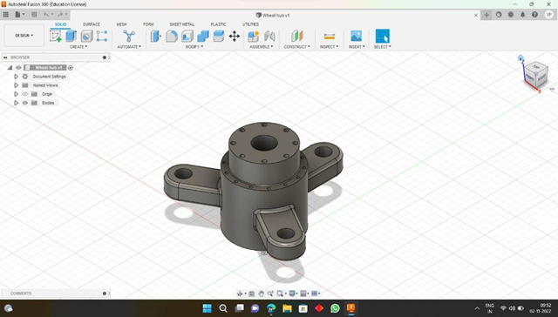

5.3 Coil Over Shock Absorber:
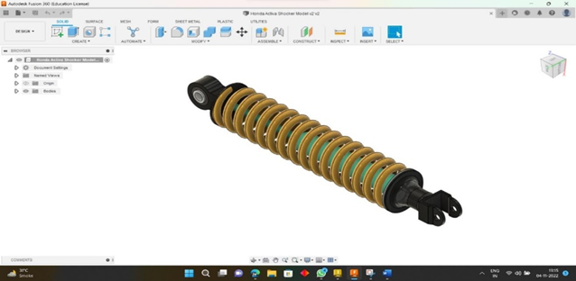
In a vehicle, shock absorbers reduce the effect of driving over rough ground, leading to improved ride quality and vehicle handling. While shock absorbers serve the purpose of restricting excessive suspension movement, their intended sole purpose is to damp spring vibrations.

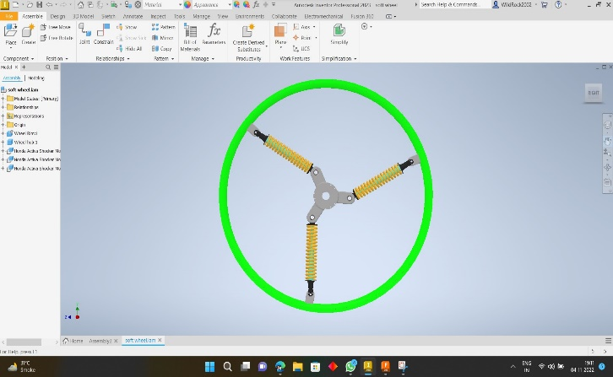
3D MODELS OF S-WHEEL SUSPENSION SYSTEM

VI-CONCLUSION
The design of wheels with shock-absorbers substituting the traditional spokes yielded positive results towards the comfort of cycling and advances of other elements, with very little or no drawbacks. Starting from the ease of cycling that comes with such a design, it also upgrades the shock absorption capabilities. It also removes the need for a shock-absorber for the frame or any other parts for the cycle. This type of wheel finds application in a situation where comfort is the absolute must, and one such area is the wheelchairs for old and sickly. And this paper goes a long way in showing just how effective the altered wheels are in the real world.

REFERENCES

- Pinku Patil, A. D. Diwate, P. M. Hombal (2018). “Design and Analysis of Loop Wheel Suspension System”. IOSR Journal of Mechanical and Civil Engineering. e-ISSN: 2278-1684,p-ISSN: 2320-334X. 12-15.
- Lakhan Agrawal1, Pavan Jadhav2, Aakash Patil3, Akshay Ahire4, S. M. Jadhav (2017). “Design and Analysis of Loop Spring Suspension System in Bicycle”. International Conference on Ideas, Impact and Innovation in Mechanical Engineering. 5(6). ISSN: 2321-8169. 1383 – 1387.
- M.C. Shinde1, S. Hanumant, P. Vishwakarma, K. Rangwani, S. Shinde (2017). “Design of Loop Wheel Suspension System”. International Journal of Innovations in Engineering and Science. 2(7). e-ISSN: 2456-3463. 34-40.
- Pinjarla.Poornamohan, Lakshmana Kishore.T (2012). “Design and analysis of a shock absorber”. IJRET: International Journal of Research in Engineering and Technology. 1(4). ISSN: 2319-1163. 578-592.
- Shweta R. Chandure, S. M. Kherde (2018). “Investigation of the Bike Wheel Rims With Modified loop Wheel Reinvents”. International Journal of Scientific Research & Engineering Trends. 4(4). ISSN: 2395-566X. 731-735.
- Rajesh Chauhan, Rohil Jankat, Anup Ghosh, Ajitesh Gaikwad, Lokesh Dhumne (2019). “Design and Development of Loop Wheel Bicycle”. International Research Journal of Engineering and Technology (IRJET). 6(4). e-ISSN: 2395-0056. 4414-4416.

