An Experimental Study on Flexural Behaviour of Reinforced Concrete Beam Strengthened with FRP Composites
Sulabh H. Bagde¹, Prof. D.L.Budhlani², Prof. B.N.Ramteke³
¹M.Tech-Student (Structural Engineering)
Guru Nanak Institute of Technology, Dahegaon, Nagpur, India-441501
^{2,3}Assistant Professor
Guru Nanak Institute of Technology, Dahegaon, Nagpur, India -441501
.

Abstract –In this paper presents an experimental study conducted to examine the effectiveness of Fibre Reinforced Polymer (FRP) composites in enhancing the flexural capacity of concrete beams. In this study, Fibre-reinforced polymer (FRP) application is a very effective way to repair and strengthen structures that have become structurally weak over their lifespan. Externally reinforced concrete beams with epoxy-bonded FRP sheets were tested to failure using a symmetrical two point concentrated static loading system. The results show that the FRP strengthened beams exhibit increased strength, deformation capacity, ductility and composite action until failure.
Keywords-FRP, Epoxy Resin, Flexure, Two Point Static Loading System

INTRODUCTION
For any structure maintenance, rehabilitation and upgrading of structural members perhaps one of the most crucial problems in civil engineering application. Infrastructure decay caused by premature deterioration of building and structure has needed to repair and strengthen. Recently, considerable attention has been focused on the use of Fibre Reinforced Polymer (FRP) for structural rehabilitation and strengthening. The most common types of FRP are aramid, glass, and carbon; AFRP, GFRP, and CFRP respectively.
So strengthening has become the way to improve the load carrying capacity and their service lives of the structure. But there is a challenge of selecting the appropriate method of strengthening for concrete that will enhance the strength and serviceability of the structure. The reinforced concrete beam in flexure, strengthened with different configuration and different layers of FRP sheets. Lastly the effect on strength and ductility of beam is obtained.

MATERIAL USED
The materials used in the specimens for this study are as follows:
- Cement (Ordinary Portland cement – OPC-43 Grade)
- Fine aggregate (It passes through 4.75 mm IS sieve)
- Coarse aggregate (Maximum size of 20 mm is used)
- Water (Clean potable water conforming to IS 456-2000 was used).
- Reinforcement (HYSD 12mm φ-Longitudinal
Reinforcement and Mild steel bar Stirrups 6mmφ bars)
- Concrete (Mix Proportion of M20 grade concrete used)

- Reinforcement Materials (carbon fibre)
Carbon are fibre about 5–10 micrometres in diameter and composed mostly of carbon atoms. Carbon fibres have several advantages including high stiffness, high tensile strength, low weight, high chemical resistance, high temperature tolerance and low thermal expansion. These properties have made carbon fibre very popular in aerospace, civil engineering, military, and motorsports, along with other competition sports. However, they are relatively expensive when compared with similar fibres, such as glass fibres or plastic fibres.CFRPs can be expensive to produce but are commonly used wherever high strength-to-weight ratio and rigidity are required, such as aerospace, automotive, civil engineering, sports goods and an increasing number of other consumer and technical applications.
- Matrix Material
The matrix materials used to bind the fibres with proper orientation and configurations, and also load transfer to the fibre. The matrix materials have mechanical properties such as strength, shear and compression.
  - Epoxy Resin
Epoxy resin is the structure of three member ring, which contains two carbons and one oxygen. The molecular weight of epoxy resin is very low for pre-polymers under various conditions.
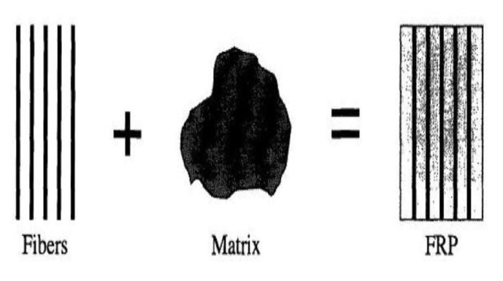
Fig. 1- fig shows formation of FRP

METHODOLOGY

The experimental study is carried out by two point loading system. In this report, three beams are tested for flexure. One for are with deflection of controlled concrete beam. Controlled beam and other two beams are casted and strengthened by applying CFRP on two beams in flexure mode. The strengthening of beam is done by different amount and different configurations of CFRP sheets provided. The application of ultimate load acting on the beam, the deflection and mode of failure each beam obtained.
The cross sectional dimensions of the beams are700 × 150 × 150 mm. The two numbers of 12 mm diameter bars are provided for main longitudinal reinforcement and 6 mm diameter bars are provided for stirrups at a spacing of 80 mm centre to centre distance. Finally the results are compared with deflection of controlled concrete beam.

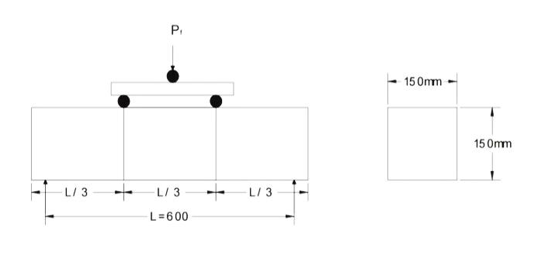Fig. 2- fig shows two point loading setup

RESULT AND DISCUSSIONS
The beams were tested for finding their ultimate strength. In this study, the three beams were tested namely F1, F2, F3 at weak in flexure mode. The beam F1 was controlled beam. It carried lesser load than other two beams F2, F3. The beam F2 was strengthened at only so fit of the beam. Then beam F3 was strengthened up to neutral axis of the beam F3.
Three beams were tested and found out their ultimate load carrying capacity which is presented in Table 1. From the Table 1, it may be found that beam F1 was failed at earlier stage, the beam F2 was failed by the influence of flexural and shear failure; as a result CFRP sheets broke down by two pieces and the beam F3 was failed, when CFRP sheets were delaminated.

Table 1.Nature of Failure and Ultimate Load of Beams (F1, F2, F3)
Beams tested in flexure mode | Initial cracking Load(KN) | Ultimate load (KN) | Nature of Failure
F1 | 30 | 75 | Flexure failure
F2 | 35 | 105 | CFRP rupture + Flexure – Shear failure
F3 | Not visible | 115 | CFRP rupture + Flexure – Shear failure

LOAD AND DEFLECTION
The graphs comparing the mid-span deflection of flexure deficient beams and their corresponding control beams follows:

Figure 1.Relationship between load and deflection of beam F1

Figure 2.Relationship between load and deflection of beam F2

Figure 3. Relationship between load and deflection of beam F3

COMPARISON OF LOAD AND DEFLECTION
The comparison of load and deflection observed on beams F1, F2, and F3 is shown in Figure 4. The beam F1 has lower ultimate load carrying capacity than F2, and F3. F1 has higher deflection than F2, and F3. The beam F2 has higher load carrying capacity than F1 but lower than F3. The beam F3 has higher load carrying capacity than F1, and F2.
Further, it may observe that the deflection of beam F2, and F3 has same magnitude at a load of 65 KN. The beam F3 maintained the same deflection for an increasing load. The deflection of beam F3 and F2 is higher than beam F1.

Figure 4.Relationship between load and deflection of beam F1,F2,F3
CONCLUSION
In this study, the beam F2 has initial flexural cracks appeared at higher load than beam F1. The ultimate load carrying capacity of beam F2 is 30%, which was higher than beam F1. Further, for an increasing load, the beam F2 failed in flexure-shear. In beam F3, the ultimate load carrying capacity is found to be40%, which is higher than beam F1 and 10% higher than beam F2. Finally, the strengthening of beam with CFRP sheets up to neutral axis of beam, leads to increase the ultimate load carrying capacity
REFERENCES
- M. A. Shahawy, M. Arockiasamy, T. Beitelman, R. Sowrirajan (1996) “Reinforced concreterectangular beams strengthened with CFRP laminates” Composites: Part B 27B 225-233
- Victor N. Kaliakin, Michael J. Chajes and Ted F. Januszka (1996) “Analysis of concrete beams reinforced with externally bonded woven composite fabrics” Composites: Part B 27B 235-244

- G. Spadea, F. Bencardino and R. N. Swamy (1998) “Structural Behavior of Composite RC Beams with Externally Bonded CFRP” Journal of Composites for Construction Vol.2, No. 3. August, 1998. 132-137
- Ahmed Khalifa, William J. Gold, Antonio Nanni, and Abdel Aziz M.I.(1998) “Contribution of externally bonded FRP to shear capacity of RC flexural members” Journal of Composites for Construction, Vol. 2. No. 4. 195-202
- N. F. Grace, G. A. Sayed, A. K. Soliman and K. R. Saleh (1999)“Strengthening Reinforced Concrete Beams Using Fiber Reinforced Polymer (FRP) Laminates” ACI Structural Journal. 865-875
- B. Taljsten and L. Elfgren “Strengthening concrete beams for shear using CFRP-materials: evaluation of different application methods” Composites: Part B 31 (2000)87–96
- Ahmed Khalifa, Antonio Nanni “Improving shear capacity of existing RC T-section beams using CFRP composites” Cement & Concrete Composites 22 (2000) 165-174
- Thanasis C. Triantaﬁllou and Costas P. Antonopoulos “Design of concrete flexural members strengthened in shear with FRP” Journal of Composites for Construction, Vol. 4, No. 4, November, 2000. 198-205
- Thanasis C. Triantaﬁllou and Costas P. Antonopoulos “Design of concrete flexural members strengthened in shear with FRP” Journal of Composites for Construction, Vol. 4, No. 4, November, 2000. 198-205
- V.P.V. Ramana, T. Kant, S.E. Morton, P.K. Dutta, A. Mukherjee and Y.M. Desai “Behavior of CFRPC strengthened reinforced concrete beams with varying degrees of strengthening” Composites: Part B 31 (2000) 461-470
- D. Kachlakev and D.D. McCurry “Behavior of full-scale reinforced concrete beams retrofitted for shear and flexural with FRP laminates” Composites: Part B 31 (2000)445-452

Details of All Authors
Sr.No | Photo | Details
1 |  | Sulabh Bagde is Mtech - student appearing (Structural Engineering) from Guru Nanak Institute of Management and Technology, Kalmeshwar road, Nagpur (RTM Nagpur University), Maharashtra State, India
2 |  | Prof.D.L.Budhlani is working as Assistant Professor, Department of Civil Engineering, Guru Nanak Institute of Technology (Formerly known as Guru Nanak Institute of Engineering & Management)Dahegaon, Nagpur
3 |  | Prof.B.N.Ramteke is working as Assistant Professor, Department of Civil Engineering, Guru Nanak Institute of Technology (Formerly known as Guru Nanak Institute of Engineering & Management) Dahegaon, Nagpur

