Review on Speed Breakers for Traffic Calming Roads

Mohit Raj¹, Prof. S. D. Ghodmare², Rakesh Kumar Choubey³

¹Master of Technology Student Transportation Engineering, GHRCE, Nagpur, Maharashtra (India)
²Assistant Professor, Department of Civil Engineering, GHRCE, Nagpur, Maharashtra (India)
³Project Manager (Structure), Dilip Buildcon limited Goa (India)

Abstract– Speeding of vehicles increases the chance and seriousness of accident, so that the minimisation of speeding vehicles is significant as the streets/roads are designed for a particular designed velocity for that reason the traffic- calming measures have been used. Speed breakers are one among the globally used traffic- calming measures; it forces the driver to cut down the vehicle velocity to a more favourable speed at which the discomfort is least. In growing countries like India maximum percentage of population utilizes bike or different non- motorized vehicles. The reason for the present survey is to assess available research information and technical literature. This survey describe numerous traffic- calming measures i.e. speed breakers, types of speed breakers, problems with their corrective measures, dimensions, evaluating the legal status of the speed breakers, gathering the available information present in literature.

Keywords- Speed breakers, IRC-99, traffic- calming, traffic guidance, human safety
- INTRODUCTION

For the right functioning of the roadway system controlling driving speed is taken into account to be an efficient approach of improving driving safety, driving velocity of vehicle plays a vital role in accident incidence, higher velocity of vehicle can cause accident chances(8). Road safety is one in every of the foremost necessary problems concerning loss of life. For the reduction of velocity of vehicles as well as sever accidents numerous traffic engineering measures are used (20).One of the foremost common strategies used is that the placement of traffic calming devices is ‘speed humps’ and ‘speed bumps’. These speed humps and speed bumps are the barriers that are placed across numerous roads to lessen the velocity of incoming motors (8) as shown in fig 3.1 below.
“There are dynamic speed bumps which are different from conventional speed bumps”. Dynamic speed bumps are called advanced speed breakers or automatic speed breakers; this is totally new idea to save you the accidents and control the velocity of vehicles across the bumps. They possibly activate if a vehicle is travelling higher than limit. Vehicles travelling under this speed won’t encounter the discomfort caused by conventional speed bumps. Advanced speed breakers are of time demand as per necessities; at the point when there is no need of speed breaker at the street, it vanishes from the street and the street turns out to be level and at the point where there is need then the speed breaker goes ahead the street by pivoting itself from its level position and it begins its operating of slowing the velocity of vehicles (International Transport Forum, 2018) as shown in fig 4.1 below.

- SPEED BREAKERS

“Speed breakers are built to lessen velocity of vehicle on roads to save you accidents; also as called speed bumps, speed humps” (20).
Indian speed breakers are in charge for death of people each month.
As per the statistical data to be had with “Ministry of Road Transport and Highways”, as several as 4,700 individual died within the year 2017 as result of the improper speed breakers on varied national and state highways.
With the proper understanding and endurance, the quantity of deaths on street can be reduced to a giant amount. One common purpose of accidents isn’t always following speed breakers that are constructed on roads to limit the velocity of vehicle (10).

- Observation with Speed Breakers

- Speed breakers are returned breakers maximum of the time.
- How generally did it appears to you that there’s no speed breakers within the busy roads and in some region, wherever there’s no demand of any speed breaker, you will stumble upon several speed bumps in a very few meters of distance.
- Sometimes we need to apply sudden breaks due to no easy demarcation due to which vehicles collides or skids, specially two wheelers (19).
- The vehicle literally bumps of the street due to small speed breakers that built in non-stop rows without constant number of rows (19).

Illegal and unplanned speed bumps are dangerous because;

- It gradual down emergency vehicles like fire trucks, ambulances, police vehicles
- Lessens fuel efficiency and builds air contamination of vehicles.
- Vehicles skid and collides can loss control over vehicle specially two wheelers.
- Causes inconvenience to patients while travelling can have a harmful effect to pregnant women and senior citizens (19).

- Speed Breakers Constructed as per IRC

The guidelines are provided by the IRC 99 (Indian Road Congress) code; Speed breakers for minor roads as follows;

- T-crossing points on Minor Street with moderately low traffic volumes however terribly high average in operation speed and poor sight distances. Such areas have a high record of lethal mishaps therefore speed breakers on the minor street are necessary.
- Crossing points of Minor Street with Major Street, and mid-block areas in urban zones wherein it is necessary to cut down the velocity of vehicle (19).
- Selected nearby streets in residential regions, schools, universities, hospitals and many more. Additionally in territories where traffic is seen to travel quicker than the controlled or safe speed in region (19).

- Different Spots Where we can Built Speed Breakers

- Any circumstances where there is constant record of mishaps basically attributed to the velocity of vehicles for example at the point when risky areas pursue a long tangent approach.
- Proceed towards brief diversions.
- Proceed towards weak or narrow bridges and culverts requiring velocity confinement for safety (19).
- Level intersections, manned or unmanned at all kind of streets
- On the minor arms of uncontrolled junctions and at railroad level intersections (19).
- Sharp curves in the road with poor sight distance (19).
- Places of ribbon development, in which street passes through the building houses and vehicles movement at excessive speeds are a supply of forthcoming risk to pedestrians (19).

- Specification for Speed Breakers as per IRC

- IRC i.e. Indian Road Congress suggested; a speed breaker need to have a radius of 17 meters with a breadth of 3.7 meters and height 0.1 meters. That is calculated to lessen the velocity of the vehicle to 25 km/hr (20).
- It is mention that additional speed humps be made at regular interval relying on desired velocity and acceleration or deceleration characteristics of motors.
- In specific areas, speed breakers needs to be repeated over a segment to keep the velocity of vehicles low throughout.
- Distance between one speed hump to another speed hump will vary from 100 m to 120 m (centre to centre) (20).

- Warning Signs Placement of Speed Breakers as per IRC

- Drivers ought to be cautioned of the nearness of speed breakers by posting reasonable pre-emptive guidance signs.
- ‘Cautioning signs ought to be put around 100 m before the speed hump or 50 m just in case of low-speed Street (20)’.

- Speed Breakers Placement as per IRC

- At T- intersection point, Speed breakers ought to be introduced on minor street or perpendicular arms (opposite) 10 meter from the inward edges of major streets (20).
- Proper markings and sign boards are required to be given at such areas or locations (20).
- ‘Speed breakers ought to be extended through the complete breadth of road supported on a correct base’.
- Speed breakers should not be provided on bridges but however in which frequent accidents have been accounted for or the bridges having sharp curves or narrow; either approach should have two speed breakers each(20).

- Marking on Speed Breakers as per IRC

- Speed breakers ought to be painted with alternate black and white bands so it will provide extra visible cautioning (20).
- It is important to have marking on speed breakers should be done by luminous paint or glowing strips for the higher night visibility (20).
- To increase the night visibility, embedded cat-eyes can also be used.

- To Construct a Speed Breaker what Should be Done

- The general public may also send suggestions on the construction of speed breakers to the traffic police department or traffic department of Municipal Corporation.
- It is examined from the traffic perspective and the suggestions sent to speed breakers committee which choose the development or evacuation of any speed breaker.
- “The committee consist of representatives of Public Works Department (PWD), New Delhi Municipal Council (NDMC), Central Road Research Institute (CCRI), and Municipal Corporation of Delhi (MCD), Traffic Police, and Resident Welfare Association (RWA) (20)”.
- The National Highway Authority of India (NHAI) is in charge of speed breakers on highways (20).

- SPEED BUMPS AND SPEED HUMPS
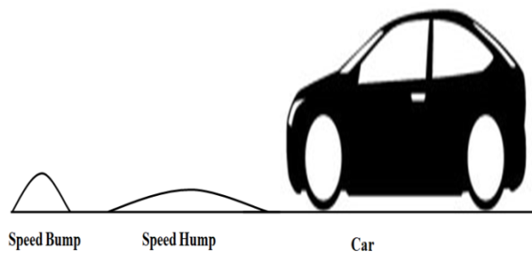
Figure 3.1 Speed Bump and Speed Hump

- Speed Bumps

The speed bump is raised part (uses the vertical deflection) in the street that is intended to make the traffic flow more gradually. Speed bumps usually slow down the velocity of vehicle in the road are 2 to 10 km/hr and the usual vertical height of the speed bump is 7cm to 10 cm (3 to 6 inches). They are more forceful to control the traffic (19).
Speed bumps offer bad impact on the driver especially at the low intersection areas and can lower their effectiveness at high interaction areas. ‘Speed bumps are placed in the garage, at stop marking places, schools, parking place, at pedestrian intersections points’. Speed bumps helps in lowering the velocity of vehicles, accidents but also can causes unsettlement (discomfort) to the vehicular and pedestrian, traffic pollution is also increases (14).

- Speed Humps

Speed hump is rounded are of much longer length and narrower and provides comfort to the driver and offers smooth gradual flow to the traffic (3). “Speed humps usually slow down the velocity of vehicle are 10 to 15 km/hr and usual height of the speed hump is 7 cm to 10 cm (3 to 4 inches) but they are longer in length as compared to bumps (3)”. Speed humps can be placed in highways and the locations where there are large vehicles, they provided at longer distance in street. ‘The speed profile of hump is circular, parabolic’. As they force the large vehicles to slow down velocity such as for the emergency vehicles can create a problem for them like delay and discomfort to the patient (3).

- ADVANCED SPEED BREAKERS

- “Advanced speed breakers (Automatic speed breakers) are the ITS equipment tools comprised of hardware equipments such as motor, metal rods, buzzer, LED’s and platform for maneuvering vehicles so combined that it can function both as speed breaker during peak hours and can subjected to road level in non- peak hours (6)”.
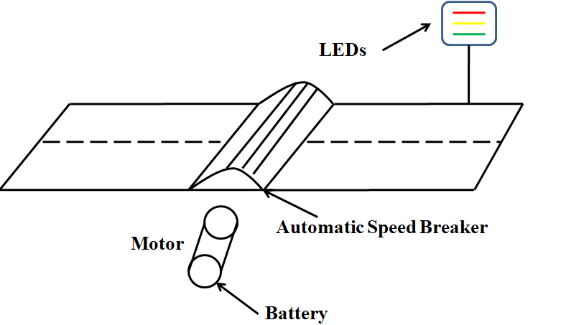

Figure 4.1 Mechanisms of Automatic Speed Breakers

- At the point when there is no need of speed breaker ( for example not a single people is on the street), then the speed breaker is not required as the road turns out to be level then all the vehicles can gradually pass from the street. When peoples are about to on the road then bell rings (sound), and for critical condition red light will glows after that the speed breaker goes ahead the street by pivoting itself from its level position and it begins it’s operating of slowing the velocity of vehicles on the road (6).
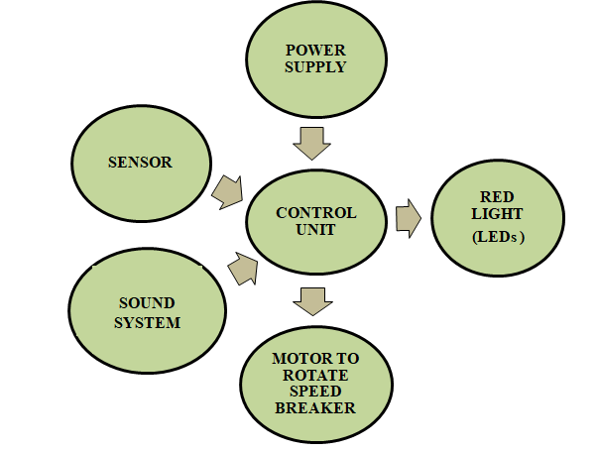

Figure 4.2 Flow Diagrams of Automatic Speed Breakers

- AVAILABLE LITERATURE REVIEW

“Speed humps and speed bumps playing a significant role in traffic- calming devices for the past numerous decades and wide number of studies has publishing on this situation”.

Chadda Himmat et.al [20] and Namee Sanya et.al [7] these researched have concluded that speed humps offers better, smoother rides and allows the vehicle speed flow gradually over it as compared to speed bumps as far as the speed limits are compiled. Patel et.al [3] this study explains the effect and discomfort level due to speed humps on motorised and non- motorised driver. Weber et.al [16] different studies have dealt numerous or diverse aspects of speed humps and speed bumps, among them in this study 1st attempt were made by figuring out the types of designs wanted for speed humps (“Seminal profiles and Watts”), which has turned out into the most well- known design; has been named as the ‘Watts Profile’/ circular hump, was made by ‘Watts’ in 1973. Salau et.al [10] this papers focus was to build a mathematical model to find out distance between two successive road bumps for various maximum speed confines so as to have transmissibility ratio low between the street and vehicular driver. Three significant road bump devices i.e. bump height, bump breadth and distance between two successive bumps, this parameter impact the control of vehicle velocity, due to this discomfort to vehicular does not go beyond certain limit. Bekheet et.al [4] this research study concluded that presence of inappropriate speed humps badly impacts the road pavement condition by lessen ‘Pavement Condition Index’ i.e. PCI value. Agerholm et.al [1] in this research two types of traffic- calming measures are used humps and chicanes; the supposition was that the average velocity is lessen from both the measures considerably. They examine the impact on driving speed: humps lessen speed variation as compared to chicanes, the study also suggested it’s not uniform enough to make comparison directly but average speed reduce by hump is 5 kmph as compared to average speed reduce by chicanes is 6.1 kmph, might be this is due to the many full stop comes in way for coming vehicles before chicane. Bjarnason et.al [11] this study examine the impact of various kinds of speed humps i.e. diverse geometry, on vehicular driver and to see the comfort level experienced by the vehicular. This research also tells diverse geometry of speed bumps (shape i.e. height and breadth) impacts the velocity of vehicle and vertical acceleration. Also gives the round speed humps has more peak acceleration as compared to that of long flat speed humps, round speed humps causes more vibration and discomfort to the vehicular. IRC-99 1998 et.al [19] as per IRC (Indian Road Congress) guidelines, the dimensions for speed breakers is given and also problem with their correctives measures. Griffin et.al [17] this study evaluates the transmissibility of socks and vibrations in human body when vehicle is travelling through humps and it depends upon the frequency, human body and the speed humps (Source of vibrations). Pau et.al [14] this study proposes the speed investigation of twenty three speed bumps within the town of Cagliari in Italy, they found out the installation of such device (speed bumps) is not very safe for crosswalks (Pedestrians). This study also suggested geometrical functions of the road influenced velocity of the vehicle more than that of the bumps. Also tells the bumps affects the vehicular behaviours more so should use humps instead of bumps. Massimiliano et.al [12] this study is shot to achieve both a quantitative and qualitative type of viable change in the driver’s behaviour or reaction because of the speed bumps. . Sanchit et.al [6] this study is based on advanced speed breakers (Automatic speed breakers) in which at the point when there is no requirement of speed breakers on the street, it vanish from the street by rotating itself (using embedded systems). At the point when there is requirement of speed breakers comes on the street and starts its working of slowing down the velocity of vehicles. Başlamişli et.al [8] in this study the main objective is to reduce the velocity below the hump crossing profile. Mansour et.al [9] in this study new methodology is introduce for the shape enhancement of the speed humps, this method takes into account the separation phenomenon that happens whilst the front tires of the motor immediately lose contact with the street surface. The effect of same study has proven that longer speed humps don’t really perform better in terms of decrease in the speed. This is different from previous studies.

- CONCLUSIONS

The Overview on speed breakers leads to following conclusions.

- There are numerous impact of speed breakers such as fuel consumption is more because of acceleration and deceleration of vehicle, discomfort to the vehicular passengers, damage to vehicles, delay. Thus, there is solid need of thorough examination to investigate the impacts of speed breakers.
- Recently road transport ministry statistics reveals that speed breakers are the cause of 30 accidents daily, reason might be faulty designs (not followings the provision for the speed breakers), using poor materials, unnecessary speed humps make it dangerous for street users. It is very necessary to follow the standard provision code given by the road ministry (IRC-99; 1988).
- Requirement of appropriate planning for placing the speed breakers is very significant.
- It is seen that the paved surface close to the humps shows the development of potholes and subsidence which requires maintenance cost, it is necessary to use good quality material.
- Nearly provision of speed breakers isn’t complete answer to enhance the street safety or to decrease the mishaps. That is because in the various instance it is found that the mishap occur due to the careless riding of the vehicles or different factors that aren’t solved through the speed breakers.
- The speed breakers ought to be constructed as per the Standard code provision (IRC-99; 1988)
- It is important to provide marking on the roads and proper sign boards.
- The speed breakers which have properly designed with all the specifications as per provision, it lessens the discomfort for the driver. However driver automatically reduces their velocity of vehicle as the speed breaker arrives.
“From this study, it’s far concluded that speed breakers are powerful manner of controlling speed moreover as reducing the velocity and seriousness of accident. However in addition the speed breakers are also the reason for sever mishap at some locations because of no provision code is followed and they place speed breakers randomly. In India maximum percentage of population utilizes bike or different non- motorized vehicles, so there is strong requirement to study speed breakers before and after execution of speed breakers to see their adequacy. Advance speed breakers help reducing fuel consumption as it only works in the peak hours so there is less acceleration and deceleration of vehicles”.
- REFERENCES

- Agerholm, Niels, Daniel Knudsen, and Kajan Variyeswaran. "Speed-calming measures and their effect on driving speed–Test of a new technique measuring speeds based on GNSS data." Transportation research part F: traffic psychology and behaviour 46 (2017): 263-270.
- Branzi, Valentina, Lorenzo Domenichini, and Francesca La Torre. "Drivers’ speed behaviour in real and simulated urban roads–A validation study." Transportation research part F: traffic psychology and behaviour 49 (2017): 1-17
- Patel, Tanuj, and Vinod Vasudevan. "Impact of speed humps of bicyclists." Safety science 89 (2016): 138-146.
- Bekheet, Wael. "Short term performance and effect of speed humps on pavement condition of Alexandria Governorate roads." Alexandria Engineering Journal 53.4 (2014): 855-861.
- Jain, Mohit, et al. "Speed-Breaker Early Warning System." NSDR. 2012.
- Sanchit Vashistha, et al. Automatic Speed Breaker on Time Demand Using Embedded Systems. IJECCT (2012).
- Namee, Sanya, and B. Witchayangkoon. "Crossroads vertical speed control devices: Suggestion from observation." International Transaction Journal of Engineering, Management, & Applied Sciences & Technologies 2.2 (2011): 161-171.
- Başlamişli, S. Caglar, and Y. Samim Ünlüsoy. "Optimization of speed control hump profiles." Journal of Transportation Engineering 135.5 (2009): 260-269.
- Ardeh, Hamid Ansari, Masoud Shariatpanahi, and Mansour Nikkhah Bahrami. "Multiobjective shape optimization of speed humps." Structural and Multidisciplinary Optimization 37.2 (2008): 203-214.
- Salau, Tajudeen Abiola Ogunniyi, Adebayo Oludele Adeyefa, and Sunday Ayoola Oke. "Vehicle speed control using road bumps." Transport 19.3 (2004): 130-136.
- Bjarnason, Sigurdur. "Round top and flat top humps-The influence of design on the effects." (2004).
- Pau, Massimiliano. "Speed bumps may induce improper drivers’ behavior: Case study in Italy." Journal of transportation engineering 128.5 (2002): 472-478.
- Godley, Stuart T., Thomas J. Triggs, and Brian N. Fildes. "Driving simulator validation for speed research." Accident analysis & prevention 34.5 (2002): 589-600.
- Pau, Massimiliano, and Silvano Angius. "Do speed bumps really decrease traffic speed? An Italian experience." Accident Analysis & Prevention 33.5 (2001): 585-597.
- Huang, Herman F., and Michael J. Cynecki. "Effects of traffic calming measures on pedestrian and motorist behavior." Transportation Research Record 1705.1 (2000): 26-31.
- Weber, Philip A. "Towards a Canadian standard for the geometric design of speed humps." Department of Civil and Environmental Engineering (1998).
- Griffin, Michael J. "A comparison of standardized methods for predicting the hazards of whole-body vibration and repeated shocks." Journal of sound and vibration 215.4 (1998): 883-914.
- Zaidel, D., Alfred-Shalom Hakkert, and A. H. Pistiner. "The use of road humps for moderating speeds on urban streets." Accident Analysis & Prevention 24.1 (1992): 45-56.
- IRC 99-1988, 1996. Tentative Guidelines on the Provision of Speed Breakers for Control of Vehicular Speeds on Minor Roads. The Indian Roads Congress, New Delhi, India
- Chadda, Himmat S., and Seward E. Cross. "Speed (road) bumps: Issues and opinions." Journal of transportation engineering 111.4 (1985): 410-418.

