Character Recognition Using Neural Network
Soni Chaturvedi1 Kashmira Satpute2,Ajinkya Gajbhiye3
1Associate Professor, Priyadarshini Institute Of Engineering And Technology,Nagpur,India,440019

2,3 Students, Priyadarshini Institute Of Engineering And Technology,Nagpur,India,440019

Abstract –
Handwritten character recognition has been one of the active and challenging research areas in the field of image processing and pattern recognition. It has numerous application which include,reading aid for blind,bank cheques and conversion of any handwritten document into structural text form. In this paper,an attempt is made to recognise hand written characters for 05 Capital Alphabets,03 Numerical and 02 Special characters without feature extraction using multi layer feed forward neural network.04 Samples of each data set are used for training the neural network. The trained network is used for classification and recognition in the proposed system,each character is resized into 10*10 pixels and these pixels are taken as features for training the neural network. The result shows that the proposed system yields good recognition rates which are comparable to that of feature extraction based schemes for hand written character recognition.

INTRODUCTION
Handwriting Character Recognition (HCR) has been quite a fascinating and challenging research area in field of image processing and pattern recognition. It contributes immensely to the advancement of automation process and improving the interface between man and machine in numerous applications. Several research works have been focusing on different methodologies in an attempt to reduce the processing time while simultaneously improving recognition accuracy In general, handwriting recognition can be classified into two major categories, namely off-line and on-line handwriting recognition methods. In the off-line recognition, the writing is usually captured optically using a scanner and the completed writing is available as an image. In the on-line system, the two dimensional coordinates of successive points are represented as a function of time and the order of strokes made by the writer are also available. Neural networks are composed of simple elements operating in parallel. These elements are inspired by biological nervous systems.

Automatic bank cheque processing are application of Character recognition. In the work on character recognition has been reviewed. Optical Character Recognition (OCR) is used to recognize printed and handwritten characters. There are numerous approaches that address the problem and they vary in the features extracted from the graphical representation of the Characters. In this paper, an off-line handwritten character recognition system using neural networks that integrate both feature extraction and classification processes is investigated. Prior to segmentation, the pre-processed image is converted into binary image. The binary image is segmented into individual characters and then, each character is resized into 10x10pixels. Each resized character is classified and recognized using different neural classifiers.
METHOLOGY
Image Preprocessing:
The first phase in our character recognition process is converting the image to Binary image by thresholding the given character image. Two intensity values are available in binary image. These values are Black and White. We are use zero for Black and one for white. Thus the color of the character is White and the background is black. Preprocessing techniques are needed on color, grey-level or binary document images containing text and/or graphics. In character recognition systems most of the applications use grey or binary images since processing color images is computationally high.Such images may also contain non-uniform background and/or water marks making it difficult to therefore; the desired result from preprocessing is a binary image containing text only. Thus, to achieve this, several steps are needed, first, some image enhancement techniques to remove noise or correct the contrast in the image, second, thresholding to remove the background containing any scenes, watermarks and/or noise, third, page segmentation to separate graphics from text, fourth, character segmentation to separate characters from each other and, finally, morphological processing to enhance the characters in cases where thresholding and/or other preprocessing techniques eroded parts of the characters or added pixels to them. The above techniques present few of those which may be used in character recognition systems and in some applications; few or some of these techniques or others may be used at different stages of the OCR system.
Pre-processing:
It covers all those functions of feature extraction to produce a original image. the feature extraction components of the character recognition used directly.
The steps in pre-processing involves Size normalization: Bicubic interpolation is used for standard sized image. Binarization: it is process of converting a gray scale image into binary image by thresholding Smoothing: the erosion and dilation smooth the Boundaries of objects. Edge detection: morphological gradient operators are used in edge detection because they enhance intensity of edges of characters. Segmentation:, the characters are always written in "print fashion", not connected,horizontal histogram profile (for line segmentation), vertical histogram profile (for word segmentation) and connected component analysis are able to handle the character segmentation problem.
Gray Scale Image:
In this proposed system hand image is captured through digital camera so the original image is colored image. For digital image processing it is necessary first colored hand image convert in to grayscale image.Each pixel has single sample which has intensity information. Now color image is converted in to gray scale image with noise because there is some noise present in the input colored image due to dust and atmospheric conditions. This noise removal is therefore essential for the system.

Feature Extraction:
The next module of character recognition is feature extraction. It is the special form of Reduction. When input algorithm is very large at that time it is reduce the data [9].If the features extracted are carefully chosen it is expected that the features set will extract the relevant information from the input data in order to perform the desired task using this reduced representation instead of the full size input.

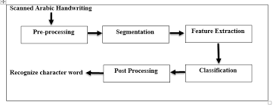

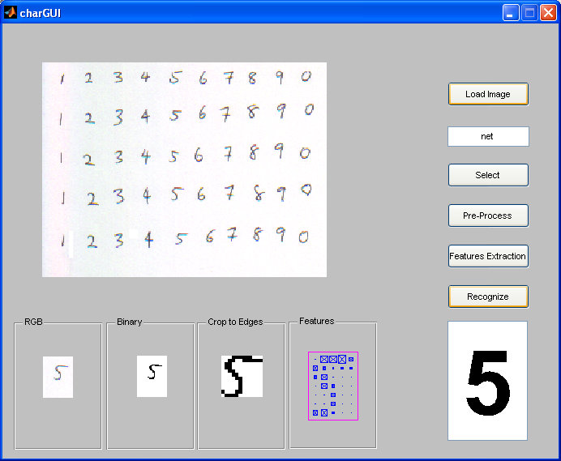

CONCLUSION
The paper gives a useful method for the recognition of handwritten characters to a great extent. The proposed method has been applied on different unknown characters. The feature extraction and classification tasks are performed together as a single process in the proposed system unlike in typical handwritten recognition systems in which these tasks are carried out in two different stages. As a result, the proposed system is found to be less complex and allows faster recognition of characters. Experimental results show that the feed forward neural network is distinctly superior to the other classifiers in recognizing the handwritten English alphabets. Further investigation was carried out to identify the recognition rates for each letter of alphabet. This would help to estimate the recognition rate irrespective of the handwritten content. It was identified that the Feedforward NN outperformed the remaining classifiers. The proposed system will find useful applications in recognizing the handwritten names, reading documents and conversion of any handwritten document into structural text form. Further improvements may be possible with a more complex Feedforward NN architecture but this would also increase the computation complexity. Therefore, combination of a standard feature extraction technique with Feedforward NN may provide better solutions.

REFERENCES
[1]. Hand printed Symbol Recognition System, Ptrttern Recognition, Vol. 21 No.2, pp. 91 - 118, I988 [2]. Rosenfeld,A. and Kak, A.C., Digital Image Processing, Academic Press Inc., 2nd. Ed., 1993 Simon, [3]. C-L. Liu and K. Marukawa, “Normalization Ensemble for Handwritten Character Recognition”, The Ninth International Workshop on Frontiers in Handwriting Recognition (IWFHR 9), Tokyo, Japan, pp. 69-74, 2004. [4] I. D. Jackel et.al., A neural network approach to handprint character recognition, IEEE Trans. PAMI, 1991. [5] Richard Buse, Zhi-Qiang Liu and Jim Bezdek, Word Recognition using Fuzzy Logic, IEEE Trans. on Fuzzy Systems, Vol 10, No 1, Feb 2002. [6] N.K.Bose,P.Liang “Neural Network Fudnamentals With Graphs,Algorithms and Applications”

