**Influence of Acid and Base Piranha Oxidation Reagent on Adsorption Activity of Graphite**

**Ansam N. Khurshid 1, Sahar H. Mourad 1, Ahmed A. Ismail 1, Ahmed M. Abbas 2,**

**Firas H. Abdulrazzak 1**

*1Department of Chemistry, College of Education for Pure Science, Diyala University, IRAQ*

*2Department of Chemistry, College of Education for Pure Science, Baghdad University IRAQ*

*(Corresponding author: Firas H. Abdulrazzak [firas_habeb2000@yahoo.com])*

***Abstract –*** *Graphite oxide was prepared by a Piranha reagent and tested as an absorbent for the removal of Congo red dyes in aqueous solution. The structure of graphite and graphite oxide was characterized by N2 adsorption, X-ray diffraction (XRD) and Fourier transform infrared (FT-IR) spectroscopy. The results showed, that graphite does not show a significant change in surface area after the oxidation process. The layered of graphene structure were swelling, due to several oxygen functional groups were formed, which play a significant role in adsorption. The amount of Congo red adsorbed on the GO was much higher than on graphite which behave pseudo first order. The increase in the behavior of adsorption for graphite after oxidation was related to functional groups which causing electrostatic attraction.*

1. **INTRODUCTION**

**G**raphite is three dimensions 3D of a sp2 hybridized crystal structure, represents one of the softest materials, consisting of bonding δ, ᴫ and anti-bonding ᴫ*-orbitals [1]. The carbon atoms bonded in graphite with three neighboring atoms in a honeycomb lattice with distance between carbon atoms equal to 0.14 nm [2]. A lot of the literature refers to Graphite as a stack of many graphene layers, where the layers with one atom thick and 2-Dimention have together become 3-D with the distance between the layers approximately 0.34 nm [2]. Graphene a mono atom thick with 2-dimensional structure, represent the primary units of graphite has huge attention to its unusual physiochemical properties. The specific properties which represent, by electronic, magnetic and mechanical behavior, encourage for many applications in various fields [3]. Therefore, many attempts trying to convert graphite to graphite oxide and graphene or graphene oxide to be able for huge applications. The large amount of oxygen-containing functional groups [4], make graphite oxide or graphene and graphene oxide easily dispersed in water and even in other solvents through further modification [5]. The common methods to prepare graphene and graphene oxide, mainly include three methods. The first were chemical oxidation[6] of graphite using strong oxidants, which has attracted much attention as a possible intermediate for manufacture of graphene in large amount. The second method depends on using chemical reduction of graphene oxide (GO) via the Hummer’s method [7]. This method involves using strong and concentric acid mixtures at long processing times, thus disadvantage of these methods related to the significant number of residuals and many defects on the surface [8]. The third, is Piranha method which mixture of two materials sulfuric acid in acidic solution [9] or in basic solution [10]. As we reported in our previous works when oxidized the multi-walled carbon nanotubes by acid and base piranha reagent [11] when succeed to addition many functional groups. The typical mixture is 3:1 parts of concentrated acid with hydrogen peroxide solution which called ''acid piranha'' or concentrated base with hydrogen peroxide as "base piranha". The important in use H2O2 as an oxidizing agent makes this process much more environmental friendly in comparison to the Hummer’s or Brodie method which related to toxic gases as by-products as compare to water that can be remove easily [12].In the present work, we perform a systematic study of the chemical oxidation of graphite treated by piranha reagents that occurs with two conditions in existing on H2SO4/H2O2 and the second with NH4OH/H2O2. The graphite after and before oxidation were characterized by measuring surfaces area BET, crystal structure by XRD and FT-IR to find the functional groups. The studies concern with the influence of oxidant piranha agent in the two mediums acid and base to make and testing the activity towards the adsorption properties.

# 2-EXPERIMENTAL

# 2-1-Materials:

The graphite was purchased from Fluka, and Hydrogen peroxide (30%) from Barcelona-Spain. Ammonium hydroxide was supplied from Sigma Aldrich. Sulfuric acid (99%) and Congo red (CR), C32H22N6Na2O6S2, with formal weight equal to 696, and λmax=495 were supplied by from Merck, Germany.

2-2- Oxidation of graphite byPiranha reagent

45 ml of concentrated H2SO4 was added very slowly to 15 ml of hydrogen peroxide then allowed to cool before use. 1 g of graphite added into 60 ml H2SO4/H2O2 mixture, then stirred for 6 hours at room temperature. The powders were rinsed several times with deionized water, then with 0.1M NaOH until the pH value reached around 7. After drying, the product, where heat treatment at 80°C over night by the oven. The material from these steps was referring to it by graphite + acid piranha. The second sample of graphite was added into NH4OH/H2O2 (45:15) mixture to use the same condition of oxidation and washing the graphite oxide with deionized water and 0.1M HCl to neutralize the solution. After that, complete the washing and during than thermal treatment for the sample which labeled graphite + base piranha. The process causing many active sites on the surface of graphite as shown in Figure 1.

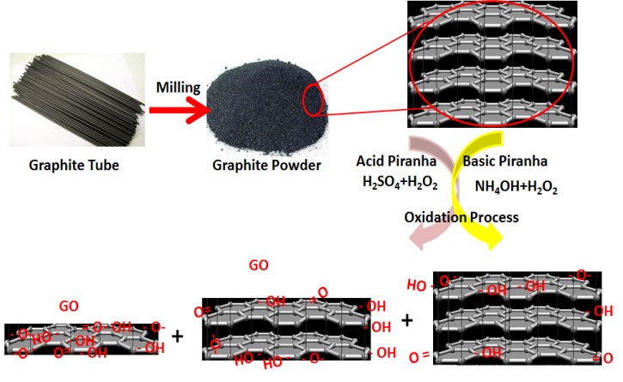

**Fig** 1: Schematic diagram for the process of oxidation graphite to graphite oxide by acid and base Piranha reagent.

# 2-3-Characterization:

The X-ray diffraction (XRD) patterns were done on a (RigakuRotalflex) (RU-200B) X-ray diffractometer using Cu Kα radiation (wavelength 0.15405 nm) with a Ni filter. The tube current was 100 mA with a tube voltage of 40 kV. The 2θ angular regions between 5 and 80° were explored at a scan rate of 5°/min. XRD measurements were taken for Graphite after and before oxidation by Piranha reagent. The peak at ~26.50° [13] represents the characteristic graphitic peak arising due to the presence of the pure graphite sheets with (002) planes. The peak near 43.2° is attributed to the (101) planes of the graphitelayers [14]. The second main peaks at 43.2° removed when oxidized by acid piranha reagents which may relate to increase the oxygen groups between the sheets. The graphite shows a characteristic peak at 2θ ~ 14 and 17 can be related to the introduction of oxygen functionalities.

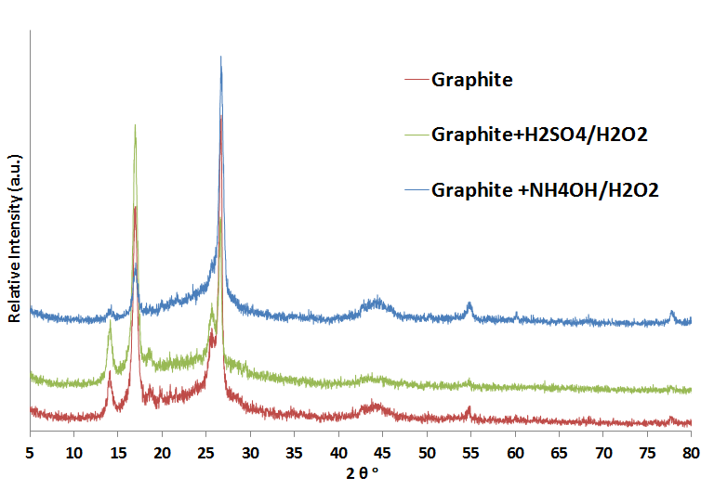

Fig 2: X-ray patterns for graphite before and after oxidized by acid or base Piranha reagent.

X-ray diffraction patterns were used to determine the crystalline size (d) estimated by line broadening measurements of the Debye-Scherrer equation [15-16] which listed in table 1:

d = K λ/β cos θ (1)

Where λ is the X-ray wavelength in nanometers (nm) equaled to (0.15405 nm), β is the peak width of the diffraction peak profile at half the maximum height FWHM resulting from small crystallite size in radians, and K is a constant related to the crystalline shape mostly equal to 0.9.

Surface area estimation of the graphite and graphite oxide powders have been performed by the Brunauer-Emmett-Teller (BET) method, on a Micrometrics Automate 23 apparatus. The samples have been previously heated to 125 °C for 30 min to remove possible contaminants and humidity adsorbed on their surfaces. The measurements have been performed using a gas mixture containing 30% N2 and 70 % He.

Table 1-The particle (crystallite) size and FWHM width of Graphite after and before oxidized with Piranha reagent.

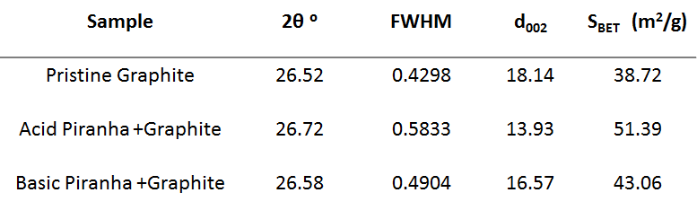

Fourier transfer infrared (FT-IR) spectra were collected on a Shimadzu IRAffinity-1 FTIR Spectrophotometer with a resolution of 4 cm-1. The spectrum was scanned from (400 to 4000) cm-1.Figure 3 shows the FT-IR spectra of graphite after and before oxidation of acid and base Piranha reagent. The results show that condition of oxidation did not make large changes in structure of graphite. The influence limit to forming new functional groups such hydroxyl, carboxyl, hydroxyl of phenolic groups. The graphite without oxidant did not show any functional groups except aromatic C=C for graphene layers at 1550 cm-1. The oxidant graphite shows broad spectra between (3000 and 3600) cm-1 due to the OH groups. The band at 1678 cm-1 can be ascribed to the C=O stretching of COOH groups, and the band at 1550 cm-1 can be assigned to aromatic C=C vibration. The week band at 1050 cm-1 is due to the vibration of C-O. The weak band at 1200 cm-1 which appears with graphite that produce from oxidation by acid Piranha that can be related to phenolic groups.

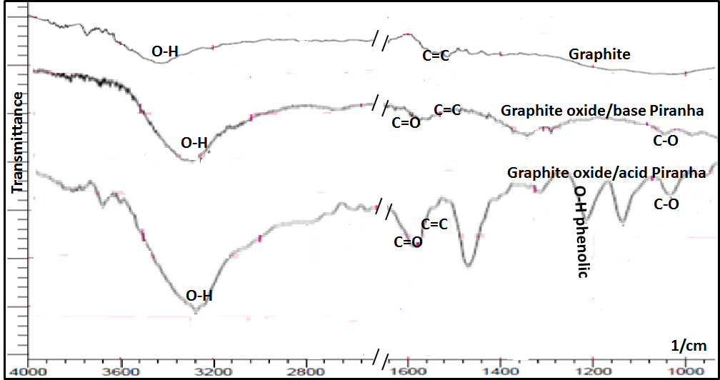

Fig 3: FT-IR spectra of graphite after and before oxidation by acid and base Piranha reagent.

**2-4-Adsorption tests:**

The testing of the activities for Graphite G and oxidized graphite with Piranha reagent was carried out by using Congo red dyes in a batch mode for 60 min at 298 K. The required amount of the adsorbent (150 mg) was suspended in100 ml of aqueous solution of 50 ppm Congo red; in various times 2ml was taken from the reaction vessel, and filtered to remove the particles by centrifuge at 4,000 rpm for 10 minutes in an 800 B centrifuge. The clean, transparent solution was analyzed using a Shimadzu Cary 100Bio UV - visible spectrophotometer. The spectrum (300-700 nm) for each sample was recorded and the absorbance was determined at the characteristic wavelength of 495 nm.

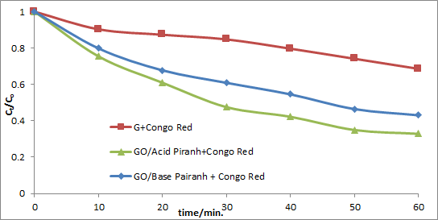

Fig 4: adsorption reaction for pristine Graphiteand oxidized graphite with acid and base Piranha with50ppm Congo red at 298K.

The results are represented in as Ct/Co against time/min. where Co and Ct represent the concentration of Congo red at time zero and different times respectively. Figure 5, shows the adsorption process as a pseudo first order by plotting ln (Co/Ct) with the times for graphite before oxidation and after oxidation with acid or base piranha reagent. Figure 6, shows the adsorption process as a pseudo second order by plotting (1/Co-Ct) with the times for graphite in three conditions. The values of the R2 in the two figures 4 and 5 show pseudo first order more quires to explain the adsorption behavior.



Fig 5: Schematic diagram for ln(C0/Ct) vs t ofpristine Graphite and oxidized graphite with acid and base Piranha within 50ppm Congo red at 298K.



Fig 6: Schematic diagram for (1/C0-Ct) vs t of pristine Graphite and oxidized graphite with acid and base Piranha within 50ppm Congo red at 298K.

The pseudo-first-order kinetics with respect to the concentration of dyestuff in the bulk solution (C):

-d C/d t = k1 C0 (2)

When made Integration for this equation and by using the same restriction of C = C0 at t = 0, and C0 being the initial concentration in the bulk solution, thus the equation become:

ln (Ct/C0) = k1 t (3)

Where k1 is the reaction rate constant. A plot of ln (C0/C) versus t for Congo red adsorption with graphite before and after oxidation presented in Fig.6. The value of k1 can be obtained directly from the slope of the respective linear curves in the plot which listed in Table 1.

The ratios of the removal Congo red by graphite after and before oxidation were estimated [17] the following equation:

% Removal =[(C0-Ct)/C0] * 100 (4)

Where C0 is the initial concentration and Ct is the final concentration.Fig.7shows the effects of contact time on Congo red removal, which increased with increasing contact time. It was found that the equilibrium time, is more than 25 min after a shaking for 60 min.

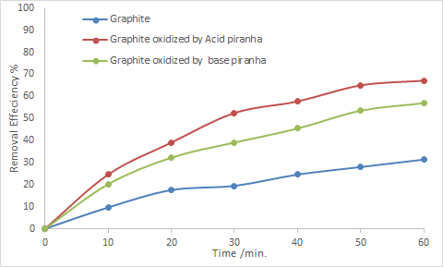

Fig 7: Effects of contact time on the removal efficiency of 50ppm Congo red by Graphite without oxidation, graphite oxidized with/Acid and Base Piranha at 298K.

The BET surfaces area of pristine graphite and oxidized as mentions before [18] witnessed very small change which could be related to Bulge the aggregates of graphite after the oxidation. The XRD profiles of G and GO which indicates a very little change in the crystal structure of graphite at (2θ ) 26.5° for the (002) planes of graphene layers 44.6°, and 54° for the (101) planes.

Table 2: The rat constant of adsorption and percent of removal Congo red by graphite after and before oxidation.

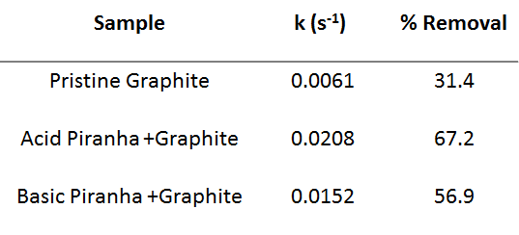

Figure 4, shows the effect of oxidation processes on the activity of graphite. It was observed that the adsorption of Congo red onto the graphite increased with the increasing the activity of oxidation. This result was expected because the increasing of adsorption sites and the variety of adsorbent gropes leads to more active surface for adsorption [19].The second main peaks at 43.2° agree with the results when disappear by oxidized with acid piranha reagents which may relate to increase the oxygen groups between the sheets. These phenomena enhance the aggregates and swelling of graphite causing increase the size of groups.

Many litterers [20] postulated that the mechanism of the removal process of dyes or bulletins was influenced directly with acid-base interactions of surface functional groups which Spread to the edges of the graphite surface. An XRD and BET result shows a week and limited change in structure of graphite after oxidation process. The change appears as expansion of the graphene layered, as shown by BET results and FT-IR. The FT-IR complete the reason for changing the activity and surface area when shows[21] various oxygen functional groups which is mostly carried negative charge which expended the distance between the layers of graphite.

**3-CONCLUSIONS**

In this work, graphite was oxidized with acid and base piranha reagent and tested for adsorption of Congo red. Characterization has shown that surface occupied by several oxygen functional groups plays the major role in behavior of adsorption. The mixture of acid Piranha succeeds to increase the activity of graphite oxide more than pristine graphite and oxidized graphite with base Piranha. The functional groups which consisted of oxygen with different atoms enhance the surface area and the activity towards the adsorption. The adsorption mechanism can be attributed to electrostatic attraction which behaves as pseudo first order. Thus, graphite oxide will be one of the common adsorbent materials for much cationic and anionic ion removal in aqueous solution.

**REFERENCES**

1. *Pierson H., "Handbook of Carbon, Graphite, Diamond and Fullerenes ",William Andrew Publishing, Norwich, 1993..*
2. *A. H. R. Palser, '' Interlayer interactions in graphite and carbon nanotubes '', Phys. Chem., vol.1, pp. 4459-4464, 1999.*
3. *Novoselov K. S, Geim A. K, Morozov S. V, Jiang D, Zhang Y, Dubonos SV, Grigorieva IV, Firsov A. A, Science 306:666, 2004.*
4. *Kovtyukhova N. I, Ollivier P. J, Martin B. R, Mallouk T. E, Chizhik S. A, Buzaneva E. V, Gorchinskiy A. D, Chem Mater 11:771, 1999.*
5. *Wang Y, Xie L, Sha J, Ma Y, Han J, Dong S, Liu H, Fang C, Gong S, Wu Z,''Preparation and chemical reduction of laurylamine-intercalated graphite oxide J Mater Sci 46:3611, 2011.*
6. *NinaI. Kovtyukhova , Yuanxi Wang, AyseBerkdemir, Rodolfo Cruz-Silva, Mauricio Terrones, Vincent H. Crespi and Thomas E. Mallouk,'' Non-oxidative intercalation and exfoliation of graphite by Brønsted acids'', Nature Chemistry, Vol. 6 , November 2014.*
7. *Hummers W., Offeman R.E,'' Preparation of graphitic oxide'',. J. Am. Chem. Soc, 80 (6): 1339-1339, 1958.*
8. *Stankovich S., Dikin D.A., Piner R.D., Kohlhaas K.A., A., Kleinhammes Y. J, Wu Y., Nguyen S.T., and Ruoff R.S.,'' Synthesis of graphene-based nanosheets via chemical reduction of exfoliated graphite oxide'', Carbon, 45: 1558-1565, 2007.*
9. *Joanna S. Y., Michelle T. T. Tan, J. C., Poi S. K. and Hingwah L.,'' A Parametric Study on the Synthesis of Graphene Using Piranha-like Thermal Exfoliation,'' 2012 2nd International Conference on Environment Science and Biotechnology, IPCBEE vol.48, pp.143-147, 2012.*
10. *Datsyuk V., M., Kalyva K., Papagelis J., Tasisb D., Siokou A., I., Kallitsis C. G,'' Chemical oxidation of multiwalled carbon nanotubes'', Carbon, vol.46, pp. 833–840, 2008..*
11. *Al Mgheer T. and Firas H Abdulrazzak, ''Oxidation of multi-walled carbon nanotubes in acidic and basic Piranha mixture'', Frontiers in Nanoscience and Nanotechnology, Volume 2(4): pp.155-158, 2016.*
12. *Kang F., Leng Y., and Zhang T.Y,'' Influences of H2O2 on synthesis of H2SO4-GICs'',. J. Phys. Chem Solids, 57 (6-8): PP.889-892, 1995.*
13. *Arthi G and Lignesh BD, Paulchamy B.,'' A Simple Approach to Stepwise Synthesis of Graphene Oxide Nanomaterial'', Nanomedicine& Nanotechnology, Volume 6,Issue 1, pp.1-4.2015.*
14. *Titelman, G. I.; Gelman, V.; Bron, S.; Khalfin, R. L.; Cohen, Y.,'' Bianco-Peled, H. Characteristics and microstructure of aqueous colloidal dispersions of graphite oxide'', Carbon, 43, PP.641–649, 2005.*
15. *Leroy A. and Harold P. K, Determination of Crystallite Size with the X-Ray Spectrometer, J. App. Phys. 21, PP.126-7 ,1950.*
16. *Firas H. Abdulrazzak, Shahad K E., Halimah A. D., Ahmed M. A. and Mustafa K. K. ,''X-ray Analysis for Purification Process of Synthesized Multi-Walled Carbon Nanotubes by Chemical Vapor Deposition'', International Journal of Theoretical & Applied Sciences, 8(1): pp.37-43,2016.*
17. *Ahmed M. Kamil, Firas H. Abdalrazak, Ahmed F. Halbus and Falah H. Hussein,''Adsorption of Bismarck Brown R Dye Onto Multiwall Carbon Nanotubes'', Environmental Analytical Chemistry, 1:1, 2014.*
18. *Yanwu Z. , Shanthi M. , Weiwei C. , Xuesong L. , Ji W. S. , Jeffrey R. P. , and Rodney S. R.,''Graphene and Graphene Oxide: Synthesis, Properties, and Applications'', Adv. Mater. 22, 3906–3924, 2010.*
19. *Bissessur, R.; Liu, P. K. Y.; Scully, S. F. Intercalation of polypyrrole into graphite oxide. Synth. Met.156, 1023–1027, 2006.*
20. *Philip B., Sie K. L., Shaobin W., and Shaomin L. ,''Dye Adsorption on Layered Graphite Oxide'', J. Chem. Eng. Data, 56, 138–141, 2011.*
21. *Jianchang L., Xiangqiong Z. ,Tianhui R. and Emile V. H.,''The Preparation of Graphene Oxide and Its Derivatives and Their Application in Bio-Tribological Systems'', Lubricants, 2, 137-161, 2014.*