Experimental and Development of Variable Refrigerant Flow(VRF) System By Using Multiple Expansion Valve in Air Condition System
Prasanna P. Gawande¹,Prof. M. P. Thakur², Prof. T. A. Koli³, Prof Dr. Vijay H Patil⁴
¹Student,²Assistance Professor, ³Assistance Professor, ⁴Acad dean &H.O.D.
^{1,2,3,4} Thermal Engineering, Godavari College Of Engineerig, Jalgaon-425002, Maharashtra,India
¹prasannagawande@gmail.com, ²mayurthakur941@gmail.com,³kolitushar09@gmail.com⁴vhpatil76@yahoo.com

Abstract –Variable Refrigerant Flow(VRF)/Variable Refrigerant Volume(VRV) is mainly know as Ductless mini-Split system. includes multiple indoor evaporators connected to a single condens- ing unit. Ductless products are fundamentally different from ducted systems in that heat is transferred to or from the space directly by circulating refrigerant to evaporators located near or within the conditioned space.The term variable refrigerant flow refers to the ability of the system to control the amount of refrigerant flowing to the multiple evaporators (indoor units), enabling the use of many evaporators of differing capacities and configurations connected to a single condensing unit. The arrangement provides an individualized comfort control, and simultaneous heating and cooling in different zones.With a higher efficiency and increased controllability, the (VRF) system can help achieve a sustainable design. Unfortunately, the design of VRF systems is more complicated and requires additional work compared to designing a conventional direct expansion (DX) system.innovation depends on the straight forward vapor pressure cycle (same as ordinary split cooling frameworks) yet enables you to persistently control and modify the stream of refrigerant to various inward units.
Keywords- variable refrigerant flow(VRF)variable refrigerant Volume(VRV),direct expansion (DX),
- INTRODUCTION
The VRF innovation/system was created and planned by Daikin Industries, Japan who named and ensured the term variable refrigerant volume (VRV) system so different makers utilize the term VRF "variable refrigerant stream". Generally both are same. The primary function of all air-conditioning systems is to provide thermal comfort for building occupants.

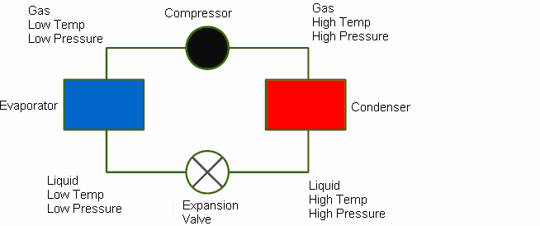
Fig:-01 VCS system
The fundamental of an air conditioning system is the use of a refrigerant to absorb heat from the indoor environment and transfer it to the external environment. In the cooling mode, indoor units are supplied with liquid refrigerant. The amount of refrigerant flowing through the unit is controlled via an expansion valve located inside the unit. When the refrigerant enters the coil, it undergoes a phase change (evaporation) that extracts heat from the space, thereby cooling the room. The heat extracted from the space is exhausted to the ambient air.
There are a wide scope of cooling systems accessible, beginning from the essential window-fitted units to the little part systems, to the medium scale bundle units, to the vast chilled water systems, and right now to the variable refrigerant stream (VRF) systems. The term VRF alludes to the capacity of the system to control the measure of refrigerant streaming to each of the evaporators, empowering the utilization of numerous evaporators of contrasting limits and arrangements, individualized comfort control, concurrent warming and cooling in various zones, and warmth recuperation starting with one zone then onto the next. VRF systems work on the Direct Expansion (DX) rule implying that heat is exchanged to or from the space straightforwardly by flowing refrigerant to evaporators situated close or inside the conditioned space. Refrigerant flow control is the key to many advantages as well as the major technical challenge of VRF systems.
VRF systems may include about twice the refrigerant of comparable roof-top units (RTUs), depending on the size of the building area served according to one manufacturer. Concern has been raised about added cost associated with replacement of this refrigerant, and with refrigerant leaks. The same manufacturer responded that their integrated design and quality control requirements, the use of proprietary components rather than secondary market components, and its training programs reduce this risk of refrigerant leaks relative to other use of refrigerant lines, such as grocery story refrigerated case work, which is known to have substantial leak issues. This study did not identify any evidence that the systems leak significantly.
- LITERATURE SURVEY
Variable refrigerant flow (VRF) systems vary the refrigerant flow to meet the dynamic zone thermal loads, leading to more efficient operations than other system types. This paper introduces a new model that simulates the energy performance of VRF systems in the heat pump (HP) operation mode.The primary function of all air-conditioning systems is to provide thermal comfort for building occupants. There are a wide range of air conditioning systems available, starting from the basic window-fitted units to the small split systems, to the medium scale package units, to the large chilled water systems, and currently to the variable refrigerant flow (VRF) systems.
VRF is an advanced air conditioning system that is developed to manage load variability by controlling the compressor speed and the expansion valve opening.
  - Problem Statement
Depending upon load condition, working load on compressor is varied and consume more power and sometimes cooling load is not obtain upto that level.(comfort zone).On summer loads on machines increases and in winter it reduces.If systems are old then due to leakage few amount of refrigerant was leak and leaves in atmosphere, at that time also loads comes on compressor.
2.2 Proposed Method/System
Proposed of this project is to save energy consumption and easy for maintance purpose and minizing cost of the unit. Using multiple expansion valve it varies load of the refrigerant so it will help to maintain comfort zone.Used multiple electronic expansion valve (EEV).The best ways for selecting the system first calculate heat load estimation depending upon building construction and peak time and orientations of building.According to heat load estimation VRF is useful for varying load condition.
- METHODOLOGY

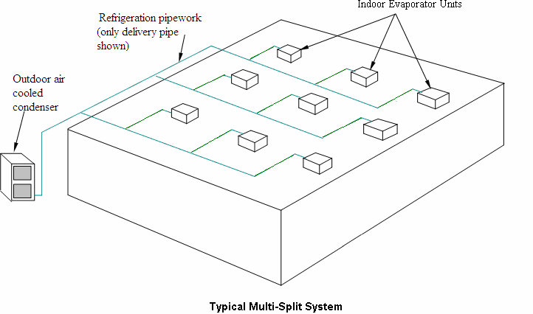
Fig:-02 Typical Multi-Split System
Finding the load in air conditioning according to that selection of air conditioning system. To finding heat load or block load we used carrier load sheet, first to know U value, K value, R value ie the rate of heat flow through wall, celling glassor floor of air condition space(BTU/HR SQFT Degree F) all the value will be taken on ISHRAE Handbook 2017. There are two of load calculation first is thumb rule and second is excel sheet load calculation in excel sheet single hours load calculation and full day calculation.
- System Software
In this project we used Elite Refrigeration Software to find load estimation.In air conditioning load estimate first direction of sun and location of that place that unit is installed,finding area and volume, then finding solar heat gain through glass, then solar and transmission gain through walls and roof, so we used CLTD method means addition ofEquivalent temp. difference and correction factor
Q=UA(dt)
Q=Amount of heat flow,
U=Thermal transmittance,
A=Area,dt=Temp difference.
Transmittance gain except wall and roof ie all glass in
sq.ftmulatiply by U value(U value is reciprocal of thermal resistance
Then find out internal load on people,power,lights Appliance which we used in given space and then apply factor of safety which will be 5 to 10%,then we consider the fresh air (outdoor air)
Outdoor air=CFM Ventilation x temp difference x bypass factor that will calculate effective room sensible heat,then latent heat that contains infilatration,people,appliances,etc then we apply factor of safety then find cfm. That cfm will decide to how many flow required to flow.

Fig:-03 Maintain Different Temp On Different Room

Types of VRF System
VRF heat pump systems:-VRF heat pump systems permit heating or cooling in all of the indoor units but NOT simultaneous heating and cooling. When the indoor units are in the cooling mode, they act as evaporators; when they are in the heating mode, they act as condensers. These are also known as two-pipe systems. VRF heat pump systems are effectively applied in open plan areas, retail stores, cellular offices and any other area that require cooling or heating during the same operational periods.
Heat Recovery VRF system (VRF-HR):-Variable refrigerant flow systems with heat recovery (VRF-HR) capability can operate simultaneously in heating and/or cooling mode, enabling heat to be used rather than rejected as it would be in traditional heat pump systems. VRF-HR systems are equipped with enhanced features like inverter drives, pulse modulating electronic expansion valves and distributed controls that allow system to operate in net heating or net cooling mode, as demanded by the space.
Each manufacturer has its own proprietary design (2-pipe or 3-pipe system), but most uses a three-pipe system (liquid line, a hot gas line and a suction line) and special valving arrangements. Each indoor unit is branched off from the 3 pipes using solenoid valves. An indoor unit requiring cooling will open its liquid line and suction line valves and act as an evaporator. An indoor unit requiring heating will open its hot gas and liquid line valves and will act as a condenser.
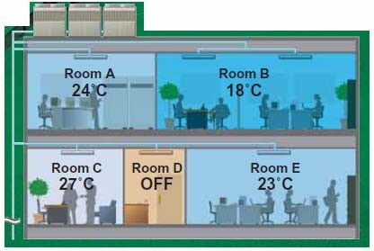
Typically, extra heat exchangers in distribution boxes are used to transfer some reject heat from the superheated refrigerant exiting the zone being cooled to the refrigerant that is going to the zone to be heated. This balancing act has the potential to produce significant energy savings
Compliance with ANSI/ASHRAE Standard 15-2001:-VRF systems must comply with ASHRAE Standard 15-2011 - Safety Standard for Refrigeration Systems (ANSI approved). ASHRAE Standard 15-2001 guides designers on how to apply a refrigeration system in a safe manner, and provides information on the type and amount of refrigerant allowed in an occupied space.While installing this project we check flexibility of project,Design Flexibility,Flexible Installation
Using Electronic Expansion Valve (EEV)
With an electronic expansion valve (EEV), you can tell the system what superheat you want and it will set it up. The primary characteristic of EEV is its ability to rotate a prescribed small angle (step) in response to each control pulse applied to its windings. EEV consists of a synchronous electronic motor that can divide a full rotation into a large number of steps, 500 steps/rev. With such a wide range, an EEV valve can go from full open to totally closed and closes down when system is satisfied.
EEV in a VRF system functions to maintain the pressure differential and also distribute the precise amount of refrigerant to each indoor unit. It allows for the fine control of the refrigerant to the evaporators and can reduce or stop the flow of refrigerant to the individual evaporator unit while meeting the targeted superheat.
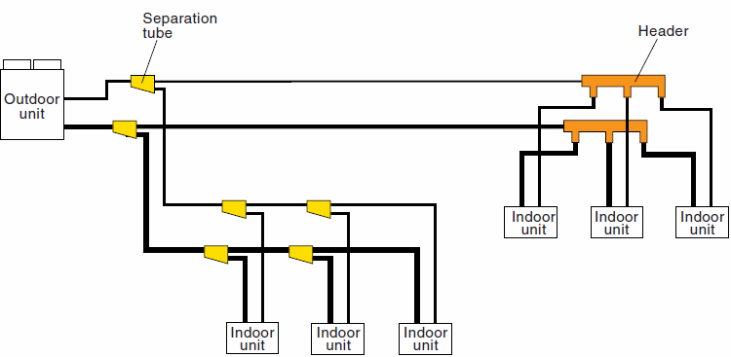
Fig:-4 Refrigerating Piping Separation Tube and Header
- RESULT AND DISCUSSION
With the help of VRF we have to improve the aesthetics of building outlet, orientations, construction.VRF systems benefits from the advantages of linear step control in conjunction with inverter and constant speed compressor combination, which allows more precise control of the necessary refrigerant circulation amount required according to the system load.
The inverter technology reacts to indoor and outdoor temperature fluctuations by varying power consumption and adjusting compressor speed to its optimal energy usage. Inverterprovides superior energy efficiency performance and also allows for a comfortable environment by use of smooth capacity control
A VRF system minimizes or eliminates ductwork completely. This reduces the duct losses often estimated to be 10% to 20% of the total airflow in a ducted system.
- CONCLUSION
From above paper we implement VRF with targeted deployment in a subset of new buildings and major retrofits of existing buildings based on the potential cost-effectiveness. Projects should be evaluated carefully with energy modeling and cost assessment during design, and with actual operating energy and maintenance costs. Energy usage should be monitored so that HVAC energy can be separated from other energy uses. Occupant comfort should also be assessed.
Reduced Noise Levels, Reliability, Continuous operation is possible even if trouble occurs at an indoor unit.
REFERENCES
- ‘’Development and validation of a new variable refrigerant flow system model in Energy Plus’’2015 Mr. TianzhenHong.
- ‘’Overview Of HVAC Variable Refrigerant Flow Systems’’ Source ASHRAE/ ISHRAE Handbook
- ‘’Evaluation of the energy performance of variable refrigerant flow systems using dynamic energy benchmarks based on data mining techniques’’ Prof.JiangyanLiua Department of Refrigeration and Cryogenics, Huazhong University of Science and Technology, china
- ‘’ Variable Refrigerant Flow (VRF) Systems Flexible Solutions for Comfort’’
- Carrier Handbook January 2013
- 5Variable Refrigerant Flow Systems’’ W. Goetzler
- Navigant Consulting, Inc. 18 PUBLICATIONS 168 CITATIONS Article in Ashrae Journal · April 2007Variable Refrigerant Flow Cooling Assessment in Humid Environment Using
- Different Refrigerants” Roba Saab, Hilal Al Quabeh Journal of Environmental Management 28 December 2017

