Design and Fabrication of Mini Electric Power Tiller

Udit R. Shukla¹, Vedant P. Laxane², Ronald D. S. Moses³, Shruti N. Moon⁴, Pragati D. Dable⁵,

Dr. Arvind Mahalle⁶

^{1,2,3,4,5} UG students , ⁶Professor
G H Raisoni Institute of Engineering and Technology, Nagpur

uditshukla006@gmail.com

Received on: 19 November, 2023 Revised on: 21 December, 2023 Published on: 23 December, 2023

Abstract- Farming has been an important part of the human being ecosystem. However, conventional agricultural methods need a lot of human effort and are very time-consuming. Agriculture tilling is one of the most labor-demanding operations in agriculture. Physical tiling of fields is a very tough task while tractors incur high investment along with heavy fuel use costs. This plugin AC-powered tiller machine is a one-stop new solution to develop the conventional agriculture methods of farming, as it reduces the human effort, at a very small price using a motorized tilling mechanism.
In Indian agriculture, the preparation of seedbed for deep tillage using additional machinery and tilling tools are increased. A power tiller or cultivator is one of the tillage machines most suitable for seedbed preparation. In a power tiller machine, the blade is a critical part, which is engaged with the soil to prepare a seedbed and mix it with fertilizer.
This is because to utilises and increases the fertility of land to increase crop productivity. In this machine, we have added a tilling blade assembly purchased from the market to enhance tilling operations. The machine's body has been fabricated in a way that allows users to simply tilt it up and down to adjust the tilling blade for the desired depth. This creates a favourable environment for sustaining crop growth.

Keywords- Farming, Ecosystem, Tiller machine, Productivity.

I- INTRODUCTION
To make farmers' lives comfortable during tilling work, earlier farmers were using Traditional farming methods which are time-consuming, hardworking, and costly, hence we introduced new technology. Normally, the machines are used for agricultural use in India which is of higher stage. All machines used in farms are high prices and not reasonable to farmers, hence to overcome this trouble, this model is designed and fabricated. This working model of power tiller is reducing manpower & reducing the health risk. This machine reduces the cost and improves the soil properties. This plug-in AC-powered power tiller reduces the use of fossil fuel and improves the productivity of agriculture.
But in the era of growth in electric vehicles and the use of renewable energy sources, it can be beneficial to use electricity as a power source instead of IC engines as they provide better sustainability and ease of use to the users along with better efficiency as compared to traditional farming equipment that creates a lot of pollution and inconvenience.
It is also beneficial as there has been a significant growing demand for sustainable and efficient agricultural equipment.
The mini electric power tiller addresses these needs by providing a compact, eco-friendly alternative for small-scale farming.
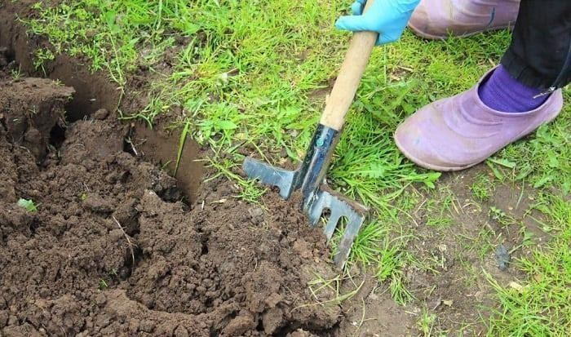
Fig 1- Old farming instrument

In India currently, farmers are unhappy with spending money on ploughing operations because of the rise in petrol prices day by day. To solve this problem, an electric power tiller and cutter machine is powered by a plug-in AC System to electric motor. This system is eco-friendly and easy to use. The power tiller is mainly used in farming operations for preparing a seedbed on the surface of land. Like other machines, this portable AC plug-in powered tiller would also be used for mixing large capacities of soil.
In the market various power tiller machines are available and they are operated using internal- combustion engines. They are operated by petrol/diesel engines using petrol/diesel as a fuel. Thus, it is a big problem because tiller machine creates pollution in the environment and dangerous for human health. To solve this problem, a portable electric power tiller is designed and fabricated.

II- LITERATURE REVIEW

Prashant Rahat et. al. [1] studied the portable battery charged electric power tiller machine. Farming practises used in traditional agriculture. To provide maximum soil grip, the machine uses a wheel with welded angles. The wheel design was created to offer a strong grip on the soil that would allow the cultivator prongs to drag during the tilling process. Using a unique portable design, the electric power tiller reduces the time and cost of tilling, enhancing agricultural output and efficiency.

Zakariya et. al. [2] ,after preliminary study, it was found out that power tiller could be adopted International Journal of Innovative Research in Science, Engineering and Technology (IJIRSET) for weeding. As a result, the study sought to improve its performance by altering some essential components, such as weeding blades and depth blades.

Mr Mahesh Gavali et. al. [3], the author investigates in this article, a comparison of portable welders and power tillers in the Indian market is examined. Various weed removal procedures for crops are also mentioned. The examination of various equipment used for mechanical weed removal is the main focus of this project. According to this survey, the majority of Indian farmers, the majority of whom are small-scale farmers, can only afford portable welders. As a result, mechanical weed management is not used by these small-scale farmers.
Vishal M. Metkari et. al. [4] look at non-conventional energy sources to tackle these concerns with fossil fuels. In order to implement this concept, we created a solar powered electrical tiller. The vehicle is meant to have two-wheel drive and may be utilised for shuttle service as well as short distance travel. All industries, including agriculture, are seeing fast expansion in the modern period.
Vasantha Kumar et. al. [5] focuses on the conception and production of an electric tiller machine for arecanut and coconut plantations that includes a fertiliser dispenser. When designing the electric power tiller, a software application called Solid Edge was used. Following the findings of our research, electric power tiller was fabricated in a manner that was compatible for engineering applications.
A J Rane et. al. [6] explained agriculture starts from human existence. It is important part in human life as it feed us and thereby it runs the ecosystem though. It is extreme important section for living beings. But modern farming techniques are heavy coughed and very intensive. Modern tractors which runs by fuel are detrimental to environment and not affordable to farmers. Tilling in farming is main step and traditional techniques were time consuming and very intensive and modern ones are non-affordable and hazardous to environment.
Shabbir J. Karjatwala et. al. [7] studies Farmers used to use traditional farming methods, which are time- consuming, labour-intensive, and expensive, therefore they introduced new technologies. Machines are commonly employed for farming purposes in India, which is at a higher level. They are creating this model in order to solve this challenge. This document discusses the operating machinery that would be used to till one and a half hectors.
III- METHODOLOGY
Following is the methodology used to design and fabricate a portable electric tiller machine.
Fabricating the machine according to the following steps: -
    - Research Market gap
    - Literature review of existing electric power tiller
    - Selection of aftermarket blade assembly
    - Selection of pulley and belt according to the required power
    - Calculation of output torque according to motor and pulley used
    - Fabrication of working model
    - Cost analysis

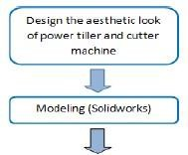
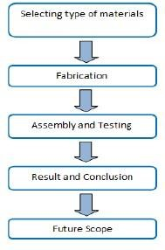
Flow Chart of Project Process

3.2 Block Diagram
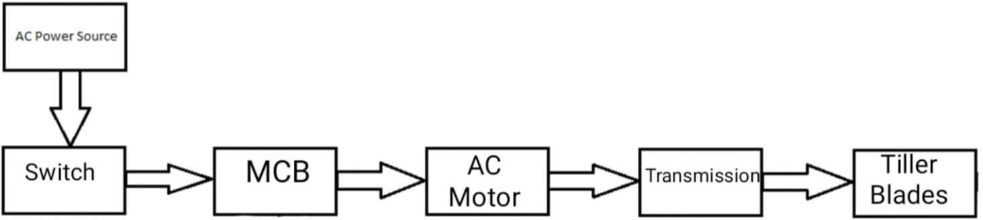

Fig. 3: Block Diagram

The machine works on motor which gives power to overall system to run the object. The machine is drive by electric motor which is in contact with belt drive which ultimate helps to run the working of wheels of tiller during operation. For tiller machine the neat and accurate modification of supporting frame is provide For tiller machine the neat and accurate modification of supporting frame is provided which gives output voltage of fixed proposition. It is in such way that magnitude remains constant and input voltage doesn't change for conditions of voltage. Regulator connected at main wire which is connected to switch. Regulator and wire are connected to motor to running the operation. Motor is fitted to suitable angle as per stability for a worker during operation. Wheels are provided for ease in working during agriculture. When motor generates power machine runs and thereby teeth run side by side capable of digging in agricultural land with ease.
3.3 CAD Modelling.
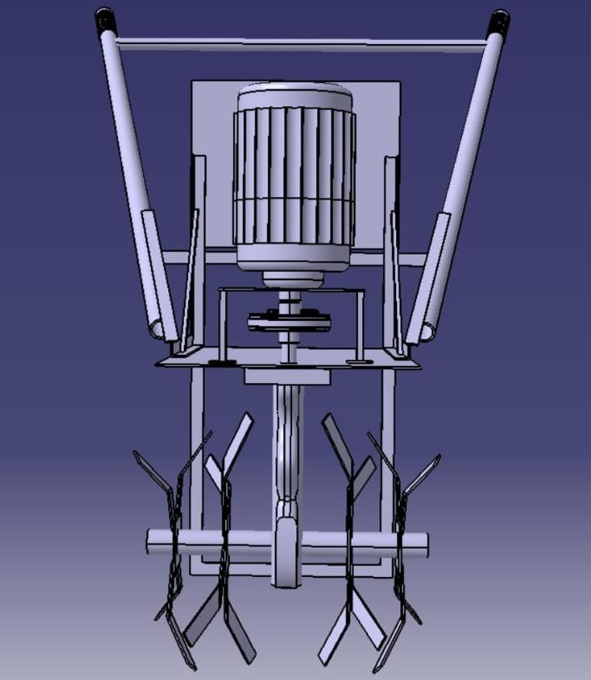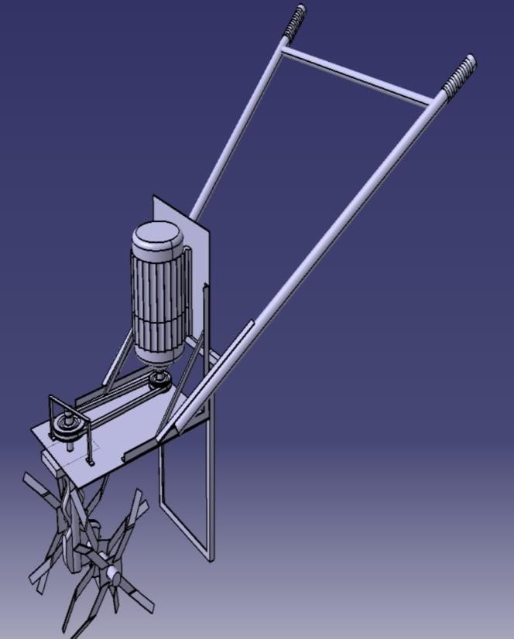
Fig 4- Front View Fig 5–Isometric View
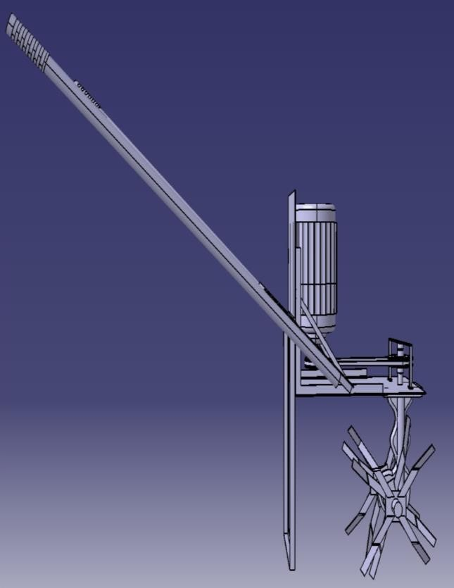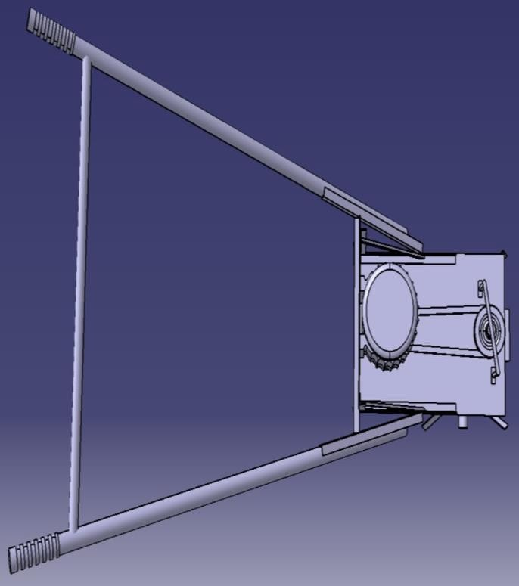
Fig 6 - Side View Fig 7–Top View
  - Fabricated Model

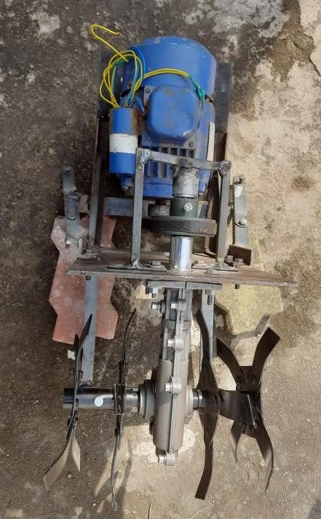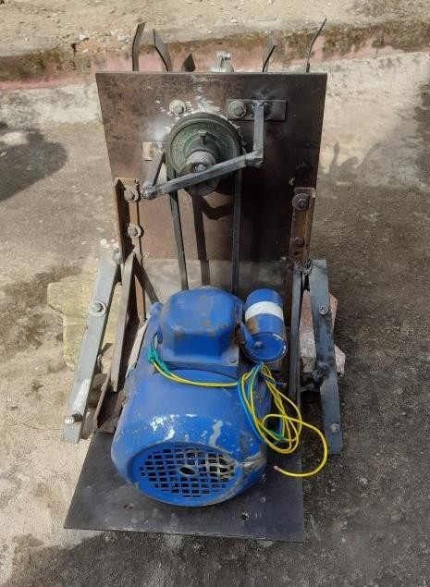
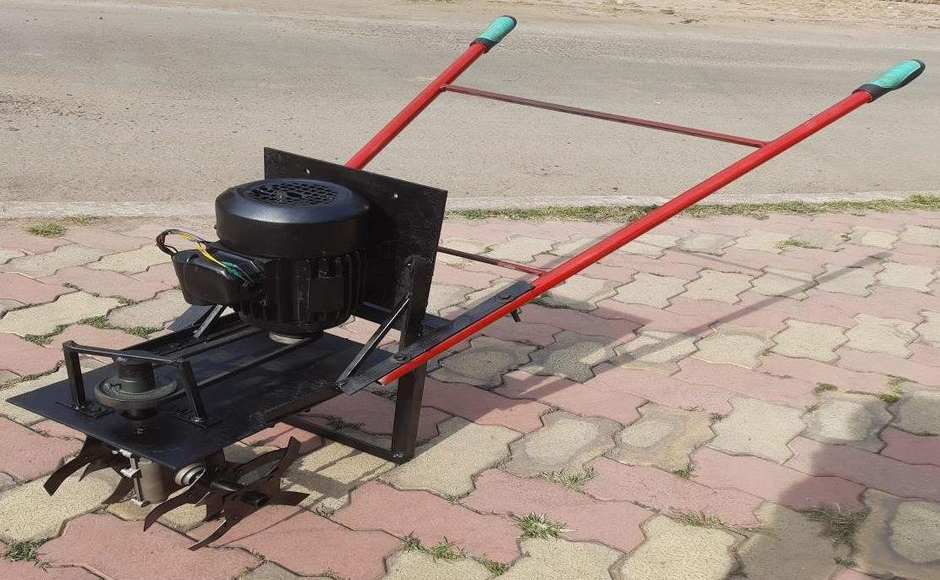
Fig 8- Fabricated Model Views
IV- RESULT & DISCUSSION
To reduce or eliminate more time consumption, hard work and high cost from traditional power tiller. New power tiller is designed which -
- Provides more comfort and generates less fatigue to the operator.
- Increases productivity in farming.
- Provides ease of use and operation of the tiller machine.
- Provides an economical alternative for small-scale farming.

The power tiller is most suited for usage in hilly locations, moist conditions, and on small farms because it can do both primary and secondary tillage operations. The power tiller, with the correct set of tools and attachments, can handle most of the field operations in intensive cultivation. The lightweight power tiller makes it ideal for working in both wet and dry situations. Depending on the type of work, external attachments can be added to the tiller. As a result, the tiller can be utilized for a variety of tasks.
V- CONCLUSION
In today’s scenario, fuel prices and environmental pollution increase day by day. So, to control environmental pollution, and to save fuel, this project is designed. With low investment it gives more energy output with low maintenance. In this work project developed (plug-in AC powered) minimizes the harmful effect of manual tiller. It concludes that by using this machine- animal use, air pollution and manpower are reduced. Our main objective is to help the farmers.

REFERENCES
- Mr. Prashant Rahat, Aug (2021), “Portable electric power tiller”, International Journal of Advanced Research in Science, communication and Technology (IJARSCT).
- Zakariya, Jun (2021), “Portable Power Tiller for Small Scale Weeding Operation”, Journal of Engineering Research and Reports.
- Mr Mahesh Gavali, Jul (2020), “a comparison of portable welders and power tillers”, International Journal of Innovative Research in Science, Engineering and Technology (An ISO 3297: 2007 Certified Organization).
- Prof. Vishal M. Metkari et. al., June (2021), “solar-powered electrical tiller”, International Journal of Innovative Research in Science, Engineering and Technology (An ISO 3297: 2007 Certified Organization).
- Prof. Vasantha Kumar et. al., Nov-Dec (2021), “electric tiller machine for areca nut and coconut plantations that includes a fertiliser dispenser”, International journal of Mechanical Engineering vol.6(special issue).
- Prof. A J Rane et. al., March (2022), “review paper on portable electric power tiller machine”, International Journal 0f Research Technology ISSN No2456-2165 volume 7, Issue 3.
- Prof. Shabbir J. Karjatwala et. al., Aug (2020), “Power tiller”, International Journal of Innovative Science and Research Technology.
- Prof. Prashant Rahate et. al., July (2021), “Portable electric tiller machine”, International Journal of Advanced Research in Science, Communication and Technology ISSN 2581- 9429.
- Prof. Srinidhi Campli et. al., Nov (2021), “Multipurpose Battery Operated Electric Mini cultivator for Tilling Operations”, Journal of Emerging Technologies and Innovative Research (JETIR).
- Prof. Kumar Swamy. R et. al., May (2019), “Fabrication of multipurpose agricultural tiller”, International Journal of Recent Technology and Engineering (IJRTE).

