Parametric study on cylindrical water tanks by varying their aspect ratios

Mr. Raja Babu¹, Mr. R.C. Singh² and Dr. Lokesh Singh³
¹ PG Scholar, Dept. of Civil Engineering, RSR Rungta College of Engineering & Technology, Bhilai, Chhattisgarh, India-490020
² Asst. Professor, Dept. of Civil Engineering, RSR Rungta College of Engineering & Technology, Bhilai, Chhattisgarh, India-490020
Abstract - Safe drinking water is one of the basic elements for humans to sustain healthy life. Reinforced concrete overhead water tanks are widely used to provide the safe drinking water. Most water supply systems in developing countries, such as India, where urbanizing is increasing day by day rely on overhead storage tanks and hence there is need to construct more number of water tanks. Earlier design of water tanks was being done using the working stress method given in IS: 3370 1965. This method leads to thicker and heavily reinforced sections. The use of limit state method of design has been adopted in the revised code IS 3370: 2009 and provision for checking the crack width is also included in this code. This study is carried out to analyze the cost of overhead water tanks of a fixed capacity, having different heights and diameters so as to determine the most economical H/D ratio to be adopted in the design of the tank. This will help the designers in making the choice for their design. To optimize the results and check the accuracy of design, six circular water tanks of 350 kL, with top and bottom dome pattern were designed by varying H/D ratio from 0.50 to 0.75 in STAAD.Pro. After assuring the safety of all the structures, further analysis is done to calculate the cost effectiveness of the structures by comparing the approximate total cost of materials.
Keywords: STAAD.Pro, Water Tank, Aspect ratio, Cost analysis, Design

- INTRODUCTION
In India, reinforced concrete structures are designed Reinforced concrete overhead water tanks are widely used to provide the safe drinking water. Most water supply systems in developing countries, such as India, where urbanizing is increasing day by day rely on overhead storage tanks and hence there is need to construct more number of water tanks. The use of limit state method of design has been adopted in the revised code IS 3370: 2009 and provision for checking the crack width is also included in this code. This study is carried out to analyze the cost of overhead water tanks of a fixed capacity, having different heights and diameters so as to determine the most economical height to diameter (H/D) ratio to be adopted in the design of the tank. This will help the designers in making the economical and efficient choice for their design. In this paper, cylindrical water tanks of fixed capacity (350 kL) with top and bottom dome pattern, were designed by varying H/D ratio from 0.50 to 0.75 in STAAD.Pro. Six separate models were prepared in STAAD.Pro to check the behavior of the water tanks under the action of applied forces and the total quantity of concrete and steel used for these models was noted down to give a preliminary idea about the overall cost of the materials. Thus obtained results are compared to the existing design data for a tank of same capacity and conclusions were drawn. The first model was given H/D = 0.50 and the successive models had H/D ratio with an increment of 0.05. This is shown ahead in Table 1. A case study was done by comparing the model designs to the one used for design of an already constructred 350kL tank at IGNOU, Telibagh, Lucknow and try to figure out the optimum values of H, D and H/D for which the tank will be most efficient and economical.
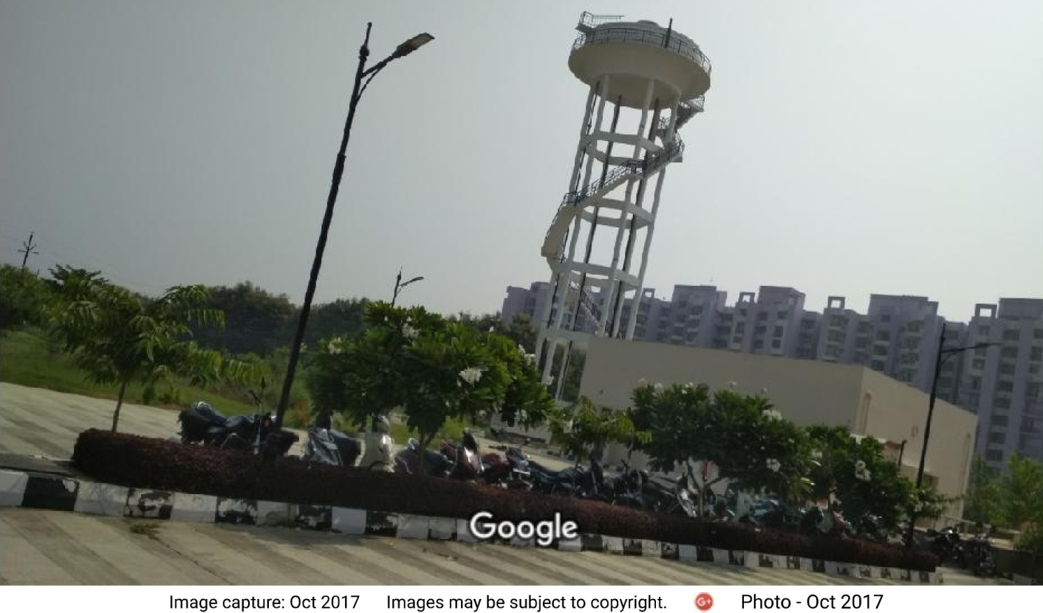

Fig. 1 – Constructed water tank at IGNOU, Lucknow (Courtesy - Google maps)
Initially the design of RCC Overhead Tank at IGNOU, Lucknow was studied in detail. An intze tank was constructed using column and brace type staging on campus using M25 grade of concrete and FE415 grade of steel in 2014. The height of the staging was set at 25m. The tank was designed for Zone III seismicity (moderate risk) as per IS:1893(Part-1)-2002 and basic wind pressure of 1.5 kN/m². The tank was originally designed for a capacity of 2000 students with a demand of 45 liters per capita per day. The tank had a design period of 30 years. Soil at site was considered soft clay.
To optimize the results and check the accuracy of design, iterative tank design was carried out with different H/D ratio varying from 0.50 to 0.75. Further analysis was then done to calculate the cost effectiveness of the structures. Circular water tank with top and bottom dome pattern was adopted as initially proposed at site.
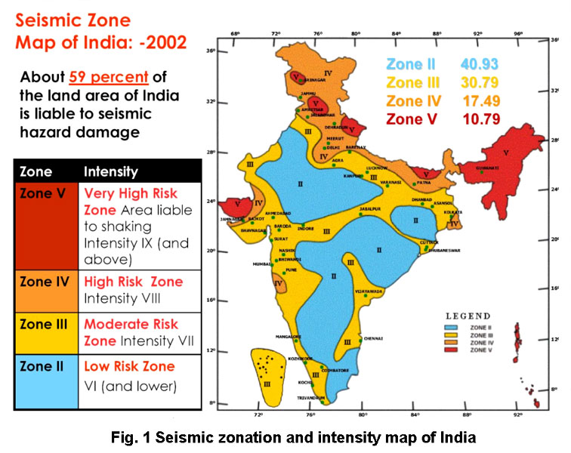
Fig. 2 - Seismic Zoning Map of India as per IS:1893(Part-1)-2002

- MODELLING & ANALYSIS

Six separate models were prepared in STAAD.Pro to check the behavior of the water tanks under the action of applied forces and the value of concrete and steel used for these models was noted down to give a preliminary idea about the overall cost of the structure. Thus obtained results are compared to the existing design data for a tank of same capacity and conclusions are drawn. The first model was given H/D = 0.50 and the successive models had H/D ratio with an increment of 0.05. This can be shown as:
Table 1 – Model Description
SN | Model Description | H  (in m.) | D  (in m.) | H/D
1 | Tank 1 | 5.00 | 10.00 | 0.50
2 | Tank 2 | 5.39 | 9.80 | 0.55
3 | Tank 3 | 5.76 | 9.60 | 0.60
4 | Tank 4 | 6.11 | 9.40 | 0.65
5 | Tank 5 | 6.44 | 9.20 | 0.70
6 | Tank 6 | 6.75 | 9.00 | 0.75
The following assumptions were made before the start of the modeling procedure so as to maintain similar conditions for all the three models:
- Only the main block of the tank is considered. The staircases are not considered in the design procedure.
- No interior walls are provided.
- At ground floor, slabs are not provided and the floor is resting directly on the ground.
- The beams are resting centrally on the columns so as to avoid the conditions of eccentricity.
- For modeling all structural elements, M25 grade of concrete & Fe415 tor steel were used.
- The top and bottom dome of the tank have a diameter of 20 m.
- The footings are not designed. Supports are assigned in the form of fixed supports.
- Sizes of the members are as follows: (All dimensions are in mm)
Table 2 – Member Specification
Property | For all the Models (in mm.)
Columns | 400 x 400
Beams | 500 x 400
Slabs | 250

- Hydrostatic loads are considered in the horizontal direction only and the effect of vertical direction are assumed to be insignificant as they did not vary by a considerable amount in different cases.
- The buildings are to be designed for the following conditions:
Live load = 5 KN/m² (Bottom Dome)
Hydrostatic Force on the walls = Range (-20 to 0.001) KN/m²
Height of Staging = 10 m (In all the models)

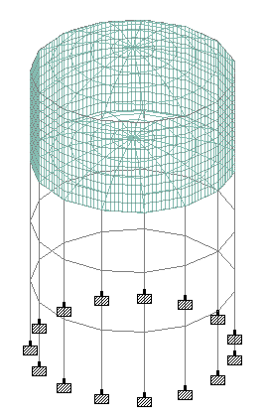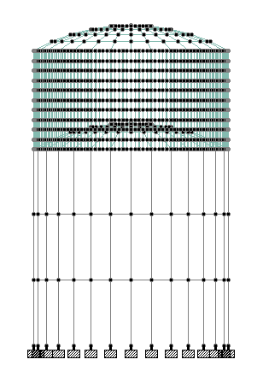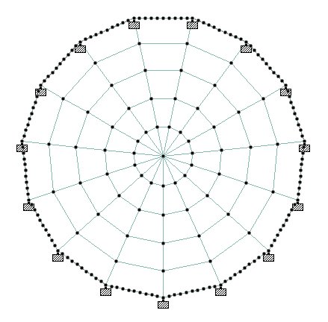

Fig. 3 – Bird-eye view, elevation and plan of the model
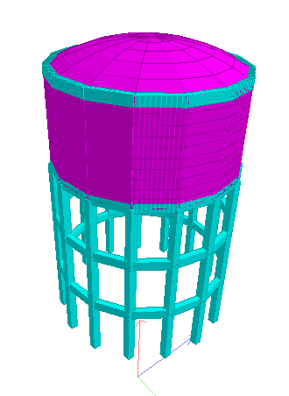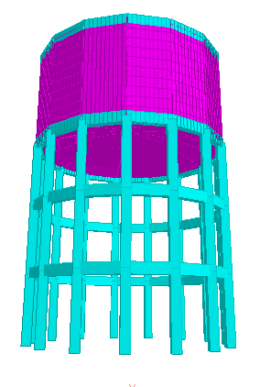
Fig.4 – 3D model of generated water tanks

The behavior of all the six systems is taken as a basic study on the modeled structure. The following parameters were considered to ascertain that the values obtained after analysis were under the acceptable limits according to IS:456-2000.
- Eigen Solutions
- Peak Storey Shear
- Peak Displacement
- Storey Drift
- Approximate cost of materials
- Maximum Plate Stresses
When found safe, the total quantity of concrete and steel used in each model is noted down to give a preliminary idea about the overall construction cost. For asserting the simplest yet reliable method for analysis, the combined action of dead loads (DL) & live loads (LL) fare considered i.e. 1.5 DL + 1.5 LL.

In order to perform the seismic analysis of a structure at any location, the actual records of time history are needed. But it is not practically possible to prepare such records for all the areas and hence in many cases, these records are unavailable. In such cases, RSA is carried out. This method involves the calculation of only the maximum or peak values of member forces and displacements in each of the considered mode using prescribed design spectra. These spectra can be used as an effective method of employing earthquake ground motions. As per IS:1893(Part-1)-2002, the response spectra shown below is recommended for design of structures subjected to seismic forces. The spectra is shown for all four seismic zones in India as per IS:1893(Part-1)-2002. A response spectrum is basically a plot of the peak steady-state response in terms of displacement, velocity or acceleration, for of a series of varying natural frequencies. The main limitation of RSA if that they are universally acceptable only for linear systems. For nonlinear analysis, Time-History Analysis is adopted. In this study, only the linear portion of the tank behavior was analyzed and in absence of time history data for Lucknow region, Response Spectrum Analysis (RSA) ws adopted for the analysis of prepared models.
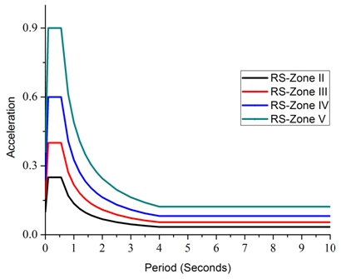
Fig. 3 – Response Spectra for different Seismic Zones as per IS:1893(Part-1)-2002

- RESULTS & DISCUSSIONS

The behavior of all the three framing systems is taken as a basic study on the modeled structure. The lateral drift/deflection ratio is checked against the clause 7.11.1 of IS-1893:2002 i.e. under transient seismic loads. Many parameters such as Nodal Deflection, Beam Shear & Moments and Slab Stresses were considered to evaluate the safety of the structures. When found safe, the quantity of materials used was analyzed to present a comparison between the different frames. The approximate cost of materials can be calculated to give us an idea about the suitability of each model.

Fig. 4 – Frequency Comparison

Fig. 5 – Time Period Comparison

Fig. 6 – Storey Shear Comparison

Fig. 7 – Top Storey Displacement Comparison
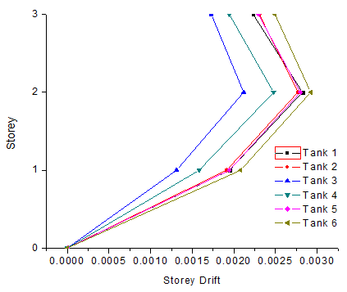
Fig. 8 – Storey Drift Comparison
The following figure shows the areas of stress concentration in the various models. The maximum stresses are occurring at the bottom ring beam (indicated by red) whereas minimum stresses are occurring at the centre of the bottom dome and at the top dome (indicated by purple).
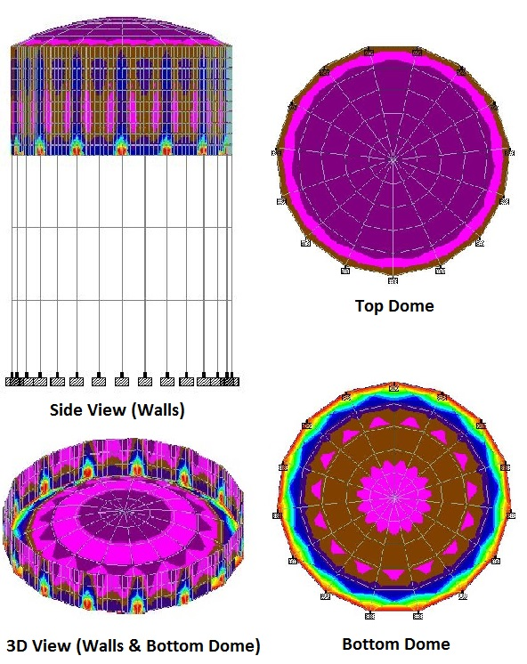
Fig.9 – Stress in Water tanks
Fig. 10 – Cost of Materials
The basic cost of materials is taken as INR 5000/- per cum. of Concrete and INR 50/- per kg. of Steel. It is clear that the initial cost of structure with larger diameters will be comparatively higher but this high initial cost can be justified because of the low height which leads to better stability against wind and seismic loads.
It is clear to all that the loading hazards have to be carefully evaluated before the construction of important and high-rise structures such as overhead water tanks. Based on the above analytical study carried out on 6 different models with different diameters and heights, the following deductions are made:
- For the same capacity of tank, there exists innumerous number of possibilities of height and diameter combination for the tank.
- In all the cases, the diameter was linearly decreased by an amount of 0.2m starting from 10m. It was seen that tanks with larger diameters have smaller heights and thus cover a larger ground span..
- The tanks with smaller diameters generally require lesser volume of concrete. However a linear relationship does not exist between the readings..
- The volume of steel was observed to be higher in cases of tanks having smaller diameter.
- In higher seismically active zone, the earthquake hazard will also increase. In such cases, further analysis will be required to accurately estimate the behaviour of the structure.

- CONCLUSIONS

It is clear to all that the loading hazards have to be carefully evaluated before the construction of important and high-rise structures such as overhead water tanks. Based on the above analytical study carried out on 6 different models with different diameters and heights, the following deductions are made:
- For the same capacity of tank, there exists innumerous number of possibilities of height and diameter combination for the tank.
- In all the cases, the diameter was linearly decreased by an amount of 0.2m starting from 10m. It was seen that tanks with larger diameters have smaller heights and thus cover a larger ground span..
- The tanks with smaller diameters generally require lesser volume of concrete. However a linear relationship does not exist between the readings..
- The volume of steel was observed to be higher in cases of tanks having smaller diameter.
- In higher seismically active zone, the earthquake hazard will also increase. In such cases, further analysis will be required to accurately estimate the behaviour of the structure.
The model Tank 4 showed the best results with minimum cost, INR 4.728 Lacs (approx.) leading us to conclude that H/D = 0.65 is the best. The height and diameter provided in this case are 6.11m and 9.40m respectively. Thus it can be said that the design opted for the construction of tank of 350 kL capacity at IGNOU, Telibagh, Lucknow was improper because the safe efficiency can be achieved more economically with the dimensions provided for Tank 4 as mentioned before.

- REFERENCES

- Dr. S.V. Itti, Prof. A. Pathade, and R.B. Karadi, “A Comparative Study on Seismic Provisions made in Indian and International Building Codes for RC Buildings”.
- Ayazhussain M. Jabar and H. S. Patel, (2012) “Seismic Behavior of RC Elevated Water Tank under Different Staging Pattern and Earthquake Characteristics”. International journal of advanced engineering research and studies e-issn2249–8974, IJAERS/Vol. I/ Issue III/April-June, 2012/293-296.
- Jain Sudhir K., Sameer U.S., 1990, “Seismic Design of Frame Staging For Elevated Water Tank” Ninth Symposium on Earthquake Engineering (9SEE-90), Roorkey, December 14-16, Vol-1.
- Durgesh C Rai, (2003) “Performance of Elevated Tanks in Mw 7.7 Bhuj Earthquake of January 26th, 2001” International Journal Of Advanced Engineering Research Proc. Indian Acad. Sci. (Earth Planet. Sci.), 112, No. 3, September 2003, pp. 421-429.
- Ranjit Singh Lodhi & Dr.Vivek Garg., (2014). “Design of Intze Tank in Perspective of Revision of IS: 3370, Vol.-03 Issue No.9, pp: 1193-1197.
- Asari Falguni, Prof. M.G.Vanza, (2012) “Structural Control System for Elevated Water Tank” International journal of advanced engineering research and studies e-issn2249–8974, IJAERS/Vol. I/ Issue III/April-June, 2012/325-328.
- Irwin P, Kilpatrick J and Frisque A (2008) “Friend or Foe, Wind Height”. CTBHU 8th World Congress.
- Aatish Kumar., R.K.Pandey., 2013, “Wind Effects on Overhead Tank under Different Soil Parameters” IJEAT Vol.-2, No.-6.
- Hasan Jasim Mohammed,(2011) “Economical Design of Water Concrete Tanks” European journal of scientific research ISSN 1450-216x vol.49 no.4 (2011), pp. 510-520 Euro Journals Publishing, inc. 2011.
- Arun Kumar, (2006) “Ductility Analysis of R.C.C.(O.H.T) Design as Per IS:3370(Part-II)” M-Tech Thesis.
- Durgesh C. Rai and Bhumika Singh, (2004) “Seismic Design of Concrete Pedestal Supported Tanks”13th World Conference on Earthquake Engineering Vancouver, B.C, Canada August 1-6, 2004.
- Sudhir K.Jain & O.R.Jaiswal, September-2005, Journal of Structural Engineering Vol-32, No.03.
- Luis A. Godoy, “Damage Due to Buckling in Above Ground Storage Tank”, University of Puerto Rico, Mayaguez, PR 00681-9041, Puerto Rico.
- IS: 3370 (Part I - II) -2009, General Requirements, Code of Practice for Concrete Structures for the Storage of liquids.
- IS: 3370 (Part IV) -1967, Design Tables, Code of Practice for Concrete Structures for the Storage of liquids.
- IS: 875 (2002) “Code of Practice for Design Load” Bureau of Indian Standard, New Delhi.
- IS: 456 (2000) “Plain and Reinforced Concrete- Code for Practice” Bureau of Indian Standard, New Delhi.
- STAAD Pro. v8i, SELECT Series 4 for analysis and design of models.

