Impact of Nagpur Metro on Other Transportation Modes In Terms of Fuel Consumption Parameter
K. M. Neware¹ , Mr. S. S. Sanghai² and Mr. K. K. Jajulwar³
¹Research Scholar, Transportation Engineering, G. H. Raisoni College of Engineering, Nagpur, Maharashtra, India.
²Professor, Civil Engineering Department, G. H. Raisoni College of Engineerng, Nagpur, Maharashtra, India.
³Professor, Electronics & Telecommunication Department, G. H. Raisoni College of Engineering, Nagpur, Maharashtra, India.
Abstract: Transportation Engineering is the growing need of developing country as the number of private vehicles are increasing in the city day by day which results in heavy congestion and delay on the road of the city. Introduction of metro rail in Nagpur city will result in passenger ridership shift from road based transport to metro rail. In order to estimate the fuel consumption, the number of vehicles of proposed area after the introduction of Nagpur metro will be estimated by using different methods which are already proposed in different research papers. This paper includes the review of analysis of fuel consumption of or emission from road based vehicles which is effected by other public transportation services especially metro rail services of other different cities or countries.

1. Introduction:

Transportation is a critical connection amongst creation and consumption, supporting social and financial exercises The vehicle division devours innumerable essential and auxiliary vitality sources like coal, gas, diesel, fuel oil, petroleum product, warmth, and power. steady with 2008 information ordered by the International Energy Agency (IEA), the vitality consumption of the world transport segment represented 29.6% of aggregate vitality consumption predictable with the IEA, oil consumption inside the vehicle division represents five hundredth of the world's aggregate oil consumption. On the contrary hand, high vitality consumption inside the transportation part implies that high contamination and outflows (Lin and Xie, 2014). reliable with the IEA, the transportation part represents about tierce of the world's carbon emanation caused by vitality consumption, and this can surpass five hundredth by 2030 essentially from Asian nations like Republic of India and China, wherever transportation enterprises square measure expanding. around 40 % of fuel consumption in mammoth urban areas is said to transportation. a justifiable amount of fuel is squandered owing to congested driving conditions in crest hours. Transportation organizers investigate for approaches to downsize blockage to abstain from squandering fuel and increment vitality power.

To predict mode share of people among various travel modes, many authors studied public travel choice pattern, metro transit service received cornerstone from people and policy makers for its huge capacity, environmental profits, ease and safety. Metro transit services are constructed especially on congested areas to smooth up jam caused due to growth in traffic. Cost, convenience and other many factors resulted in shifting of people from private mode to public mode transport which is a keystone of sustainable transport. Metro rail services uses optimal accessible road area and less transportation fuels. They wonted to deplete vehicle exhaustion pollution, related with road transportation. It is come in expectation that growth in metro ridership can result in changes in mode transfer, energy saving and also CO₂ exhaustion recovery.
Rail System | Avoided emission (t CO2)
MTA-New York ª | 15,000,000/year
Los Angeles Metro | 12,997,000/year
RENFE-Spain | 2,460,488/year
Lisbon Metro-Portugal | 130,275/year
Porto Metro-Portugal | 46,996/year
Sao Paulo Metro-Brazil | 820,000/year
California High Speed Rail | 1,150,000/year
LGC Mediterranean | 237,000/year
HSR-4500 km-France | 1,000,000/year
Bangalore Metro-India | 2200/km-year
ª Including the bus system
Source: C.E.S.D. Andrade et.al 2016
The examination space comprised of the Nagpur Municipal partnership space. The examination space is around 217 km². Bolstered the different sorts of reviews done by the DMRC, metro arrangements were concluded when repetitive examination of the street organize, 14 crossing points, voyager activity stream, road turned parking lot, interfacing with principle arrive employments. The Nagpur metro framework region incorporates two arrangements; north south corridor and east west corridor. The point of this examination is to introduce and apply a method to appraise the vitality and fuel utilization and CO₂ emanation abstained from inferable from the execution of Nagpur metro rail framework and evaluating sustainability of it, misuse the mode move affect.
2. Literature Review:
Boqiang Lin et. al. [1], calculated energy utilization considered for respect to 10.73% of overall energy utilization in china during 2015. They take binary choice model to examine vital parameters effecting the evolution of rail transport in china. They examined influence of metro rail transport on fuel utilization with the help of DID model
Chatrali Shirke et. al. [2], presented a strategy to estimate the effect of ordered Transit Oriented Evolution (TOE) with fresh metro rail plan. The strategy emphasis on forecasting of mode choice behavior & effect of TOE like less oil exhaustion and journey period for programmed period of 2036 are estimated
Carlos Eduardo Sanches et.al. [3] put forward & used method for evaluating energy consumption & exhaustion prevented by line 4 of Rio De Janeiro metro by inviting commuters from different vehicle modes in year between 2016 to 2040. The strategy take a thorough demand prediction for this duration & takes account on native transport outlines & various fuels utilized.
Christopher N.H. Doll et.al. [4] presented an examination which recognizes the co benefits of the on going condition as well promising co benefits depend on growth in trips & changing mode proportion involvement. They put forward a strategy outlined to calculate the co benefits of transport inventiveness & put to use to the situation of Delhi metro. A quantifiable mechanism has been evolved at (UNU-IAS) United Nations University – Institute of Advanced Studies as component of big assignment on metropolitan evolution with co benefits. It targets to get to know how dissimilar approaches would influence the co benefits of freightage system in any given town .
Niraj Sharma et. al. [5], carried out sensitivity examination to evaluate the effect of contrastive fusion of inserting constants like modal alteration, engine automation and fuel variety on exhalation. Plus CO₂ exhalation recovery because of transfer of road vehicle ridership onto metro rail has been calculated. It is predicted that because of growth in metro trips, modification in modal transfer and energy preservation inventiveness by Delhi metro, CO₂ exhalation recovery could be attainable.

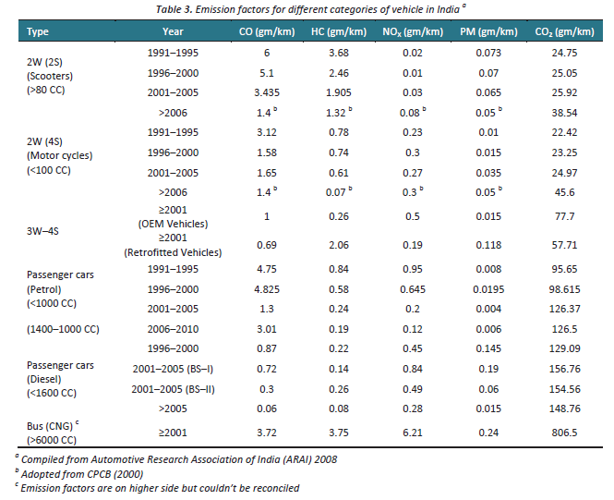

Prachi Khanna et.al. [6] carried out an analysis on influence on energy consumption and environment which can happen after entrance of another modes of transportation. In this article two situations; growth in the bus and metro services are equate with business as usual situation. Both are compared in respect to energy consumption and exhalation and presents that a bus influenced transport service consequence in 31% depletion in energy consumption and on another side metro influenced service deplete 61%.

3. Methodology:
Methodology adopted is as follows:
Boqiang Lin et.al. [1] fuel expenditure of the transport area is calculated using Lin & Du (2015) calculation procedure. They examine the vital parameters effecting construction of metro transport for town with the help of binary choice modal and if road transport fuel expenditure is the cause of establishment of metro rail transport. On the other side, they establish control team as stated by outcome of binary choice model and examine effect of metro rail transport on vehicle fuel expenditure.
Chatrali Shirke et.al. [2] The effect of TOE on metro facility, oil exhaustion & journey period are examined for getting unintended influence of TOE. The mode option pattern of these tours are examined with the help of Multinomial Logit Model (MNL). The MNL model taken for this theory are chosen models from CTS article of MMR. Calculated fresh applicability functions from MNL for mode option pattern of tours evaluated for programmed years. With the help of traffic increase described in imitation theory accomplished by MMRDA. With the help of refined journey period & like journey price in MNL model, modal split is estimated for planned years. Oil exhaustion is estimated using equation described by Papacostas & Prevendouros.
Carlos Eduarde Sanches et.al. [3] the logical thought of this method is to take into account the application of structure changes changes traffic outline in the area, so it can used to reduce the application of cars & buses. Less cars & buses on roads results in less CO₂ exhaustion and minimum traffic crowding. The demand prediction analysis for line 4 was accomplished with a strategical method which used revealed and stated preference survey tactics, along with particularization of logit mode choice mathematical model. CO₂ emission is calculated by multiplying energy consumption per car km with CO₂ emission factor per unit of energy.
Christopher N.H. Doll [4] The anamnesis of Delhi metro put forward in this article announces the first outcomes of application of mechanism infusing a quanfiable estimation of environmental profits of metro with qualitative estimation of parameters causing the magnitude of assessed environmental profits. A spreadsheet dependent mechanism was evolved depend on ASIF bodywork of Schipper et.al (2000) which look on as alteration to the freightage network depend on trip movement (A), mode share (S), fuel intensity of every type of mode (I) & emission parameters of fuels (F). Once information is inserted, initial emission estimation is formed. Changing trip movement can be inserted as a percentage difference in overall commuter km; this exercise then circulated throughout the modes and finally the portion of the fuels in trips to create produced emission table.
1. Initial City Data
2A. Total Travel Demand

2S. Mode Share
2E. Fuel Efficiency

3. Output Scenario
2F. Fuel Share in each mode
1. Preliminary Emission Calculation
3. Post Emission Calculation

4. CO-BENEFIT CALCULATION

Fig. Flow chart of the quantitative evaluation tool
Niraj Sharma et.al [5] the metro train trips is first of all turned to amount of vehicle in figure transferred with the help of details on occupancy, general journey stretch & vehicle kilometer travelled (VKT) with the dissimilar type of vehicles. Overall vehicular exhalation recovery is estimated for each day by a specific type of vehicle in km.
Prachi Khanna et.al. [6] the method chosen to collect information were stratified sampling technique from nine areas. 70 locations undergone with research survey. Types of vehicle and travel attributes like stretch of trip, vehicle use, fuel effectiveness, occupancy such type of data were gathered in personal interviews. Economic survey in delhi helped to get modal split and many sources lead to assemble emission factors. Travel status are recede against time and outcome exponential equation applied to forecast future trips for particular upcoming years. The calculated travel is then circulated among several transport modes. ASIF approach is used to calculate energy use and emission under various situations.
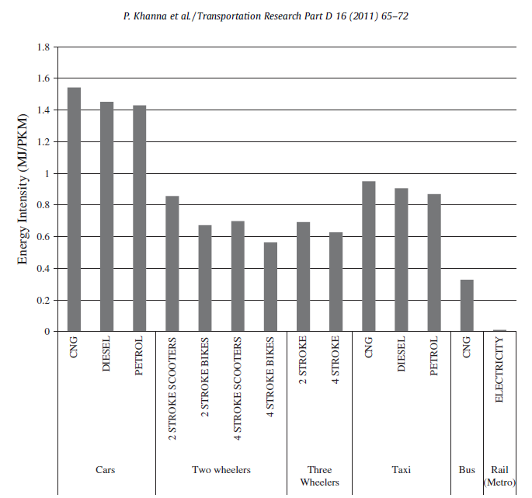
4. Conclusion & Result :
[1]. The regression outcome of individualistic factor signify the that populace and per person earning are even now very vital parameter influencing energy utilization in transport area. Which signify that building of metro rail transport can hold up vehicular fuel expenditure notably.
[2]. At the time of dawn peak time in 2036, all fuel exhaustion will be nearby 400 gallons if portion of metro is acknowledged to grow with the growth in residents and recruitment. Therefore it is noticed that due to TOE 76976 litres of fuel will be recovered at the time of dawn peak time each day as it will lessen the volume of traffic on roads.
[3]. The method evolved to evaluate energy and total prevented exhaustion was put on to Rio de Janeiro metro line 4 and outturned in yearly total depletion of 55.45 thousand tonnes of CO₂ and 949 million MJ. Each commuter kilometer outturned in total prevented discharge of 44.53g CO₂ and prevented non renewable energy utilization of 0.70 MJ.
[4]. The mechanism applied to evaluate situations of maximum amount of car takers could be transferred to metro than the bus takers and this would contribute with growth in metro use. It showed CO₂ exhalation differs with growth in metro trips and mode involvement to the metro.

[5]. The CO₂ exhalation recovery because of modal transfer from road to metro train was calculated to be 120 tonne for each day during 2006 and 724 tonne for each day during 2011. Calculation and sensitivity examination signify that more advantage of CO₂ might be attained if traveler transfer from one type of non private transit to metro rail.
[6]. Cars were resulted as the biggest user of energy in base year as they use nearby 45% and energy utilized in commuter travel and after that 2 wheeler and buses use 30% and 20% respectively. The research recommend that growth in use of public transport mode, each of two bus or rail can result in remarkable depletion in energy appeal against in BAU situation. Despite rail transport can result in more depletion in emission than bus.
5. References:
1. Lin, Boqiang, and Zhili Du. "Can urban rail transit curb automobile energy consumption?." Energy Policy 105 (2017): 120-127.
2. Shirke, Chatrali, et al. "Transit Oriented Development and Its Impact on Level of Service of Roads & METRO: A Case Study of Mumbai Metro Line-I." Transportation Research Procedia 25 (2017): 3039-3058.

3. Andrade, Carlos Eduardo Sanches de, and Márcio de Almeida D’Agosto. "The role of rail transit systems in reducing energy and carbon dioxide emissions: The case of the city of Rio de Janeiro." Sustainability 8.2 (2016): 150.

4. Doll, Christopher NH, and Osman Balaban. "A methodology for evaluating environmental co-benefits in the transport sector: application to the Delhi metro." Journal of Cleaner Production 58 (2013): 61-73.

5. Sharma, Niraj, et al. "Emission reduction from MRTS projects–a case study of Delhi metro." Atmospheric Pollution Research 5.4 (2014): 721-728.

6. Khanna, Prachi, et al. "Impact of increasing mass transit share on energy use and emissions from transport sector for National Capital Territory of Delhi." Transportation Research Part D: Transport and Environment 16.1 (2011): 65-72.

