Reliability Analysis of High Rise Building
Raj Gathe¹, G. B. Bhaskar²
¹M. Tech Scholar (Structural)
G. H. Raisoni Academy of Engineering and Technology, Nagpur, India, 440016
²Assistant Professor
G. H. Raisoni Academy of Engineering and Technology, Nagpur, India, 440016

Abstract –Researchers and Engineers are working on variety of materials and use of lightweight materials which can reduce the use of conventional concrete in some extent. More focus is on use of waste materials like fly ash, rice husk etc. In this paper investigation on high rise building using properties of materials- EPS and concrete is done using ETABS and also reliability analysis is done. Reliability is the ability of a structure to comply with given requirements under specified conditions during the intended life for which it was designed. Planning of building is done in such a way that less space is occupied with more occupancy. Wind and earthquake analysis is done on G+16 storey building for concrete and EPS and various properties like base shear, storey drift and storey displacement is compared for both the materials. It was observed that stability of expanded polystyrene (EPS) material meets the requirement.
Keywords: EPS, reliability analysis, lightweight materials.
INTRODUCTION
Human activities mainly the construction activities has increased the carbon footprint and are causing severe damage to the environment. It has also led to disturbance in the ecological cycle. This growing concern has caused the researchers and engineers to focus on new materials which will have less impact on the environment. With the growing population comes huge resource demand. So, sustainable development shall be done along with adopting the waste reduction techniques. In this past years, different methods have been immerged to provide environmental benefits like use of light weight material. These materials led to speedy construction and also reduced the raw materials required. These specific

characteristics result in lower environmental loads and enhanced seismic resistance [1].
Drift analysis is done to check the stability of structure. As building heights increase, the forces of nature begin to dominate the structural system and take on importance in the overall building system. The analysis and design of tall building are affected by lateral loads, particularly drift or sway caused by such loads Response-spectrum analysis is a linear-dynamic statistical analysis method which measures the contribution from each natural mode of vibration to indicate the likely maximum seismic response of an essentially elastic structure. Lateral drift is the amount of side-sway between two adjacent stories of a building caused by lateral loads. Horizontal deflection of a wall refers to its horizontal movement between supports under wind or earthquake loading.

METHOLOGY
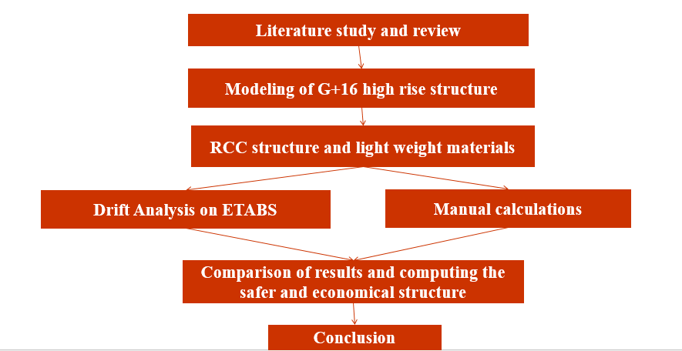
DESIGN
For linear dynamic analysis, sixteen storey is considered having builtup area of (24x 19.5) m. Height of each storey is same i.e. 3 m. The slab thickness is 125 mm. The dimensions of beam and column are given in table 1. Outer wall thickness is 230 mm and inner wall thickness is 115 mm.
Table 1-Size of beam and column
No | Beam/Column | Size (mm)
1  2  3  4  5  6 | Beam  Beam  Column  Column  Column  Column | 230 x 400  230 x 450  350 x 650  300 x 600  300 x 450  230 x 400
The dead load is considered as (density x thickness + floor finish) = (25*0.125*1 + 0.75) = 3.875 KN/m². The live load of 2 KN/m² is considered on the building. Masonry load for 230 mm wall is 13.225 KN/m² and for 115 mm wall is 6.612 KN/m². The modelling of the building is done with the help of CSI based software ETABS. The linear dynamic, Response Spectrum analysis is used to analyze the Lateral loads acting on the building. As per code if the height of the building is between 40-90m in Zone1, 2, 3. Modal analysis using Response Spectrum Method. Along with that Wind analysis (linear static) is also performed. Fig 1 shows the architectural view of each story floor plan and Fig 2 shows the ETABS model top view. The details of the Material properties are given in table 2 & 3.
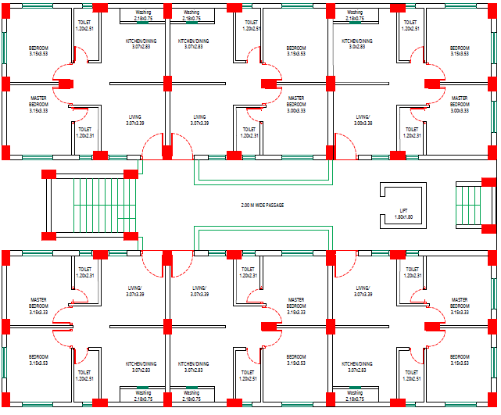
Fig. 1- Architectural view of each story floor plan
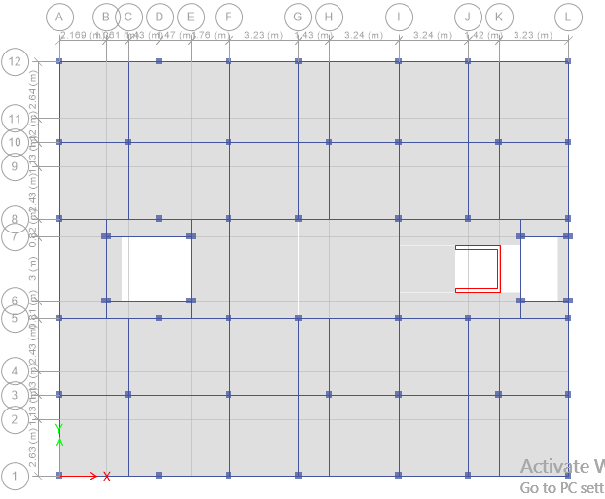
Fig. 2 - ETABS model top view1
Table 2- Properties of Concrete
Modulus of elasticity | 27386.13 Mpa
Poisson’s Ratio (u) | 0.2
Coefficient of thermal expansion | α= 0.0000055/ºC
Shear Modulus (G) | 11410.89 Mpa

Table 3- Properties of Steel
Modulus of elasticity | 199947.98 Mpa
Poisson’s Ratio (u) | 0.3
Coefficient of thermal expansion | α= 0.00000117/ºC
Shear Modulus (G) | 76903.07 Mpa

The material used for the comparison is EPS. Density of EPS are (15, 20, 30, 35) kg/m^{3.} [4]

RESULTS AND INTERPRETATION
The materials used shows the results in reduction of displacement, drift due to earthquake. It has been observed that with the use of EPS, top storey displacement and inter-storey drift is minimized from 40 to 50%. The comparative analysis is shown for both the buildings in the form of graphs. Fig. 3 & Fig. 4 shows the comparison between concrete and EPS for displacement and drift.

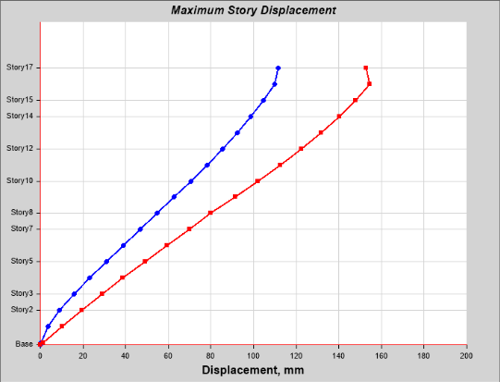
Fig. 3.1 – Displacement chart for Concrete
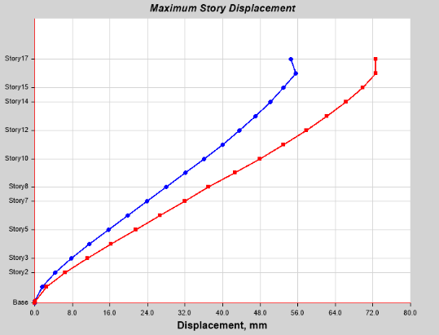
Fig. 3.2 – Displacement chart for EPS
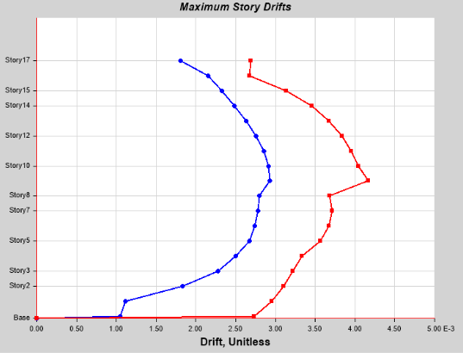
Fig. 4.1 – Storey drift chart for Concrete

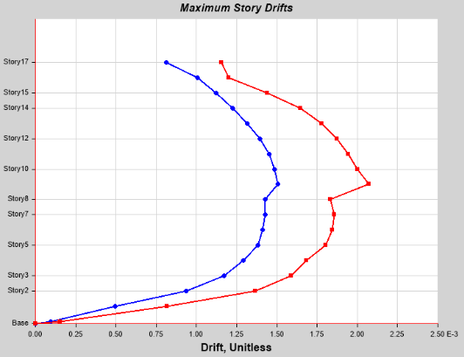
Fig. 4.1 – Storey drift chart for EPS
CONCLUSION
The introduction of EPS material in the structure reduces the seismic response of the structure. Because of EPS, displacement and inter-story drift at various floors shows significant reduction. With EPS, shear force and bending moment of all columns can reduce up to (40) %. Reduction in axial force is very small as compared to reduction in shear force and bending moment in all columns at top storey. EPS reduces the weight of the building due to which the lateral forces acting on the building changes to less by 50%. This makes the structure stable. It was observed that the structure with EPS has performed considerably well in displacement and storey drift as compared with brick masonry and also as it reduces the overall cost of structure and causes reduction in material use, it can be better option for construction with desirable stability.

ACKNOWLEDGMENT
The authors acknowledge the support provided through the Rashtrasant Tukadoji Maharaj Nagpur University, Nagpur and chairman and principle of G.H. Raisoni Academy of engineering and technology.

REFERENCES
- Naji, S., Çelik, O.C., Alengaram, U.J., Jumaat, M.Z. and Shamshirband, S., 2014. Structure, energy and cost efficiency evaluation of three different lightweight construction systems used in low-rise residential buildings. Energy and buildings, 84, pp.727-739.
- Di Sarno, L. and Wyatt, T.A., 2006. High rise steel buildings under wind loads. In XI International Conference on Metal Structures (ICMS-2006) (pp. 362-364). Taylor &Francis Group.
- Lu, D.G., Song, P.Y., Yu, X.H. and Wang, G.Y., 2008, October. Global seismic reliability analysis of building structures based on system-level limit states. In Proceedings of the 14th World Conference on Earthquake Engineering.
- Manual for Expanded Polystyrene (EPS) Core Panel System and its field Application. CSIR-CBRI Report No.: S.E(G)/ 0605
- Lee, J.H., Hong, S.G. and Ha, Y.J., 2017. Sandwich panels of ultra-high performance concrete composite with expanded polystyrene. Journal of Asian Concrete Federation, 3(2), pp.90-97.
- Gangwar, A.G., Affordable Housing: Emerging Technologies and Building Materials in Indian Context.
- Einea, A., Salmon, D.C., Fogarasi, G.J., Culp, T.D. and Tadros, M.K., 1991. State-of the-art of precast concrete sandwich panels. PCI JOURNAL, 36(6), pp.78-98.
- Liu, M.Y. and Li, Y.J., 2012. Reliability analysis of high-rise buildings under wind loads.
- Krishna G.V. and Kumar, R., 2018. Issues In Design Of Tall Concrete Buildings In India With Reference To Is 16700: 2017 Code. In International Conference on Advances in Construction Materials and Structures (ACMS-2018), March 7-8, 2018.

