Blind People Guidance System
Nikita Sonkusale, Prajakta Sakhare, Heena Kapgate
¹Assistant Professor, Professor (10,Times ,Italic)
Name of the Institute, City, Country, Pin
²Assistant Professor, Professor
Name of the Institute, City, Country, Pin

Abstract- The project presents the concept and a model that provides a smart electronic aid for blind people. The paper describes a system that will help blind or partially sighted people for detecting partially sighted people for detecting external obstacles. This work puts a step ahead in modulation of technology which will help people with disabilities to improve their quality of life. The paper describes functional and technical design with available resources for guiding a blind person. The system contains sensors which detects the location of the obstacles. The location of the obstacles will be indicated by a voice guidance system.
Keywords- location detection, navigation system, sensors, sound waves.
INTRODUCTION
People having disabilities related to vision or sight come across many difficulties while performing their daily life activities. The society today gives each and every person freedom of movement to achieve their desired goal under any condition. The blind people face physiological, social, economic, psychological problem which keep them away from all the social rights. The project presents prototype model and concept of the system. The system tries to provide a smart electronic device which will guide the blind people. The system contains a microcontroller, ultrasonic sensor, water detector sensor, solar panel, a Bluetooth device, a battery and connecting wires. The system will work as: Blind person will wear the shoes and start walking. As soon as obstacle will come in the range of ultrasonic sensor, ultrasonic sensor will send the signal to microcontroller. The microcontroller which is connected to the Bluetooth device. The Bluetooth device will then send a voice message in the blind person’s earphones which he is wearing. The connection of Bluetooth device to the system takes help of an android application which will be installed in the blind person’s mobile phone. The system runs on power supply. For power supply a

battery is provided. A solar panel is also provided so that there will not occur system failure due to unavailability power supply. The system provides high-end technology by removing various disadvantages of previous works that have been done related to this issue. Previously smart sticks were used to guide the blind person. But it had disadvantages one of which is it was difficult to carry the stick. Blind people also used to carry dogs to guide them. This also had drawbacks. This system helps to remove all these drawbacks.
METHOLOGY
Previously lots of solutions were adopted as a solution to the problem. Some of these are as follows:
- Human assistant: The blind person would take a human guide along with him wherever he wants to go. But it is not practical that the guide will always be available. Also it is not a permanent solution and it also disturbs the privacy the blind person.
- Dogs: Specially trained dogs were used to guide the blind person. But dogs were only used avoid the obstacles. Dogs are not useful for finding the path. Plus it was very hectic and costly to train a dog and its maintenance.
- Blind Canes: Canes are the sticks which the blind person would hold in hand and would walk. But the cane invented was very heavy and hard to carry.
- Advanced Blind Canes: Later on some improvements were done in the cane to remove the disadvantages. This cane was not heavy as the previous one. But it also had a drawback. This cane contained Infrared Sensor. The infrared sensors are slower and do not give the accurate measurement of the distance.
The proposed system removes all the drawbacks that above systems had. The system is very easy to carry and it uses ultrasonic sensors instead of Infrared Sensor which is faster and gives the accurate measurement of the distance.
DESIGN
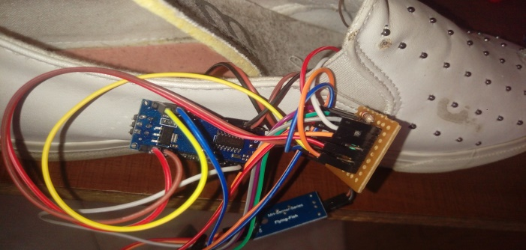
Fig.: Internal Circuit Design
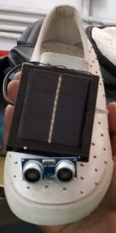
Fig.: Original System
FUTURE SCOPE
1) We can use GPS transmitter and receiver so that rang of indication is not limited.
2) Instead of mobile SMS at remote location we transmit all parameter at remote location and at there is also another display, which show this parameter
3) We provide 6v 4.5 Ah battery back up to our system so that in case of power failure our
project works properly.
CONCLUSION
Hence we conclude that the system which was proposed has been successfully created according to the problem statement.

REFERENCES
[1] S.Gangwar (2013) designed a smart stick for blind which can give early warning of an obstacle using Infrared (IR) sensors, “A Smart Infrared Microcontroller-Based Blind Guidance System”, Hindawi Transactions on Active and Passive Electronic Components,Vol.3, No.2, pp.1-7, June 2013.
[2] S.Chew (2012) proposed the smart white cane, called Blind spot that combines GPS technology, “Electronic Path Guidance for Visually Impaired People”, The International Journal Of Engineering And Science (IJES), Vol.2, No.4, pp.9-12, April 2012.
[3] Benjamin etal (2014), Mrs. Shimi S. L. and Dr. S.Chatterji, “Design of microcontroller based Virtual Eye for the Blind”, International Journal of Scientific Research Engineering & Technology (IJSRET), Vol.3, No.8, pp.1137-1142, November 2014.
[4] Central Michigan University (2009) developed an electronic cane for blind people “A Review on Obstacle Detection and Vision”, International Journal of Engineering Sciences and Research Technology”, Vol.4, No.1, pp. 1-11, January 2009.
[5] Mohd Helmyabd Wahab and Amirul A. Talibetal , “A Review on an Obstacle Detection in Navigation of Visually Impaired”, International Organization of Scientific Research Journal of Engineering (IOSRJEN), Vol.3, No.1 pp. 01-06, January 2013.
[6] Alejandro R. Garcia Ramirez and Renato Fonseca Livramento da Silvaetal (2012)‟ Artificial EYE An Innovative Idea to Help the Blind”, Conference Proceeding of the International Journal of Engineering Development and Research(IJEDR), SRM University, Kattankulathur, pp.205-207, 2012.
[7] José, Miguel Farrajota, Joao M.F. Rodrigues (2013), “A Smart Infrared MicrocontrollerBased Blind Guidance System”, Hindawi Transactions on Active and Passive Electronic Components,Vol.3, No.2, pp.1-7, June 2013.

[8], Dambhare and A.Sakhare (2011) “Effective Navigation for Visually Impaired by Wearable Obstacle Avoidance System”, International Journal of Power Control Signal and Computation (IJPCSC), Vol.3, No.1, pp. 51-53, January-March 2011.

