**“Fabrication And Study of thick film SnO2 doped with TiO2gas sensor to sense O2gas”- Environmental Study**

**Ms. D.H.Chaudhari1,Mr.K.V.Madurwar2,Ms.D.R.Motwani3**

*1,2,3Asst. Professor,Civil Engg. Deptt. PBCOE, Nagpur*

***Abstract:****In the last few years, there has been an increasing interest in the electronic world for those aspects related to semiconducting gas sensor (SGS) materials. In the view of the increasingly strict legal limits for pollutant gas emissions, there is a great interest in developing high performance gas sensors for applications such as controlling air pollution and exhaust gases. The aim of project work is to find out the best material, which gives accurate count of gas sensitivity within shortest possible time.*

*Gas sensors based on semiconductor metal oxides have been one of the most investigated devices of gas sensors. They have aroused the attention from many*

*researchers interested in gas sensing due to their low cost, ease of fabrication, simplicity of use and large*

*numbers of detectable gases. [4]. We need to develop good gas sensor working at relatively high as well as low temperature. We still need sensitive and selective semiconducting sensor in the field of sericulture, germination of seeds, utility of marshy lands, field of health etc.*

*The semiconductor gas sensors offer good advantages with respect to other gas sensor devices (such as spectroscopic and optic systems), due to their simple implementation, low cost, good reliability for real-time control systems and easy make [1-3].*

***Keywords: SEM, Semiconductor sensor, gas sensor, sensitivity etc.***

**I-INTRODUCTION**

**A** gas sensor is a transducer that detects gas molecules and which produces an electrical signal with magnitude proportional to the concentration of the gas.

Unlike other types of measurement, types that are relatively straightforward and deal with voltage, temperature, and humidity, the measurement of gases is much more complicated. Because there are literally hundreds of different gases, and there is a wide array of diverse applications in which these gases are present, each application must implement a unique set of requirements. For example, some applications may require the detection of one specific gas, while eliminating readings from other background gases. Conversely, other applications may require a quantitative value of the concentration of every gas present in the area.

In this way, semiconductor gas sensors offer good advantages with respect to other gas sensor devices (such as spectroscopic and optic systems), due to their simple implementation, low cost, good reliability for real-time control systems and easy make [1-3].

Gas sensors based on semiconductor metal oxides have been one of the most investigated devices of gas sensors. They have aroused the attention from many researchers interested in gas sensing due to their low cost, ease of fabrication, simplicity of use and large numbers of detectable gases. [4]. Most of the companies provide metal oxide based gas sensors due to their applications range from detection of combustible or toxic gas to air intake control in automobile and glucose bio-sensors [5].

Characteristics of Sensors are static characteristics, dynamic characteristics, environmental conditions and structural related characteristics. Static parameters are the ones that describe the transfer function of a sensor, i.e., the relation between the input and the output of a sensor, when the input does not vary significantly with time. On the other hand, dynamic characteristic describes the performance of the sensor taking account of the variation of the stimulus with time.

Environmental, conditions are all those factors that interfere with the sensor mechanisms and thus change its response to the input stimulus. Finally, structural related characteristics are those which result from the specific design and components of the sensor. The last characteristics includes: cost, weight, power consumption, lifetime and compatibility with silicon based manufacturing technologies.

Coal mines is the best example for sensing toxic gases & combustible gas detection. Underground mining requires equipment and manpower to operate under the earth surface. Subsurface atmosphere may be contaminated with poisonous gases that displace the necessary oxygen to support life or flammable gases that may cause explosion. Therefore, it is necessary to develop technologies and find ways to accurately measure concentration levels of toxic and flammable gases levels in subsurface atmosphere for safety of underground coal mines. Each sensor has its own advantages and constraints, like some sensors are better for sensing toxic gases and some are better for combustible gas detection.

The sensitivity of the sensor is defined as the ratio of the change in resistance to the resistance in presence of air. In many fields of research, sensitivity is defined as the ratio of the measured variation to the variation of the output.

|  |  |
| --- | --- |
| **Class** | **Detected Properties** |
| Mechanical | Length, acceleration, flow, force, pressure etc. |
| Thermal | Temperature, specific heat, heat flow, etc. |
| Electrical | Charge, current, voltage, resistance,inductance |
| Magnetic | Magnetic flux density, magnetic moment etc. |
| Optical | Light intensity, wavelength, polarization etc. |
| Radiation | Type, number or energy of radiation particles, light properties far from the visible spectrum etc. |
| Chemical | Composition, concentration, pH etc. |

1. **Methodology:**

**2.1. Resources of semiconductor gas sensors:SnO2, TiO2.**

The surface and materials properties of SnO2 (and impurity doped SnO2) should be discussed in context of its three major applications. These applications are (i) as a transparent conducting oxide (TCO), (ii) as an oxidation catalyst, and (iii) as a solid state gas sensingmaterial. For the latter two applications the surface of the material is where the ‘‘action’’ isand thus surface science investigations are

of direct relevance. For the first application it is the bulk properties that are responsible for makingSnO2 a TCO.

However, many applications of TCO’s require interfacing them with a dissimilar material. Thus the surface and interface properties of SnO2 are also important in the use of SnO2 in TCO applications.SnO2 belongs to the important family of oxide materials that combine low electrical resistance with high optical transparency in the visible range of the electromagnetic spectrum. These properties are sought in a number of applications; notably as electrode materials in solar cells, light emitting diodes, flat panel displays, and other opto-electronic devices where an electric contact needs to be made without obstructing hoons from either entering or escaping the optical active area and in transparent electronics such as transparent field effect transistors .

Another property of SnO2 and other TCO’s is that although they are transparent in the visible they are highly reflective for infrared light. This property is responsible for today’s dominant use of SnO2 as an energy conserving crystals or established methods for growing well-defined thin films. Suitable SnO2 single crystals were grown in the past. New fields like dilute ferromagnetic oxides (briefly discussed. as well as new approaches in the study of traditional applications of SnO2 may sporn again the growth of suitable single crystals for surface science investigations[3,7]. It is the intend of this article to increase the interest in the study of SnO2within the surface science community and to show avenues for possible future investigations.

**2.2. Structure of TiO2**

TiO2 is extensively used in gas sensing because of its desirable sensitivity good stability in adverse environments. The stable phase of TiO2 corresponds to the rutile structure or titania. The space group and atoms location sites corresponds to those presented above for the SnO2 rutile phase.

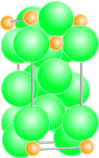 

**Fig1:-Anatase metastable phase Figure2 :-Rutile structure for crystalline TiO2 for crystalline TiO2**

TiO2 is extensively used in gas sensing because of its desirable sensitivity and mainly because of its good stability in adverse environments. Titanium Oxide has one stable phase, rutile (tetragonal) and two metastable polymorph phases, brookite (orthorhombic) and anatase (tetragonal). Both metastable phases become rutile (stable) when submitting the material at temperatures above 700 °C (in pure state, when no additives have been added). All the TiO2 samples analyzed in the present work were firstly synthesized from anatase phase and submitted to a calcination process in order to reach the stable rutile phase.

**2.3 Study of Materials:**

Following are the essential criteria for materials to be used as sensors:

1. The material should show high sensitivity in terms of the variation of resistance or capacitance on contact with a very small quantity of the gas or vapor concerned.
2. Some materials are equally sensitive to many gases. This is a not desirable characteristic. Sensitivity is an important criterion.
3. The material should sense the gas over a large number of cycles for extended periods and sensor should not undergo environmental degradation rapidly due to humidity, temperature and other factors.
4. As far as possible, the sensor should not employ expensive materials such as noble metals.
5. The operating temperature should be as low as possible.
6. The device should not consume more power for continuous operation.
7. The response time as well as recovery time should be as small as possible.

**2.4 Applications:**

1. measurement of O2 in laboratory experiments

2. monitoring gaseous O2 in indoor

environments for climate control

1. monitoring of O2 levels in compost piles and

mine tailings

1. monitoring redox potential in soils
2. determination of respiration rates through

measurement of O2 consumption in sealed

chambers

1. measurement of O2 gradients in soil/porous

media

**3. Research Work**

**3.1 Preparation of Thick Film:**

The entire sample Tin Oxide, Titanium dioxide are used. Initially the samples are calcinated to remove the impurity present in it at 5000C for 5 Hrs. using Muffle furnace. The sensor was made by using screen printing technique method. The fine powder of pristine composite material was formed by using Modder-Piston. The binder used for preparation of thick film by thoroughly mixing of butyl Digol and ethyl cellulose was added and paste is made for screen printing technique. Initially the glass plate was cleaned by using acetone. The paste of pristine and composite material was taken in different ratio and it was screen printed on the glass substrate. Then plate was dried at room temperature and binder was removed by heating it at 4500 C in furnace. The thickness of made sample .was measured by digital micrometer (Japan).

**3.2 O2 gas Sensor:**

Sensors characteristics can be grouped into static or dynamic parameters, environmental conditions and structural related characteristics. Static parameters are the ones that describes the transfer function of a sensor, i.e., the significantly with time. On the other hand, dynamic characteristics try to describe the performance of the sensor taking account of the variation of the stimulus with time. Environmental conditions are all those factors that interfere with the sensor mechanisms and thus change its response to the input stimulus. Finally, structural related characteristics are those that results from the specific design and components of the sensor.

These last characteristics could be including cost, weight, power consumption, lifetime and compatibility with silicon based manufacturing technologies.

**3.3 Fabrication of O2 Gas chamber:**

D.C. electrical conductivity of the thick films was measured with the help of Static System which is developed in our laboratory. Static Gas Sensing System consists of Pico ammeter, Temperature Controller, Dimmer, and Computer System. Static System provides high accuracy and faster rising time. It can take measurements at Speedup to 1000 reading per second and voltage source 200 micro volt to 50 Volt.

**3.4 Pico Ammeter:**

This is very versatile multipurpose equipment for the measurement of low D.C. Currents. The instrument uses a well-designed precision FET input, Electrometer op-amp ADP 15, the output current on digit panel meter. It is capable of accepting either polarity of input currents. Well-regulated power supplies are incorporated to use the instrument up to 10% change in A.C. voltage. It can measure the current 1 pA to 1999x105 pA.

**3.5 Temperature controller:** As the name implies, temperature controller is an instrument used to control Temperature. The temperature controller takes an input from a temperature sensor and has an output that is connected to a control element such as a heater.

**3.6** **Kithley picometer:**

Dimmer is used to generate the heat i.e. heating source. It is ranging from 20V to270V. The schematic diagram **Kithley picometer** is shown below.

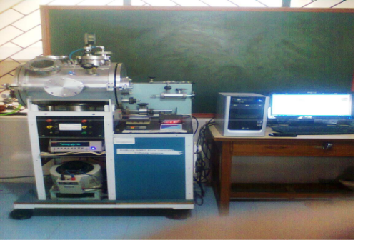

Fig. 3.1 Kithley picometer

Thus, by measuring the voltage across standard resistance R, the sample resistance was calculated. Knowing the sensor resistance and dimension (area and thickness) of the sensor, the conductivity was calculated.

|  |  |  |
| --- | --- | --- |
| **Sr. No** | **Sample Code** | **Sensors** |
|  | S1 | Pure SnO2 |
|  | S2 | 80% SnO2 + 20% TiO2 |
|  | S3 | 60% SnO2 + 40% TiO2 |
|  | S4 | 50% SnO2 + 50% TiO2 |
|  | S5 | 40% SnO2 + 60% TiO2 |
|  | S6 | 20% SnO2 + 80% TiO2 |
|  | S7 | Pure TiO2 |

**4. Result:**

**A. Experimental Result:**

|  |
| --- |
| **SEM of the samples:** |

A scanning electron microscope (SEM) images a sample by scanning it with a high-energy beam of [electrons](http://en.wikipedia.org/wiki/Electron) in a [raster scan](http://en.wikipedia.org/wiki/Raster_scan) pattern.

It includes thermal run VI characteristics, variation of conductivity with concentration of O2 gas of various sensors and variation of sensitivity with the concentration of O2 gas at constant temperature.

SEM picture shows some rods with fine voids over them which helps to increase sensing properties. SEM pictures are shown below.

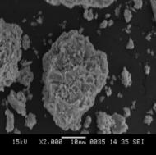 

SEM picture of SnO2  SEM picture of TiO2

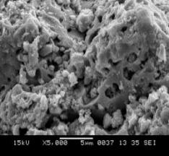 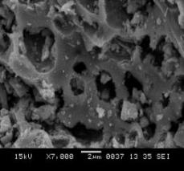

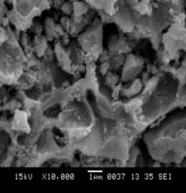 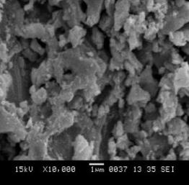

SEM pictures of 60SnO2:40TiO2 at different magnifications

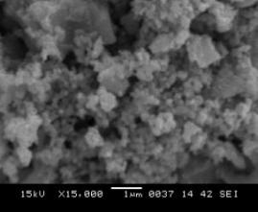 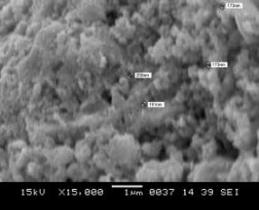

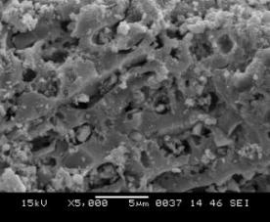 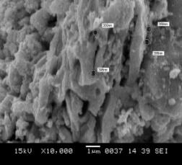

SEM pictures of 70SnO2:30TiO2 at different magnifications

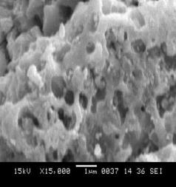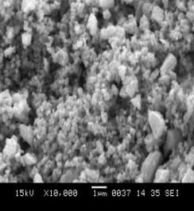 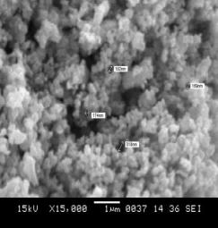 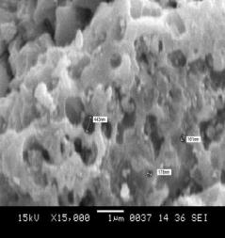

SEM pictures of 80SnO2:20TiO2 at different magnifications

The surface morphologies of pure SnO2 and TiO2 materials were studied by SEM and SEM pictures of 60SnO2:40TiO2, 70SnO2:30TiO2 and 80SnO2:20TiO2, are shown in above figures.

Following Table shows the average diameter and number of pores per inch of SnO2, TiO2 and composites of SnO2 and TiO2.

|  |  |  |  |  |
| --- | --- | --- | --- | --- |
| **Sr. No.** | **Sensor** | **Pure sample and their compositions (mole %)** | **Average diameter of pore (nm)** | **Number of pores per inch**  **(in x 2000 magnification)** |
| 1. | S1 | SnO2 | 590 | 67 |
| 2. | S7 | TiO2 | 630 | 85 |
| 3. | S3 | 60SnO2:40TiO2 | 390 | 99 |
| 4. | S | 70SnO2:30TiO2 | 230 | 105 |
| 5. | S2 | 80SnO2:20TiO2 | 250 | 115 |

**B. Graphical Result:5.1** Thermal run graphs:

**Figure - shows variation of current versus temperature**

**4.2 VI characteristics graphs: -**

**Figure - shows variation of current versus Voltage**

The V-I characteristics of the pure materials and the composite materials were studied at room temperature (30o C) and at high temperature (100o C & 200°C).

The variation of current with the applied voltage is found to be linear for all thick films at room temperature. From these nature of graph we conclude that the entire sample obeys Ohms Law (V=IR).

**4.3 Variation of Conductivity verses Temperature**

**4.4 Variation of sensitivity with PPM at constant temperature**

provides high thermal conductivity, low electrical conductivity, mechanical support

and electrical insulation; therefore it is selected as a base material.

The gas sensing process is strongly related to the surface reactions. Different metal oxide based materials have different reaction activation to the target gases. Composite metal oxides usually show better gas response than the single component if the catalytic actions of the components complement each other. It is also showed that grain size is useful to enhance the sensitivity.

**6. Conclusion:**

The aim of project work is to find out the best material, which gives accurate count of gas sensitivity within shortest possible time. We need to develop good gas sensor working at relatively high as well as low temperature. We still need sensitive and selective semiconducting sensor in the field of sericulture, germination of seeds, utility of marshy lands, field of health etc. To improve the quality of working of precipitator to reduce air pollution.

In the present work, the chemicals and materials selected are SnO2 and TiO2 in the preparation of multilayer gas sensors. Al2O3

The catalysis results obtained when using the composite support this idea. This explanation suggests that not all composite gas sensors will have better performances than those of individual components alone. composite sensors comprising mixture of stannic dioxide and Titanium dioxide show variation in sensitivity when compared directly with the equivalent single oxide sensors.

From sensitivity-ppm graph, it is observed that sensor S2 (80% SnO2 + 20% TiO2) is best among the sensors to sense O2 gas. This is due to fact that porosity in this sensor is large and absorption of O2 gas takes in large amount.

It is concluded that studies on gas sensing technologies should concentrate more on solving urgent problems like high energy consumption, Control air Pollution and fabrication complexity.

**REFERENCES:**

1. *Joshi S.K.,TsurataT,Rao C.M.R.,nagakura S., New Materials, Narosa Publishing House (1992) 2-3.*
2. *T. Seiyama, A. Kato, K. Fujiishi, M. Nagatani, Anal. Chern.,34 (1962) 1502.*
3. *N. Yamazoe, Y. Kurokawa, T. Seiyama, Sensors and Actuators, 4 (1983) 283.*
4. *T. Kabayashi, M. Haruta, H. Sano, M. Nakane, Sensors and Actuators, 13 (1988) 339.*
5. *J. Tamaki, T. Maekawa, S. Matsushima, N. Miura, N. Yamazoe, Chern. Left.,19 (1990) 477.*
6. *U. Lampe, J. Gerblinger, H.\Meixner, Sensors and Actuators B, 25 (1995) 657.*
7. *Y. Nakamura, H. Zhang, A. Kishimoto, O. Okada, H. Yanagida, J. Electrochem. Soc., 145 (1998) 632.*
8. *W.-H. Tao, C.-H. Tsai, Sensors and Actuators B, 81 (2002) 237.*
9. *C. Cantalini, Sensors and Actuators B, 24 (2004) 1421.*
10. *Y.S. Shen, T.S. Zhang, Sensors and Actuators B, 12 (1993) 5.*
11. *S. Matsushima, J. Electrochem. Soc. Jpn., 103 (1995) 302.*
12. *1. H. Yu, G.M. Choi, Sensors and Actuators B, 52 (1998) 251.*
13. *Z.H. Mkhitaryan, A.A. Shatveryan, V.M. Aroutiounian, M. Ghulinyan, L. Pavesi: Low-frequency noise in structures with porous silicon in different gas media, Phys. Stat. Sol. (c),* ***4****, N 6, pp. 2063-2067, 2007.*
14. *S. Roy, C. Jacob, S. Basu: Studies on Pd/3C-SiC Schottky-junction hydrogen sensors at high*
15. *temperature, Sensors and Actuators B,* ***94****, pp. 298-303, 2003.*
16. *P. TobisÏka, O. Hugon, A. Trouillet, H. Gagnaire: An integrated optic hydrogen sensor based*
17. *on SPR on palladium, Sensors and Actuators B,* ***74****, pp. 168-172, 2001.*
18. *P. MITRA1\* and A.K. MUKHOPADHYAY2;BULLETIN OF THE POLISH ACADEMY OF SCIESNCESTECHNICAL SCIENCES;* ***Vol. 55****, No. 3, 2007.*
19. *Dewei Chua, Yu-Ping Zenga,∗, DongliangJianga, YoshitakeMasudab: Sensors and Actuators****B 137*** *(2009) 630–636*
20. *17. N. Yamazoe, “Toward innovations of gas sensor technology,” Sensors and Actuators B, vol.*
21. ***108****, no. 1-2, pp. 2–14, 2005.*
22. *18. K. Takahata, Tin Dioxide Sensors—Development and Applications. Chemical Sensor Technology,* ***vol.****, Elsevier, Amsterdam, The Netherlands, 1988.*
23. *19.N. S. Baik, G. Sakai, N. Miura, and N. Yamozoe, “Hydrothermally treated sol solution of tin oxide for thin-film gas sensor,” Sensors and Actuators B,* ***vol. 63****, pp. 74–79, 2000.*

**Details of All Authors (Optional)**

|  |  |  |
| --- | --- | --- |
| **SR.NO.** | **PHOTO** | **DETAILS** |
| 1 |  | ***Ms. Dipali. H. Chaudhari,*** *have passed my B. E in civil engineering from RTMNU, Nagpur. I have completed my M-tech in Environmental Engineering from RTMNU, Nagpur and currently working as a Asst. Professor in Department of Civil Engineering, Priyadarshini Bhagwati College of Engineering, Nagpur, RTMNU, Maharashtra, India (440009). Work Experience: Teaching -10 years, I have published 3 papers in international journals and 2 in National/ international conferences. I am also having membership of professional bodies like Indian Society of Technical Education (ISTE), IAENG, IRED.* |
| 2 | C:\Users\abc\Desktop\Kamlesh_V.Madurwar.jpg | ***Mr. K.V. Madurwar****, I have passed my B.E in civil engineering from RTMNU, Nagpur. I have completed my M-tech in Geotechnical Engineering from RTMNU, Nagpur and currently working as a Asst. Professor in department of Civil Engineering, Priyadarshini Bhagwati College of Engineering, Nagpur, RTMNU, Maharashtra, India(440009). Work Experience: 18 years,. I am having membership of professional bodies like Indian Geotechnical Society(IGS), Indian Concrete Institute(ICI), Institute of Engineers(IEI).* |
| 3 |  | ***Ms D. R. Motwani,*** *I have passed my BSc in Physics From Sant Gadgebaba Univesity, Amaravati, I have completed my Msc in physics from SSGBU, Amaravati and currently working as a Asstt professor in Priyadarshini Bhagwati College of Engineering, Nagpur,RTMNU,Maharashtra, India. Work Experience: Teaching -1.5 years.* |