Archimedes Screw Hydropower Generation
Danish pinjari¹, Ibrahim pinjari², Syed Aazam³, Ahemad Raza⁴

^{1,2,3,4} UG students, Department of Mechanical Engineering, Godavari College of Engineering, Jalgaon, India.
danishpinjari40@gmail.com ¹, ibrahimkhalilpinjari@gmail.com ², azam51199@gmail.com ³, arkkhan2375@gmail.com ⁴

Received on: xxxx,20xx, Revised on: xxxx,20xx, Published on: xxxx,20xx

Abstract – Due to their excellent efficiency (more than 80% in some installations), low cost, and little environmental effect, Archimedes screw generators (ASGs) are becoming more extensively used at low head hydro sites in Europe. ASGs have the most potential at low head sites as compared to other generation technologies (less than about 5 m). The performance of an Archimedes screw used as a generator is determined by a variety of factors, including the screw's inner and outer diameters, slope, screw pitch, and a number of flights, as well as intake and outlet conditions, site head, and flow. Despite the Archimedes screw's extensive history, English literature contains very little on the dynamics of these devices when utilized for power generation. To support the creation and validation of ASG design tools, laboratory testing of miniature Archimedes screws (about 1 W mechanical power) was done. The link between torque, rotation speed, and power is investigated in this work using experimental results. Although separate efficiency peaks were discovered, the laboratory screw maintained reasonable efficiency throughout a wide variety of operating circumstances. The source of changes in power output induced by modifying the water level at the screw's outlet was primarily attributed to the corresponding variation in the head, as well as dynamic restriction of screw rotation speed, which created comparable limits in volume flow through the screw. The test results were qualitatively similar with data from a prototype ASG erected by Greenbug Energy in southern Ontario, Canada, as well as data from recent laboratory testing and commercial installations in Europe.
Keywords- Low head hydropower, Archimedes screw, run of river power plant.
I. INTRODUCTION
The screw turbine, also known as an Archimedean turbine, is a water turbine that converts the potential energy of water into work using the Archimedean screw principle. It's comparable to a water wheel. The turbine is made out of an Archimedean screw-shaped rotor rotating in a semicircular trough. The weight of the water flowing into the turbine presses down on the turbine blades, causing the turbine to whirl. The water pours freely into the river from the turbine's end. The screw's top end is connected to a generator through a gearbox. Because of their great efficiency, low cost, and little environmental effect, Archimedes screw generators (ASGs) are becoming more extensively used at low head sites in Europe.
A major market for ASGs in North America is predicted to emerge as a result of these same considerations, as well as increased regulatory support for distributed renewable energy generation. ASGs are a relatively new addition to the micro-hydro generation technology landscape. Williamson, Stark, and Booker (2011) address the relative merits of micro-hydro technologies, as well as a design approach for selecting the best technology for a particular site. ASGs, in comparison to other generation technologies, have the greatest potential at low head locations (less than around 5 m), and, unlike conventional reaction or impulse turbines, may retain high efficiencies even as the head approaches zero (Williamson et al., 2011).
The inner cylindrical shaft of an Archimedes screw is wrapped with one or more helical surfaces (flights) that are orthogonal to the cylinder surface (Fig 1). The resulting geometry is quite similar to that of a standard screw. A cylindrical trough holds the screw (and in some cases has been fastened to it). This trough could be a tube that encircles the screw or a tube that simply extends around the screw's lower half. An Archimedes screw is operated as a pump, trapping water between two consecutive flights. The bucket is a body of water that is raised along the trough as the screw revolves. ASGs work in the opposite direction: water runs into the top of the screw, turning it as a result.

II. LITERATURE REVIEW
There is currently inadequate English literature on ASGs to help designers optimize an ASG for a specific site and flow conditions. There is a substantial amount of non-English literature on ASGs, with recent examples including Brada (1996), Aigner (2008), Schmalz (2010), and Lashofer et al (2011). Even this non-English literature, however, does not answer all of the questions about ASGs. The experimental tests of a set of laboratory-scale prototype ASG turbines are the focus of this research. This research is part of a wider initiative aimed at developing engineering models of ASG turbines that may be used as engineering tools.
Fish and small detritus can flow through a running ASG without damaging the screw, unlike most micro-hydro technologies. ASGs, on the other hand, do not affect fish in general. In the aquaculture business, Archimedes screw pumps are used to transfer fish, and California research indicated that more than 98 percent of young salmon survived passage via Archimedes screw pumps (Mcnabb, Liston, & Borthwick, 2003). Studies of an ASG on the River Dart in the United Kingdom indicated that practically all species, including eels, trout, and salmonoids, passed through the ASG undamaged, and that no intake screening was required (Kibel, 2008; Kibel, Pike, and Coe, 2009). Contact with fish weighing less than 1 kilogram did not cause harm in laboratory studies. If the tip speed was less than 4.5 m/s (which is faster than many running ASGs), the screw leading edge would be: At higher tip speeds, the addition of a rubber leading-edge significantly decreased injury to larger fish (Kibel, Pike, and Coe, 2009).

Technical limitation:
Due to material, structural, technological, and physical restrictions, a single screw may not be able to take advantage of all possible possibilities for very high flow rates or water heads: bending could be a severe issue for very long structures. Archimedes screws operate at low rotation speeds compared to other hydropower turbines, so increasing the inner diameter of the screw could help to increase the AST length at the cost of making the screw larger or reducing the effective Archimedes screws operate at low rotation speeds compared to other hydropower turbines. This has environmental benefits such as reduced noise and improved ecological behavior. However, a gearbox is needed to convert this rotational speed to the generator's required speed. Despite the fact that this isn't necessarily a good thing, a significant issue the gearbox losses, as well as the generator losses It's possible that this will have an impact on the system's overall efficiency.
III. METHODOLOGY
The importance of gaining a full understanding of AST design and operation was emphasized. This differs from previous evaluations on efficiency [4], [5], and operation, which primarily reflects manufacturer perspectives and individual favorable or bad experiences. As a result, all three known manufacturers (2010) were approached to ensure that all brands' installations were included in the study.
In lab tests and a study of actual ASG sites across Europe, Hawle et al. (2012b) investigated the impact of screw geometry on turbine efficiency. Fixed-speed generators are far less tolerant of big flow changes than variable-speed generators, according to the survey, which revealed that plants ranging from 10 kW to 60 kW were the most frequent.
Generators with varying speeds. In order to boost efficiency, their lab studies looked into using a rotating trough. They discovered that a fixed-trough design is more efficient and tolerant of changing flow conditions in most circumstances.
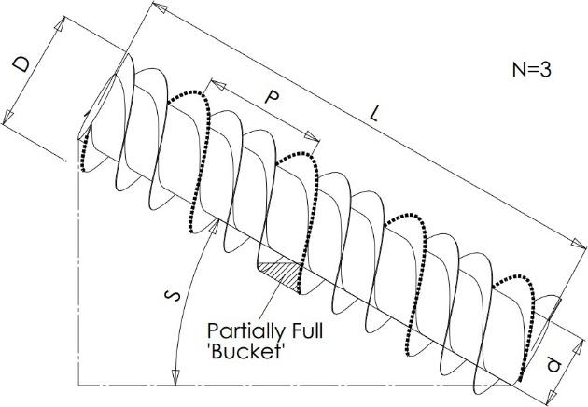
Figure 1. Example ASG with 3 flights

Figure 1. Example ASG with 3 flights, and geometric
An adjustable friction brake on the top end of the rotation shaft diminished the screw's power output. A load cell (Omegadyne LCM703-25) mounted to an arm integrated into the brake system was used to measure torque. A special Hall effect sensor circuit was placed in the route of rare earth magnets affixed to the ASG shaft to measure rotational velocity.
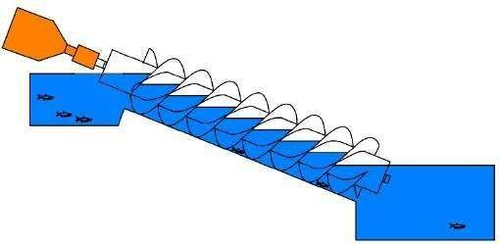
Figure 2.
Visual observation of sight gauges and V notch depths was used to record head and flow data. A National Instruments (NI USB-6009) DAQ was used to record rotational velocity and torque measurements. Before data was collected, reservoir levels, system flow, and braking force were set and allowed to settle to equilibrium.was gathered in preparation for a trial While reservoir levels and flow rate were monitored and recorded, torque and rotational velocity were measured for one minute at 1000 Hz.

Table 1. Test Turbines

Parameter | Lab ASG | Prototype ASG
Diameter D (cm) | 14.6 | 59.95
P/D | 1.0 | 1.72
d/D | 0.522 | 0.54
Length L (cm) | 58.4 | 244.26
Number of flights N | 3 | 3
Slope (°) | 22.7 | 22

IV. DESIGN
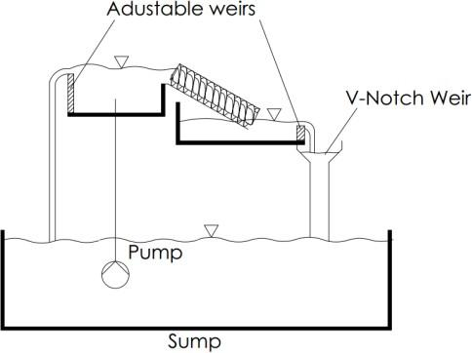
Figure 2. Diagram of Experimental Apparatus

For a long time, Archimedes screws have been utilized as water pumps for irrigation and de-watering. According to some historical accounts, Archimedes used the apparatus to launch a ship. Archimedes screws are routinely employed as high-volume pumps nowadays, and they're especially well-suited to wastewater treatment facilities because debris and obstructions in the water have little or no influence on the functioning screw. The Archimedes screw can be used as a pump or a generator, as seen in Figure.
V. RESULT & DISCUSSION
P = T is the mechanical power generated by an ASG, where T is the torque in Nm and R is the turbine's rotational speed in rad/s. Setting operating parameters (flow Q, inclination angle S, and so on) and adjusting brake load to form a torque/speed curve was a usual test. Figure 3 illustrates torque-speed curves for a variety of lower reservoir levels. Because power is the combination of torque and rotation speed, there will be an optimal point on the torque-speed curve for each operating situation that maximizes power production.
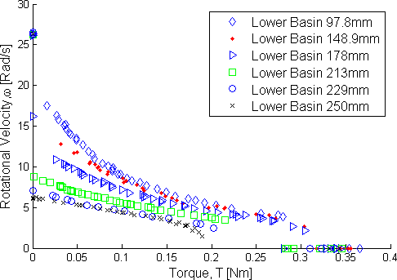
Figure 3. Rotational velocity versus torque, varying lower reservoir level
The maximum power Pmax that a hydroelectric turbine can generate is given by

P_{max} = QHρg | (1)

where Q is the flow rate, H is the head drop across the turbine, g is the gravitational constant, and p is the water density. The ASG's efficiency can be expressed as

η = P / P_{max} = ωT / QHρg | (2)
A notional flow rate of 0.785 l/s and ahead of 248 mm were employed during testing, resulting in a typical Pmax of 1.9 W. For each profile, tests were undertaken under halted (= 0) and free-wheeling (zero applied torque) situations in addition to a variety of torque and speed combinations. The leakage losses may be quantified at stall using the test ASGs. Leakage was estimated to be responsible for 30 percent of overall flow (minimum 6 percent) through the ASG. During the lab testing, typical efficiencies were around 45 percent.
In all circumstances, increasing the efficiency increases the power extracted from the water. This includes when the ASG's flow and/or head changes.
DISCUSSION
After the prototype, ASG was seen to have a significant drop in performance as the water rose above the midway of the outlet in the lower reservoir, research into the impact of lower reservoir depth on ASG performance began. While the lab test screws exhibited lower efficiency than commercial counterparts, this was most likely owing to the lab's relatively substantial leakage losses, which were attributable to the test screws' tiny scale.
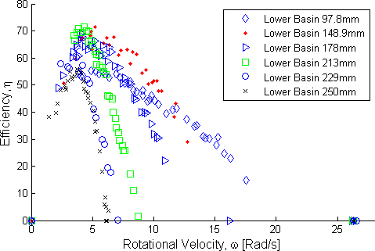

Figure 4. Efficiency versus rotational velocity, varying lower basin level
The peak efficiencies were reasonably stable over the range of depths tested, as shown in Fig. 4. This shows that a decrease in the overall head is responsible for a significant portion of the influence on power output produced by changing lower reservoir depth. The range of rotation speeds that the screw can attain is reduced when the bottom end of the reservoir is flooded, resulting in a reduction in volume flow rate. The screw's efficiency stays high as the lower reservoir level rises, but the rotation speed decreases, limiting the volume of water that goes through the screw. The maximum amount of power that can be collected diminishes noticeably when the screw's end is "flooded": the screw is efficiently extracting energy from a flow that lowers noticeably as the lower reservoir depth rises above the screw outlet's midpoint.
Operational and Maintenance:
Costs ASTs are predicted to have lower overall operation and maintenance costs than other turbines. Checking fluid levels and refilling grease cartridges at the upper bearing and gearbox are part of routine AST maintenance. The bottom bearings are normally designed to last for a long time before needing to be replaced. ASTs feature few wear spots and operate at a slow pace, which reduces wear and scouring. Only trough and blade flights experience the most prevalent types of physical and chemical degradation. The lower bearing of an AST usually requires major maintenance after 20 to 30 years. When the lower bearing and trough are replaced, the screw flights are usually repaired.
ASTs are one of the greatest solutions for undeveloped regions and areas with no easy access, such as high elevations of mountains or tiny towns far from facilities and infrastructure, because their maintenance and operating expenses are lower than those of other micro-hydro turbines. This is a significant benefit for tiny towns when connecting to central grids is difficult and expensive.

VI. CONCLUSION

Archimedes Screw Turbines (ASTs) are a novel type of turbine for small hydroelectric power facilities that can be used in low-head locations. ASTs provide a clean and sustainable energy source. They are less harmful to wildlife, particularly fish. ASTs have a modest rotation speed, which means they have fewer detrimental effects on aquatic life and fish..
ASG performance was measured in the lab under various operating situations, including changes in rotational velocity and decreased reservoir depth. In addition, data from a prototype ASG was obtained to investigate the impacts of varying flow rates. Both sets of data indicate that ASGs should perform well under a variety of head and flow situations.
It's crucial to remember that ASTs aren't a one-size-fits-all answer for all energy generation requirements. ASTs, like any other technology, have drawbacks: employing Archimedes screws as generators is a relatively new technology, and there are many things about ASTs that are not well-known in comparison to other hydropower technologies. There are currently no design standards for ASTs, and AST hydro powerplant designs are heavily reliant on the skill of the engineer who creates them. Due to material, structural, technological, and physical limitations, a single screw may not be able to take advantage of all possible potential for very high flow rates or water heads. However, the growing interest in ASTs, as well as new breakthroughs and ideas like multi-AST powerplants, provide some options for extending AST usage.
ASGs are generally resistant to fluctuations in inflow and water levels, retaining a high level of efficiency over a large range of these variables. This feature is particularly useful for ASGs used in small-scale run-of-river applications. The prototype ASG's operational volume flow rate range was limited due to the induction generator's requirement for a set rotation speed. Variable speed generators will be a focus of future research. These would allow the ASG to reduce rotation speed during periods of low flow, resulting in higher bucket fill and torque, allowing the machine to keep running.
Flow visualization within the buckets of the ASG is also on the agenda for future research. The impacts of changing other factors, such as inlet and outlet geometry, installed slope and pitch, will also be studied. A parametric model of an ASG is being built, based in part on the presented data and ongoing research, to allow numerically-based site-specific optimization of ASG designs..

REFERENCES
- Aigner, D. (2008). Uberfalle - Asserbauliche Mittelungen - Aktuelle Forschungen im Wasservau 1993-2008. Institut fur Wasserbau und Technische Hydromechanik der TU Dresden. Selbstverlag der Technischen universitat Dresden, Dresden, 36.
- Bard, N. (2007). River Dart Hydro Performance Assessment By Nick Bard Hydro Services For Manpower Consulting Ltd. Nick Bard Hydro Services, 44(0). Retrieved from http://www.mannpower- hydro.co.uk/research.php
- Brada, K. (1996). Schneckentrogpumpe als Mikroturbine, in Wasserkraftanlagen - Klein- und kleinstkraftwerke. expert-Verlag, Malsheim, 1st edition.
- Brada, K. (1999). Wasserkraftschnecke ermöglicht Stromerzeugung über Kleinkraftwerke [Hydraulic screw generates electricity from micro hydropower stations]. Maschinenmarkt Würzburg, (14), 52–56.
- Hawle, W., Lashofer, A., & Pelikan, B. (2012b). State of technology and design guidelines for the Archimedes screw turbine. University of Natural Resources and Life Sciences Vienna (BOKU), 1–8.
- Kibel, P. (2008). Archimedes Screw Turbine Fisheries Assessment. Phase II: Eels and Kelts. Report. Fishtek Consulting Ltd. (UK).
- Kibel, P., Pike, R., Coe, T. (2009). The Archimedes Screw Turbine: Assessment of Three Leading Edge Profiles. Report. Fishtek Consulting Ltd. (UK).
- Koetsier, T., & Blauwendraat, H. (2004). THE ARCHIMEDEAN SCREW-PUMP : A NOTE ON ITS INVENTION AND THE DEVELOPMENT OF THE THEORY. Proc. of Int. Symposium on History of Machines and Mechanism (HMM04). Kluwer, Dordercht, 181–194.
- Lashofer, A., Kaltenberger, F. and Pelikan, F. (2011). Wie gut bewährt sich die Wasserkraftschnecke in der Praxis. Wasserwirtschaft, 7,8, 76–82.
- Mcnabb, C. D., Liston, C. R., & Borthwick, S. M. (2003). Passage of Juvenile Chinook Salmon and other Fish Species through Archimedes Lifts and a Hidrostal Pump at Red Bluff , California. Transactions of the American Fisheries Society, (February 2012), 132:326–334.
- Muller, G., & Senior, J. (2009). Simplified theory of Archimedean screws. Journal of Hydraulic Research, 47(5), 666–669. doi:10.3826/jhr.2009.3475
- Nagel, G. (1968). Archimedean Screw Pump Handbook. Schwabisch Gmund: RITZ Pumpenfabrik OHG.
- Nuernbergk, D. M., & Rorres, C. (2012). An Analytical Model for the Water Inflow of an Archimedes Screw Used in Hydropower Generation. Journal of Hydraulic Engineering, 120723125453009. doi:10.1061/(ASCE)HY.1943-7900.0000661
- Rorres, C. (2000). THE TURN OF THE SCREW : OPTIMAL DESIGN OF AN ARCHIMEDES SCREW. Journal of Hydraulic Engineering, (January), 72–80.

