Fitness and Healthcare App

Ketan Vilas Shetye¹, Shreyash Patil ², Rehan Quereshi ³, Sunder Mishra⁴, Dipali Bhole⁵

^{1,2,3,4} UG Students, ⁵ Asstt. Professor
Shree L R Tiwari College of Engineering, Thane, India, 401107,

ketan.shetye@slrtce.in

Received on: 28 April, 2023 Revised on: 23 May, 2023 Published on: 25 May, 2023

Abstract –Exercise and body workout are referred in the action of being fatter, fitter, stronger and inactive in day to day life. There are numerous android apps goaling to replace or justify a personal assistant is growing. However, due to this arises a question about the reliability, safety, integrity, and even security of the information and facts provided by such android systems. In this study, we researched android apps that treat as renown virtual personal assistant. We present a systematic review of top 10 popular android apps, clustering them according to their characteristics and properties and attributes. The choosing polls considers the following set of keywords: "fitness", "Android App", "features”, "daily plan", "systematic review", "diet plan". Based on the review of the popular android apps, we promote a new research and present in detail guidelines on generating android apps for personalized workouts and exercises. Finally, we researched and investigated how an android app will promote health, fitness, active and well-being lifestyle of users and either the popular applications are used in any studies.
Keywords- health, Android App, features, daily plan, systematic review, diet plan.
- INTRODUCTION
Being healthy, fit, active is a life-long journey full of rising and falling. Sometimes you may get prone to an accident start losing motivation or get prone to an injury or life just gets in the way or many more thousand reasons. But, let any be the case, you should never give up because it's never too late to start or restart yours be fit journey[1]. At the end of the day goal is to achieve a better physical and mental version of yourself. Though you can just walk on being fit path on your own having some crazy dedication inside you, but you can consider some of the best mobile fitness workouts, nutritionist application which can offer help, guidance, support and motivation to keep you going strong, consistent and dedicated[10]. A fitness application is a mobile application that can be installed on any mobile system and used anywhere anytime to get fit, active, strong. As of in this modern world, there are numerous fitness, workouts, exercises, nutrition apps released on the two leading platforms, iOS, and Android, and according to statistics number of such types of application has reached more than millions. Applications can perform various events, behavior’s such as allowing users to set health related objective, tracking water intake, evaluating calorie burn, evaluating fat burn, gathering exercise innovations, and uploading progress on social media to justify your fat to fit change. They can be used as a stage to represent fitness, provide nutrition plans, provide diet plans and easy to access[3].

II. MOTIVATION
The objective of a health-related mobile application is to provide the user with cutting edge features and functionality like providing one or more types of workouts, physical events, diet plans, or any other health-related information. Numerous health- related mobile applications are available to achieve from the web[7]. Each and every application provide different set of features on exercise or diets and collect data on walking, running and cycling. Some health-related mobile application connects to the user as a personal assistant or dietitian to support with areas of concerns when using a specific health related plan or just generally with exercise[9]. Further, some health-related application provides a combines list of music, each consisting of similar beat when doing such exercises such as running and Zumba and yoga

III. PROBLEM STATMENT
For the increasing awareness of Fit India movement, it is significant that the message gets distributed to each and every corner of the nation. Aiming a motivational job at such a large scale would require the authority of a highly scalable, reliable, safe and affordable messaging platform which is also easily accessible and safe and self-deterministic to the larger section of nation. In the modern period of time, android apps provide the perfect stage to execute the mission of Fit India and make it a truly patriotic move. Stats say that, India has an estimated mobile phone user of more than 500M with a city coverage of more than 50%. Mobile phone users are spread across the entire nation of the population which makes it the perfect medium to aware each and every Indian about Fit India in every section of society with a common message.
Most of the people have to use more than one health-related application or go for multiple personal assistance for keeping track of their workouts, plans, diets, nutrition’s planning, etc. As a result, people start losing interest in accessing applications as it becomes cumbersome to do so and keep track of it. Android app will help and support fitness freak to develop the habit of performing daily to track their achievements and stay motivated especially when they are inconsistent.

IV. OBJECTIVES
- To innovate and implement android app for syncing the physical events of each user.
- To generate a model for providing bonus points to each human based on their physical events considering every one user will engage in different kind of physical events such as doing workouts, exercise, Zumba, yoga, by-cycling etc.
- To try best of ours to generate a mobile app which matches level of other ones existing in the market
- To provide social awareness and bonuses to most physically active users through social media.
- To create a collection of simultaneous users showing interest in various physical events by providing different features for user involvement and not losing user on platform.

V. SIGNIFICANCE
Mass spectator or humans who want to achieve mass can choose the variety and quantity of foods attend at each time. From these details, fitness applications evaluate the fat, water intake, burn, vitamins content of your food[1]. Thus, you cannot eat junk foods that will be wrong for your fitness. You can keep sync of all your meal complexly and apply for an only meal registry at one step. Researchers have invented that maintain a meal registry or a meal database supports users to consume meal necessarily. Thus now you can easily justify schedule all your exercise and fitness success in one step[2]. Health-related applications provide one to fulfill all your fitness needs. Consider instance where you can keep sync of your activity, energy levels and BP levels, sugar levels each and every time. Therefore, you can keep track of fitness-related facts in just one step. You can also picturize what’s you’re at present body situation and what’s you’re past according to that you can farm your future activities at just one step. Numerous android apps related to fitness provide tips or facts or info related to health which help you providing support in your nearby future to develop yourself[6]. User would be able to get free demo sections where he could see how he is progressing and see new workouts he could do for better fitness[2].
IV. LIMITATIONS
  - It’s significant to mention that numerous health-related applications ask clients to mention everything they do each day.
  - Health-related applications are prone to lack of Artificial Intelligence features that allow users to provide all required information easily
  - It’s difficult to assume clients who would spend time on providing their daily activities every single day for a long period of time.
  - Due to these cumbersome numerous users stop using these apps after a month or two. As it starts feeling to bore.
IV. LITERATURE REVIEW
Focusing on analyzing the fitness apps to determine whether they help in tracking physical activity and promoting health. The study reveals that respondents of different ages prefer smartphone apps for their physical activity as it favorably help in coaching and motivating them[1]. Conducts an extensive research on the well-known smartphone fitness apps. It points out how the apps help users to associate with the rest of the world. It also concludes that the apps place great emphasis on activity tracking to promote fitness[2]. Analyses the quality of top 200-rated weight-loss apps available for smartphone users. Those apps available in market were less than standard quality and Behavior Change Technique incorporation was also limited[3]. Focused on the effectiveness of fitness apps by examining three fitness apps for a period of 5 months. The apps were examined based on the theory of planned behaviour (TPB) which was done by a survey and measured by t-test, sign test, fisher's exact tests. They found that the intensity of usage decreased over time as the participants were not comfortable in using the app. They concluded that the app should focus more on usefulness and ease of use in order to increase the adherence and effectiveness of apps[4]. Tries to examine whether the fitness apps drives the user to maintain workout regime. The study examined 682 profiles for analyzing and disclosing the use of fitness apps. The study includes a content analysis for analyzing the pivotal qualities which helps in retaining the users in a long run[5].
V. METHODOLOGY
SDLC method used to develop the healthcare and fitness android app is Incremental Process Model. As this model is best fit for developing large projects. So basically, we have divided our project into smaller modules. After dividing the project into smaller modules, we start working on each module one by one and develop and implement and execute and test and get reviewed by our guide and then we move to the next module[4].
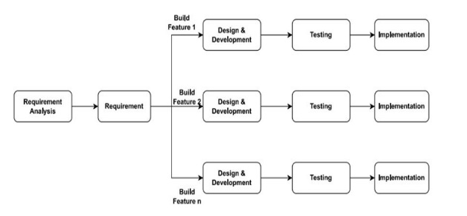

Fig. 1- fig represents incremental process model

VI. REQUIRMENT ANALYSIS
- Safety Requirements: If there is extensive damage to a wide portion of the database due to catastrophic failure, such as a disk crash, the recovery method restores a past copy of the database that was backed up to archival storage (typically tape) and reconstructs a more current state by reapplying or redoing the operations of committed transactions from the backed up log, up to the time of failure.
- Security Requirements: Security systems need database storage confidentiality .
- Cost-Saving Requirements: User will now need not to buy gym-membership to be fit.
- Flexibility Requirements: Our app will be flexible for a large set of users
- Availability: Since we are hosting our project on the server it will be available all the time.
- Correctness: The system should generate an appropriate report about different activities of the lab and should keep track of all records.
- Maintainability: The system should maintain correct schedules of labs and the documentation of all the lab equipment.
- Usability: The system should satisfy the maximum number of user’s needs.

VII. FEASIBILITY STUDY REPORT
Table 1- Feasibility study report
Type | Description | Remark
Resources Feasibility | Resources that are required for the project include, Programming device (Laptop), Hosting space (freely available), Programming tools (freely available) | FEASIBLE
Time Feasibility | Project developed plan prepared according to availability of a number of weeks and hours/week in bi-semester | FEASIBLE
Financial Feasibility | The app is going to be built on android studio software so there will be no financial investments | FEASIBLE
Risk Feasibility | Risk Feasibility: As it is a Software-based APP there is a risk of corruption and interference of the virus which may slow down its working | FEASIBLE
Technical Feasibility | App will be implemented using java, XML and Gradle script. Moving further, more and more libraries will be exploited. All the components are correctly functional. Maximum features related to this feature are achieved using these technologies | FEASIBLE
Social Feasibility | If App Will be deployed it will be freely available on the web world. | FEASIBLE

VII. ALGORITHM
- Analysing top fitness application’s
- Discussing fitness with professional gym trainers
- Generating a list of common, rare and important features provided by fitness applications
- Finalising the list of features
- Implementation of each feature one by one
For step frequency measurement the most common algorithm that is the moving average filter method is used. Out of many algorithms to measure steps it’s the most widely implemented and preferred and efficient pedometer method for trailing footsteps.The moving average filter method works by inspecting the information from the cellphones accelerometer and suing a evening filter to cut out any noise or extrinsic movements that could be erroneous for steps. The algorithm then measures the number of times the evened data crosses a threshold limit that implies that a step has been taken. We will typically set a threshold value for the minimum acceleration required to measure a step. Once user walks, the algorithm simultaneously evaluates the rolling average of the acceleration data over window of time, usually around quarter of seconds.
Table 2- Various Fitness Calculators details
Calculators Name | Description
Body Adiposity Index | The BAI is function of evaluating the sum of body fat in person. The Body Adiposity Index is calculated without using body wt., unlike the BMI.  else, it uses the  volume of the waist to humans ht.
Body Fat | Estimates body fat percentage based on U.S. navy method and BMI method. It gives the loss needed to reach ideal body
Body Surface Area | It is a parameter which evaluates surface area of person body
Body Mass Index | BMI is a person’s wt. in kg’s divided by square of ht. in meters. BMI is an inexpensive and easy screening method for wt. category underweight, healthy wt., overweight and obesity
Chest To Hip Ratio | Our HTR evaluator tools in describe the activity level of an user. User just need to provide hip wait and chest measurements and this evaluator will display your level of fitness. Numerous hospital alignments disabilities can be stopped once you have routine on your health level and thus this tool gives you all that you need.
Calories Burn | The number of calories burned each day is directly linked to weight loss, weight gain, or weight maintenance. For a person to lose weight , they must burn more calories than they take in, creating a calorie deficit. But, to do this, they need to know how many calories they burn each day.
Water Intake | So how much fluid does the average, healthy adult living in a temperate climate need? The U.S. National Academies of Sciences, Engineering, and Medicine determined that an adequate daily fluid intake is about 15.5 cups (3.7 liters) of fluids a day for men. About 11.5 cups (2.7 liters) of fluids a day for women.
Various Exercises | Which exercise to do when and perform a daily routine and a well schedule plan for doing those. There are many exercise related to each and every body part which contribute in keeping the body healthy and wealthy.

VIII. DESIGN
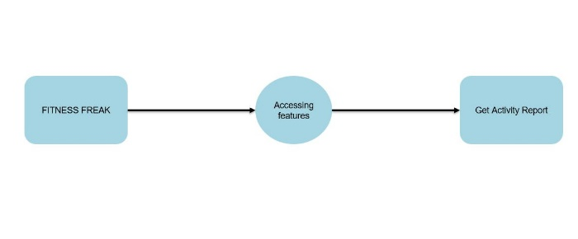
Fig. 2- fig represents Data Flow Diagram level-0

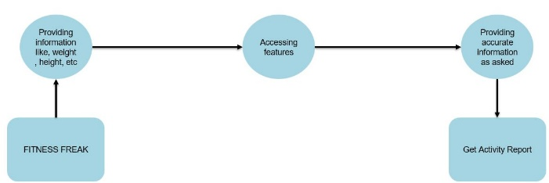
Fig. 3- fig represents Data Flow Diagram level-1

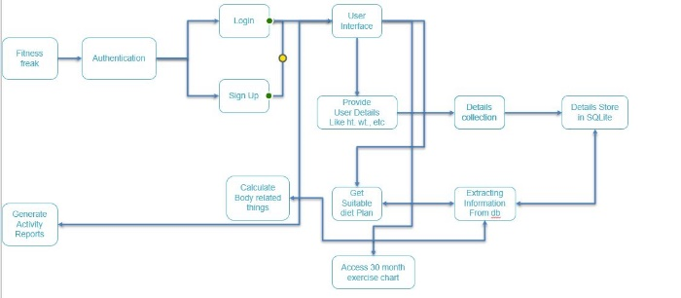
Fig. 4- fig represents Data Flow Diagram level-2
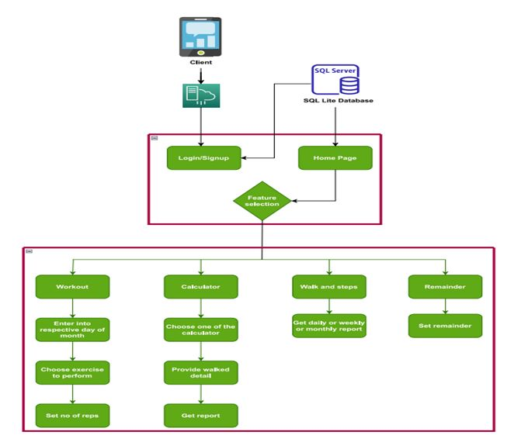
Fig. 5- fig represents System Architecture Diagram

IX. RESULT & DISCUSSION
The research tells users outlook towards the android fitness applications and its affection in promoting fitness health. After performing the review, it is known that most of the users will use fitness apps. Being healthy, fit, active is a life-long journey full of rising and falling. Sometimes you may get prone to an accident start losing motivation or get prone to an injury or life just gets in the way or many more thousand reasons. But, let any be the case, you should never give up because it's never too late to start or restart your be fit journey. At the end of the day goal is to achieve a better physical and mental version of yourself .Though you can just walk on being fit path on your own having some crazy dedication inside you, but you can consider some of the best mobile fitness workouts, nutritionist application which can offer help, guidance, support and motivation to keep you going strong, consistent and dedicated.
VI. CONCLUSION
It will help you live longer. It will help you enjoy the happiness and the sadness in life. It will keep your body strong and give a good impression of your sense of self-worth to those around you. We are up to create a unique app for workout routine and fitness training. Be fit and be healthy.

REFERENCES
- Jerzy Kukuczka “MOBILE FITNESS APPS USAGE AMONG FITNESS CENTERS ATTENDERS”, The Academy of Physical Education in Katowice, Poland, Scientific Review of Physical Culture, volume 6, issue3, 15 December 2016.
- Sakitha Anna Joseph, Reshma Raj K., Sony Vijayan, “User’s Perspective about Mobile Fitness Applications”, Published By: Blue Eyes Intelligence Engineering & Sciences Publication, International Journal of Recent Technology and Engineering (IJRTE) ISSN: 2277-3878 (Online), Volume-8 Issue-6, March 2020.
- Bruno F. Tavares, Ivan Miguel Pires, Gonçalo Marques, Nuno M. Garcia, Eftim Zdravevski, Petre Lameski, Vladimir Trajkovik and Aleksandar Jevremovic, “Mobile Applications for Training Plan Using Android Devices: A Systematic Review and a Taxonomy Proposal”, Received: 15 June 2020; Accepted: 30 June 2020; Published: 2 July 2020.
- Maria Żabińska, “Development of a fitness mobile application”, published:- 19.11.2020.
- Ehlers D.K., Hubert J.L. (2014), “Journal of Physical Activity and Health” Middle-aged women’s preferred theory- based features in mobile physical activity applications. 11, pp. 1379 -1385.
- Eaton S.B., Shasta M., Konner M. (1998), “A program of diet & exercise and a design for living”. Harper & Row Publishers, New York.
- Middelweerd A. et al. (2014 “International Journal of Behavioral Nutrition and Physical Activity”) Apps to promote physical activity among adults: A review and content analysis. 11, pp. 1-9.
- Vickey T., Breslin J., Williams A. (2013), Fitness-There's an app for that: Review of mobile fitness apps. “The International Journal of Sport and Society”, 3, pp. 109-127.
- Wilson K., Brookfield D. (2009). “International Journal of Sport and Exercise Physiology”, Effect of goal setting on motivation and adherence in a six-week exercise program. 6, pp. 89-100.
- H. Erin Lee and Jaheem Cho (2017). “What Motivates Users to Continue Using Diet and Fitness Apps” Application of the Uses and Gratifications Approach. Health Communication, 32(12), 1445-1453. doi:10.1080/10410236.2016.1167998.

