City-cab Smart way to Travel

Dhanashri Bisane, Pratiksha Sarode, Deoyani Bawankule, Sakshi Jaswani, Savi Raut
Prof. Shirish Singnapure
Dept. of Computer Science Engineering,Manoharbhai Patel Institute of Engineering And Technology Shahapur, Bhanadara- 441906

Abstract - The project mainly deals with creating an application regarding cab booking and checking the availability of vehicles. The project is been considered in order to reduce and eliminate loss of customers to competitors. For this application we will store some model names, their registration number, rent rate on the basis of per day and the amount will be deposited accordingly.cab booking system provides reliable online cab booking facility to people in various cities in India, free of cost.cab acts like a bridge between the cab operators customers/users/people to book a cab. This is a online cab booking system provided to customers it is more convenient then carrying the cost of owning and maintaining the unit. This system provides complete functionality of listing and booking car the customer can go online and reserve any kind of vehicle they want from the inventory of available vehicles. Even the customers can book a cab by scanning the QR-code at a time of emergency. The application will maintained the database has.it will also keep track of all the cab reservation and return.
Keywords-Quick Response Code (QR-Code), Cab booking, cab Reservation, Scanning QR-Code.

- INTRODUCTION
In the past decade, the transportation facilities in urban areas have undergone tremendous changes. Among various modes of transportation the cabs have become important mode of transportation in metro cities in India. The modern world’s technology have always fulfill the need of human being. But modern world life become very complicated when it is relate with time. Now a days’ time factor really matters n life of human being. Here we are introducing an android application named as “CITY CAB- Smart Way to travel”. Our application helpspeople to save their precious time. This application

improves the method of cab booking. Our project aims our different way to book the cabs at all the fare charges by using QR code. Booking a cab acts like a bridge a gap between operators and the customer which can avail through application. The vision behind city cab is to provide a hassle-free, reliable and technology-efficient car rental service in India. With the help of this project we can maximize the revenue by increasing the reach to customers.
The project mainly deals with creating an application regarding cab booking and checking the availability of vehicles. The project is being considered in order to eliminate loss of customers to competitors. For this application we will store some model names, registration number, rent rate on the basis of per day and the amount to be deposited accordingly. Cab booking system provides reliable online cab booking facility to people in various cities in India, free of cost. The customers can book a cab by scanning the QR-code at the time of emergency. In this application, we will maintain the database of all vehicles and drivers for the security purpose. The customer can also able to see their booking related information. It will also keep a track of all cab reservation and return. It improves the method of booking and helps the costumer to save their valuable time.
This android application is developed in android studio. Android studio is the official integrated development environment (IDE) for the android platform. Android studio was in early access preview stage starting from version 0.1 in May 2013, then entered beta stage starting from version 0.8 which was released in June 2014. The first stable build was released in December 2014, starting from version 1.0. Based on get brain Intel IDEA software, Android Studio is designed specifically for android development. It is available for download on Windows, Mac OS and Linux and replaced Eclipse android development tool (ADT) as Google’s primary IDE for native Android Application Development.
- RELATED WORK

Before developing this project, we studied current online booking software like ola, uber, meru, ixigo, zoomcar, jugnoo etc. we observed that these applications still have some disadvantages, that we are trying to overcome through our project.
A Quick Overview on Online Taxi Booking Industry:
In big cities of India, taxi services follow the new trend “Take a cab, don't buy car”. Nowadays, taxi service market in India has huge potentials which covers the large economy. Owning a car is not possible with the middle class family. A person would have to spend Rs 25,000 per month on fuel and drivers salary.

Uber is a transportation service which allows riders to communicate with the drivers such as in the area for a ride through an Uber app which is founded in 2009 by Garrete camp and Travis Kalanick under the name Uber cab.

Ola cab was founded on 3 December 2010 by Bhavesh Agrawal as an online cab aggregator in Mumbai. Ola offers different levels of service which accepts both cash and cashless payments with Ola money.[1]

Meru cab was founded by Neeraj Gupta in Mumbai on April 2007 by Rising Funds against an equity stake in the company from India Value Fund (IVF).

Zoomcar self-drive car Rental Company headquartered in Bangalore, India. The company was founded in 2013 by David Back and Garg Moran.

Jugnoo is the India’s first auto rickshaw aggregator. It is founded in November2014 by team of IITians. The main objective of this application was to make daily commute easy and reliable.

Ixigo is the travel and hotel booking e-commerce booking website founded in the year 2007 in Gurgaon. The company launched its flights product to provide best deals and make flying accessible for all. In 2008, apps for hotels and buses were launched followed by launch of the Ixigo trains app.

- PROPOSED METHOD

In this project we are going to proposed a very unique and innovative concept related to the cab booking service. Which is very convenient as compare to current booking process. Our concept is of booking a cab by using QR-Code. It is very simple to use. We have to just open the application, scan QR-Code which is available on the cab, set destination and we are ready to go. Our bookig process is very fast. On the spot booking experience will be delivered to the customer, which is the key factor of our project.

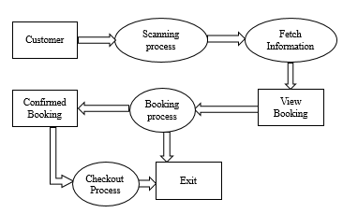

Figure 1: Block Diagram of our proposed cab booking process.
1.Scanning process
The first step of booking cab is scanning process. Here customer first have to scan the QR-Code which is available on the cab. In scanning process customer will get the information related to the cab and related to the driver after scanning the QR-Code.
2.Fetch information process
The reflection of scanning process is in form of fetch information process. All information related to the driver and related to the cab will be fetch from the database. And displayed on the screen. The information such as current location, driver name, driver mobile number and cab related information such as cab number, confirmation of rregistration, license, etc.
3.View booking
In this step, the customer is able to see all information which is gathered from the scanning process and from fetch information process.
4..Booking process
This is most important step above overall process, after reading all information related to the cab and related to the driver. If the customer agree to the conditions related to the cab booking then customer have to decide whether they are agree and ready for the ride or not. At this stagethe customer can also exit from this process. And if the customer is agree then they will send the destination area.
5.Confirm booking
The reflection of booking process is in the form of confirm booking. On the basis of the destination area the distance the fare will be calculated and the customer is ready for the next process.
6.Checkout process
In checkout process, the ccustomer have to choose the payment method. This is the last stage of booking a cab. There are two payment options are available for the customer one is cash and amother is card transaction.

- IMPLEMENTATION OF ANDROID APPLICATION
This app is developed in Android studio which provide IDE for development of the android project.Android studio was in early access preview stage starting from version 0.1 in may 2013, then entered beta stage starting from version 0.8 which was released in June 2014. The first stable build was released in December 2014,starting from 1.0. Based on JetBrain inteleJIDEA software, android studio is designed specifically for android development tool (ADT) as google’s primary IDE for native Android application development.[2]
(A) Signup screen :
This is the first screen of our project which shows signup process. Various fields related to signup process are first name, last name, mobile number and login password.
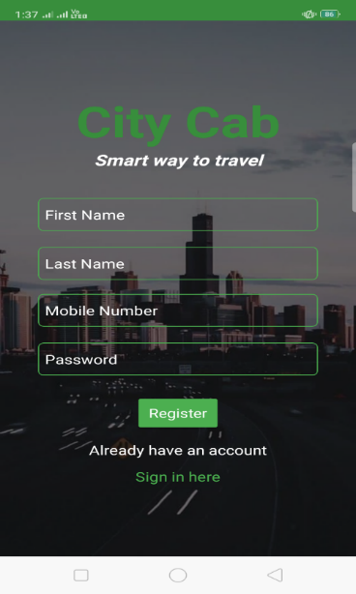

Fig 1: Signup Screen
(B)Login screen :
Figure2 shows login screen containing two fields such as mobile number of user and signup password. It also has another option of creating new user account. And if user have forget his/her login password then it also have option of creating new login password.
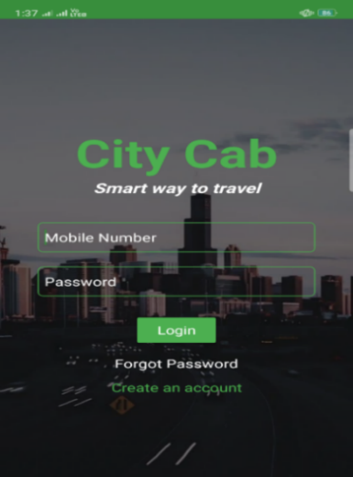

Fig 2: Login Screen
(C)Scanning Screen :
Figure3 shows scanning screen, which is the main highlight of our project. The booking process of the cab will be always done through this scanning screen only. After registration process the first screen which is appear able to user is scanning screen. The booking of cab is done after the scanning QR-Code. If the user is already registered, then he/she is ready to scan the QR code.
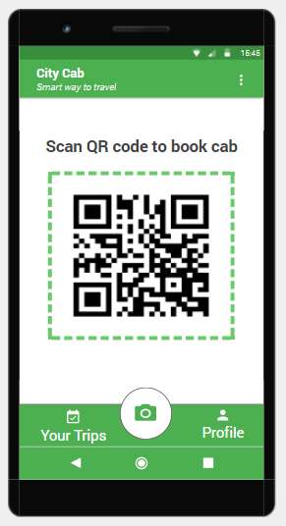

Fig 3: Scanning Screen
(D)Fetch Information Screen :
Figure4 shows fetch information screen. After scanning QR-code the relevant information related to the vehicle and driver such as vehicle number, vehicle name, drivers name, drivers mobile number will be fetch from the database.
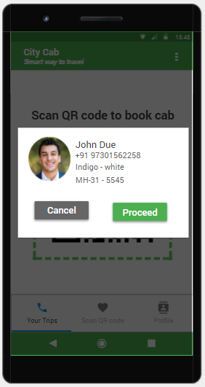

Fig 4 : Fetch Information Screen
(E)Location Screen :
In this Screen the user have to enter his/her destination and according to the distance the fair will be calculated. The fair will be calculated by using the longitude and altitude which is stored in the database.
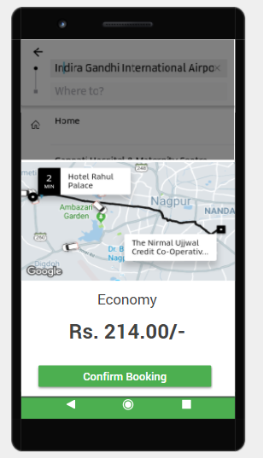

Fig 5: Location Screen
(F)Checkout Screen :
Figure5 shows the checkout screen, after entering the user destination. The checkout screen will be appealable to the user. Which shows the two payment options such as cash payment and online payment.
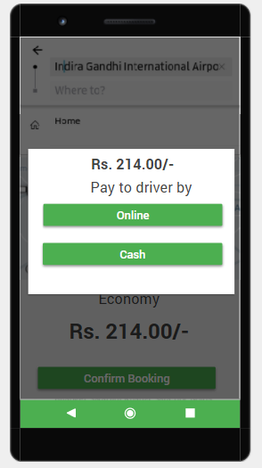

Fig 6: Checkout Screen
(G)Confirm Booking Screen :
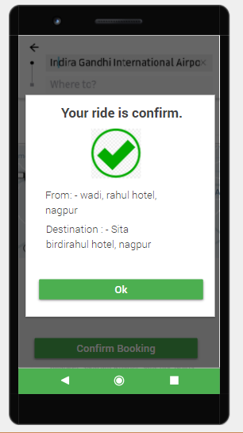
Figure7 shows the confirmation screen. After the payment mode the confirmation screen will be visible to the user, which shows the confirmation message of Booking.

Fig 7 : Confirm Booking Screen
(H)Booking history :
Figure8 shows the booking history screen. The various bookings done by the user will be shown to the user such as booing date, booking time, and trip status and fair will be displayed.
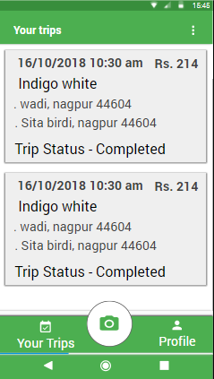

Fig 8: Booking History Screen

- CONCLUSION AND FUTURE SCOPE
The CITY-Cab Application will be very helpful for those customer which are always in rush. This application provides smart and easy method of booking which is very beneficial and it enhance our daily life experiences. There is tough competition in the cab services industry. By using this application we can solve the everyday problems of the customers which they are facing now-a-days.
In future, we can also add the concept of tracking and transportation of goods from one place to another and we can also provide the facility of pre-booking of cab. So, this app based cab services surely have much enough scope in the future.
REFERENCE
[1] Technologies,OLA cab-ANI.”About us-car rental-car hire-taxi india – olacabs.com”
[2] Programming Android : By: Zigurd Mednieks,Laird Dorni,G.Blake Meike & Masumi Nakamura
[3]Android Programming: The Big Nerd Ranch Guide :By : Big Nerd Ranch Guides and Bill Philips & Brain hardy
[4]Android User Interface Design:Turnig Ideas and Sketches inti Beautifully Designed Apps :By:Ian G.Clifton
[5] Android User Interface Design:Turning Ideas and Sketches into Beautifully Designed Apps By: Dave Smith & Jeff Friesen
[6] Hello Android : Introducing Google’s Mobile Development Platform :By: Ed Burnette
[7]Android Cookbook:Problems and solutions for android developers :By:Ian F. Darwin
[8] Head First Android Development : A Bartin-Friendly Guide :By : Dawn Griffiths and David Griffiths
[9] Android App Development for Dummies By: Michel Burton
[10] Android Programming : The big nerd ranch guide By: Bill Phillips, Chris
[11] Kotlin for android developers : Learn Kotlin the easy way developing an android app By : Antonio leiva

