Bi-Directional DC-DC Converter (Zeta Converter)

Vipul Pandey¹, Mohammad Abuzar², Devang Kubitkar³, Viren Chawda⁴, Praful Nandankar⁵
^{1,2,3,4}Final year Student
⁵Assistant Professor, Electrical Engineering Department
Government College of Engineering, Nagpur, India, 441108

Abstract –A power electronic circuit known as a bidirectional DC-DC converter enables the bidirectional transmission of energy between two DC voltage sources with various voltage levels. Depending on the flow of power, the converter can function in either a buck mode or a boost mode. It is often used in renewable energy systems, energy storage systems, and electric cars in order to provide efficient energy transfer between sources and loads. In this study, a bidirectional DC-DC converter with minimal harmonic distortion and low switching losses is proposed. Other benefits of the proposed Zeta converter include reduced conduction losses, less voltage stress on the switches, and reduced electromagnetic interference. In a simulation environment, the proposed converter's validity has been examined..
Keywords-Power electronic converter, dc-dc converter, bidirectional, zeta converter.
INTRODUCTION
Electrical power can be converted from one form to another using power electronic converters, which are electronic devices. They are essential components of contemporary power systems because they manage voltage and current levels, govern electrical energy flow, and convert power between various voltage and frequency levels. Electric vehicles, industrial drives, consumer electronics, and renewable energy systems are just a few of the many applications of power electronic converters.The advancement of semiconductor technologywhich resulted in the creation of high-power, high-voltage devices capable of switching at high frequencies, has been the driving force behind the development of power electronic converters. In power electronic converters, these components, such as MOSFETs, IGBTs, and thyristors serve as switching elements.Every topology has its own distinct traits and benefits, and There are numerous topologies available for power electronic converters, including DC-DC, AC-DC, DC-AC, and AC-AC converters.Overall, power electronic converters are crucial parts of contemporary power systems because they offer reliable and efficient power conversion and control for a variety of applications. A power electronic circuit known as a bidirectional DC-DC converter enables the bidirectional transmission of energy between two DC voltage sources with various voltage levels. It is utilized in many different applications, such as energy storage systems, electric vehicles, and renewable energy sources. The converter can transmit power in either direction because it can operate in both buck and boost modes.
The rapid adoption of renewable energy sources like solar and wind has considerably increased the demand for bidirectional DC-DC converters in recent years. These energy sources produce DC power, which needs to be changed into AC power before it can be connected to the grid. In this conversion process, the bidirectional DC-DC converter is essential because it enables efficient and dependable energy transfer between the sources and the grid.To manage the output voltage and current of the converter, the control circuit modifies the duty cycle of the power switches. The bidirectional DC-DC converter's main job is to transfer energy in both directions, but it also offers other advantages including power conditioning, voltage management, and fault protection.Using the Zeta architecture, a bidirectional DC-DC Zeta converter is a kind of power electronic circuit that enables bidirectional energy transfer between two DC voltage sources with various voltage levels. To achieve voltage gain andvoltage reduction with a single inductor, the Zeta topology combines the Buck and Boost topologies.
In applications like electric vehicles, renewable energy systems, and energy storage systems where energy needs to be efficiently transmitted between sources and loads, the bidirectional DC-DC Zeta converter is frequently used. Power can be transferred in either direction because the converter can function in both buck and boost modes. Usually, two power switches, a Zeta inductor, and a control circuit make up the bidirectional DC-DC Zeta converter. Power electronics have transformed many facets of contemporary power systems and have taken the place of traditional systems in a number of applications.
Different shortcomings of isolated DC-DC converters are eliminated by bidirectional DC-DC Zeta converters. excessive duty ratio operation is not recommended for DC-DC converters since doing so causes excessive voltage and current stress across the switch. The current DC-DC converters are not able to achieve the high voltage gain. With buck-boost converters, the power flow can be reversed, but the control circuit is quite complicated. This work proposes a bidirectional DC-DC zeta converter that overcomes a number of shortcomings, including lower voltage gain, lower duty ratio, higher voltage and current stress, etc. .
PROPOSED ZETA CONVERTER
The schematic diagram of bidirectional DC-DC Zeta converter is shown in Fig.1.
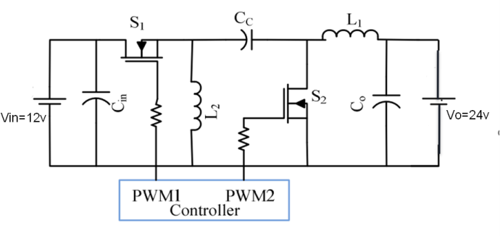
Fig. 1- Schematic diagram of bidirectional Zeta converter
Two bidirectional switches (such as MOSFETs) that may be turned on and off in Fig. 1, S₁ and S₂, allow power to flow in both directions between the converter's input and output. L₁ and L₂ are inductors and C_{C} is a capacitor between the source side and load side. With this type of arrangement, a buck-boost converter known as a Zeta converter is created, which can provide voltage step-up and step-down functionality in both directions.
During Operating Mode 1:
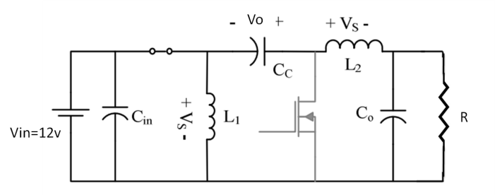
Fig. 2- Zeta converter schematic during mode-1 operation
Inductor L₁ stores energy from the source voltage, and inductor L₂ stores energy from the source voltage and capacitor (C_{C}), when S₁ is ON and S₂ is OFF. The voltage across L₂ is V_{S} due to the linear growth in the inductor currents (I_{L1} and I_{L2}), capacitor (C_{C}) charging to Vbatt, and C_{C} being connected in series with L₂. The operational modes of the Zeta converter are shown in Figs. 2 and 3.Using KVL, the voltage across L₁ and L₂ in the circuit shown in Fig. 4 is stated as follows:
$L1\frac{dL1}{dt}=Vs$ (1)
$L2\frac{dL2}{dt}=Vs$ (2)
During Operating Mode 2:
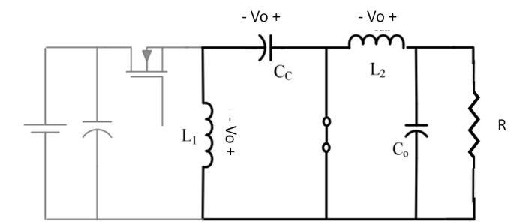
Fig. 3- Zeta converter schematic during mode-2 operation
During turning ON of switch S₂and turning OFF of switch S₁, inductors L₁ and L₂ discharge through switch S₂. Inductor L₂ is linked in parallel to the battery as a capacitor (C_{C}) charge to voltage Vbatt. The following gives a description of the voltage between L₁ and L₂.
$L1\frac{dL1}{dt}= -Vo$ (3)
$L2\frac{dL2}{dt}= -Vo$ (4)
Average output voltage
$Vo=Vs(\frac{D}{1-D})$ (5)
where D represents duty period of S₁
SIMULATION RESULTS
Using the design equations (1) to (5), a model of bidirectional DC-DC Zeta converter is created in a simulation environment to test the charging method of the Zeta converter.Fig. 4displays the simulation results of the charging method. Zeta DC-DC converter switches S₁& S₂ duty cycles. The inductorvoltage and inductor current characteristics are also shown in Fig. 4. In this experimental investigation, S₁'s switching frequency is set to 2500 Hz.A minimum value of input capacitor (Cin) (i.e., 100F) is chosen to carry the input ripple content to the battery charging current, and 3mH inductors are also utilised to maintain continuous conduction. It is clear from Fig. 4's simulation result of the characteristic that thecharge current fluctuates by 1A from peak to peak. 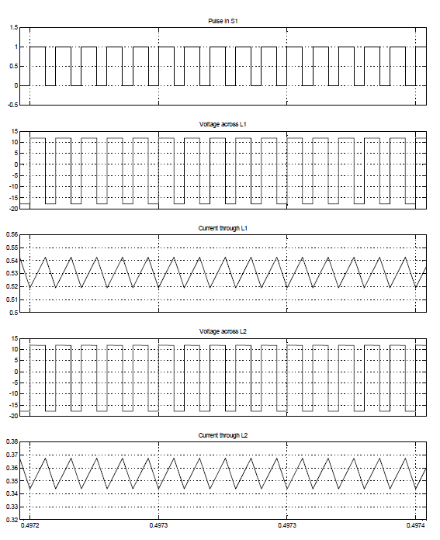
Fig. 4- Switching pulses to S₁, voltage across L₁ and L₂, current through L₁ and L₂ during forward operation (charging method)

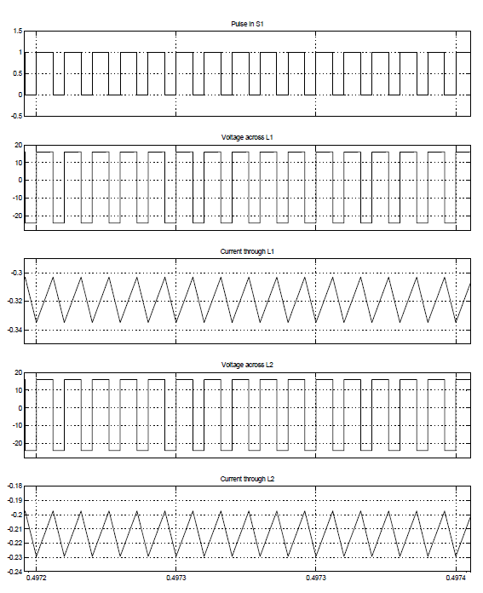
Fig. 5- Switching pulses to S₁, voltage across L₁ and L₂, current through L₁ and L₂ during reverse operation (discharging method)
Fig. 5displays the simulation results of the discharging method. Zeta DC-DC converter switches S₁& S₂ duty cycles, inductor (L₁& L₂) voltage and current characteristics are shown in Fig. 5.A bidirectional DC-DC Zeta converter with a MOSFET, current sensor, input voltage of 12 volts, and output voltage of 24 volts has been designed. A bidirectional dc-dc converter is built which is capable of functioning or transferring the power on both sides that are in the first operation (from load to source i.e. 12V to 24V) and in the second operation (from source to load i.e., 24V to 12V) the circuit consists of MOSFET which is used forswitching purpose and current sensor is used to note the value of current flowing through the circuit along with it inductors and capacitors are also used.
CONCLUSION
In conclusion, the bidirectional Zeta converter is an exciting new technology that offers soft switching and minimal harmonic distortion for a variety of applications. Because of its gentle switching characteristics, this topology can achieve great efficiency with low switching losses. The Zeta converter also offers a broad range ofvoltage conversion ratios, which makes it appropriate for differentstorage systems of energy, electric vehicle charging systems, and non-conventional energy systems. The Zeta converter has a number of benefits over other bidirectional DC-DC converters, including lower conduction losses, less voltage stress on the switches, and lower electromagnetic interference. The Zeta converter is additionally more adaptable in various applications because it may run in modes of operation i.e., buck and boost.Overall, proposed converter offers an efficient method of converting energy with little harmonic distortion and switching loss. As a result, it makes for a fantastic subject for additional power electronics research.
REFERENCES
- Gorji, S. A., Sahebi, H. G., Ektesabi, M., & Rad, A. B. (2019). Topologies and control schemes of bidirectional DC–DC power converters: An overview. IEEE Access, 7, 117997- 118019.
- J. Falin, “Designing DC/DC converters based on ZETA topology” 2010, Analog Applications Journal, Texas Instruments Incorporated
- X. Fang, “A Novel Z-Source dc-dc converter”, IEEE International Conference On Industrial Technology (ICIT) ,pp. 1- 4, Chengdu, China,21-24 April 2008.
- Falin, Jeff. “Designing DC/DC converters based on SEPIC topology” 2008, Texas Instruments. December 2013.
- J.liu, J. Hu and L.Xu, “Dynamic Modeling & Analysis Of ZSource Converter –Derivation of AC Small Signal Model and Design –Oriented Analysis”,IEEE Transaction on Power Electronics vol.22, no.5, sept.2007, pp.1786-1796.
- H. Xiao and S. Xie, ‘‘Interleaving double-switch buck–boost converter,’’ IET Power Electron., vol. 5, no. 6, pp. 899–908, Jul. 2012.
- C.-C. Lin, L.-S. Yang, and G. W. Wu, ‘‘Study of a non-isolated bidirectional DC–DC converter,’’ IET Power Electron., vol. 6, no. 1, pp. 30–37, Jan. 2013.
- M. A. Khan, A. Ahmed, I. Husain, Y. Sozer, and M. Badawy, ‘‘Performance analysis of bidirectional DC–DC converters for electric vehicles,’’ IEEE Trans. Ind. Appl., vol. 51, no. 4, pp. 3442–3452, Jul. 2015.
- S. Dusmez, A. Khaligh, and A. Hasanzadeh, ‘‘A zero-voltage-transition bidirectional DC/DC converter,’’ IEEE Trans. Ind. Electron., vol. 62, no. 5, pp. 3152–3162, May 2015.
- H. Tao, A. Kotsopoulos, J. L. Duarte, and M. A. M. Hendrix, ‘‘Family of multiport bidirectional DC–DC converters,’’ IEE Proc.-Electr. Power Appl., vol. 153, no. 3, pp. 451–458, May 2006.
- Nandankar, P., Dasarwar, A., Kachare, G., “Comparison of improved converter topologies for high voltage gain,” International Conference on Communication information and Computing Technology (ICCICT), (2018), DOI: https://doi.org/10.1109/ICCICT.2018.8325893.
- Nandankar, P.V., Bedekar, P.P., Dhawas, P.K.V.: Variable switching frequency control for efficient DC/DC converter. Material Today: Proceedings (2021).
- Nandankar, P., Thaker R., Mughal, S.N., Saidireddy M., Linda, A., Kostka J.E., Nag, M.A., “An IoT based healthcare data analytics using fog and cloud computing,” Turkish Journal of Physiotherapy and Rehabilitation, (2021), 3, 32.

