**Optimization process parameter of submerged arc welding by using ANOVA method**

**Mr. Chetan Kumar Bagde1, Mr. Shridev Tamrakar2,Mr. Lokesh singh3**

*1,2,3Department of Mechanical Engineering, GDRCET , Bhilai,.*

***Abstract-*** *Submerged arc welding (SAW) is a high quality, high deposition rate welding process commonly used to join plates of higher thickness The main objectives to identify main factors, viz. Current, Voltage, Standoff distance and Travel speed, there way of affecting the welding bead parameters, influence of the interactions among the main factors and finally to determine the optimum settings of the main factors. An orthogonal array is constructed for four input process parameters a) Welding current, b) Voltage c) Standoff distance, d)Travel speed to the value of temperature. To get desired to be minimum uses of resources, investigation into effect of process parameter on performance parameter and its optimization is necessary. ANOVA method is use for optimization.*

***Keyword –“ Submerged arc welding (SAW), Analysis of variance (ANOVA), Orthogonal array(OR****)”*

**INTRODUCTION**

Welding is a process of joining different materials. It is more economical and is a much faster process compared to both casting and riveting .Welding is classified in many ways such as by joining similar metal and joining dissimilar metals. A dissimilar type of welding is further classified in many ways such as fusion welding, non-fusion welding and low dilution welding. But we will be discussing only on submerge arc welding which is under the fusion welding process. ]. Submerged arc welding is an ‘Arc Welding’ process in which the arc is concealed by a blanket of granular and fusible flux. Heat for SAW is generated by an arc between a bare, solid metal (or cored) consumable-wire or strip electrode and the work-piece. The arc is maintained in a cavity of molten flux or slag which refines the weld metal and also protects it from atmospheric contamination. In this study, the process parameters affecting weld quality in SAW have been identified and their effects on performance measures have been analyzed using an inexpensive and easy-to-operate experimental strategy based on Taguchi’s parameter design. Further, an attempt has been made to analyses the impact of more than one parameter on welding process because the resultant performance output is the combined effect of the impacts of several interacting parameters in actual practice. Optimization is the act of achieving the best possible result under given circumstances. In design, construction, maintenance, engineers have to take decisions. The goal of all such decisions is either to minimize effort or to maximize benefit. The effort or the benefit can be usually expressed as a purpose of certain design variables. Hence, optimization is the process of finding the conditions that give the maximum or the minimum value of a function.

**PROBLEM STATEMENT**

The performance of conventional SAW depends on the practice of the operators. Error between the measured and the real values of welding conditions is accumulated as time goes on. Therefore, the weld quality cannot be certain because of the error. Even if a number of welding defects occur, workers are not able to find out the cause of defects because the measured signals show a big dissimilarity with the actual values. If the error between monitored and measured signals occurs, workers are able to easily correct the actual welding conditions.

**METHODOLOGY**

We using experimental data and check as well as compared that parameter on Minitab software. Orthogonal array is used to design sets of experiment. After comprehensive study of literature available, internet suffering, industry feedback and discussion with practicing technicians it is found that four process parameters viz. Welding current, voltage, standoff distance and travel speed are dominating performance parameters for submerged arc welding process. The selected input parameters with 3 levels each are mentioned in table I. The performance parameters are Temperature and Quality of welded joint.

Table I -Process parameters and their levels

|  |  |  |  |  |
| --- | --- | --- | --- | --- |
| **Factors** | **Process parameters** |  | | |
| **Level I** | **Level**  **II** | **Level III** |
| A | Welding current (amp) | 400 | 500 | 600 |
| B | Voltage (v) | 30 | 32 | 36 |
| **C** | Standoff distance (mm) | 25 | 27 | 30 |
| D | Travel speed (mm/min) | 125 | `150 | 175 |

Performance parameters: Based on the literature review and discussion with practicing

Engineers, following two performance parameters are selected.

• Temperature

• Repair result

These are one of the most important quality characteristics in the welding of thick plate which influences the performance of mechanical parts as well as cost.

Welding is carried out with SAW machine. This machine is available in METALFAB HIGHTECHB PVT.LTD., MIDC area Nagpur (M.H.). They allowed doing all the necessary experiments. They also provided the ultrasonic testing facilities on the welded joint to find failure of welded pipe.

Signal to Noise ratio

The experimental results are transform in to a signal to noise (S/N) ratio. Taguchi recommends the use of S/N ratio to measure the quality characteristics deviating from the desired values. The S/N ratio for each level of process parameters is computed based on the signal to noise analysis.

There are three Signal-to noise ratios used for optimization of static problem.

Smaller is Better

S/N = −10*log (Σ(Y2)/n)

Where Y = responses for the given factor level combination and n = number of responses in the factor level combination.

Above formula is used to define the S/N ratio for all undesirable characteristics like defects etc. for which the ideal value is zero. Also, when an ideal value is finite and its maximum or minimum value is defined, then the difference between measured data and ideal value is expected to be as small as possible.

Larger is Better

S/N = −10*log (Σ(1/Y2)/n)

Where Y = responses for the given factor level combination and n = number of responses in the factor level combination.

This case has been converted to smaller-the-better by taking the reciprocals of measured data.

Table II**:** Design of experiment (L9Orthogonal Array)

|  |  |  |  |  |  |  |  |
| --- | --- | --- | --- | --- | --- | --- | --- |
| **Input process variables** | | | | **Output variables** | | **Signal to Noise (S/N) ratio** | |
| **Welding**  **Current** | **Voltage** | **Standoff**  **Distance** | **Travel**  **Speed** | **Temp.** | **Repair**  **result** | **SN Temp high** | **SN Result high** |
| 400 | 30 | 25 | 125 | 1928 | 88 | 65.7021 | 38.88 |
| 400 | 32 | 27 | 150 | 1860 | 92 | 65.3902 | 39.27 |
| 400 | 36 | 30 | 175 | 1728 | 31 | 64.7508 | 29.82 |
| 500 | 30 | 27 | 175 | 2680 | 24 | 68.5626 | 27.60 |
| 500 | 32 | 30 | 125 | 2530 | 89 | 68.0624 | 38.98 |
| 500 | 36 | 25 | 150 | 2700 | 93 | 68.6272 | 39.36 |
| 600 | 30 | 30 | 150 | 3024 | 36 | 69.6116 | 31.12 |
| 600 | 32 | 25 | 175 | 3240 | 80 | 70.2109 | 38.06 |
| 600 | 36 | 27 | 125 | 2900 | 89 | 69.2479 | 38.98 |

**ANALYSIS OF VARIANCE (ANOVA)**

Sir Ronald Fisher introduced the Analysis of Variance (ANOVA) in the year 1930 and used it for agriculture experiment. ANOVA is a statistical based, objective decision-making tool used to interpret experimental data and make the necessary decisions as well as detecting any difference in average performance of groups of item tested. The decision, rather than using pure judgment, takes variation into account. ANOVA is a mathematical technique which breaks total variation down into accountable sources. Total variation is decomposed into its appropriate components. Generally ANOVA is applied to experimental situation employing structure. This technique does not directly analyze the data, but rather determines the specific difference between the data. it is a mathematical technique which breaks total variation down into accountable sources. it consists of component like sums of squares, degree of freedom, error variance and F-test and percentage contribution . Analysis of variance is a method for testing differences among means by analyzing variance

Two types of population variation are used in ANOVA to conduct the test. These are :

i)Mean square error (MSE)

ii)Mean square between (MSB)

Mean square error

It is based on difference among scores within the groups. it estimates population variation even when population means are equal.

Mean square between

It is based on difference among the sample means. It estimates variation even when population means are not equal.

The formula for MSB is based on the fact the variance of the sampling distribution Is

𝜎2 =𝜎2/𝑛 (1)

Where, n = sample size of each group

Sum of squares

In ANOVA, The term sum of square (SSQ) is used to indicate variation. The total variation may be included that the sum of squared differences between each score and the mean of all subjects. Sum of squares is important to include in ANOVA to quantitatively examine the deviation of a control factor effect. it is calculated as summation of squares of the differences from the mean. The calculation of the total sum of squares considers both the sum of squares from the factors and from randomness or error.

It plays a vital role in case of ANOVA. It is a statically data associated with each piece of information in ANOVA calculation. To complete the ANOVA calculation, degree of freedom plays a vital role. The concept of degrees of freedom is to allow one degree of freedom for each independent comparison that can be made in the data. The number of independent parameters associated with an entity like a matrix experiment, or a factor or a sum of squares is called the degree of freedom A matrix experiment with nine rows has nine degree of freedom and so does the grand total sum of squares. The overall mean has nine degree of freedom and so does the sum of squares due to mean. Thus, the degree of freedom associated with the total sum of squares is n-1.

The mean square for a factor is computed by dividing the sum of squares by the degree of freedom. Estimation of error variance:

Error variance

It is a kind of variance which describes an unexplained variance in a collection of observation value. Generally variance is equal to the sum of squares for error divided by the degrees of freedom for error. Error variance is descriptive statistic can be calculated from the ANOVA table. Generally variance is equal to the sums of squares for error divided by the degrees of freedom for error. error variance is a measure of the variance due to all the uncontrolled parameters, including measurement error involved in a particular experiment.

F – Value

F ratio is commonly used to test hypotheses about the effect of an independent variable on the dependent variable. F- Value also used to measure the distance of an individual distribution. The F test is simply a ratio of sample variance. This tool is called as F-test, named after Sir Ronald Fisher, a British statistician, who invented the ANOVA method. More the F value less is P value. This is the statistical tools which provide a decision at some confidence level as to whether these estimates are significantly different or not.

P- Value

P Value is used in hypothesis tests used to decide either to select or reject a hypothesis. A commonly use cut off value for the P value is 0.12.

Analysis of Variance Method (ANOVA)

Analysis of variance (ANOVA) is used to investigate the dominating parameters which significantly affect the quality characteristic. This is accomplished by separating the total variability of S/N ratio, into contribution by each welding process parameters and the error. Which is depicted in table III and IV .The test of significance of the regression model was performed using software MINITAB 18.

Regression equation has been developed by ANOVA to validate the effectiveness of relationship between the process and performance parameter. Relation of response parameters with process parameter is depicted in following equations.

Regression Equation by ANOVA for temperature

S/N Temp = 67.80 - 2.515 Current_400 + 0.6212 Current_500 + 1.894 Current_600 + 0.1626 Voltage_30 + 0.09162 Voltage_32 - 0.2542 Voltage_36 + 0.3839 Distance_25 - 0.06260 Distance_27 - 0.3213 Distance_30 - 0.1254 Travel Speed_125 + 0.08015 Travel Speed_150 + 0.04525 Travel Speed_175

Regression Equation by ANOVA for repair result

S/N Repair Result = 35.79 + 0.2053 Current_400 - 0.4717 Current_500 + 0.2663 Current_600 3.252 Voltage_30 + 2.983 Voltage_32 + 0.2693 Voltage_3 + 2.981 Distance_25 - 0.5030 Distance_27 - 2.479 Distance_30 + 3.163 Travel Speed_125 + 0.7983 Travel Speed_150 - 3.961 Travel Speed_175

Optimization of performed all 9 experiment in done by ANOVA method in Minitab software.

**Table III**: Analysis of variance for temperature

|  |  |  |  |  |  |
| --- | --- | --- | --- | --- | --- |
| **Source** | **DF** | **Adj** **SS** | **Adj** **MS** | **F-Value** | **P-Value** |
| Welding current | 2 | 30.8965 | 15.4483 | * | * |
| Voltage | 2 | 0.2983 | 0.1492 | * | * |
| standoff distance | 2 | 0.7635 | 0.3817 | * | * |
| Error | 2 | 0.0726 | 0.0363 |  |  |
| Total | 8 | 32.0309 |  |  |  |
| S = * | | R-sq=100% | | R-sq(adj)= * | |

**Table** **IV** Analysis of variance for repair result

|  |  |  |  |  |  |
| --- | --- | --- | --- | --- | --- |
| **Source** | **DF** | **Adj** **SS** | **Adj** **MS** | **F-Value** | **P-Value** |
| welding current | 2 | 1.007 | 0.5033 | * | * |
| Voltage | 2 | 58.642 | 29.3210 | * | * |
| standoff distance | 2 | 45.856 | 22.9280 | * | * |
| Error | 2 | 78.995 | 39.4973 |  |  |
| Total | 8 | 184.499 |  |  |  |
| S= * | | R-sq=100% | | R-sq(adj)= * | |

Above both table shows different process parameter use for optimized them is shows in a graphical manner.

**RESULT**

In present research, Taguchi based optimum results have been validated and the information is presented in table III and IV. For all four response variable welding current, voltage, standoff distance, travel speed and combined effect of all parameter respectively. The analysis has been done for significance level of 5% i.e. the confidence level is 95%. F- Test indicates that the larger value has more significant influence on response parameter.

The ANOVA table III & IV also present the measure of S, R- square and R- square (adjusted) for each response and combined effect of each response.

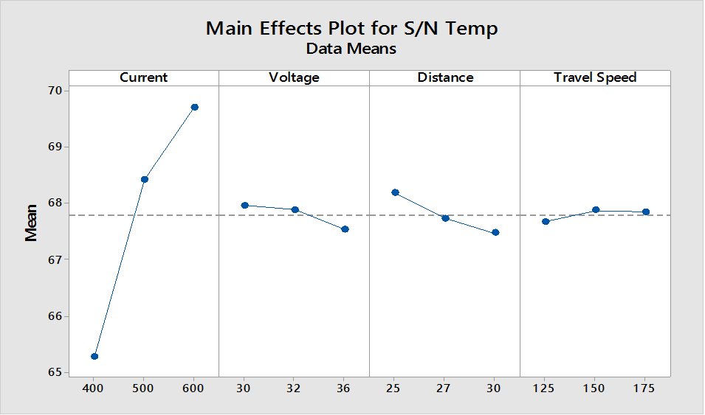

Figure 1: Main effect plot for signal to noise ratio for temperature high



Figure 2: Main effect plot for signal to noise ratio for SNR repair result



Figure 3: Graphical representation of ANOVA (Analysis of Variance) optimization Result

**CONCLUSION**

The effect of different variables on the performance parameters temperature and Repair results. At the value of current 600amp, voltage 30volt, Standoff distance 25mm and Travel speed 150 mm/min the optimized parameters for the Temperature are shown in figure 1. Similarly at the value of current 600amp, voltage 32volt, Standoff distance 25mm and Travel speed 125 mm/min the optimized parameters for the Temperature are shown in figure 2.and Figure 3 shows the Optimized value for Temperature and Repair result having optimal demand value is 1 at the value of current 600amp, voltage range 32 volt, Distance value is 25mm and Travel speed 150 mm/min.

**REFERENCES**

[1] Behcetgulence, “submerged arc welding process is used with the high current and ability to deposit a large amount of weld” International Journal of Technology, pp 2122-1815 2003.

[2] Suck-Joo Na and Degala Ventaka Kiran “Numerical Studies on Submerged Arc Welding Process”, Journal of Welding and Joining(Vol. 32, No. 4) 2014.

[3] M.R.Nezamdost “Investigation of temperature and residual stresses field of and submerged arc welding by finite element method experiments” Springer (c the authors) 2016.

[4] Ali Moarrefzadeh “Numerical Simulation of Copper Temperature Field in Submerged Arc Welding (SAW) Process” INTERNATIONAL JOURNAL OF MULTIDISCIPLINARY SCIENCES AND ENGINEERING.

[5] Abhijit Sarkar “ A STUDY OF PARAMETRIC EFFECTS ON THERMAL PROFILE OF SUBMERGED ARC WELDING PROCESS” Journal of Naval Architecture and Marine Engineering pp. 22670 2015.

[6] DR. S.M. SAWANT, PRANESH B. BAMANKAR, “Study of The Effect of Process Parameters on Depth of Penetration and Bead Width in Saw (Submerged Arc Welding) Process”, International Journal of Advanced Engineering Research and Studies, EISSN2249–8974, PP08-10, (July-Sept.,2013).