Fabrication of Mechanical (Human Powered) Lawn Mower
Manoharbhai Patel Institute of Engineering and Technology, Bhandara
R. T. M. Nagpur University, Nagpur
¹Amar Bhiogade
Professor, Mechanical Department
amarbhiogade75@gmail.com

²Bhupesh Chaudhari ³Santosh Yenchilwar⁴Amol Raut⁵Piyush Fulbandhe⁶Lomesh Shende
Scholars, B.E, Mechanical Department
bhupeshchaudhari1997@gmail.com
santoshyenchilwar1997@gmail.com
piyush.fulbandhe@gmail.com
amolraut9767@gmail.com
lomesh30@gmail.com
--------------------------------------------------------------------------------------------------------------------------------------------

Abstract —Now a days, grass cutter machines are operated by fuel and electrical energy which are costly and requires high maintenance. Hence, in this study, a hand-held operated machine for grass cutting was designed and fabricated by using locally available materials. The generated torque will be transferred to the cutting head mechanism for efficient grass cutting. The entire configuration set up was mounted on set of wheel arrangement. This project was embarked on to help in keeping our environment clean due to fuel less system.

Keywords—Fuel less, grass cutter, walk behind, low maintenance.

- INTRODUCTION
A lawn mower is a machine utilizing one or more revolving blades to cut a grass surface to an even height. The height of the cut grass may be fixed by the design of the mower. The blades may be powered by muscle, with wheels mechanically connected to the cutting blades so that when the mower is pushed forward, the blades spin. There are many types of machines available in market some of them are giants, complicated, and cause pollution^{[1]}.The concept of mechanically operated lawn mower comes under the consideration where there is no need of fuel and no need of skilled operator. Concept behind this is to have user friendly, durable and cheapest kind of machine. So the project seems as an answer to all these needs and uncertainties.
- OBJECTIVE OF PROJECT
The main objective is to design and develop a machine, which uses the human power as an energy source and it will help to maintain small and medium size area (residential garden lawn) thereby it will sort a problems of owners to take care of their lawn by their own and also it will help to mitigate air pollution and noise pollution. Also it is desired to be handled by unskilled worker as well as it should hold at as low cost as possible. Hence thereby it will lead to reduce the daily expenditure of the maintenance and fuel.
- WORKING PRINCIPAL OF THE PROJECT
Lawn mower is an essential device for the maintenance of garden. They basically classified on the basis of sizes, mode of operations and power source via, electrical, I.C. engine.
Manual operated mower is aimed to be fabricated considering aesthetics and ergonomics. The grass cutter vehicle is moving help of pushing and pulling action. It is fabricated in simple way and the used components are wheels, crank, lever, blades, rope, bearing, chain and sprocket, etc. The cutting arrangement is kept like trimmers where two blades are used, out of which one blade movable one by keeping another blade is fixed. The movable cutter is connected to the crank link and crank is kept rotating with the help of chain and sprocket drive. The rear wheel of shaft is connected with the chain and sprocket arrangement. Here the sprocket gets its motion due to push forward motion of machine .when machine start running the shaft is rotate and it rotate the crank arrangement which is attach with the cutting blade. The power source for lawn mower is taken from human power. Whole arrangement is designed for four wheel walk behind type. The upper blade reciprocates over fixed blade. The crank converts rotary motion into reciprocating motion. The Reciprocating motion of the blades produces shearing force on cutting edges which is sufficient for cutting grass.

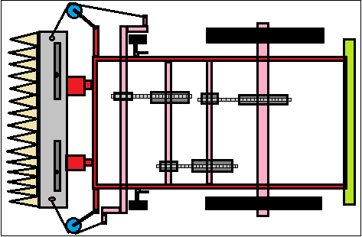
Fig.1- Principle of Operation of human powered lawn mower
- CONCEPT OF HUMAN POWERED LAWN MOWAR
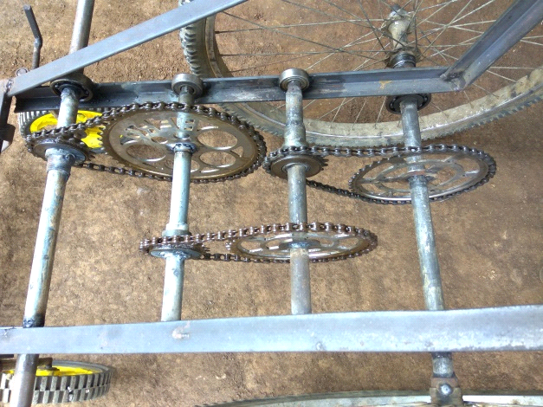
S6
S4
S3
S2
S1
SF4

SF3
SF2
SF1
B3
B4
B2
B1
S5
Fig.2-Human powered transmission mechanism

Shafts = SF1, SF2, SF3, SF4
Pairs of Bearings = B1, B2, B3, B4
Sprockets = S1, S2, S3, S4, S5, S6
Mechanical lawn mower is manual operated. Project doesn’t need any power source or fuel to run.
Rotary motion is converted to transverse motion. The power will transmit through the shaft Power will transmit with the help of chain drive.
When the machine is operated manually means when machine is push forward, wheels get rotate and help to get rotate the shaft (SF1). With the help of chain drive, power is transmitted to the shaft (SF4) with increased speed is get increased due to gear ratio of small sprocket and large sprocket. Rotational motion of the shafts is converted onto reciprocating motion with the help of crank.

- MODEL OF HUMAN POWERED LAWN MOWER

As per the designed and analytical calculations made following model is developed.

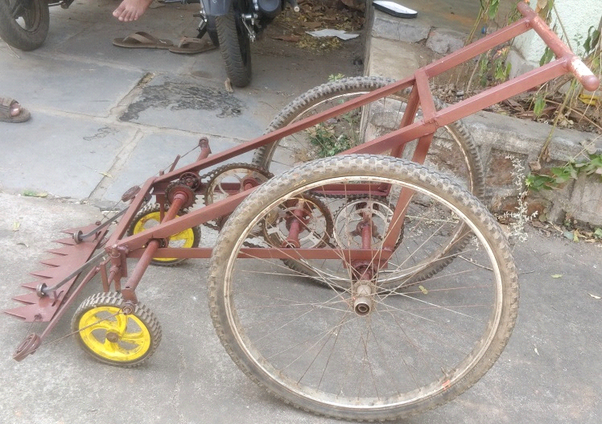

(a) Side view
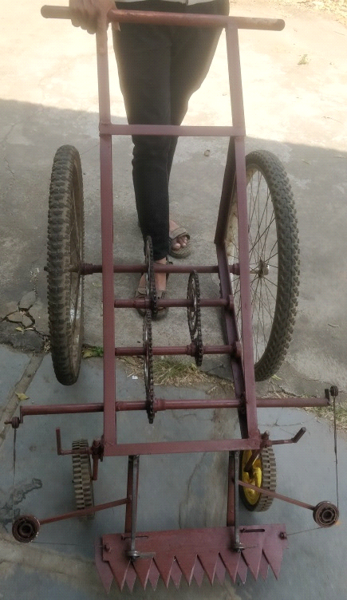

(b) Front view

Fig.2- Human powered lawn mower

- CONCLUSION

This project is made with pre planning, that it provides flexibility in operation. Model will provide to design and development such that will be simple to build and labor required to operate this machine is only one and less skilled labor can operate this machine. This project “HUMAN POWERED LAWN MOWER” is designed with the hope that it is very much economical and help full to many gardening areas. Minimum numbers of parts are used for minimizing weight as well as transmission losses. All the components of the machine, especially the parts used in the transmission unit are simple, kind of strong and less expensive. Test revealed that, higher grass cutting efficiency is obtained when the lawn is dry. It is also affordable since the cost of production is low. This project helped us to know the periodic steps in completing a project work. Thus we have completed the project successfully.
Few things need to be worked like feasibility of changing parts of model when needed as well as grass cutting ability doesn’t look polished like as available mowers do. Reason behind this may be blade quality and blade speed.

REFERENCES

- DR. P. P. DUTTA, MR. A. BARUAH AND MR. A. KONWAR
“Technical Review of Lawn Mower Technology”
ADBU Journal of Engineering TechnologyVolume 4(1), 2016

- DR.SATWIK, N.RAMALINGESWARA RAO, SHREE RAMREDDY
“Design and fabrication of lever operated solar lawn mower and contact stress analysis of spur gear”
International Journal of Science, Engineering and Technology Research Volume 3, 2014

- “C. J. SHENDE Assistant Professor, Mechanical Department
“Literature Review of Grass Cutter Machine”
International Journal of Emerging Technologies in Engineering Research (IJETER) Volume 6, Issue 2, February 2018

- LAUKIK P. RAUT- Assistant Professor
“Design, Development and Fabrication of a Compact Harvester”
IJSRD - International Journal for Scientific Research & Development Vol. 2, Issue 10, 2014

- VENKATESH.K- Assistant Professor
“Fabrication and Analysis of Lawn Mower”
International Journal of Innovative Research in Science Engineering and Technology
(An ISO 3297: 2007 Certified Organization) Vol. 4, Special Issue 6, May 2015

- JEGAN RAJ-Lecturer in Mechanical Engineering
“Design of Mechanical Tef Harvesting Machine”
International journal of advance research in science and engineering vol. no.5 Issue may 2016.

